GP Comprehension – Reflective Issues – Fairness (SAJC 2013)

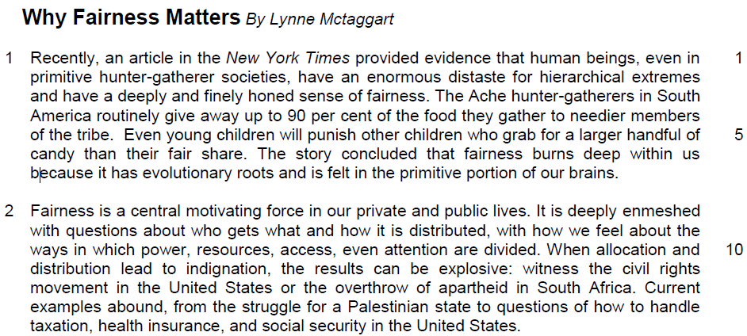

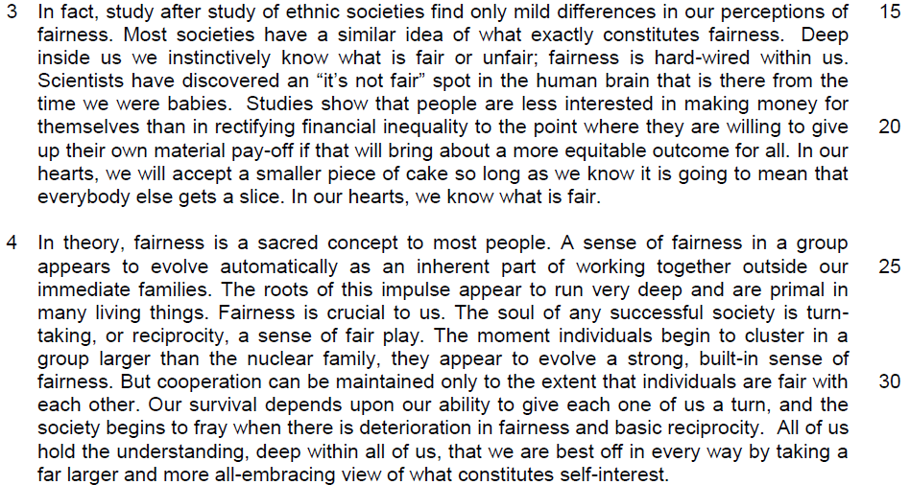

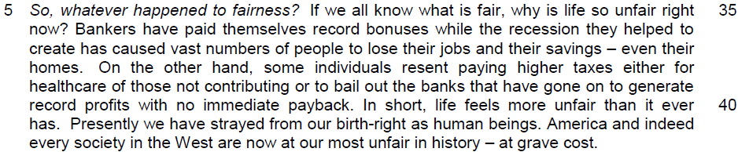

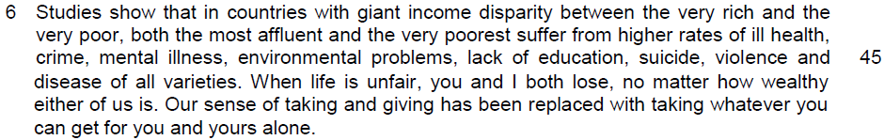

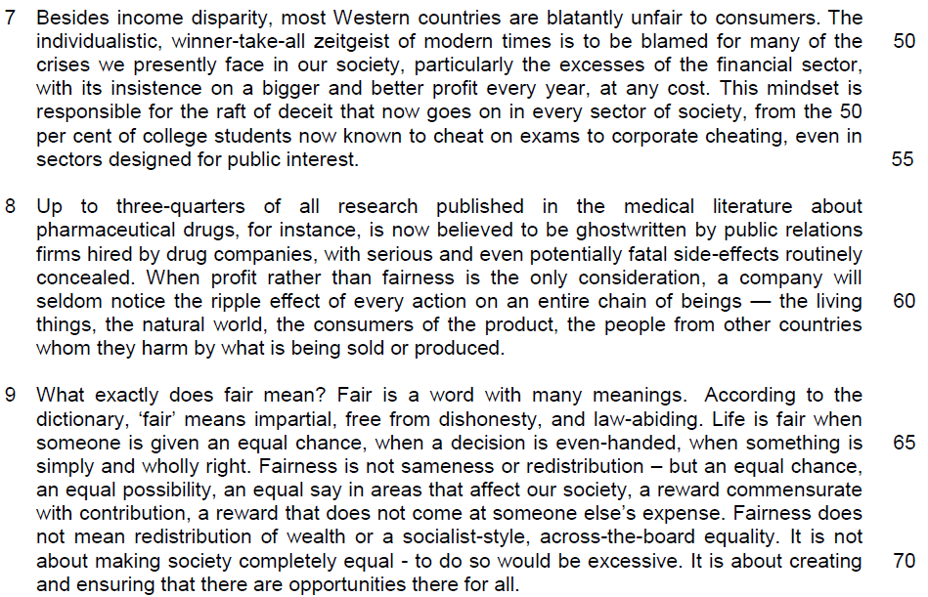

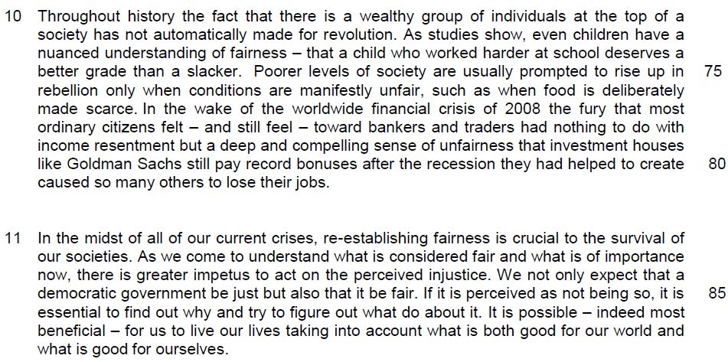

Read the passage in the insert and then answer all the questions which follow below. Note that up to fifteen marks will be given for the quality and accuracy of your use of English throughout this paper.

NOTE: When a question asks for an answer IN YOUR OWN WORDS AS FAR AS POSSIBLE and you select the appropriate material from the passages for your answer, you must still use your own words to express it. Little credit can be given to answers which only copy words or phrases from the passages.

1. What is the ‘enormous distaste’ (line 2) that primitive hunter-gatherer societies share? Use your own words as far as possible.

……………………………………………………………………………………...…
………………………………………………………………………………………[1]

2. Why is the sentence ‘So, whatever happened to fairness?’ in line 35 italicised?

…………………………………………………………………………………………

…………………………………………………………………………………………
………………………………………………………………………………………[2]

3. Explain what the author means by the phrase ‘strayed from our birth-right as human beings’ (line 41).

…………………………………………………………………………………………

…………………………………………………………………………………………
……………………………………………………………………………………….[2]

4. Why does the author use the words ‘you’ and ‘I’ in line 46?

…………………………………………………………………………………………
………………………………………………………………………………………[1]

5. Explain what the author means by ‘our sense of taking and giving has been replaced with taking whatever you can get for you and yours alone’ (lines 47-48).

…………………………………………………………………………………………
………………………………………………………………………………………[1]

6. (i) Why are most western countries ‘blatantly unfair to consumers’ (line 49)? Use your own words as far as possible.

…………………………………………………………………………………………
………………………………………………………………………………………[1]

6. (ii) How is this blatant unfairness to consumers illustrated?

…………………………………………………………………………………………
…………………………………………………………………………………………
………………………………………………………………………………………[2]

7. In paragraph 8, instead of public relations firms, suggest who should write the research about pharmaceutical drugs?

…………………………………………………………………………………………
………………………………………………………………………………………[1]

8. What does the word ‘routinely’ (line 58) imply about the attitude of drug companies in concealing the side-effects of drugs?

…………………………………………………………………………………………
………………………………………………………………………………………[1]

9. When the author cited fairness as ‘…impartial, free from dishonesty, and law-abiding’ (line 64), what is he implying about unfairness? Use your own words as far as possible.

…………………………………………………………………………………………

…………………………………………………………………………………………

…………………………………………………………………………………………
………………………………………………………………………………………[3]

10. Explain why inequality does not automatically lead to revolution in paragraph 10. Use your own words as far as possible.

…………………………………………………………………………………………

…………………………………………………………………………………………
………………………………………………………………………………………[2]

=

11. Using material from paragraphs 2 to 4 only, summarise why fairness is important. Write your summary in no more than 120 words, not counting the opening words which are printed below. Use your own words as far as possible.

Fairness has always been …………………………………………………………

…………………………………………………………………………………………

…………………………………………………………………………………………
…………………………………………………………………………………………

…………………………………………………………………………………………

…………………………………………………………………………………………

…………………………………………………………………………………………

…………………………………………………………………………………………

…………………………………………………………………………………………

…………………………………………………………………………………………

…………………………………………………………………………………………

…………………………………………………………………………………………

…………………………………………………………………………………………

…………………………………………………………………………………………

…………………………………………………………………………………………

…………………………………………………………………………………………

…………………………………………………………………………………………

…………………………………………………………………………………………

…………………………………………………………………………………………

…………………………………………………………………………………………

…………………………………………………………………………………………
………………………………………………………………………………………[8]

12. In this article, Lynne Mctaggart argues for the need for fairness in society today. How relevant are her views to you and your society?

…………………………………………………………………………………………

…………………………………………………………………………………………
…………………………………………………………………………………………

…………………………………………………………………………………………

…………………………………………………………………………………………

…………………………………………………………………………………………

…………………………………………………………………………………………

…………………………………………………………………………………………

…………………………………………………………………………………………

…………………………………………………………………………………………

…………………………………………………………………………………………

…………………………………………………………………………………………

…………………………………………………………………………………………

…………………………………………………………………………………………

…………………………………………………………………………………………

…………………………………………………………………………………………

…………………………………………………………………………………………

…………………………………………………………………………………………

…………………………………………………………………………………………

…………………………………………………………………………………………

…………………………………………………………………………………………

…………………………………………………………………………………………

…………………………………………………………………………………………

…………………………………………………………………………………………
…………………………………………………………………………………………

…………………………………………………………………………………………

…………………………………………………………………………………………

…………………………………………………………………………………………

…………………………………………………………………………………………

…………………………………………………………………………………………

…………………………………………………………………………………………

…………………………………………………………………………………………

…………………………………………………………………………………………

…………………………………………………………………………………………

…………………………………………………………………………………………

…………………………………………………………………………………………

…………………………………………………………………………………………

…………………………………………………………………………………………

…………………………………………………………………………………………

…………………………………………………………………………………………

…………………………………………………………………………………………

…………………………………………………………………………………………

…………………………………………………………………………………………

…………………………………………………………………………………………

…………………………………………………………………………………………

…………………………………………………………………………………………

…………………………………………………………………………………………

…………………………………………………………………………………………
…………………………………………………………………………………………

…………………………………………………………………………………………

…………………………………………………………………………………………

…………………………………………………………………………………………

…………………………………………………………………………………………

…………………………………………………………………………………………

…………………………………………………………………………………………

…………………………………………………………………………………………

…………………………………………………………………………………………

…………………………………………………………………………………………

…………………………………………………………………………………………

…………………………………………………………………………………………

…………………………………………………………………………………………

…………………………………………………………………………………………

…………………………………………………………………………………………

…………………………………………………………………………………………

…………………………………………………………………………………………

…………………………………………………………………………………………

…………………………………………………………………………………………

…………………………………………………………………………………………
……………………………………………………………………………………..[10]

Suggested Answers

1. What is the ‘enormous distaste’ (line 2) that primitive hunter-gatherer societies share? Use your own words as far as possible. [1m]

Lift
“…human beings, even in primitive hunter-gatherer societies, have an enormous distaste for hierarchical extremes”

Paraphrased
They share the enormous distaste for immense/excessive/great/intense social disparity/inequality.

2. Why is the sentence ‘So, whatever happened to fairness?’ in line 35 italicised? [2m]

Lift
So, whatever happened to fairness?

Inferred
It serves to bring our attention to something significant the author is saying, in this case, an unexpected/unanticipated/sudden outcome/ turn of events, that is, the loss or decline of fairness.

3. Explain what the author means by the phrase ‘strayed from our birth-right as human beings’ (line 41). [2m]

Lift
The idea of ‘innate’ and ‘drifted away’ must be clearly captured

Paraphrased
By this, the author means to say that we have drifted away from our innate/inherent right to fair treatment.

4. Why does the author use the words ‘you’ and ‘I’ in line 46? [1m]

Lift
When life is unfair, you and I both lose, no matter how wealthy either of us is.

Inferred
The writer is trying to engage the reader/ establish a rapport with reader/ to convince/ persuade the reader that this issue affects everyone/is common to everyone.

5. Explain what the author means by ‘our sense of taking and giving has been replaced with taking whatever you can get for you and yours alone’ (lines 47-48). [1m]

Lift
Our sense of taking and giving has been replaced with taking whatever you can get for you and yours alone”.

Paraphrased
The author is saying that reciprocity/mutuality/mutual benefit is now supplanted/ superseded; undermined/ taken over by selfishness.

6 (i) Why are most western countries ‘blatantly unfair to consumers’ (line 49)? Use your own words as far as possible. [1m]

Lift
The individualistic, winner-take-all zeitgeist of modern times is to blame for many of the crises we presently face in our society

Paraphrased
Most western countries are so because many of them have adopted a culture that is egocentric/ self-centred/ self-serving/ selfish/ self-seeking/ focusing only on success that benefits the individual rather than the whole community.

6(ii) How is this blatant unfairness to consumers illustrated? [2m]

Lift
“…particularly the excesses of the financial sector, with its insistence on a bigger and better profit every year…corporate cheating, even in sectors designed for public interest.

Paraphrased
This blatant unfairness to consumers is illustrated through greed as companies that are obsessed with making more profits/with getting more than what they deserve/ driven by greed.

Also, the blatant unfairness to consumers is manifested through cheating, in which companies are unethical/deceitful in their practices. Public services take advantage of the people that they are supposed to serve/ Drug companies intentionally hide side-effects of drugs from consumers.

7. In paragraph 8, instead of public relations firms, suggest who should write the research about pharmaceutical drugs? [1m]

Lift
“Up to three-quarters of all research published in the medical literature about pharmaceutical drugs, for instance, is now believed to be ghostwritten by public relations firms hired by drug companies…”

Paraphrased
Instead of public relations firms, independent writers with no vested interests should write the research about pharmaceutical drugs.

Also accept the following:
- People who are not affiliated to the companies
- People who publish in their real names
- People who have integrity/write honestly or truthfully

8. What does the word ‘routinely’ (line 58) imply about the attitude of drug companies in concealing the side-effects of drugs? [1m]

Lift
“…with serious and even potentially fatal side-effects routinely concealed.”

Inferred
Drug companies are nonchalant/ unconcerned/ taking it for granted as a practice to hide the truth.

9. When the author cited fairness as ‘…impartial, free from dishonesty, and law-abiding’ (line 64), what is he implying about unfairness? Use your own words as far as possible. [3m]

Lift
Impartial; free from dishonesty; law-abiding

Paraphrased
Unfairness is being bias/prejudiced. It is deceptive/fraudulent/disingenuous/not veracious/not truthful and it is illegal/illicit/illegitimate.

10. Explain why inequality does not automatically lead to revolution in paragraph 10. Use your own words as far as possible. [2m]

Lift
“…even children have a nuanced understanding of fairness”
“…only when conditions are manifestly unfair such as when food is deliberately made scarce.”

Paraphrased
People have fine/subtle understanding/ delicate definition of fairness/ consider mediating factors before pronouncing a situation as unfair. It is not always clear/obvious/evident that there is manipulation of resources for selfish or discriminatory intent/ artificially created scarcity/ exploitation.

11. Using material from paragraphs 2 to 4 only, summarise why fairness is important. Write your summary in no more than 120 words, not counting the opening words which are printed below. Use your own words as far as possible.

Fairness has always been…
# | Passage | Paraphrase
1 | Fairness is a central motivating force in our private and public lives ( Para 2 line 8)
2 | It is deeply enmeshed with questions about who gets what and how it is distributed… (Para 2 line 8)
3 | When allocation and distribution lead to indignation,
4 | results can be explosive ( Para 2 line10)
5 | Deep inside us we instinctively know what is fair or unfair; fairness is hard-wired within us. ( Para 3 line 17)  OR  The roots of this impulse appear to run very deep and are primal in many living things. (Para 4 line 26)
6 | fairness is a sacred concept to most people. ( Para 4 line 24)
7 | A sense of fairness in a group appears to evolve automatically as an inherent part of working together outside our immediate families. (Para 4 line25)
8 | The soul of any successful society (Para 4 line 27)
9 | Cooperation can be maintained only to the extent that individuals are fair with each other. (Para 4 line 30)
10 | Our survival depends upon our ability… (Para 4 line 31)

# | Passage | Paraphrase
11 | to give each one of us a turn ( Para 4 line 31)
12 | the society begins to fray when there is deterioration in fairness (Para 4, line 32)
13 | (deterioration) and basic reciprocity. (Para 4 line 32)
14 | we are best off in every way by taking a far larger and more all-embracing view of what constitutes self-interest. (Para 4 lines 33 to 34)

11. Using material from paragraphs 2 to 4 only, summarise why fairness is important. Write your summary in no more than 120 words, not counting the opening words which are printed below. Use your own words as far as possible.
Fairness has always been…
# | Passage | Paraphrase
1 | Fairness is a central motivating force in our private and public lives ( Para 2 line 8) | Fairness is a key motivator/ power in our world/  a primary force
2 | It is deeply enmeshed with questions about who gets what and how it is distributed… (Para 2 line 8) | It helps us in answering issues on allocation of resources…
3 | When allocation and distribution lead to indignation, | Unfair distribution may lead to resentment…
4 | results can be explosive ( Para 2 line10) | Outcomes can be very negative…
5 | Deep inside us we instinctively know what is fair or unfair; fairness is hard-wired within us. ( Para 3 line 17)  OR  The roots of this impulse appear to run very deep and are primal in many living things. (Para 4 line 26) | The common understanding of what entails fairness is ingrained in all human beings.
6 | fairness is a sacred concept to most people. ( Para 4 line 24) | It is a sacrosanct/ revered concept for most individuals
7 | A sense of fairness in a group appears to evolve automatically as an inherent part of working together outside our immediate families. (Para 4 line25) | Fairness is developed naturally/ spontaneously when we need to work with non-family members.
8 | The soul of any successful society (Para 4 line 27) | It remains the essence of a successful society.
9 | Cooperation can be maintained only to the extent that individuals are fair with each other. (Para 4 line 30) | Collaboration can only be sustained if people are fair to one another.
10 | Our survival depends upon our ability… (Para 4 line 31) | It is important as fairness affects the success and demise of our society..

# | Passage | Paraphrase
11 | to give each one of us a turn ( Para 4 line 31) | We need to learn to take turns
12 | the society begins to fray when there is deterioration in fairness (Para 4, line 32) | Conflicts in society will arise when there is a decline in fairness
13 | (deterioration) and basic reciprocity. (Para 4 line 32) | Decline in mutual care/ dependence
14 | we are best off in every way by taking a far larger and more all-embracing view of what constitutes self-interest. (Para 4 lines 33 to 34) | Advantageous for us to adopt/ consider collective interests based on fairness.  Improving everyone’s standard of living/ quality of living.

12. In this article, Lynne Mctaggart argues for the need for fairness in society today. How relevant are her views to you and your society?

Relevant points for evaluation from the passage
Paragraph 1 (lines 5-7)
“Even young children will punish other children who grab for a larger handful of candy than their fair share. The story concluded that fairness burns deep within us because it has evolutionary roots and is felt in the primitive portion of our brains.”

Paragraph 2 (lines 8-10)
Fairness is a central motivating force in our private and public lives. It is deeply enmeshed with questions about who gets what and how it is distributed, with how we feel about the ways in which power, resources, access, even attention are divided.

Paragraph 2 (lines 10-11)
“When allocation and distribution lead to indignation, the results can be explosive…”

Paragraph 3 (lines 19-23)
Studies show that people are less interested in making money for themselves than in rectifying financial inequality to the point where they are willing to give up their own material pay-off if that will bring about a more equitable outcome for all. In our hearts, we will accept a smaller piece of cake so long as we know it is going to mean that everybody else gets a slice. In our hearts, we know what is fair.

Paragraph 4
But cooperation can be maintained only to the extent that individuals are fair with each other. (lines28-30)

Our survival depends upon our ability to give each one of us a turn, and the society begins to fray when there is deterioration in fairness and basic reciprocity. (lines 30-32)

All of us hold the understanding, deep within all of us, that we are best off in every way by taking a far larger and more all-embracing view of what constitutes self-interest. (lines 32-34)

Paragraph 5
“If we all know what is fair, why is life so unfair right now?” (lines 35-36)
“Presently we have strayed from our birth-right as human beings. America and indeed every society in the West are now at our most unfair in history- at grave cost” (lines 41-42)

“Our sense of taking and giving has been replaced with taking whatever you can get for you and yours alone” (line 47)

Paragraph 6
“When life is unfair, you and I both lose, no matter how wealthy either of us is.” (line 46-47)

“Our sense of taking and giving has been replaced with taking whatever you can get for you and yours alone” (line 47-48)

Paragraph 7 (lines 49-52)
“The individualistic, winner-take-all zeitgeist of modern times is to blame for many of the crises we presently face in our society, particularly the excesses of the financial sector, with its insistence on a bigger and better profit every year, at any cost.”

Paragraph 7 (lines 53-54)
“from the 50 per cent of college students now known to cheat on exams”

Paragraph 7 (line 54)
“to corporate cheating”

Paragraph 7 (line 54-55)
“even in sectors designed for public interest.”

Paragraph 8 (lines 56-58)
“Up to three-quarters of all research published in the medical literature about pharmaceutical drugs, for instance, is now believed to be ghostwritten by public relations firms hired by drug companies, with serious and even potentially fatal side-effects routinely concealed.”

Paragraph 8 (lines 59-62)
“When profit rather than fairness is the only consideration, a company will seldom notice the ripple effect of every action on an entire chain of beings — the living things, the natural world, the consumers of the product, the people from other countries whom they harm by what is being sold or produced.”

Paragraph 9 (lines 68-71)
“Fairness does not mean redistribution of wealth, or a socialist-style government, across the board equality… it is about creating and ensuring that there are equal opportunities for all.”

Paragraph 10 (lines 76-77)
“Poorer levels of society are prompted to rise up in rebellion when conditions are manifestly unfair”.

Paragraph 11
“…re-establishing fairness is crucial to the survival of our societies...there is greater impetus to act on the perceived injustice.” (lines 83-85)

We not only expect that a democratic government be just but also that it be fair” (lines 85-86).

