GP Term 3 2017 – Comprehension – Topic 10: International Issues – Similarities & Differences

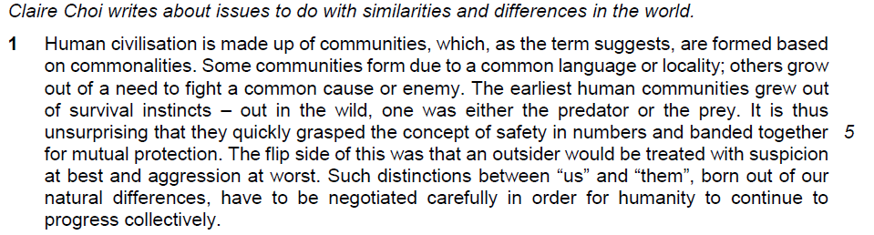
How communities group together to protect themselves – the basic notion of the development of a nation – the result of tribal organization

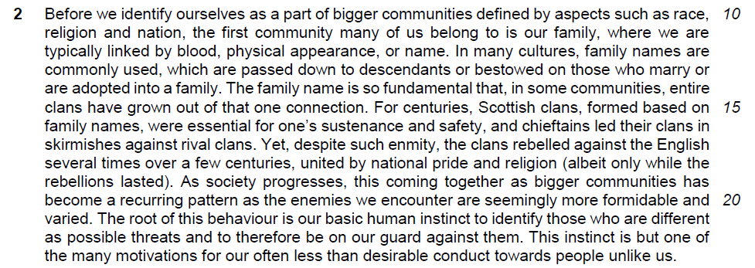
The influence of the family or clan which help to forge nationhood – nations led by family – heritage
Social – family, religion and nation there are the entities that the Scottish fought to protect
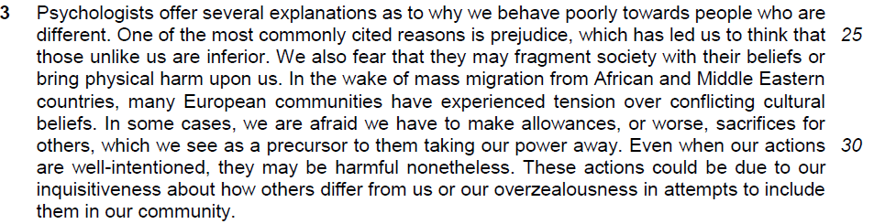
Psychological factor – attitudes towards the people who are different – prejudice, foreign ideas may undermine the values of the community, may have to compromise what we want to have due to the interests of the foreigners, curiosity towards foreigners

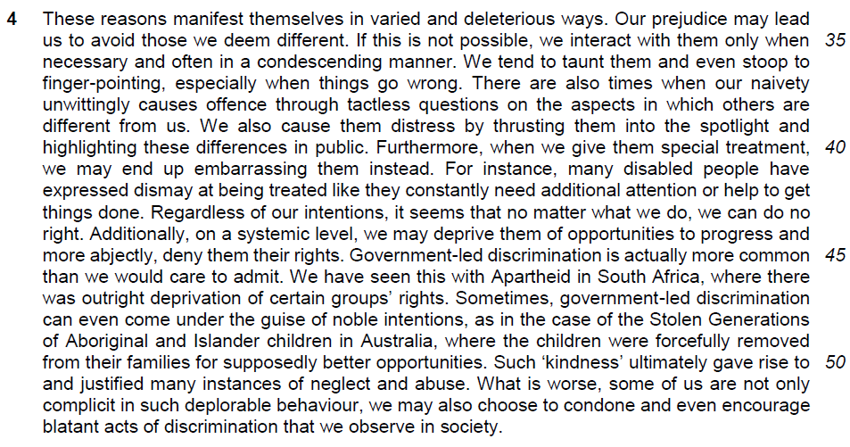

How we treat people who are different from us? ( negative response)

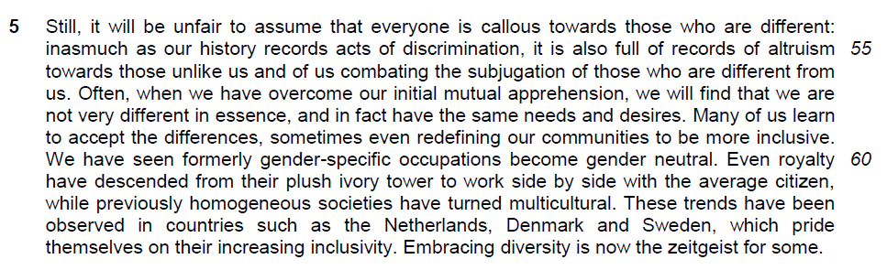
positive response towards those who are different from us

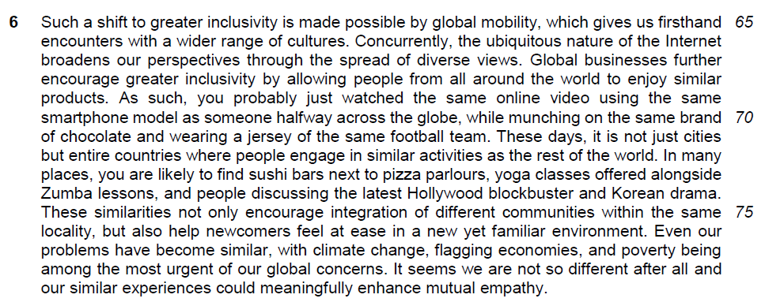
factors that will help to integrate foreignness into the community -technology, globalization economic activities, world-wide issues, entertainment, sports, environmental issues

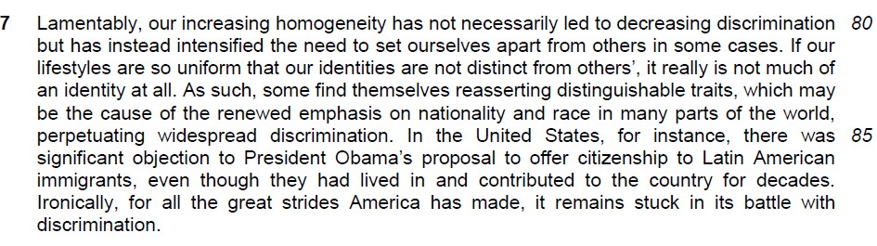
the need to stay different and reject integration

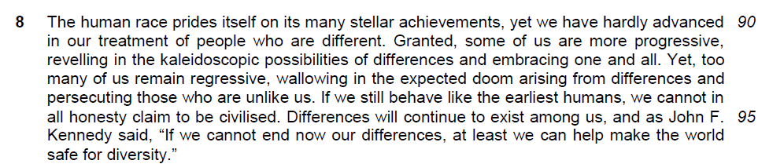
not realistic to accept integration but need to accept and respect diversity
Suggested Answers
Q1) Explain what the author means by “with suspicion at best” (lines 6-7). [2]

From the Passage
an outsider would be treated with suspicion at best

Answer
In our most friendly way we treat outsiders, they are still treated with scepticism by the people in the community

Q2) Why has the author placed brackets around the comment in lines 18-19? [2] intention of the writer -meaning of the intention to the issue

From the Passage
Yet, despite such enmity, the clans rebelled against the English several times over a few centuries, united by national pride and religion (albeit only while the rebellions lasted).

Answer
The author wishes to show how the unity of the clans did not last long although the clans could unite themselves to fight the English.

Q3) Why has the author placed the word “kindness” in inverted commas (line 50)? [1]

From the Passage
Such ‘kindness’ ultimately gave rise to and justified many instances of neglect and abuse.

Answer
She wants to show the act in helping the foreigners is not kind. In fact, it is quite cruel to the children.

Q4) How does the author justify her use of the word “unfair” (line 54)? Use your own words as far as possible. [2]

From the Passage
Still, it will be unfair to assume that everyone is callous towards those who are different: inasmuch as our history records acts of discrimination, it is also full of records of altruism towards those unlike us and of us combating the subjugation of those who are different from us.

Answer

Answer A
There are actually many accounts of charity towards people who are different and people fight for these people to show that it is unfair to conclude that people will be cruel or unkind to those who are different.

Answer B
The writer thinks that the accusation of being abusive towards outsider is unfair as there are many accounts of selfless acts in helping the outsiders and there are also people who fought against the discrimination against outsiders.

Q5) What does the phrase “plush ivory tower” (line 61) suggest about the royalty? [1]

From the Passage
Even royalty have descended from their plush ivory tower to work side by side with the average citizen

Answer
They live in comfortable conditions, far removed from the average person.

Q6) What explanations does the author offer for the “shift to greater inclusivity” (lines 65)? Use your own words as far as possible. [2]

From the Passage
Such a shift to greater inclusivity is made possible by global mobility, which gives us first and encounters with a wider range of cultures. Concurrently, the ubiquitous nature of the Internet broadens our perspectives through the spread of diverse views. Global businesses further encourage greater inclusivity by allowing people from all around the world to enjoy similar products.

Answer
International travel allows us direct contact with a greater variety of cultures. The widely available Internet makes us more open-minded through exposure to different opinions. International companies offer international access to identical goods.

Q7) What does the author mean by “distinguishable traits” (line 83), and what has led to the need to reassert them? Use your own words as far as possible. [2] maintain their uniqueness to assert individuality

From the Passage
Our increasing homogeneity has however not necessarily led to decreasing discrimination but has instead intensified the need to set ourselves apart from others in some cases. If our lifestyles are so uniform that our identities are not distinct from others’, it really is not much of an identity at all.

Answer
They are differentiating attributes. Some people want to reassert these traits because they feel that our growing similarities are eroding their individuality and they want to re-establish their uniqueness.

Q8) Using your own words as far as possible, explain the irony in lines 88-89. [2]

From the Passage
Ironically, for all the great strides America has made, it remains stuck in its battle with discrimination.

Answer
With the numerous progress America has made, it should be able to similarly tackle the problem of discrimination. In reality, it has not made progress in resolving the issue.

Q9) In paragraph 8, what contrasts does the author make between people who are “more progressive” and those who “remain regressive” in their approach towards people who are different? Use your own words as far as possible. [2]

From the Passage
The human race prides itself on its many stellar achievements, yet we have hardly advanced in our treatment of people who are different. Granted, some of us are more progressive, revelling in the kaleidoscopic possibilities of differences and embracing one and all. Yet, too many of us remain regressive, wallowing in the expected doom arising from differences and persecuting those who are unlike us. If we still behave like the earliest humans, we cannot in all honesty claim to be civilised. Differences will continue to exist among us, and as John F. Kennedy said, “If we cannot end now our differences, at least we can help make the world safe for diversity.”

Answer
The more progressive delight in the prospects offered by diversity and accept everybody while the regressive are preoccupied by the catastrophe differences could bring and discriminate against those who are different.

Q10) Which idea in paragraph 1 is supported by the quotation from John F. Kennedy (lines 96-97)? [1]

From the Passage
Differences will continue to exist among us, and as John F. Kennedy said, “If we cannot end now our differences, at least we can help make the world safe for diversity.”

Answer
It is the idea in the last sentence.

Summary Question
Q11) Using material from paragraphs 3-4 only (lines 24-53), summarise what the author has to say about why people behave poorly towards those who are unlike them and how they act towards those who are different.

Write your summary in no more than 120 words, not counting the opening words which are printed below. Use your own words as far as possible. [8]

Firstly, people behave poorly towards those who are unlike them because…
From passage | Suggested answer
One of the most commonly cited reasons is prejudice, which has led us to think that those unlike us are inferior. | …of bias
We also fear that they may fragment society with their beliefs | They are also afraid the different views may break society up
or bring physical harm upon us. | or these people may assault them
In some cases, we are afraid we have to make allowances, | Sometimes, they fear having to compromise
or worse, sacrifices for others, | or even give up something for them,
which we see as a precursor to them taking our power away. | losing their rule.
Our prejudice may lead us to avoid those we deem different. | As such, people stay away from those unlike them
If this is not possible, we interact with them only when necessary | or deal with them only when needed,
and often in a condescending manner. | usually in an arrogant way.
We tend to taunt them | People may mock
and even stoop to finger-pointing | and even push blame onto those who are different.
our naivety unwittingly causes offence through tactless questions | Sometimes, people upset others by asking inconsiderate questions,
We also cause them distress by thrusting them into the spotlight and highlighting these differences in public. | by drawing attention to their differences,

From passage | Suggested answer
when we give them special treatment, we may end up embarrassing them instead. | or by showing favouritism, making them feel self-conscious.
on a systemic level, we may deprive them of opportunities to progress | They may prevent those who are different from advancing,
and more abjectly, deny them their rights. | or worse, take away their rights.
Such ‘kindness’ ultimately gave rise to and justified many instances of neglect | Sometimes, these people are denied attention
and abuse. | and even mistreated
What is worse…we may also choose to condone | More appallingly, some do nothing to stop such behaviour,
and even encourage blatant acts of discrimination that we observe in society. | and even incite outright discrimination.

