GP June Intensive Revision
Comprehension Learning Skills – Application Question

The application question requires the student to apply his understanding of the passage to the context of requirement as seen in the question. In doing so, the students will need to conduct the following steps:

Understand the main ideas in the passage

Understanding of the question

Strategy of Development

Writing Approach

1) Understand the main ideas in the passage

To have a good understanding of the passage, students need to comprehend the following areas of discussion:

- the main theme of the passage
- the main ideas of the passage
- the derivation of the main proposition

Theme : Pessimism and optimism
main ideas – views by the society, usefulness, impact on the society, causes (category)
proposition by the author - both are beneficial
2) Understanding of the question
A good understanding of the question will provide students the information on how to answer the question. Students need to take know of the following requirements:
- the proposition required for the question (main argument)
- the types of application
- agreement or disagreement
- extent of agreement
- application of the writer’s point of view to the context of question
- comparison of the writer’s point of view to the context of the question
- the nature of discussion
- the analysis of causes
- the provision of solutions
- the prediction of consequences and possibilities
- the application of the ideas and proposition
- other forms of generation of ideas
- the context of application - is this applicable to you and your society?
- the society
- your personal experiences
- the government
- the time period

Example 1
Q. John Ciardi says happiness is the pursuit itself rather than the possession of anything concrete. Erich Fromm says man’s happiness is superficial because it is directed by bureaucracy.

Which author’s view do you subscribe to more and explain why. Discuss the concerns your generation has in its search for happiness.

In your answer, develop some of the points made by the authors and give your own views.

1) What is the focus of the question?
To assess and select the view which is more agreeable to you in your understanding of happiness and explain and evaluate the apprehension of the youngsters in their pursuit for happiness.

2) Proposition of the requirement of the question.
Having considered the diverse views of both writers on the notion of happiness, I would feel that John Ciardi’s perception of happiness is more rational and sensible. As for the concern, both writers have also underlined some factors that shape the apprehension of the young people in Singapore in their pursuit of happiness.

3) Nature of Application
The nature of discussion is based on the application of ideas on the basis of alignment of discussion and use of information from the passage for the assessment of the condition in Singapore about the young people’s life.

4) Context of Application
The context of application is based on personal evaluation and society.

perspectives

- agree with the writer A or B
- disagree with writer A or B
- Identify one point from passage A as the concern of your generation
- identify one point from passage B as the concern of your generation

Writing Approach

- Introduction
  - Establish the background of the discussion
Summarize the writer’s view (may not be necessary)
  - requirement of the question
(eg. How applicable is the notion to your society?)
  - your stand on the issue (Agreement or disagreement) or how the question is to be answered (extent of agreement)

- Main Body – For one point
  - Quote the noun phrase and sub-clause in the passage that will explain the perspective
- Explain what the writer says

  - Provide the explanation of the ideas of the writer and depict how it is related to the focus of the question
- Explain how you agree or disagree with the writer
- (cannot use the substituted word that are used to explain the writer’s idea or reason)
  - Apply the discussion to the context of the question – state the example in relation to your country or examples in the real world according to the category
  - Other perspectives of discussion (If necessary – extent of agreement)
- counter-arguments
- rebuttals
- constraints of the applications

- Conclusion
  - Link the main points of discussion and link to the requirement of the question
  - retrospective summary and link to the stand

Types of Questions

Example 1
In passage 1, Trevor Turner describes the manifestations of narcissism in society and discusses some possible reasons for it. In passage 2, Lakshmi Chanudhry examines how the new media has fostered narcissism in people’s lives.

Which author do you find more convincing? To what extent are these views relevant to you and your generation?
Justify your views using materials from the passages as well as your own experiences and observations.

Example 2
Johann Hari takes a strong stand in support of liberal eugenics.
How convincing do you find his arguments in light of your own experience and
knowledge?

Example 3
Passage 1 suggests that freedom of though and expressions are universal rights. Passage 2 claims that limiting freedom of speech is justified.

How far should your society address the demand for freedom of thoughts and expression? Justify your view with reference to relevant material from the two passages as well as your knowledge and experience. (10)

GP Term 4 2017 – Comprehension –

Topic 1: Reflective Issues (Positive) – Importance of Failure
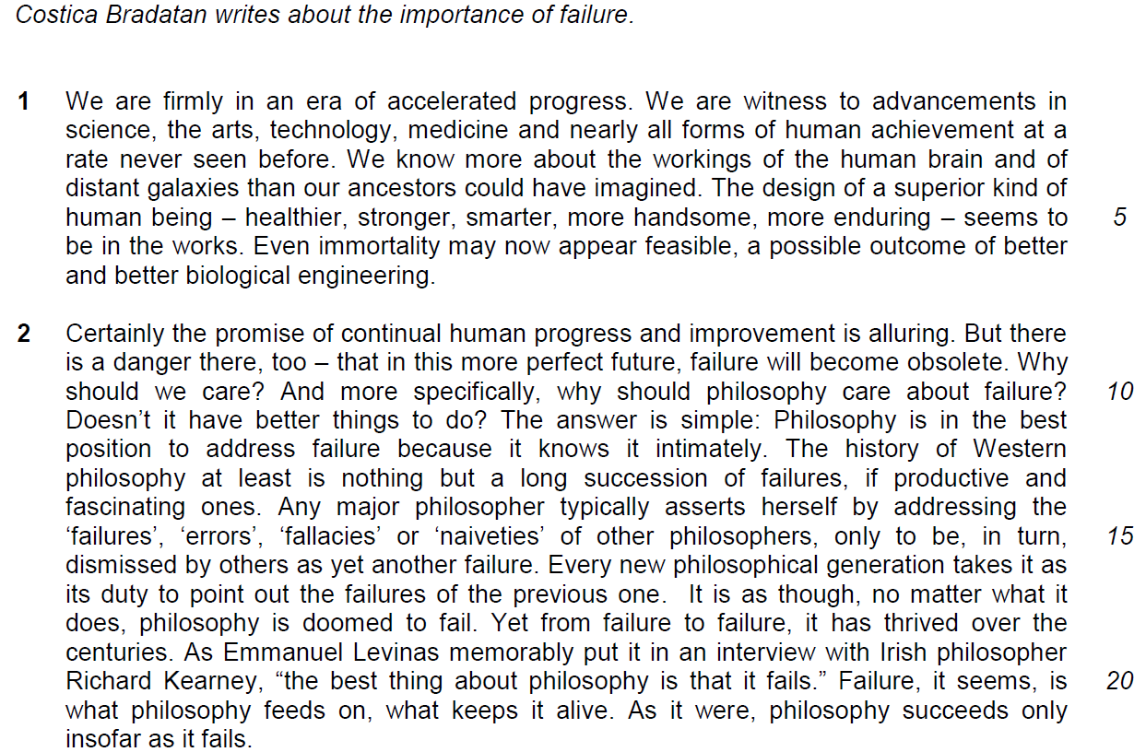

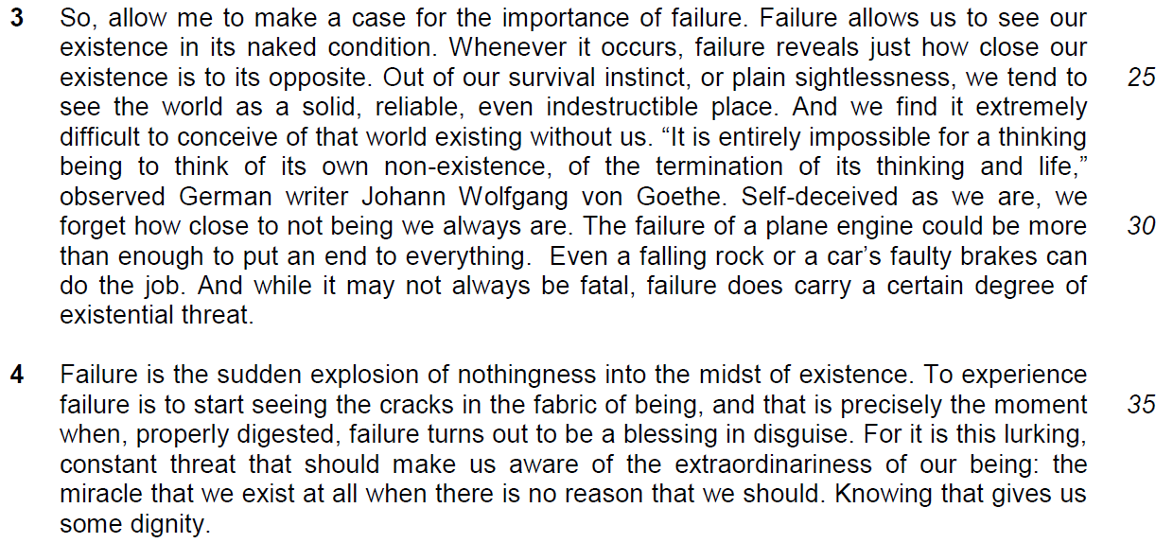

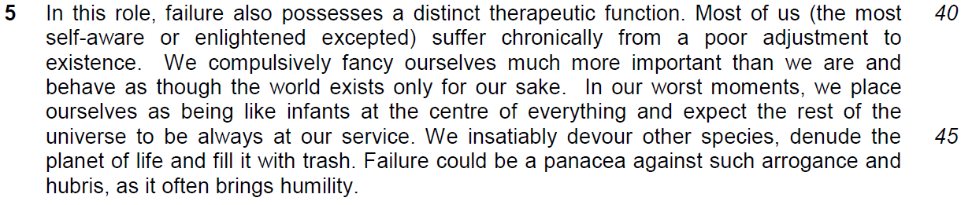

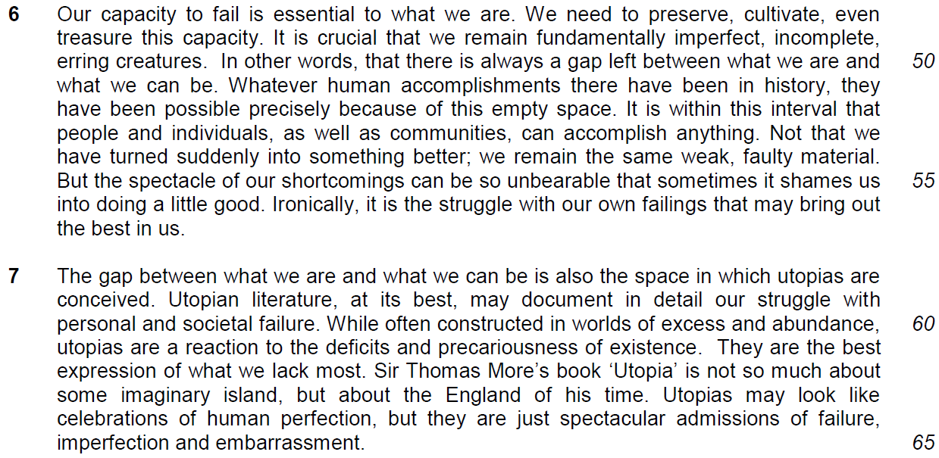

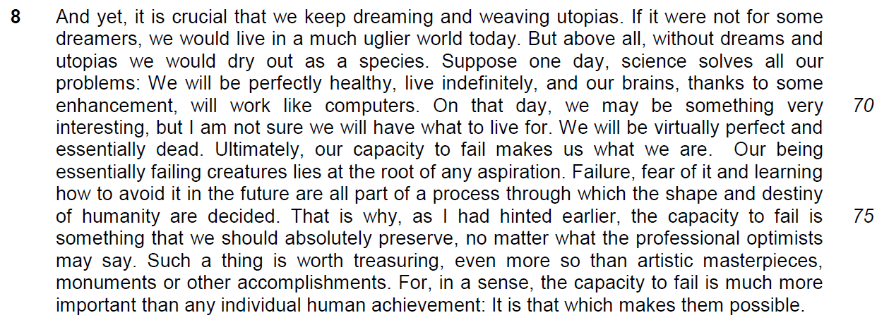

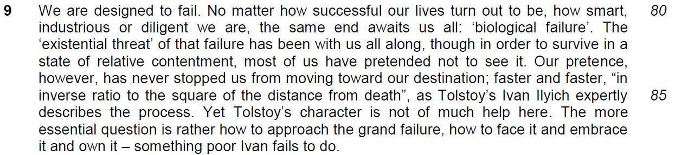

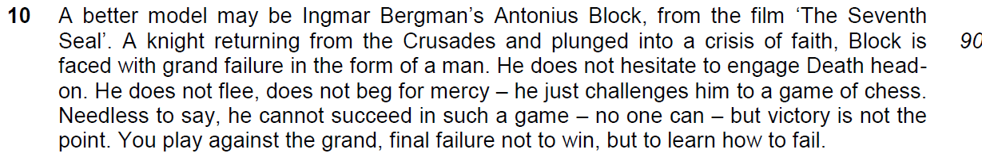

Application Question (AQ)
12. Costica Bradatan argues strongly in favour of failure. How applicable are the author’s observations to you and your society? Illustrate your answer by referring to the ways in which you and your society regard failure. [10]
Introduction
Brief description of what the writer said and the stand on the requirement of the question.

Main body
1. Quote
2. Explanation
3. Applicability of the observation
4. Example
5. Concluding sentence

6. Extent of Agreement
6.1 linking sentence to show that it is an EOA para
6.2 the main point of argument for EOA
7. Elaboration
8. Use the above example to rebut / set another example to rebut
9. linking sentence

OBSERVATION 1
1. Quote :
The observation that ‘Failure allows us to see our existence in its naked condition is very applicable to the Singaporean society.
2. Explanation:
Failure will let us realize our threat and vulnerability and we must recognize our vulnerability and the failure to recognize failure will mean that we do not recognize our vulnerability and threats.

3. Application:
Past failures to keep our society safe forced us confront the precariousness of our lives. When we fail to defend our country, our survival as a people comes under threat. Even when facing various crises and emergencies and in times of disaster, we realize our vulnerability and the fragility of our lives.

4. Example
- Singapore’s vulnerability during WW2 was due to failure of security/military defense resulted in the Japanese Occupation.
- Such costly lessons are not easily forgotten and post independent Singapore has implemented various policies to better safeguard ourselves against such failures.
  - According to IHS Jane’s Defence Weekly reports that defense expenditure will increase as a proportion of GDP for the first time since 2009, rising from 3.2% of GDP in 2014 to 3.3% for 2015
  - Importance of National Education and Total Defence – Military, Civil, Economic, Social & Psychological
  - Singapore is now better prepared and reacts quickly to terrorist threats (e.g. prevention of JI threat of bombing after 9/11; two youths arrested for links to ISIS)
- Singaporeans’ vulnerability to threats and dangers. These accidents and disasters show just how close our existence is hanging by a thread at times.
  - Eg. SARS (initial failure/difficulties in managing the spread but quick action by govt and healthcare sector contained the epidemic) and dengue epidemics (failure of people in keeping a clean environment)

Part B – Extent of Agreement
OBSERVATION 2
Step 1: Quote
The author argues that ‘The possibility of failure ‘should make us aware of the extraordinariness of our being.
Step 2: Explanation
Explanation: going through failure will make us better people and give us a sense of pride over what we have done to overcome failures
Step 3A: Applicability
This observation is definitely applicable and relatable to the Singapore narrative because our nation was born of failure and did experience failure in its infancy. This makes our current success even more amazing to behold.
Step 4A - Example
- Independence was thrust upon us because of the failed merger with Malaysia. LKY famously described the split as “a moment of anguish”, and his grief is immortalized in the video recording of his interview with members of the press after the split was announced. He, and many of the PAP (including Dr Toh Chin Chye, S. Rajaratnam and Mr. Ong Pang Boon), felt that it was a disaster, and that separation was not the right thing to do.
- The knowledge of our uncertain and tumultuous beginnings makes for an even more striking contrast with Singapore’s considerable economic growth and development today, as well as her racial harmony. It is something that all Singaporeans can be proud of.

Step 3B: extent of agreement
However, it may not be as applicable in modern day Singapore where anything other than the absolute best is considered a failure, and the cost of failure is seen to be high, the perceived enormity of failure may be may be too “indigestible” (unacceptable) for people to bounce back from, contributing to the increase in stress and anxiety related mental issues, and to high suicide rates. There is no “dignity” in failure, only shame, and the desire to escape it.
Step 4B: Example
- 901 people were arrested for attempting suicide in 2014, and the suicide rate has fluctuated over the years in the 400 range (415 in 2014)
- The most recently publicized case of suicide involved a straight-As student committing suicide because of two B grades at O levels (The New Paper, July 27 2015: ‘Straight A student commits suicide over O-level results, mum takes her own life months later’). Her perception of herself as a failure because of B grades, her inability to accept less than stellar results, led her to find a permanent way out of living instead of deriving greater appreciation of life, developing and growing from failure.

OBSERVATION 3
Step 1 - Quote
The author’s observation that ‘Failure could be a panacea against … arrogance and hubris, as it often brings humility.’ (lines 46-47) may not be entirely applicable to the Singaporean context.
Step 2 - Explanation
Failure only brings about humility if people are willing to admit mistakes and change for the better. If people are obstinate, they may dig in their heels and refuse to acknowledge mistakes, or try to shift the blame to others.

Step 3. Applicability
In Singapore, we can see many government bodies and private institutions refusing to recognise their wrongdoings and failures as it involves huge commercial or social course. Consequently, this lack of responsibility undermines the respect and recognition from the society and the citizens.

Step 4. Example
- Examples - Singapore companies or government bodies refusing to acknowledge the severity of problems/issues/mistakes through the use of euphemisms:
  - 2011 Flooding -> Initially described by PUB as “ponding”
  - Current train repair works -> “urgent / unscheduled maintenance”
  - Problems in the new DBSS projects, new condominium projects – Failure to deliver quality products and no one is taking responsibility

Conclusion

