GP Comprehension – Importance of Tradition

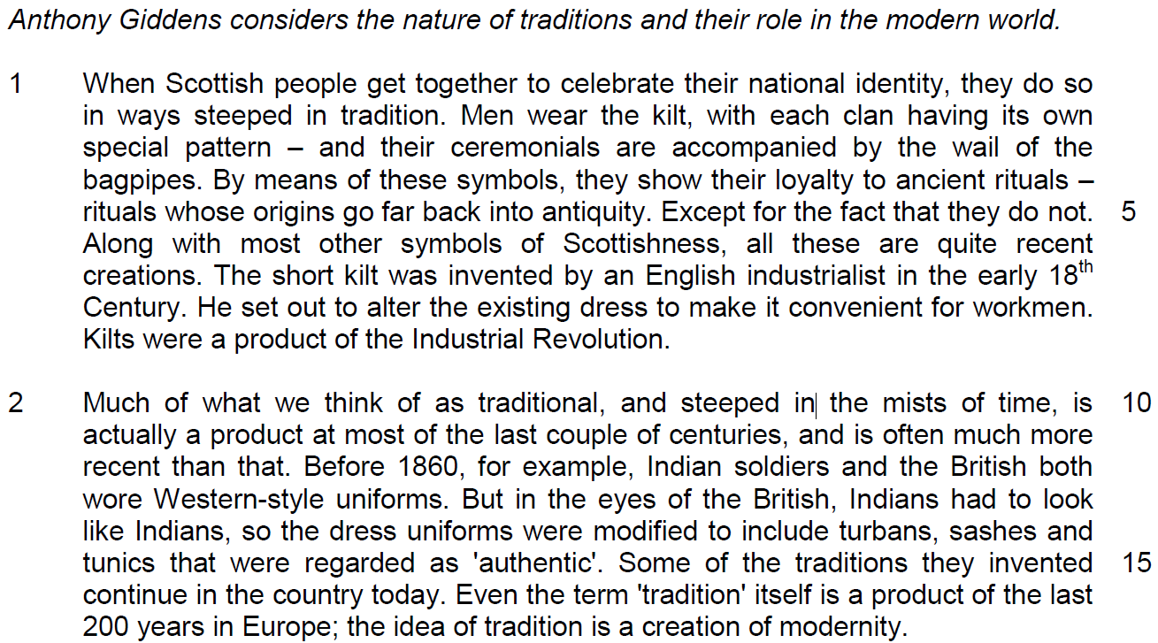

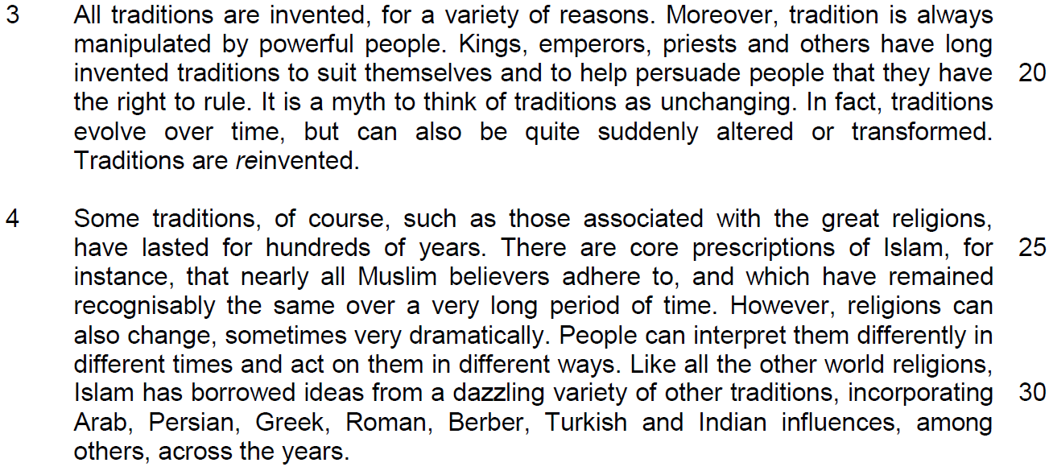

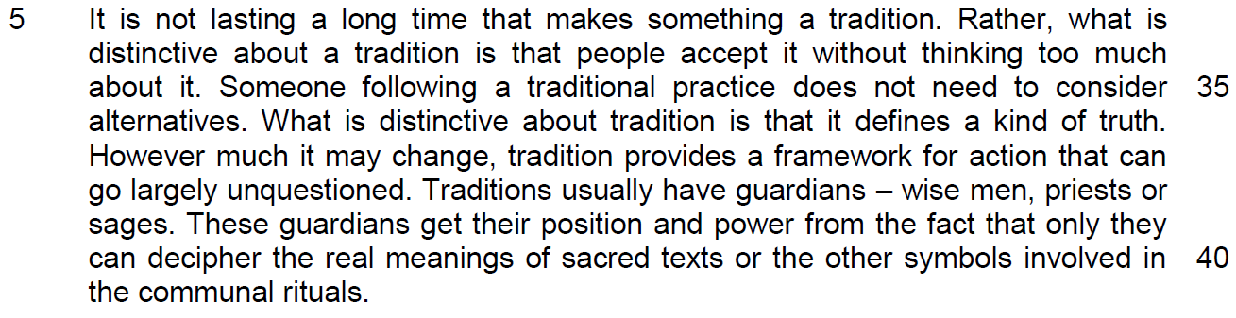
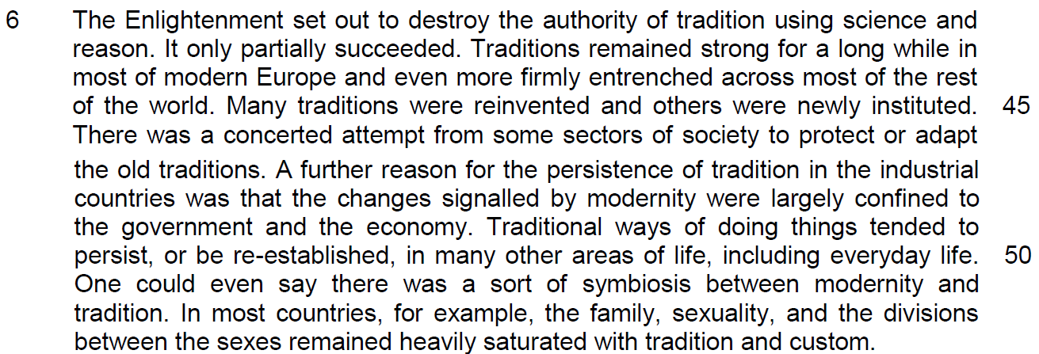

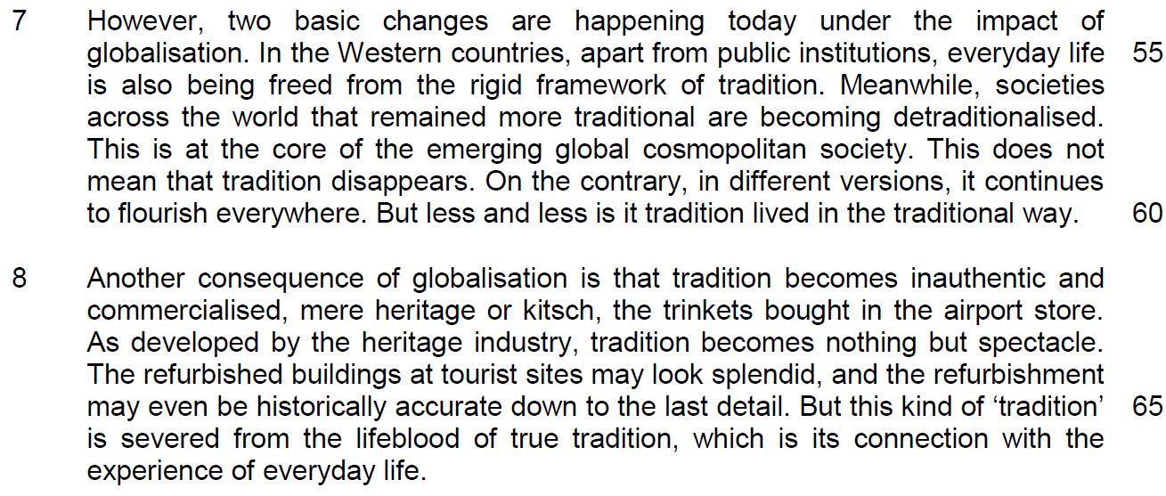

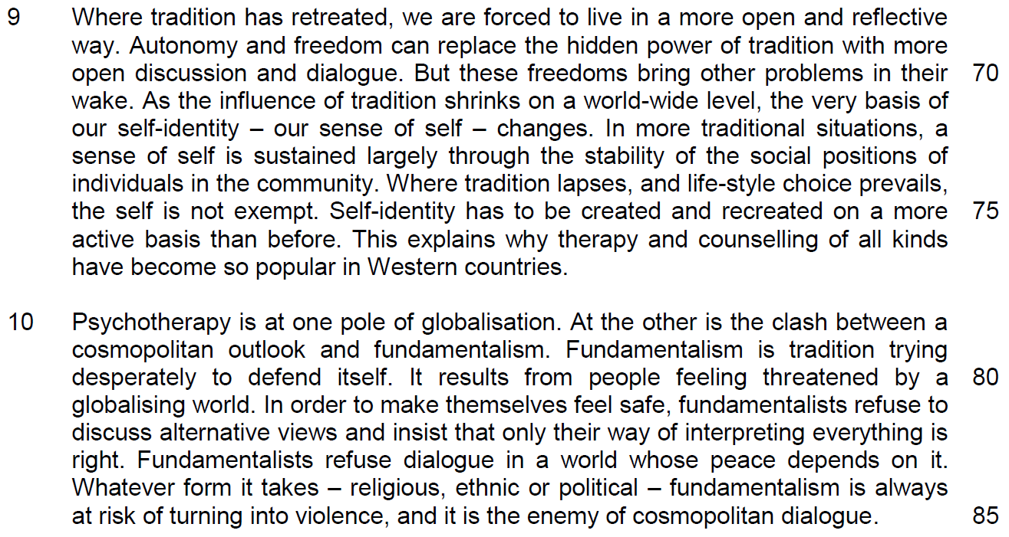
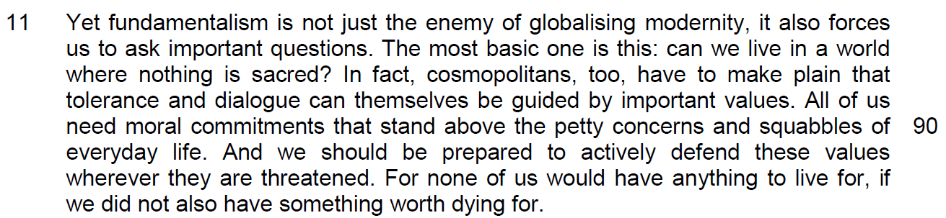

Suggested Answers
Q1) ‘Except for the fact that they do not.’ (line 5) What does this sentence indicate about the perception of rituals described in lines 1 – 5? [1]

From Passage
By means of these symbols, they show their loyalty to ancient rituals – rituals whose origins go far back into antiquity. Except for the fact that they do not.

Answer
There is a widespread assumption / perception that Scottish rituals are very old is a misconception as ………………..

Q2) Why is the word ‘authentic’ (line 15) in inverted commas? [2]
The intention and the content of intention

From Passage
So the dress uniforms were modified to include turbans, sashes and tunics regarded as 'authentic'.

Answer 1. Explanation of the concept, 2 implication of the answer
The author is indicating that although the British imagined/assumed/ supposed/accepted the stereotype that the elements of the dress uniform they created to be genuine expressions of Indian culture. (it is not the original form of dressing that reflects the Indian culture)

The author is trying to show that the modification of the uniform is not reflective of the origins of Indian culture.

Q3) Why is it paradoxical that ‘the idea of tradition is a creation of modernity’ (line 17)? [2] – two truths which contradicts each other in their result and explanation - Truths that contradicts /

irony – outcome differs from expectation
The question should be asking for the irony rather than to ask for the paradoxical nature.
From Passage
Even the term 'tradition' itself is a product of the last 200 years in Europe; the idea of tradition is a creation of modernity.

Answer
It is seen that what we call traditional has its origins in long-lost practices but in fact even the notion of ‘tradition’ itself was invented quite recently.

Irony – We expect tradition to be an idea developed in the past but in reality, it was a recent idea developed to create the notion of modernity.

4) In the third paragraph, how does the author illustrate the idea that ‘tradition is always manipulated by powerful people’ (lines 18 – 19)? Use your own words as far as possible. [2]

From Passage
Kings, emperors, priests and others have long invented traditions to suit themselves and to help persuade people that they have the right to rule.

Answer
Rulers have always made up customs for their own purposes and to legitimise/justify/rationalise their reign/power. (use traditions to justify their authority)

Q5) Why is the prefix ‘re’ in italics in the word ‘reinvented’ (line 23)? [2]
Ways to show the writer’s emphasis – the nature of invention
From Passage
In fact, traditions evolve over time, but can also be quite suddenly altered or transformed. Traditions are reinvented.

Answer
The author is emphasizing/reinforcing/highlighting that traditions are repeatedly created anew.

Q6) What is the author implying about the core prescriptions of Islam by his use of the word ‘recognisably’ (line 27)? [1]
Vocabulary question – use the word to describe the idea of the subject
From Passage
There are core prescriptions of Islam, for instance, that nearly all Muslim believers adhere to, and which have remained recognisably the same over a very long period of time.

Answer
Present-day prescriptions are visibly/perceptibly/observably the same as those of long ago for Muslims and this proves that religions are still the entity can still retain their original essences.

Q7) Why are ‘therapy and counselling of all kinds’ (lines 76) becoming popular in Western countries? Use your own words as far as possible. [3]

From Passage
In more traditional situations, a sense of self is sustained largely through the stability of the social positions of individuals in the community.

Where tradition lapses/ as tradition shrinks and life-style choice prevails, the self isn't exempt. Self-identity has to be created and recreated on a more active basis than before. Tradition must change.

Answer
In traditional societies, one’s identity is mainly determined by fixed societal roles, where tradition fails to play a significant role and where individual freedom takes centre stage. Our personal identity needs to be shaped continually and consciously with effort and this will create social pressure and discomfort which lead to more mental issues, requiring psychological support.

Q8) In paragraph 10, what are two differences between a cosmopolitan outlook and fundamentalism? Use your own words as far as possible. [2]

From Passage
Fundamentalism is tradition trying desperately to defend itself. It results from people feeling threatened by a globalising world.(lines 79-81)

In order to make themselves feel safe, fundamentalists refuse to discuss alternative views and insist that only their way of interpreting everything is right. (lines 81-83)

Fundamentalists refuse dialogue in a world whose peace depends on it. Whatever form it takes - religious, ethnic or political - fundamentalism is always at risk of turning into violence, and it is the enemy of cosmopolitan dialogue. (lines 83-85)

Answer
People who subscribe to/follow/believe in fundamentalism are very wary/fearful of a globalising world whereas people who subscribe to/follow/believe in a cosmopolitan outlook are welcome/look forward to a globalising world. (attitude towards globalization)

Fundamentalists choose not to/will not negotiate/talk about different/other views because all other views are wrong. However, people who subscribe to/follow/believe in a cosmopolitan outlook welcome debate and different views. (behaviours towards open discussion – receptiveness to towards other views)

Fundamentalism is constantly vulnerable to degenerating/resulting in violence. However, a cosmopolitan outlook has a higher chance of maintaining peace/stability.
(outcome of the attitude and behaviours)

Q9) From paragraph 11, identify two phrases or sentences in which the author seeks to engage his audience, and in each case, explain how the author’s language seeks to achieve this effect. [2]

From Passage
Yet fundamentalism isn't just the antithesis of globalising modernity, but poses questions to it. The most basic one is this: can we live in a world where nothing is sacred?

All of us need moral commitments that stand above the petty concerns and squabbles of everyday life.

We should be prepared to mount an active defence of these values wherever they are poorly developed, or threatened.

For none of us would have anything to live for, if we didn't also have something worth dying for.

Answer
The author uses a rhetorical question to challenge his readership to disagree

The author uses ‘we’/the first person plural to include his readership in his conclusions

The author uses words like ‘should’ or ‘need’/modals that express necessity/ obligation/ strong recommendation/ to create a sense of urgency/an imperative tone.

The author uses an effective and thought- provoking concluding statement to force readers to be more introspective.

Summary Writing
Q12) Using material from paragraphs 5 – 8 only, summarise what the author has to say about the defining features of tradition, the reasons why traditions remained strong in modern society and the impact of globalisation on traditions.

Write your summary in no more than 120 words, not counting the opening words which are printed below. Use your own words as far as possible.

One defining feature of tradition is …
S/No | From the passage | Paraphrased equivalent
1 | people accept it without thinking too much about it / largely unquestioned
2 | What is distinctive about tradition is that it defines a kind of truth
3 | tradition provides a framework for action
4 | Traditions usually have guardians
5 | Many traditions were reinvented
6 | others were newly instituted
7 | There was a concerted attempt from some sectors of society
8 | to protect
9 | or adapt the old traditions
10 | Changes signaled by modernity were largely confined to the government.
11 | and the economy

S/No | Points/Ideas from the passage (Essence of the point/idea in bold) | Paraphrased equivalent
12 | Traditional ways of doing things tended to persist, or be re-established, in many other areas of life, including everyday life.
13 | there was a sort of symbiosis between modernity and tradition.
14 | the family, sexuality, and the divisions between the sexes remained heavily saturated with tradition and custom.
15 | In the Western countries, not just public institutions
16 | but everyday life
17 | being freed from the rigid framework of tradition
18 | Societies across the world that remained more traditional are becoming detraditionalised.
19 | in different versions
20 | It continues to flourish everywhere.
21 | But less and less is it tradition lived in the traditional way.
22 | tradition becomes inauthentic
23 | Commercialized, mere heritage or kitsch
24 | tradition becomes nothing but spectacle
25 | But this kind of ‘tradition’ is severed from …connection with the experience of everyday life

Summary Writing
Q12) Using material from paragraphs 5 – 8 only, summarise what the author has to say about the defining features of tradition, the reasons why traditions remained strong in modern society and the impact of globalisation on traditions.

Write your summary in no more than 120 words, not counting the opening words which are printed below. Use your own words as far as possible.

One defining feature of tradition is …
S/No | From the passage | Paraphrased equivalent
1 | people accept it without thinking too much about it / largely unquestioned | One defining feature of tradition is that it is blindly adhered to/followed/ followed uncritically/ no consideration of alternatives
2 | What is distinctive about tradition is that it defines a kind of truth | encapsulates a verity/constructs a form of correct understanding/ represents a worldview/form of reality.
3 | tradition provides a framework for action | and provides guidelines/norms/codes of conduct/principles for what we do
4 | Traditions usually have guardians | There will be people sworn to protect/ preserve these traditions
5 | Many traditions were reinvented | Some traditions were repeatedly modified
6 | others were newly instituted | Others were established afresh
7 | There was a concerted attempt from some sectors of society | There was joint/focused effort by various people in society
8 | to protect | To defend/prevent traditions from dying out
9 | or adapt the old traditions | Make changes to suit a new environment
10 | Changes signaled by modernity were largely confined to the government. | Modernity only affected the political sphere
11 | and the economy | And the financial domain

S/No | Points/Ideas from the passage (Essence of the point/idea in bold) | Paraphrased equivalent
12 | Traditional ways of doing things tended to persist, or be re-established, in many other areas of life, including everyday life. | Traditions remained relevant in many other aspects of life/domains
13 | there was a sort of symbiosis between modernity and tradition. | There was collaboration between old practices and new
14 | the family, sexuality, and the divisions between the sexes remained heavily saturated with tradition and custom. | Many social spheres/family and gender roles etc. were steeped in the old ways OR remained deeply/widely influenced by tradition
15 | In the Western countries, not just public institutions | Not just government/the bureaucracy/the establishment
16 | but everyday life | But also ordinary/quotidian activities
17 | being freed from the rigid framework of tradition | being loosed from the straightjacket of tradition/being liberated from uncompromising traditional norms
18 | Societies across the world that remained more traditional are becoming detraditionalised. | This trend is even taking place in countries which are predominantly more traditional
19 | in different versions | They occur in other forms
20 | It continues to flourish everywhere. | And they thrive in all places/ have spread widely
21 | But less and less is it tradition lived in the traditional way. | Traditions are practiced unconventionally
22 | tradition becomes inauthentic | Tradition has lost its true meaning/is fake/false/not genuine etc.
23 | Commercialized, mere heritage or kitsch | and has been cheapened/rendered tacky/tawdry
24 | tradition becomes nothing but spectacle | It is just superficial/ staged/ contrived/ a mere show
25 | But this kind of ‘tradition’ is severed from …connection with the experience of everyday life | it is no longer relevant to/no longer bears any strong link to quotidian/ordinary experience/activity.

Application Question

Q13) In this article, Giddens discusses the changing nature of tradition and its importance in society. How applicable do you find his observations to yourself and your society? [10] encompass the idea on whether it is agreeable into the applicability

Requirement of the question
1. To identify the changing nature of tradition and the importance of tradition that the writer has identified and applied whether these observations have occurred to you and in Singapore.
2. Need to give the reasons why they have happened to make your explanation more applicable.
Structure of discussion

1. Quote – ‘tradition becomes more inauthentic and commercialised’
2. explanation – it changes from its original form to the modernised context where the tradition is used for business purposes – gain more profit – this implies that the society will experience cultural erosion

3. Applicability –
- why Singapore allows her cultures to become commercialised? - a source of tourist receipt – promote economic growth – employment opportunities and higher salary
3.1 why this change will occur in Singapore? Why it is important to Singapore?
- in line with modernisation, appeal to tourist for a taste of local favourites in a comfortable environment
- fast-paced life – as a result of modernisation brought about by technological advancement
consistent with efficiency and mass production
- a source of tourist attraction – cuisine like Chilli Crabs, Hainanese Chicken Rice – Singapore Food Festival

4. Example – hawker centre becomes food court, Lau Pat Sa, observe our ethnic enclaves have changed, more commercialized to attract tourist (very different from Thailand – street hawkers still remain)

5. Concluding sentence:

EOA -

2nd point
1. Quote – the influence of tradition shrinks on a world-wide level – our sense of self changes
2. – tradition is important to our self-identity – and tradition has been changed by freedom of expression and speech – and thus affect our self-identity
3. applicability – social media and the proliferation of education – society is now changing towards diversity – strengthened by attitude towards globalization
4. rise of social media – how we define ourselves in a multicultural society – transform from a cultural and ethnic identity to a modernized-cultural identity – number of facebook members in SG, modern way of life – promote individualism

3rd point – impact of change of tradition and its importance on you

According to the 2000 census of the population approximately 42% of the resident population is Buddhist, just under 15% Muslim, 14% each Christian and professing no religion, 8% Taoist, and 4% Hindu (Department of Statistics 2000aDepartment of Statistics, Singapore , 2000a . Singapore census of population 2000 advance data release no. 2: religion [online] . Available from:http://www.singstat.gov.sg[Accessed 18 May 2001] . [Google Scholar], p. 1). The 2000 census revealed “a strong correlation among ethnicity, home language and … religion among the Malays and Indians”, where “almost all Malay-speaking residents were Muslims while most Tamil-speaking residents were Hindus” (Department of Statistics 2000aDepartment of Statistics, Singapore , 2000a . Singapore census of population 2000 advance data release no. 2: religion [online] . Available from:http://www.singstat.gov.sg[Accessed 18 May 2001] . [Google Scholar], p. 7).

