GP Comprehension – Foreignness

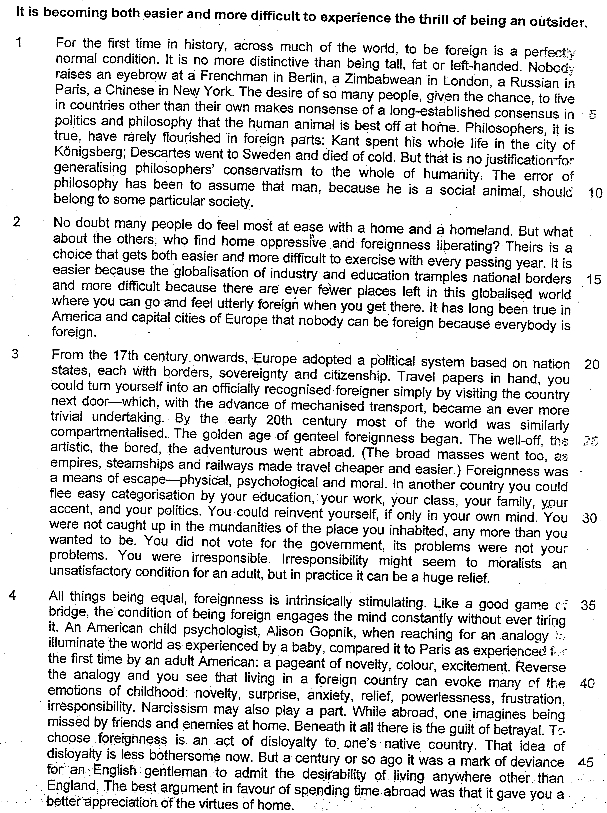

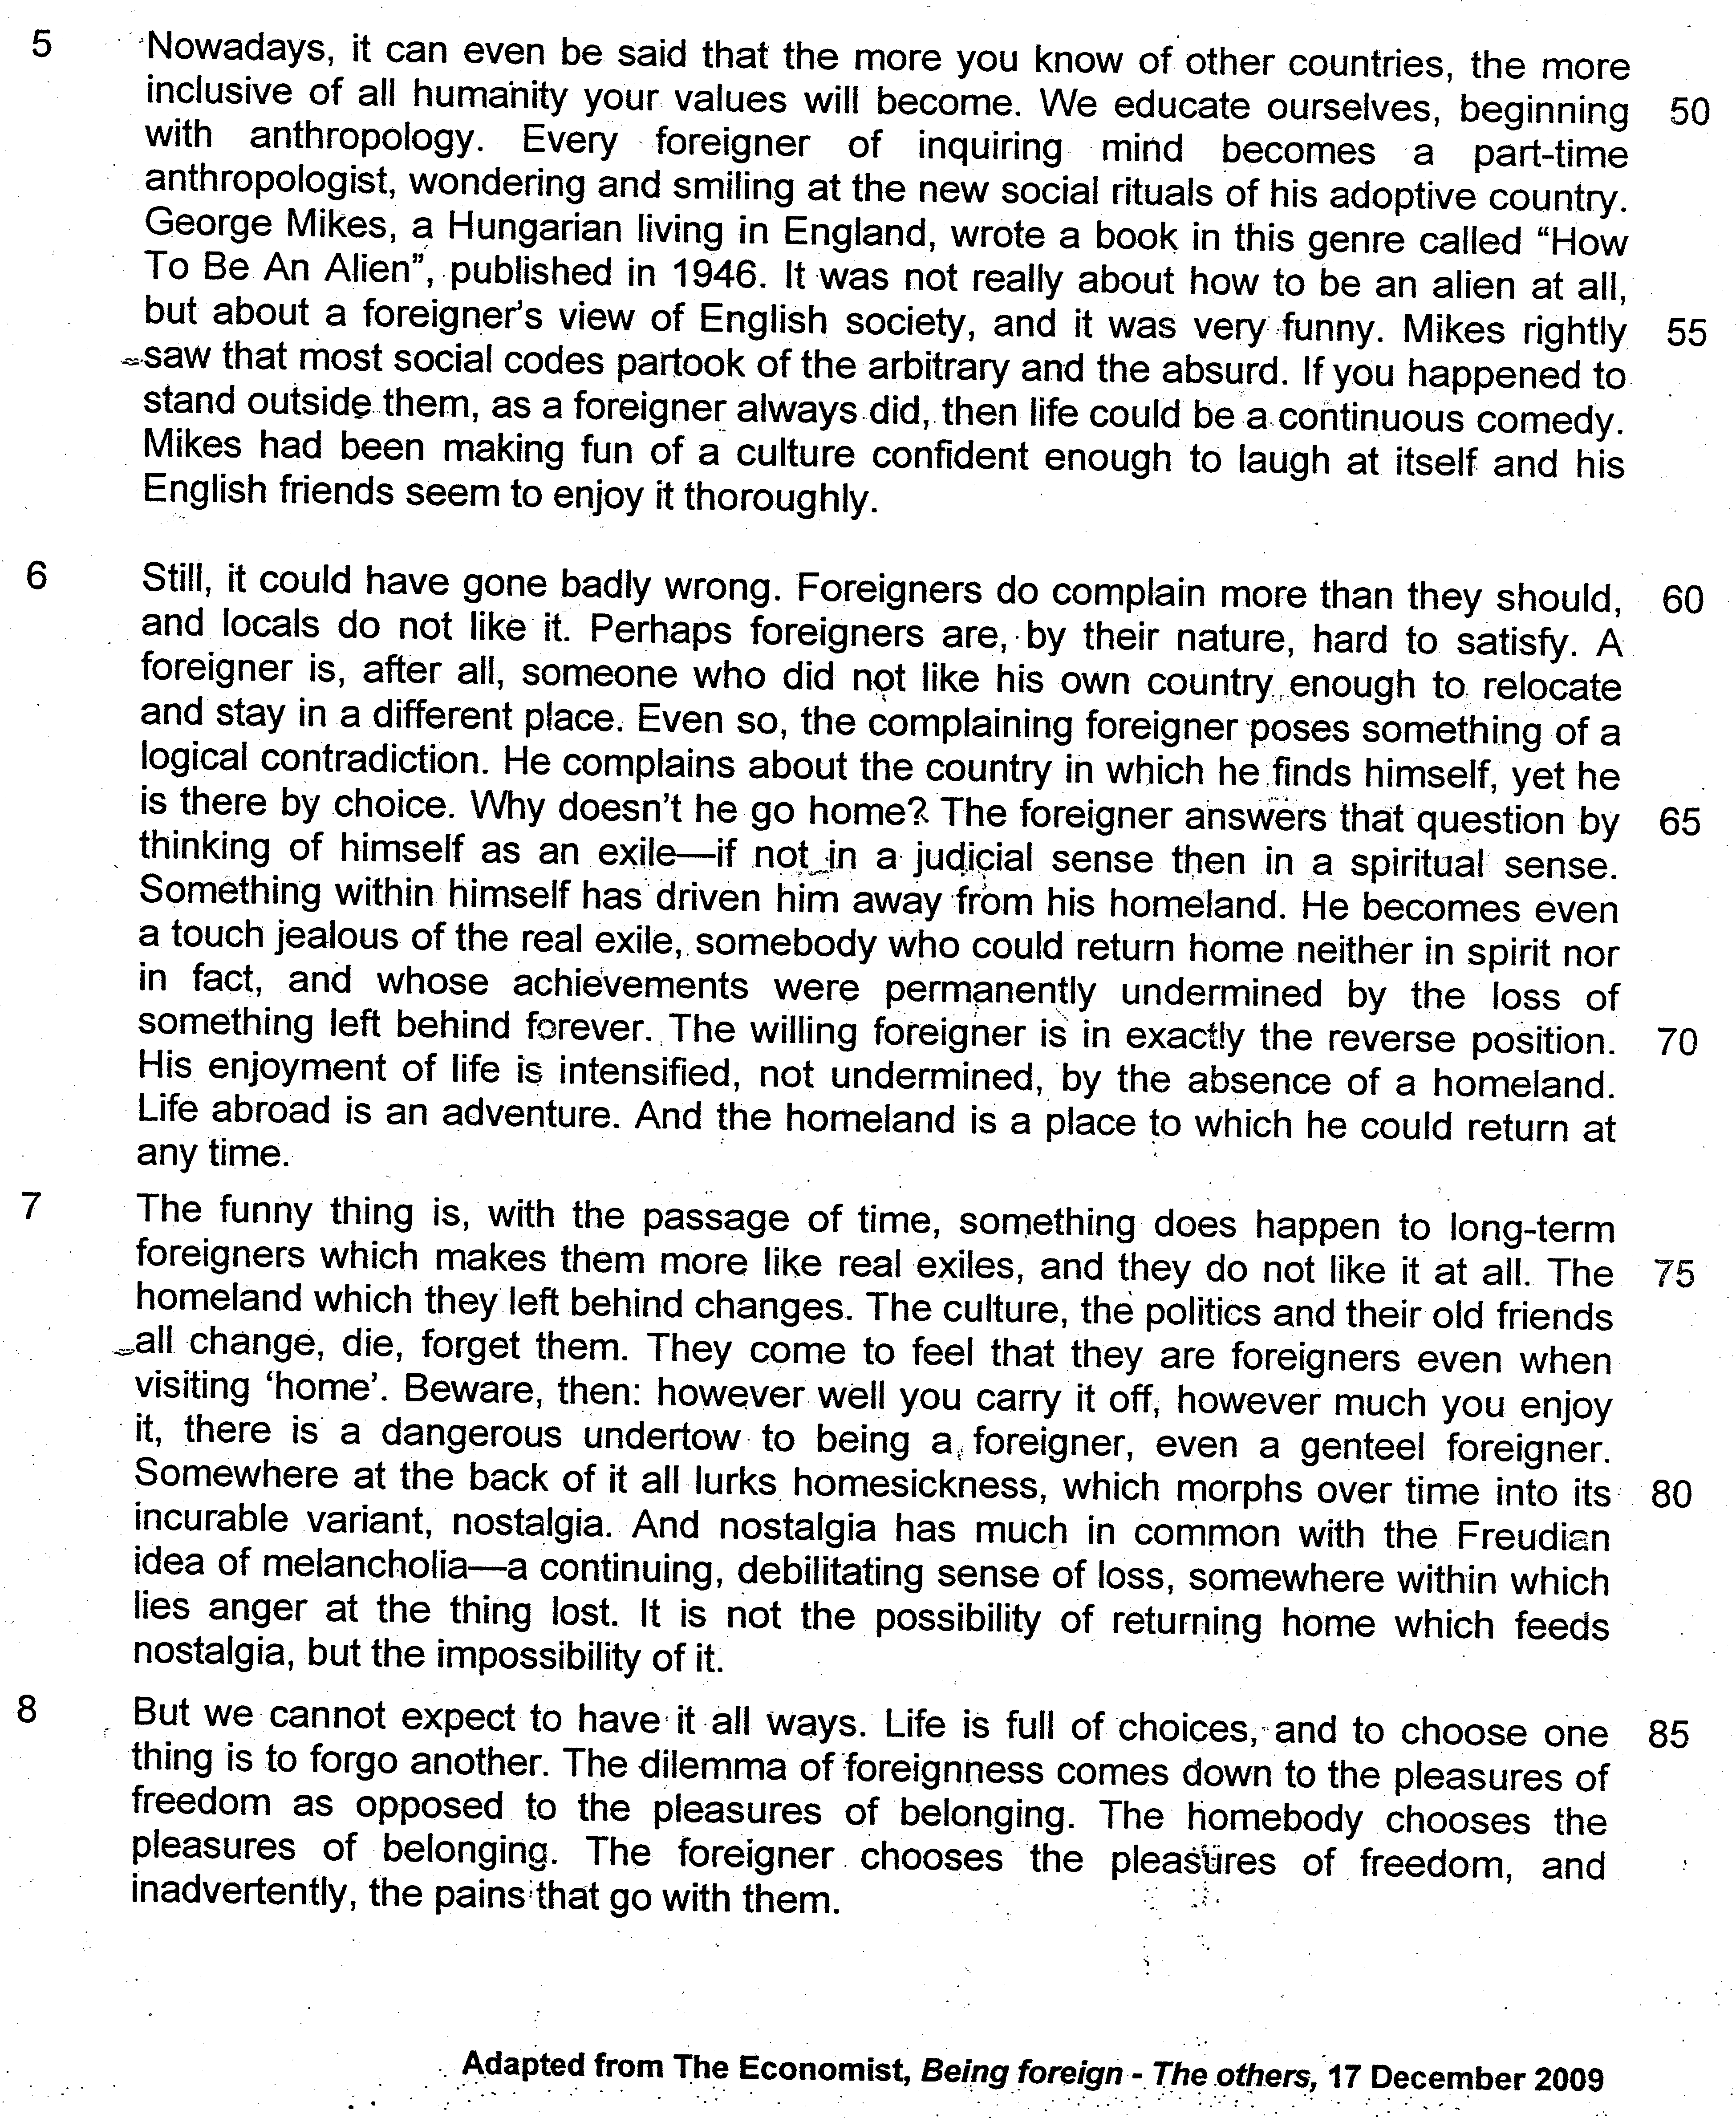

Read the passage in the insert and then answer all the questions which follow below. Note that up to fifteen marks will be given for the quality and accuracy of your use of English throughout this paper.

NOTE: When a question asks for an answer IN YOUR OWN WORDS AS FAR AS POSSIBLE and you select the appropriate material from the passages for your answer, you must still use your own words to express it. Little credit can be given to answers which only copy words or phrases from the passages.
1. What does the writer mean when he says ‘to be foreign is a perfectly normal condition’ (lines 1 – 2)? Use your own words as far as possible. [1]

…………………………………………………………………………………………………..

…………………………………………………………………………………………………..

…………………………………………………………………………………………………..

…………………………………………………………………………………………………..

- Explain in your own words as far as possible the error in ‘generalizing philosophers’ conservatism to the whole humanity’ (line 9). [1]

…………………………………………………………………………………………………..
…………………………………………………………………………………………………..

- Identify and explain one paradox in paragraph 2. [2]

…………………………………………………………………………………………………..

…………………………………………………………………………………………………..

…………………………………………………………………………………………………..

…………………………………………………………………………………………………..

- ‘Every foreigner of inquiring mind becomes a part-time anthropologist’ (lines 51 – 52)

Explain in your own words as far as possible what the author is saying by bringing out the meaning of the italicized words. [2]

…………………………………………………………………………………………………..

…………………………………………………………………………………………………..

…………………………………………………………………………………………………..

- Explain the irony in the reactions of Mikes’ friends to his portrayal of the country in paragraph 5. [2]

…………………………………………………………………………………………………..

…………………………………………………………………………………………………..

…………………………………………………………………………………………………..

- (a) According to paragraph 6, what are the differences between the ‘complaining foreigner’ and the ‘real exile’? Use your own words as far as possible. [1]

…………………………………………………………………………………………………..

…………………………………………………………………………………………………..

…………………………………………………………………………………………………..

(b) Explain why these differences make the complaining foreigners ‘a touch jealous of the real exile’ (line 68). [1]

…………………………………………………………………………………………………..

…………………………………………………………………………………………………..

…………………………………………………………………………………………………..

- Explain why the writer uses quotation marks around the word ‘home’ (line 78). Use your own words as far as possible. [1]

…………………………………………………………………………………………………..

…………………………………………………………………………………………………..

- Explain in your own words the warning that is issued in paragraph 7. [2]

…………………………………………………………………………………………………..

…………………………………………………………………………………………………..

…………………………………………………………………………………………………..

…………………………………………………………………………………………………..

- Explain the writer’s attitude towards the freedom experienced by the foreigner in paragraph 8. Use your own words as far as possible. [1]

…………………………………………………………………………………………………..

…………………………………………………………………………………………………..

- Using material from paragraphs 3 and 4, summarise how being foreign is made easier and why it is now more attractive. Write your summary in no more than 120 words, not counting the opening words printed below. Use your own words as far as possible. [8]

Being foreign is made easier because.……………………………………………………..

…………………………………………………………………………………………………..

…………………………………………………………………………………………………..

…………………………………………………………………………………………………..
…………………………………………………………………………………………………..

…………………………………………………………………………………………………..

…………………………………………………………………………………………………..
…………………………………………………………………………………………………..

…………………………………………………………………………………………………..

…………………………………………………………………………………………………..
…………………………………………………………………………………………………..

…………………………………………………………………………………………………..

…………………………………………………………………………………………………..
…………………………………………………………………………………………………..

…………………………………………………………………………………………………..

…………………………………………………………………………………………………..
…………………………………………………………………………………………………..

…………………………………………………………………………………………………..

…………………………………………………………………………………………………..

…………………………………………………………………………………………………..

…………………………………………………………………………………………………..

- ‘The dilemma of foreignness comes down to the pleasures of freedom as opposed to the pleasures of belonging’.

Drawing references from the passage and based on your observations, discuss the attractiveness of being foreign in today’s world.

…………………………………………………………………………………………………..

…………………………………………………………………………………………………..

…………………………………………………………………………………………………..
…………………………………………………………………………………………………..

…………………………………………………………………………………………………..

…………………………………………………………………………………………………..
…………………………………………………………………………………………………..

…………………………………………………………………………………………………..

…………………………………………………………………………………………………..
…………………………………………………………………………………………………..

…………………………………………………………………………………………………..

…………………………………………………………………………………………………..
…………………………………………………………………………………………………..

…………………………………………………………………………………………………..

…………………………………………………………………………………………………..
…………………………………………………………………………………………………..

…………………………………………………………………………………………………..

…………………………………………………………………………………………………..

…………………………………………………………………………………………………..

…………………………………………………………………………………………………..

…………………………………………………………………………………………………..

…………………………………………………………………………………………………..

…………………………………………………………………………………………………..
…………………………………………………………………………………………………..

…………………………………………………………………………………………………..

…………………………………………………………………………………………………..
…………………………………………………………………………………………………..

…………………………………………………………………………………………………..

…………………………………………………………………………………………………..
…………………………………………………………………………………………………..

…………………………………………………………………………………………………..

…………………………………………………………………………………………………..
…………………………………………………………………………………………………..

…………………………………………………………………………………………………..

…………………………………………………………………………………………………..
…………………………………………………………………………………………………..

…………………………………………………………………………………………………..

…………………………………………………………………………………………………..

…………………………………………………………………………………………………..

…………………………………………………………………………………………………..

…………………………………………………………………………………………………..

…………………………………………………………………………………………………..

…………………………………………………………………………………………………..

…………………………………………………………………………………………………..

