GP Term 4 2017 – Comprehension Topic 2: Social Issues – Non-Violence & Civil Societies

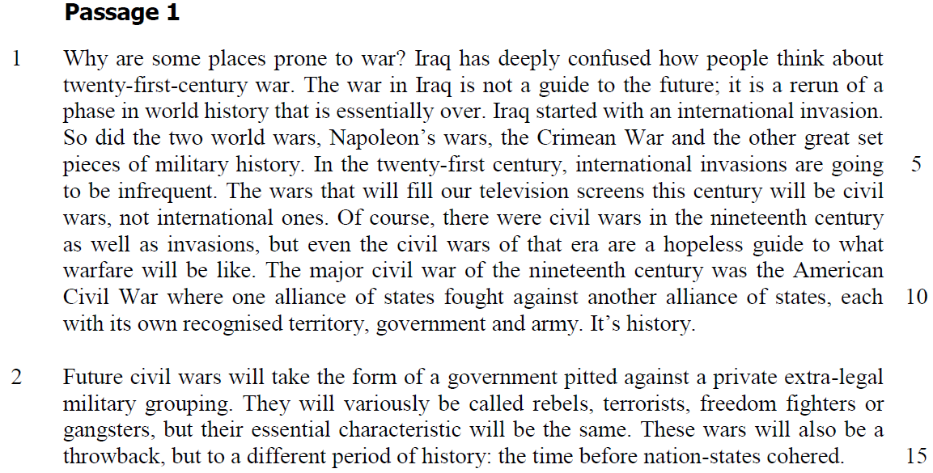

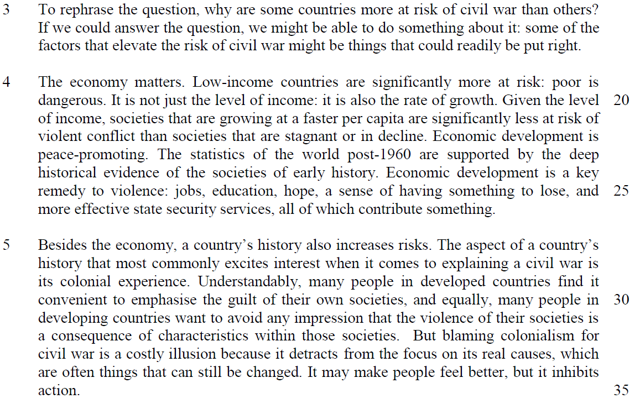

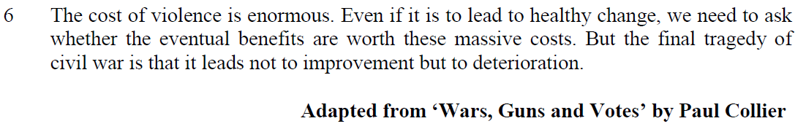

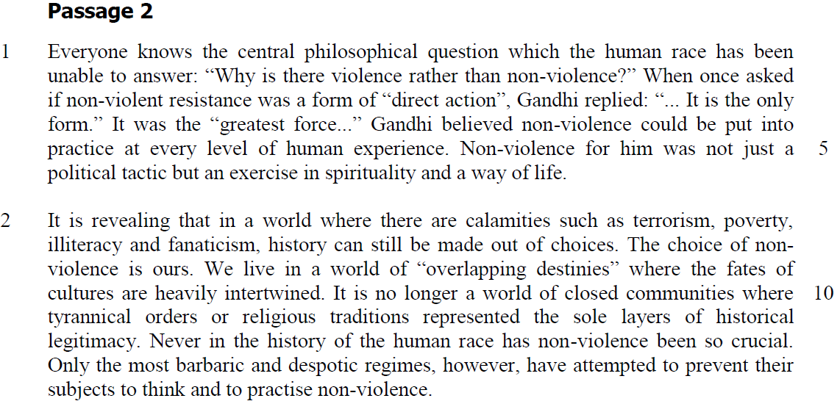

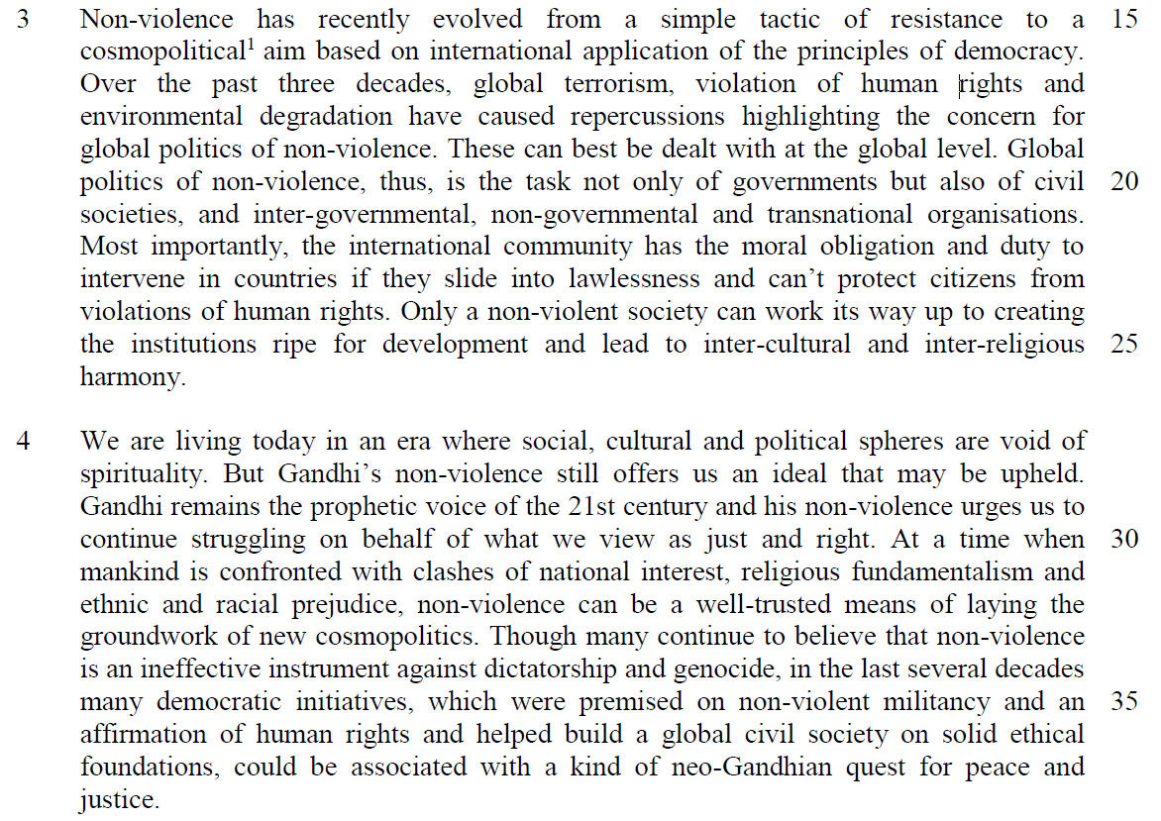

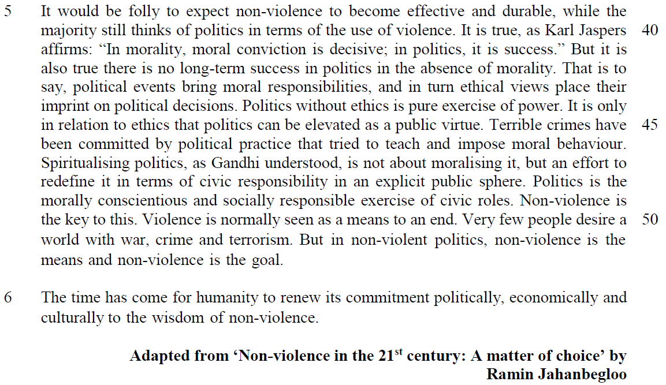

Suggested Answers
Questions on Passage 1
1. Explain what the author means by “The wars that will fill our television screens this century will be civil wars …” (lines 6-7). [1]

If wars occur, they will be internal in nature/there will be internal strife/conflict and will be given media coverage.

2. What does the author intend you to understand by the statement “It’s history.” at the end of the first paragraph? [1]

From the Passage
In the twenty-first century, internal invasions are going to be infrequent… it’s history (line 5-6)

The wars… this century will be …not international ones.

…each with its own recognised territory, government and army.

Inferred
There will no longer be wars where a country or a group of countries each with its own land, lawful authority and military forces, fight one another.

OR
The conflict between different countries/international wars, each with its own land, lawful authority and military forces, would be a thing of the past.

3. “They will variously be called rebels, terrorists, freedom fighters or gangsters, but their essential characteristic will be the same.” (lines 13-14)

What essential characteristic is the author thinking of here? [1]

From the Passage
…pitted against a private extra-legal military grouping. (line 12-13)

Inferred
The author refers to government opposition/anti-government.

4. Explain how, according to paragraph 2, future civil wars will differ from those of the nineteenth century. Use your own words as far as possible. [2]

From the Passage
a government pitted against a private extra-legal military grouping. (line 12-13)

but to a different period of history: the time before nation-states cohered. (line 15)

Paraphrased Answer
In the 21st century, violent unrest/disturbances/ fighting will be between a group of people/lawful authority governing a country and a secret military force/ armed forces not regulated or sanctioned by law.

Also, fighting will take place between different groups/states within a country because of differences/ lack of cooperation between them.

5. In paragraph 4, why does the author say that the “… poor is dangerous” (lines 19-20)? [1]

From the Passage
societies that are growing at a faster per capita are significantly less at risk of violent conflict than societies that are stagnant or in decline. (line 21-22)

Economic development is a key remedy to violence: jobs, education, hope, a sense of having something to lose, and more effective state security services, all of which contribute something. (line 24-26)

Inferred Answer
When the poor cannot afford things due to low salaries/lack of economic growth/for a better life/suffer from low income, they try to secure them by fighting others/going to war/civil war/causing violent conflicts.

6. Using your own words as far as possible, explain the danger of “… blaming colonialism for civil war…” (lines 32-33). [2]

From the Passage
… costly illusion …it detracts from the focus on its real causes (line 33)

it inhibits action which are often things that can still be changed (line 34-35)

Paraphrased Answer
Disadvantaged/ taking a huge risk / disastrous / detrimental as they are deluded /gives them a false sense of security/assurance that others are responsible for their plight.

When they do not address the actual reasons for their problem / they do not have to do anything about the situation /By ignoring/neglecting the actual cause of the conflict, which can be altered/controlled/they avoid adopting the necessary measures which can prevent conflicts.

Questions on Passage 2
7. From paragraph 1, explain how the writer thinks we can be advantaged by Gandhi’s approach of non-violence. [2]

From the Passage
Gandhi believed non-violence could be put into practice at every level of human experience and a way of life. Non-violence for him was not just a political tactic but spirituality… (line 4-6)

Paraphrased Answer
Non-aggressive methods/ an ethos of peaceful ways can be implemented in all aspects of our life/ as our culture/ widespread serves not only to help us settle political differences/political strategy/ government technique, but also to make us more morally upright /inner peace/ inner calm/ haven for the soul/ go beyond worldly existence/ go beyond material/ physical world/ mental and emotional well-being.

8. Explain why you would disagree with the writer’s use of quotation marks round “overlapping destinies” (line 9). [2]

From the Passage
We live in a world of “overlapping destinies” where the fates of cultures are heavily intertwined. It is no longer a world of closed communities where tyrannical orders or religious traditions represented the sole layers of historical legitimacy. (Line 9-12)

Inferred Answer
The use of quotation marks would usually indicate a contradiction. However, there is none here. The “overlapping destinies” are explained as “no longer a world of closed communities” / interconnected, and war in one country would affect others hence, they should not resort to brutal force fight to settle differences or achieve certain objectives.

9. The writer recognises that many people may doubt the effectiveness of Gandhi’s approach of non-violence. Identify two words from paragraph four and explain how each of them reflects this scepticism. [2]’

From the Passage
But Gandhi’s non-violence still offers us an ideal that may be upheld.

Inferred Answer
‘Ideal’ refers to something perfect and so the practice of non-violence may not be achievable ‘may’ or ‘could’ implies uncertainty/ doubt/ probability that non-violence will work.

Summary Writing
10. Summarise the writer’s rationale for using non-violence as an effective strategy in building civil societies.

Using material from paragraphs 4 and 5, write your summary in no more than 120 words, not counting the opening words which are printed below. Use your own words as far as possible. [8]

Non-violence is effective in building civil societies because…

 | Line | Lifted | Paraphrased or inferred
1 | 27-28 | living today in an era where social, cultural and political spheres are void of spirituality | most people today who being secular in their thinking/ atheists/ do not have religious/moral values to govern/ guide the way/ lead their lives may turn to aggression to settle their differences
2 | 28 | offers us an ideal … | provides us a vision/ noble goal to aspire towards
3 | 29-30 | his non-violence urges us to continue struggling on behalf of what we view as right and just. | Gandhi’s approach of non-violence encourages us to persevere and uphold what we perceive as correct/ fair
4 | 30-32 | At a time when mankind is confronted with clashes of national interest, religious fundamentalisms and ethnic and racial prejudices, | Currently there is much tension arising from conflicting beliefs in a society/ strict following of basic/ orthodox religious teachings and cultural and racial discrimination
5 | 32-33 | non-violence can be a well-trusted means of laying the groundwork of a new cosmopolitics. | Non-violence can be a very reliable instrument to build the foundation/basis of a global political structure
6 | 34-35 | in the last several decades many democratic initiatives, which were premised on non-violent militancy | Lately numerous new policies/ measures to enforce equal rights/equality for everyone were based on non-aggressive defence tactics/strategies

 | Line | Lifted | Paraphrased or inferred
7 | 36-37 | helped build global civil society on solid ethical foundations  [Repetition]…affirmation of human rights | Non-violence has helped to promote morally upright international communities  OR  or uphold human rights
8 | 41-42 | it is also true there is no long-term success in politics in the absence of morality. | Non-violence is based on correct values that would ensure long term political stability
9 | 42-45 | That is to say, political events bring moral responsibilities, and in turn ethical views place their imprint on political decisions.  It is only in relation with ethics that politics can be elevated as a public virtue | if political duties are conducted observing these correct / acceptable standards / with accountability then, the system of governing a state can be glorified/ given credit/recognised as something worthy/ a value/ benefit/ advantage
10 | 45-46 | Terrible crimes have been committed by political practice that tried to teach and impose moral behaviour. | If allowed, violence can be misused to impose law and order and this itself is a violation of the law
11 | 47-50 | Spiritualising politics, …an effort to redefine it in terms of civic responsibility in an explicit public sphere.  Politics is the morally conscientious and socially responsible exercise of civic roles.  Non-violence is the key to this. | Political leaders have a moral duty/obligation to influence their people following accepted standards of behaviour on what is right or wrong and this can be done without the use of brutal force.
12 | 50-51 | Very few people desire a world with war, crime and terrorism. | Many people do not like fighting, violation of the law and terrorist activities.

Application Question (AQ)
11. Both passages deal with the importance of promoting peace to help build a global civil society.

How far do you agree with the writers’ views? Using material from both passages, discuss how your view has been challenged or confirmed by these passages. You must also rely on your own ideas and knowledge of today’s world. [8]

Introduction
- writers have discussed about how peace is to be promoted to build a global civil society
- their views are in lined with my perspective except for some

Main Body

- quote
- explanation of the writer’s point
- Writer A’s view confirmed by my belief that …….
- justify your view
- example
- extent of agreement

low income countries are significantly more at risk of being engaged in violent and instability
economic development is a solution to violence as it can provide employment and employment opportunities to give me the sense of commitment to make society more stable
this confirmed my view as the economic benefits that individuals can derive from the society will make them willing to agree to social codes of the society and they will be willing to abide the law. As a result, the society will be more stable and less violent
SEA countries – real GDP per capita and low unemployment rate – more stable and less violent

EOA – widen income inequality – SEA countries -possible risk of social and political instability – Thailand red and yellow shirt political rivalry – reflection of income equality between rural and city region
why income inequality will be a source of tension? progress for respective individuals will be different – a sense of injustice – alienated certain individuals – forms social class – social divide – dissatisfaction that fuel social unrest and crime

there is no long-term success in politics in the absence of ethics
we need ethics to exercise political virtue to rule as decision in politics should be based moral responsibilities and values – this will ensure civic and moral behaviours in the society
this challenges my view - ethical values of society do not encourage social and political stability – diverse view of ethics will invite more contradictions and debates that undermine society – different factions of the society have diverse opinions and view to constitute what is the standard ethics of society – disagreements often leads to social controversy and extreme disturbance in terms of riots – the social stigmas and dogmatism is part of this belief that leads discrimination and social conflicts – therefore my belief follows the majority that there is a need of strong governmental force to ensure stability and peace instead of the use of yardstick of ethics

Amos Yee’s youtube racial and religious slurs will create social disturbance and must not be considered as exercise of freedom of speech for diversity to set as ethical yardstick for the society

EOA – ethics and morality is still needed to influence the behaviours and values of the individuals – strong governmental rule is imposed along with certain national or social values to inculcate proper social behaviour to promote a civic order society – racial harmony is part of the idea to promote social stability in a multiracial society in Singapore but we Sedition Act as part of laws to impose social stability

Requirements:
- Refer to points raised by both writers in passages 1 and 2 and identify key ideas which support the view that peace is crucial in helping to develop/create a civil society in the world.
- Make your stand and evaluate the extent of how these points influence you to accept or reject the writers’ views.
- Go beyond the texts and substantiate your stand by giving examples in today’s world which show the importance of promoting peace to help build a global civil society.

From Passage 1
Point #1.1) Paragraph 2: ‘Future civil wars…extralegal military grouping. They will variously be called rebels, terrorists, freedom fighters…before nation-states cohered’.

(A civil society believes in co-operation and peace.)

Evaluate the extent of how important the promotion of peace is in helping to build a global civil society

(a) View has been challenged (Disagree with writers’ views)
The fact that there are still acts of terrorism in today’s world shows that promoting peace does not help to build a global civil society. Despite of global efforts to curb terrorism, there are new occurrences of terrorism in today’s world. Thus, violence is needed to rid these terrorists.
- E.g. 1st May 2010 New York City, Times Square was evacuated after the discovery of a car bomb.
- E.g. Up to the middle of 2010, there were quite a number of suicide bombings in Iran, Pakistan, Greece and Turkey.

(b) View has been confirmed (Agree with writers’ views)
One of the causes of terrorism is hatred and radicalization by non-fundamentalists, hence violence often is not a good solution to curb terrorism as it can result in more violence.
- E.g The Iraq War

To achieve global civility, peaceful methods such global co-operation, political diplomacy and negotiation could be adopted instead. The advent of globalisation brings about more interconnectedness amongst nations, hence all the more necessary for them to guard each other’s stability.
- E.g. Singapore has spearheaded the development and sharing of best practices for countering terrorism including terrorist finance. With the support of New Scotland Yard’s National Terrorist Financial Investigative Unit, the International Centre for Political Violence & Terrorism Research (ICPVTR) has built its capacity in Singapore and overseas to train and support countries that need counter terrorist finance capacity. World-Check specialists joined ICPVTR instructors in conducting and sponsoring ICPVTR counter terrorist finance training in a number of countries in Southeast Asia.

Point #1.2)
Paragraph 4: ‘Economic development is peace-promoting’.
Paragraph 5: ‘Economic development is a key remedy to violence…a sense of having something to lose…’

As we continue through the 21st century, the principles of civil society must move beyond the nation-state to include a global political economy of relations and groups. Everyone is to be viewed as one another's neighbour; we are mutually responsible for everyone's opportunity to experience a satisfying life. Our global economy, having brought us together, pushes us to develop appropriate political and social systems through which participation, authority, and responsibility can be just, equitable, and non-violent--responding with concern for the disenfranchised, marginalized, and impoverished.

(a) View has been challenged (Disagree with writers’ views)
Global trade does not always foster peace and hence hinders the building of a global civil society. This happens when developed countries engage in unfair trade practices and have protectionistic policies toward the developing countries.

- E.g. In 2006, America's manufacturing sector produced about $2.7 trillion in goods. China's manufacturing sector produced about 8.74 trillion yuan in goods, or about $1.124 trillion at the prevailing exchange rate of 7.77 yuan to the U.S. dollar.
  - The impact of China's cheap labor costs has managed to lower consumer prices worldwide, particularly for "such diverse items as televisions, toys, T-shirts, kitchen appliances, athletic shoes and power tools."
  - However, the good news for China manufacturing has led to "massive layoffs throughout the world, as factories either were shut down or moved to China to be competitive. The Economic Policy Institute, a liberal-leaning think tank in Washington, D.C., said the United States is losing more than 2,000 factory jobs a month because of the shift of work to China."
  - International aid can sometimes pose more problems and hinder the promotion of peace so crucial in the development of a global civil society.
- E.g. Food aid can sometimes hurt starving populations, by keeping poor nations intertwined with the economy of the donor country (namely the US)
  - The US is the largest food donor. The aid is given in kind or sold at subsidised rates to recipient governments. Under its current regulations, at least 75% of food aid has to be grown, procured and bought in the US and handled and shipped by US firms. When shipping costs rise, so does the price for food aid. To keep costs in check, sometimes less food is delivered.
  - Selling cheaper food aid below market prices in recipient nations undercuts local farmers’ market share, resulting in them becoming poor.

(b) View has been confirmed (Agree with writers’ views)
'Globalisation' refers to 'a process of removing government-imposed restrictions on movements between countries in order to create an "open", "borderless" world economy' (Scholte 2000: 16) and global trade is one outcome of globalisation.

Although global trade does not guarantee peace, it does strengthen peace by raising the cost of war to governments and citizens. As nations become more integrated through expanding markets, they have more to lose should trade be disrupted. Hence, with vested interests (e.g. creation of jobs and education opportunities), no nation would want to destabilise one another.

- E.g. In 2007, Indian firms, led by Hindalco and Tata Steel, have bought some 34 foreign companies for a combined $10.7 billion. Indian IT-services companies such as Infosys, Tata Consultancy Services and Wipro are putting the fear of God into the old guard, including Accenture and even mighty IBM. Big Blue sold its personal-computer business to a Chinese multinational, Lenovo, which is now starting to get its act together.
Point #1.3)
Paragraph 7: ‘The cost of violence is enormous…that it leads not to improvement but to deterioration.’

A civil society upholds the belief that there should be love, hope and peace rather than hatred and violence.

(a) View has been challenged (Disagree with writers’ views)
Indiscriminate bombing is a strategy often used by terrorists to undermine the will and morale of the whole community. Therefore, violence is needed to rid these terrorists
- E.g. The use of force and violence against terrorism has been demonstrated periodically. U.S. military action against the Taliban in Afghanistan is an example of the use of force against terrorism.

(b) View has been confirmed (Agree with writers’ views)
The cost of violence is enormous and there are many past evidences of such destruction. Non-violence is the foundation of a global civil society.
- E.g. World Wars I & II
- E.g. Some 400,000 ethnic Uzbeks remained displaced on both sides of the Kyrgyzstan-Uzbekistan border following a series of attacks in June 2010, killing at least 251 and possibly as many as 2,000.

From Passage 2
Evaluate the extent of how important the promotion of peace is in helping to build a global civil society.

Point #2.1)
Paragraph 3: ‘Global politics of non-violence…also of civil society, and inter-governmental, non-governmental and transnational organisations.’

Paragraph 4: …’non-violence is an ineffective instrument against dictatorships and genocide…’
A civil society is inclusive and involves all sectors of a society with each having a stake in it.

(a) View has been challenged (Disagree with writers’ views)
The 1990s saw the UN refocus its attention on genocide and ethnic cleansing. The Civil War in Rwanda and the breakup of Yugoslavia both were occasions of widespread atrocities and ethnic violence.

The UN launched its peacekeeping mission in October 1993, but its mandate did not allow for military force protection in the investigation of cease-fire violations or securing humanitarian aid.
- E.g. The United Nations and its member states failed Rwanda "in deplorable ways" in 1994, ignoring evidence of planned genocide and abandoning Rwandans in need of protection, according to a report released today. http://www.un.org/News/dh/latest/rwanda.htm (UN Newservice, 15 Dec 1999).
The independent report, commissioned by the then UN Secretary-General Kofi Annan, says the UN peacekeeping operation in Rwanda was "doomed from the start" by an inadequate mandate and destroyed by the Security Council's refusal to strengthen it once killings began." The fundamental failure was the lack of resources and political commitment devoted to developments in Rwanda and to the United Nations presence there," the report said. "The manner in which the troops left, including attempts to pretend to the refugees that they were not in fact leaving, was disgraceful," the report added (Nicole Winfield, Associated Press, 16 Dec).

(b) View has been confirmed (Agree with writers’ views)
International aid is a remedy for the global income- divide problems and thus help build a global civil society.
- E.g. Oxfam International which is a confederation of 13 organisations working with over 3,000 partners in more than 100 countries to find lasting solutions to poverty and injustice.
- E.g. The UN is involved in supporting development, e.g. by the formulation of the Millennium Development Goals. The UN Development Programme (UNDP) is the largest multilateral source of grant technical assistance in the world. Organizations like the World Health Organization (WHO), UNAIDS, and The Global Fund to Fight AIDS, Tuberculosis and Malaria are leading institutions in the battle against diseases around the world, especially in poor countries.

Point #2.2)
Paragraph 3: ‘Only a non-violent society can work its way up to creating the institutions ripe for development and lead to inter-cultural and inter-religious harmony.’

Paragraph 4: ‘…an affirmation of human rights and helped build global civil society on solid ethical foundations…’

Social cohesion is crucial in a civil society.

(a) View has been challenged (Disagree with writers’ views)
Promoting social solidarity in practice means confronting corruption and trying to ensure democratic governance, power sharing, and the equitable distribution of resources among all members of society.

The threat of the use force i.e. the use of military can prevent conflict amongst different factions of society.
- E.g. Ethnic riots in Urumqi, western Xinjiang province between the majority Han and minority Uighurs on 5 July 2009 witnessed the use of the police to help control further uprisings.

(b) View has been confirmed (Agree with writers’ views)
Social cohesion involves tolerance and unity in a diversified world. This is important in promoting peace and therefore in building a global civil society.

Some countries are still fraught with incompetent political leaders and are unable to establish civil societies; therefore there is a need for some international organisations to help to overcome this problem.

- E.g. The pursuit of human rights was a central reason for creating the UN. World War II atrocities and genocide led to a ready consensus that the new organization must work to prevent any similar tragedies in the future.
  - The UN and its agencies are central in upholding and implementing the principles enshrined in the Universal Declaration of Human Rights. A case in point is support by the UN for countries in transition to democracy. Technical assistance in providing free and fair elections, improving judicial structures, drafting constitutions, training human rights officials, and transforming armed movements into political parties have contributed significantly to democratization worldwide. The UN has helped run elections in countries with little or no democratic history, including recently in Afghanistan.

Point #2.3)
Paragraph 4: ‘…non-violence is an ineffective instrument against dictatorships and genocide’

A civil society resorts to peaceful methods in conflict resolution.

(a) View has been challenged (Disagree with writers’ views)
Violence such as coup d’état is sometimes necessary in order to bring about civility in societies.

A failed state often has a government that is unable to exercise authority (law and order; taxation etc.) over most of the country.

This failure can be manifested by wide gap between rich and poor, endemic corruption, rising child mortality rate, etc.

Hence violence is inevitable to prevent these states from being a threat (economic, political, social etc) to other nation(s) as they are unable to exercise their sovereignty over their political boundaries.

E.g. Liberia; Sierre Leone; Ivory Coast; Solomon Islands; Ex-Yugoslavia; Congo; Taleban and post-Taleban Afghanistan.

(b) View has been confirmed (Agree with writers’ views)
A civil society resorts to peaceful methods such as civil obedience* in solving tensions and can be effective in overthrowing an autocratic leader.

Civil disobedience is a public, non-violent and conscientious breach of law undertaken with the aim of bringing about a change in laws or government policies.
- E.g. In 1985 under mounting pressure, Marcos called for a snap presidential election and a million signatures were quickly amassed. When Marcos claimed victory in the contest, a surge of “people power” signalled that his authority and credibility had drained away. His resort to widespread fraud and intimidation had been as brazen as the killing of Benigno Aquino. Hundreds of thousands took to the streets, staging a civil disobedience campaign and boycotting businesses owned by Marcos supporters. Key army figures declared in favour of Aquino, ending a dictatorial rule under Marcos.

