GP Term 3 2017 – Comprehension – Topic 3: Education – Moral Education

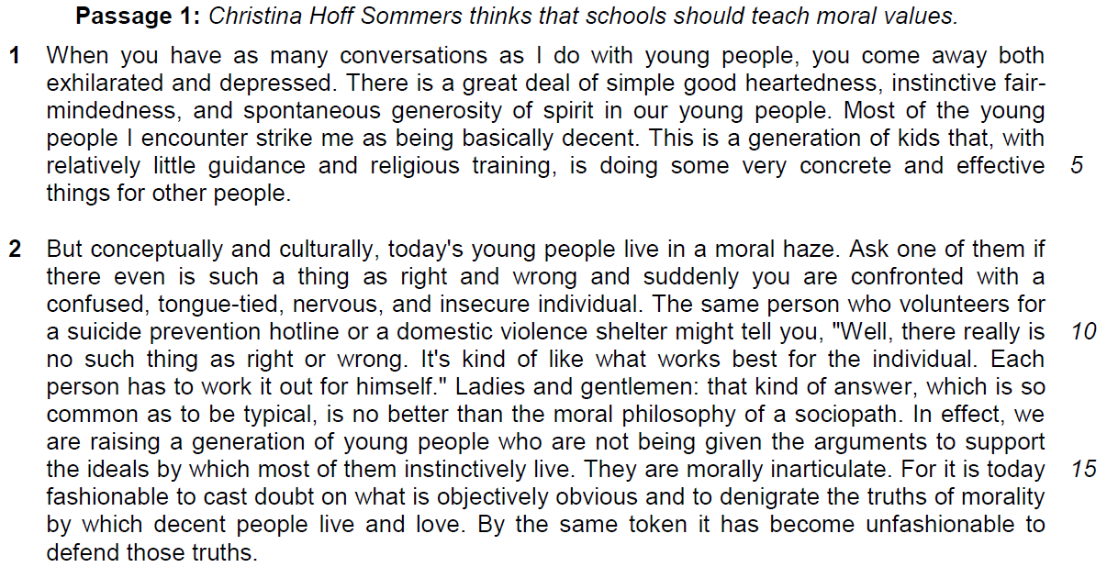

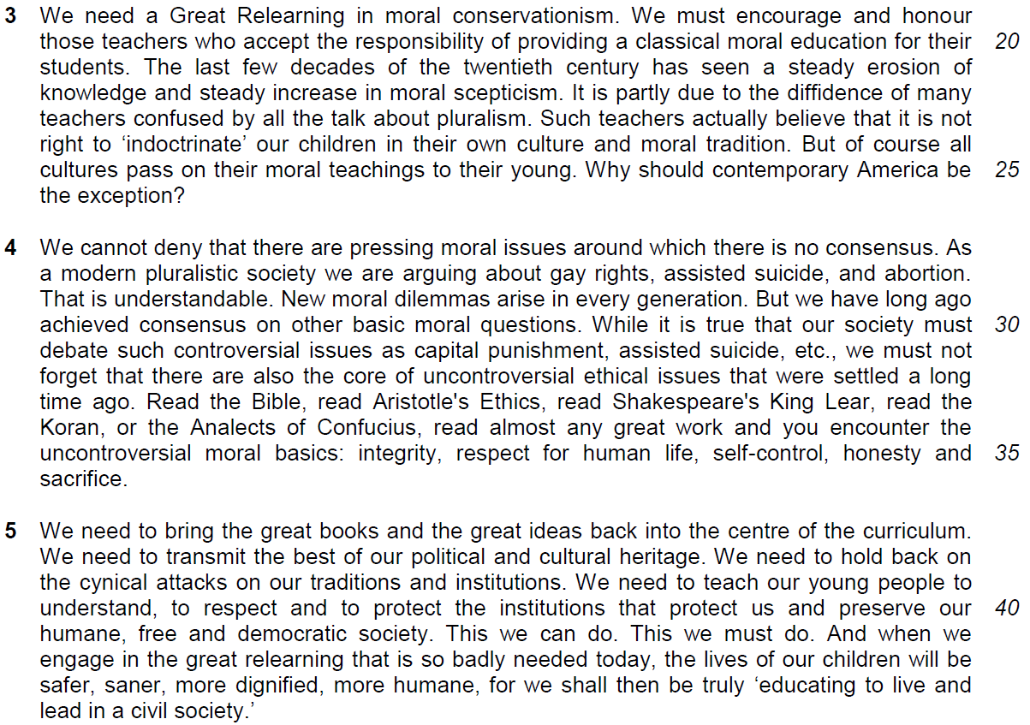
Why do the youths need moral education?

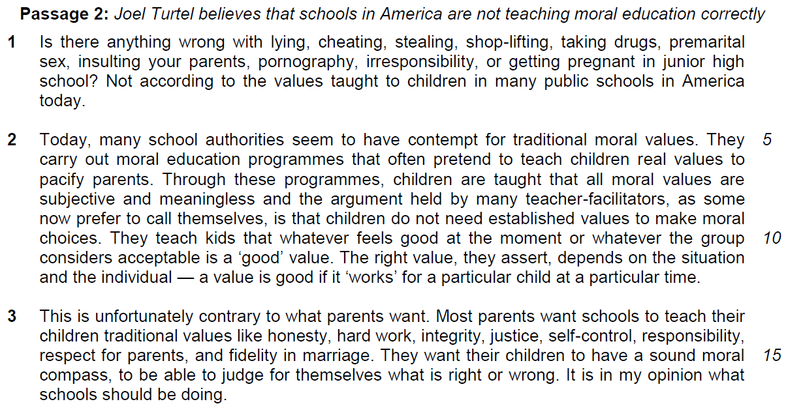

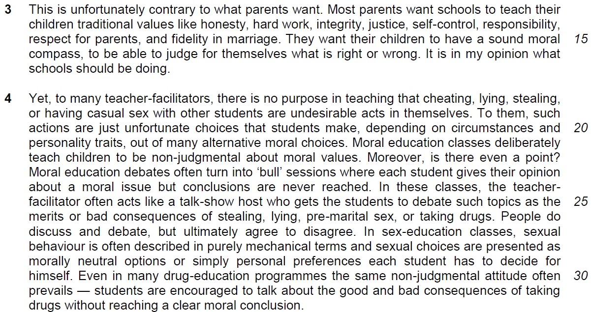

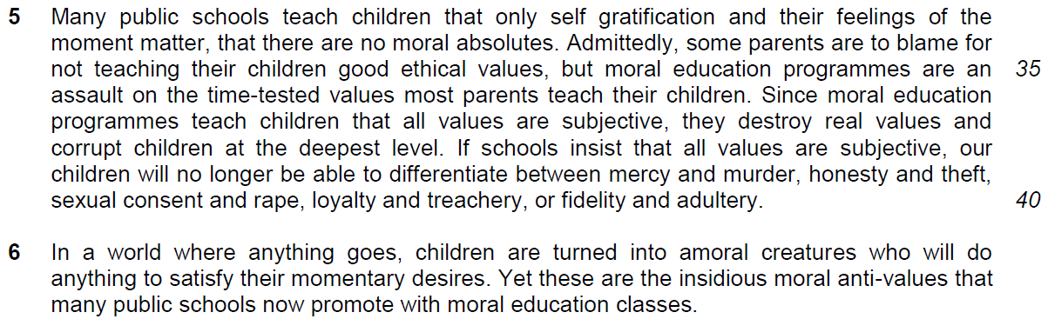

Suggested Answers

From Passage 1
Q1) 1 What does the phrase ‘exhilarated and depressed’ (line 2) suggest about the writer’s attitude towards young people? [1]

From the Passage
When you have as many conversations as I do with young people, you come away both exhilarated and depressed.

Inferred Answer
The two words are of opposite meaning, which shows that the author is having mixed feelings/feeling ambivalent about young people today.

Q2) Explain in your own words as far as possible, the irony in lines 9 – 12. [2]

From the Passage
The same person who volunteers for a suicide prevention hotline or a domestic violence shelter might tell you, "Well, there really is no such thing as right or wrong. It’s kind of like what works best for the individual. Each person has to work it out for himself.”

Inferred Answer
We would expect a helpline volunteer to be able to give sound moral advice to people who call them for help, yet such individuals feel that there is no real need to be able to discern between what is acceptable and what is not/ are unable to make a stand.

Q3) Explain in your own words as far as possible what the writer means when he says young people are ‘morally inarticulate’ (line 15). [2]

From the Passage
We are raising a generation of young people who are not being given the arguments to support the ideals… by which most of them instinctively live.

Inferred Answer
These youths are unable to provide reasons for/justify/articulate/speak up to defend/rationalise their ethical decision. To them, the decision seems to be made without them even questioning/ trying to justify it.

Q4) According to the writer, explain what ‘the diffidence of many teachers confused by all the talk about pluralism’ (lines 22 – 23) has caused. Use your own words as far as possible. [2]
meaning of this phrase – how it is linked to issue (moral education) – what kind of impact will this phrase cause
From the Passage
The last few decades of the twentieth century has seen a steady erosion of knowledge and steady increase in moral scepticism.

Inferred Answer
It has caused a gradual decline in the ability to discern right from wrong, and more people are starting to question traditional notions of morality as the society is more diverse and has many views and values.

Q5) Explain why ‘indoctrinate’ (line 24) is in quotation marks. [1]

From the Passage
Such teachers actually believe that it is not right to ‘indoctrinate’ our children in their own culture and moral tradition.

Inferred Answer
The writer does not think/ is sceptical that teachers are actually brainwashing their students to accept certain values.

It is to depict that the writers’ doubt that the teachers are actually radicalizing or instilling the students to abide to a set of moral values.

Q6) Explain in your own words as far as possible the writer’s intention for beginning four sentences with ‘We need…’ in paragraph 5. [2]

From the Passage
We need to bring the great books and the great ideas back into the centre of the curriculum.

We need to transmit the best of our political and cultural heritage.

We need to hold back on the cynical attacks on our traditions and institutions.

We need to teach our young people to understand, to respect and to protect the institutions that protect us and preserve our humane, free and democratic society.

Inferred Answer
He is emphasising/highlighting the importance of teaching teenagers the right moral values.

From Passage 2
Q7) What does the writer suggest about teacher-facilitators when he says that they ‘often pretend to teach children real values to pacify parents’ (lines 6 – 7)? Explain in your own words as far as possible. [3]
show what the writer think of the teacher
From the Passage
Today, many school authorities seem to have contempt for traditional moral values.

Inferred Answer
He suggests that the teacher-facilitators are hypocrites as they despise the teaching of orthodox/conventional moral values but they still abide to the parents’ demands of moral education.

Q8) According to the writer, what do school authorities consider to be a ‘good’ value (line 11)? Explain in your own words as far as possible. [2]

From the Passage
They teach kids that whatever feels good at the moment or whatever the group considers acceptable is a "good" value

OR
The right value… depends on the situation and the individual. A value is good if it “works” for a particular child at a particular time.

Inferred Answer
School authorities feel that a ‘good’ value is anything which seems right at that point in time or anything which the majority think it is appropriate based on the circumstances and who the person is.

Summary Question
Q9) Turtel strongly believes that public schools in America are not conducting moral education programmes properly.

Using material from paragraphs 3 to 5, summarise the criticisms he has towards the way moral education programmes are conducted and the consequences of such programmes. Write your answer in no more than 120 words, not counting the opening words which are printed below. Use your own words as far as possible. [7]

The writer disapproves of moral education programmes in American public schools because…

From the passage | Answer
- This is unfortunately contrary to what  - parents want. (line 13) (cause) | they do not fulfil parental desires /meet parental expectations/ goes against what parents desire.
b. Most parents want schools to teach their children traditional values like honesty, hard work…(line 14) (cause) | of hoping schools impart/inculcate/nurture their children with time-honoured/long-established/ conventional values.
c. They want their children to have a sound moral compass, to be able to judge for themselves what is right or wrong. (line 15-16) (cause)  OR  children will no longer be able to differentiate between mercy and murder, honesty and theft… (lines 39-40)  (consequence) | and ensuring that they have the ability to distinguish/discern/differentiate between what is acceptable and unacceptable/good and bad/sound and unsound values.
d. Yet, to many teacher-facilitators, there is no purpose in teaching that cheating, lying, stealing or having casual sex with other students are undesirable acts in themselves. (cause)  (lines 18-19) | Some teachers do not see a need for/ fail to see the need for / significance for/ importance of/ motive behind/ students to learn that certain behaviours are unacceptable/ objectionable.
e. To them, such actions are just unfortunate choices that students make... (line 20) (cause) | These are merely perceived to be regrettable/ mistaken decisions/ mistakes made by students
f. depending on circumstances and personality, out of many alternative moral values. (lines 20-21) (cause) | that are based on/influenced by situational factors and individuality.
g. Moral education classes deliberately teach children to be non-judgmental about moral values. (lines 21-22) (cause) | Moral education lessons intentionally teach pupils not to make choices/ not to decide what is right or wrong.
h. Each student gives their opinion about a moral issue but conclusions are never reached. (lines 23-24) (consequence) | Also, students present their views/thoughts on moral issues but do not make final decisions/arrive at resolutions.
i. teach children only self gratification and feelings of the moment matter, (lines 33-34)  (cause) | Children are told that solely satisfying their individual desires and temporal/transient sentiments/ emotions/ acting on impulse is important/count.
j. but moral education programmes are an assault on the time-tested values most parents teach their children. (lines 35-36)  (consequence) | Such classes undermines traditional/ conventional/ long-established/ accepted/ entrenched values the majority of parents teach their kids
k. corrupt children at the deepest level. (line 38) (consequence) | and causing their belief systems to be totally warped.

Application Question
Q10) Both writers believe that schools should guide children in developing a sound moral character. Sommers suggests that schools should engage in a Great Relearning while Turtel criticises the way American public schools conduct moral education programmes.

With reference to the ideas presented in the passages, consider how far the young people in your society need a school-based moral education programme. [8]

Thinking perspective:
Use the points given by the writers to explain why Singapore needs a school-based moral education or not.
Justify the reason that explain why the writer‘s point of view is justifiable.
eg1 – why Singapore students are unable to make moral judgement

Structure of Discussion:

Introduction
State briefly the requirement of the question – how far you do you agree with the proposition

Main body
Point 1:
1. Quote from the passage
According to Joel Turtel, - students live in a ‘moral haze’ and are ‘morally inarticulate’
2. Explanation on why this explains Singapore youths need a moral-based education
The writer’s view is that they are unable to make moral judgement and decision and thus, this explains why there is a need for Singapore to have a school-based moral education.
3. why do you think that the youths in Singapore will need a school-based moral education
Discuss on how Singapore students are brought up and taught in school and society.

According to National Crime Prevention Council, most problem youths come from homes lacking in parental guidance and are usually under-achievers in schools and with low self-esteem.

4. Example

According to Department of Singapore Statistics, the number of youth crime has been falling which shows the relentless efforts by Ministry of Education in imparting moral education has become a significant recognition that school-based moral education is needed by youths especially for the group from 12 -14 age groups.

5. Extent of Agreement:
There is extensive regulation by the government as imposed by Juvenile Court and social institution like National Youth Challenge Council There also many religious institutions which act as moral institutions to guide the youths. The fact that the number of juvenile delinquents is on the fall explains why there is no need of school-based moral education which is demanding task for the teacher.

6. linking sentence
It is a very debateable issue whether school-based moral education is needed. However, it is rational to conclude that all or more means of education by more institutions would be helpful to enrich the moral acumen of our youths.

Point 2

2.1 Quote
According to Joel Tutel, ‘there is no purposes in teaching that cheating, lying, stealing, or having casual sex with other students are undesirable acts in themselves’

2.2 Explanation – why this explains that the youth of Singapore does not need a school-based education

2.3 Why you agree with this view that Singapore does not need a school-based education

2.4 Example

2.5 Extent of Agreement – why you may not agree

2.6 Linking sentence

3. Conclusion

Q10) Both writers believe that schools should guide children in developing a sound moral character. Sommers suggests that schools should engage in a Great Relearning while Turtel criticises the way American public schools conduct moral education programmes.

With reference to the ideas presented in the passages, consider how far the young people in your society need a school-based moral education programme. [8]

Both writers have expressed their views on the need of school-based moral education and provided reasons for the justification on why we may need a school-based moral education. Their views are justifiable but at a certain level only.

In paragraph 2, Joel Turtle makes the claim that students today are living in a “moral haze” and are “morally inarticulate”. Based on this view, he is suggesting that students are confused about their moral compass as they are unable to distinguish between right and wrong, and they are unable to justify their moral judgement and decisions. As such, I agree that this bring about an pressing need for Singapore to have a school-based moral education. This is especially the case for our Singaporeans youth who may be lack of parental guidance in cultivating their moral compass. Living in our fast paced and competitive society, many parents end up prioritising their careers over spending time with their children as a means of sustaining their livelihood. As a result, their children lack a strong guiding pillar as they do not have anyone to turn to for advice regarding the moral struggles that they face as their parents fail to be there for them. Thus, this leads to a compromise in their moral compass as they lack the moral acumen to resolve their moral dilemmas. Additionally, it has been difficult to educate our youths on such matters due to the complexity of the morals - they are subjective and would differ across people due to their growing environment and upbringing. As such, it is difficult to set a yardstick for morals as there is no right or wrong, which makes it so much more difficult for the youth to decide how to best approach their moral dilemmas with the lack of guidance that they have. This compromise on their moral compass due to this lack guidance and complexity of the issue can be seen from the National Crime Prevention Council, where it was reported that most problem youths come from homes lacking in parental guidance and are usually in schools with Low self-esteem. As such, it is imperative to have a school-based moral education to fill in this direct and cultivate value these youths are lacking in.

However, despite the lack of parental guidance, there is no pressing need for school based moral education due to the relentless efforts by other organisations in our society in cultivating moral values and judgement in students. For instance, there is extensive regulation by the government as imposed by the Juvenile Court and social institutions like National Youth Challenge Council. Apart from the many other religious institutions such as churches to guides the youth, we can see from the fall of youth crimes, as reported by the department of Singapore statistics, proving that there is no need for a school-based moral education which is a demanding task for the teacher. Thus, it is very debatable to whether school-based moral education is needed. Therefore, it is rational to conclude that all or more means for education by more institutions would be helpful to enrich the moral acumen of our youth instead of just a school-based moral education.

In paragraph 4, Joel Turtel makes the claims that “there is no purposes in teaching that cheating, lying, stealing or having casual sex with other students are undesirable acts in themselves”. The writer is suggesting that it is unnecessary to educate students on such matters as these are merely poor choices that students make in their lives depending on their situation at that point in time, thus implying that there is no need for the youth to have a school-based moral education. However, I do not agree with this, instead I feel that it tells us that there is now a greater need for such education in our Singaporean youths. Adolescent is a period where many youths are susceptible to the peer pressure and the environment they grow in, and the period where undesirable actions that they make can have dire consequences on their lives. As such, it imperative that they receive proper guidance on what to and not to do in their life. Without a doubt, an effective moral education on such matters are effective as these interventions would prevent the youths from committing the wrong acts that would likely to ruin their lives. This importance of educating them on such matters can be seen from the Department of Singapore statistics, where the number of youth crimes have been failing due to the efforts of MOE in imparting moral education for the youths in recent years. Such acts would bring such issues to light to the youth and ensures that they do not make similar mistakes as they grow up.

However, they is some truth to the authors claim where there is no purpose to have a school based moral education as current measures taken by society are ineffective in solving the situation. Most of the efforts by our society in correcting such issues are consequential ramification - where action is only taken when youths become delinquents. More than just a consequential ramification, there is a greater need for a preventative measure in order to alleviate the problem. As such, school based moral education will do little to solve this problem, as measures such as consultations and lessons is merely a reflection of what society is currently doing. The juvenile law, that deals with youth below the age of 18 commuting unlawful activities is one such example consequential ramification, which only intervenes when the problem surfaces rather than prevent. As such, there is little purpose in having a school based moral education which would bring about a similar effect.

In view of the above discussion, school-based moral education are functional in helping to nurture morally upright youths but the focus on whether it is needed or not is not the issue. The main point of discussion is on how it is properly implemented to educate the youths as this writer would advocate.

Source of Reference

Reference #1:
Today’s young people live in a moral haze. (Passage 1, Para 2, line 6)
They are morally inarticulate. (Passage 1, Para 2, line 15)
The last few decades of the twentieth century has seen a steady erosion of knowledge and steady increase in moral scepticism. (Passage 1, Para 3, line 21)
For it is today fashionable to cast doubt on what is objectively obvious and to denigrate the truths of morality by which decent people live and love. (Passage 1, Para 2, line 16)

The writer’s view is that they are unable to make moral judgement and decision and thus, this explains why there is a need for Singapore to have a school-based moral education.

Perspective A: Young people are in need of school-based moral education programmes
(a) Increasing lack of parental guidance
- Rise in nuclear families (lack of advice from the elderly)
- Dual-income families
- Parents’ mindset: Schools have the responsibility to co-teach morals and values
- Even MOE recognises this and hence establish CME, NE programmes etc.
- Some parents may be ill-equipped to teach the right values.
  - E.g. Increasing competitiveness (being kiasu) in society leads to young people possibly becoming more selfish (the need to be ahead of the pack)
- Some parents could also be misguided and miss the big picture
  - The clash of the need for racial harmony could be misconstrued as an attempt to erode a particular cultural/ religious belief

(b) Too many influences, possibly negative
- Via the media, especially the Internet.
- Difficult to distinguish what is right from wrong.
- Therefore, young people need to be guided accordingly.

(c) Clash of different value-systems
- Asian values vs. Western ideals.
- Therefore, young people need to be taught how to strike a balance between the two.
- Since they spend most of their time in schools, they should be receiving moral education from schools.
- Traditionally, moral ed is usually taught by parents, grandparents or the more elderly members of the family. Yet with modernisation, there is a question of whether they can adapt to the new environment themselves. Hence, we cannot rely on the family to teach moral ed., as in society, there is a need to stay relevant and the school is seen as institution that has the ability to keep up with times.

Perspective B: Young people are NOT in need of school-based moral education programmes

Point 1
(a) Other sources of moral guidance
Society presents itself many other sources of moral guidance rendering school-based moral education unnecessary.
- Parents/ family
- Personal experience
- The media
- Government ‘propaganda’
- E.g. the government transmits messages of desired moral values via the media such as the “courtesy campaign”.
- Laws sets limits on acceptable/ unacceptable conduct – check and balance for one’s value system.

Reference #2:
We need to hold back on the cynical attacks on our traditions and institutions. We need to teach our young people to understand, to respect and to protect the institutions that protect us and preserve our humane, free and democratic society. (Passage 1, Para 5, lines 38-41)

Perspective A: Young people are in need of school-based moral education programmes
Pluralistic society (diverse society in terms of culture, idealogy, religions and social and political structure)
- Over-riding concern to ensure political stability, and the need to be sensitive to ethnic sensibilities.
- Singapore aims to achieve stability and growth without losing “national character”.
- Hence, we cannot just depend on parents to teach their children to teach the value systems of various racial/ religious groups.
- There needs to a multi-prong approach so as to ensure that Singapore society at large has a similar set of social norms.

Perspective B: Young people are NOT in need of school-based moral education programmes
Pluralistic society
Precisely because we are a pluralistic society, with many differences, it will be unrealistic for schools to try to chart a common ground or impose values.
Hence. we should leave it up to the parents and families to teach children what desired values fit their religion and culture. (multicultural society, globalized and cosmopolitan, young nation – difficult to set yardstick)

Reference #3:
We cannot deny that there are pressing moral issues around which there is no consensus… But we have long ago achieved consensus on other basic moral questions. (Passage 1, Para 4, line 27-30)

Perspective B: Young people are NOT in need of school-based moral education programmes
Moral definitions are constantly changing
- “Yesterday’s moral outrage has a way of becoming today’s necessary evil and tomorrow’s common good”
- Because of the clash of value-systems, it is difficult to determine what the ‘right’ values are.
- There is a constant need to adapt to the changing social norms, hence there is no point in teaching moral ed.
- Moral basics can be overridden depending on circumstances
  - E.g. The value “respect for human life” has been overridden under many situations for multiple reasons – abortion, capital punishment; killing for self-defence, embryonic stem cell research.

Reference #4:
They carry out moral education programmes that often pretend to teach children real values to pacify parents. (Passage 2, Para 2, line 6)

Yet these are the insidious moral anti-values that many public schools now promote with moral education classes. (Passage 2, Para 6, line 42)

Perspective B: Young people are NOT in need of school-based moral education programmes
School-based moral education programmes are rather strategy-based and didactic
- One value after another is targeted, with each assigned its own day, week, or month. This approach is unlikely to result in a lasting commitment to any of these values, much less a feeling for how they may be related.
- Students are rewarded when they are good. These rewards/ awards like certificates, plaques, trophies, and other tokens of recognition whose numbers have been artificially limited so only a few can get them.
- When some children are singled out as "winners," the central message that every child learns is this: "Other people are potential obstacles to my success."
Reference #5:
Some teachers actually believe that it is not right to “indoctrinate” our children in their own culture and moral tradition. (Passage 1, Para 3, line 23) the writer disagrees with this, and thinks otherwise

Perspective B: Young people are NOT in need of school-based moral education programmes
Scepticism among young people
- Young people today are increasing wary of indoctrination methods and what is perceived to be government propaganda
- This explains the high level of resistance against moral ed. programmes like NE, CME especially with the slightly older students.
- Hence, a softer approach needs to be taken instead of dictating in schools what the desired values are.
  - E.g. Some government initiatives like “Eat with your family day” (respect for parents/ family members), “Yellow Ribbon Project” (forgiveness and acceptance), “Don’t drink and drive” (respect for human life/ social responsibility)
  - These measures allow the desired values to be inferred rather than to be forced upon the young minds.

Reference #6:
They carry out moral education programmes that often pretend to teach children real values to pacify parents. (Passage 2, Para 2, Line 6)

Perspective B: Young people are NOT in need of school-based moral education programmes
Teachers ill-equipped to teach moral values
- Teacher education programmes do not focus on how moral education programmes can be conducted.
- The teaching of moral education is rather superficial (during formal CME lessons) as it is meant to be incorporated into academic lessons. However, the focus of many teachers is still on imparting academic skills and knowledge and whatever inculcation of moral values is a by-product rather than the focus.
- Increasingly, the demographics of teachers are changing – more young teachers who are not that much older than their students – they are also stuck in the clash of value-system and there is no guarantee that they can even deal with it themselves
- E.g. Local Tamil teacher who was sentenced to 8 weeks jail for amending 3 of her students’ PSLE scripts.

