GP Comprehension – Importance of Tradition

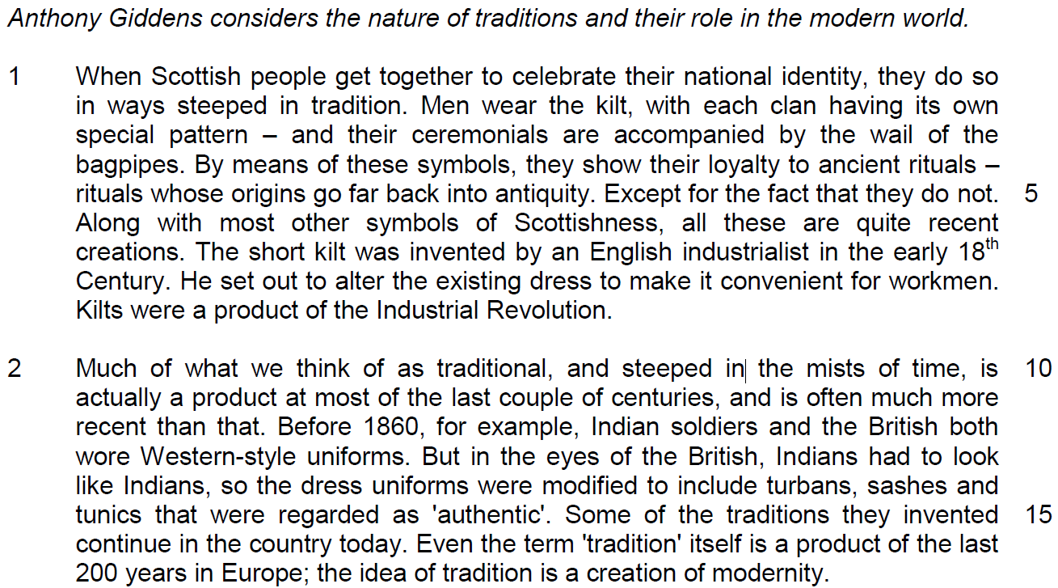

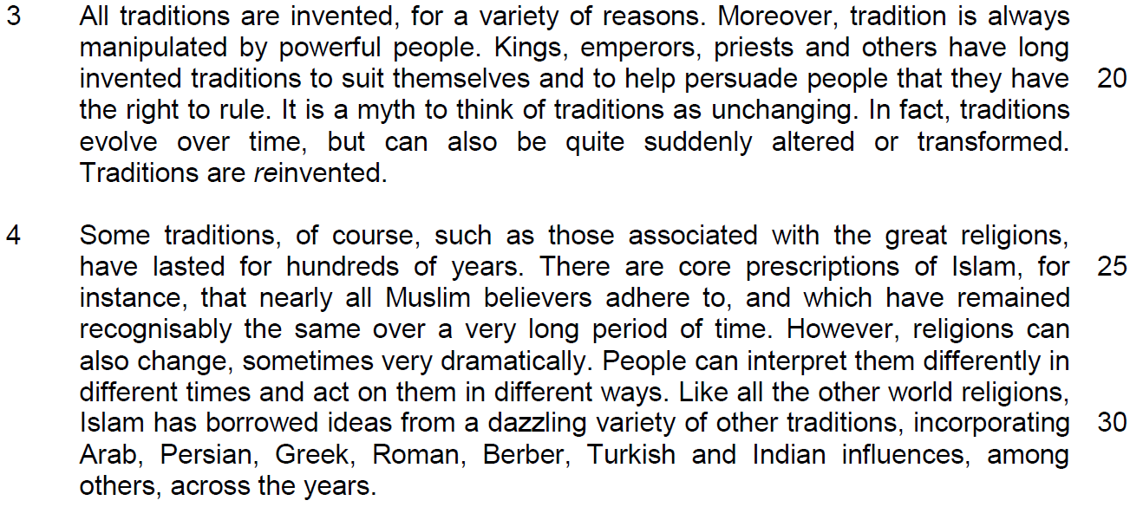

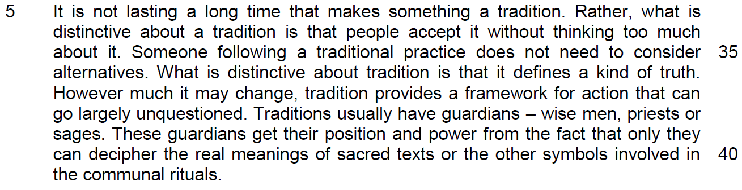
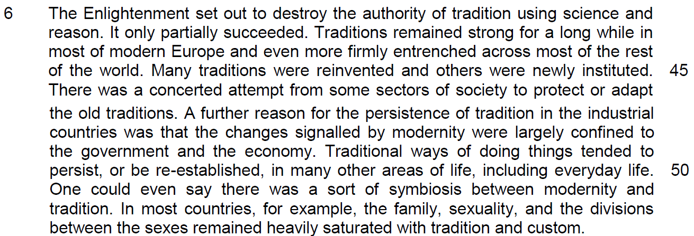

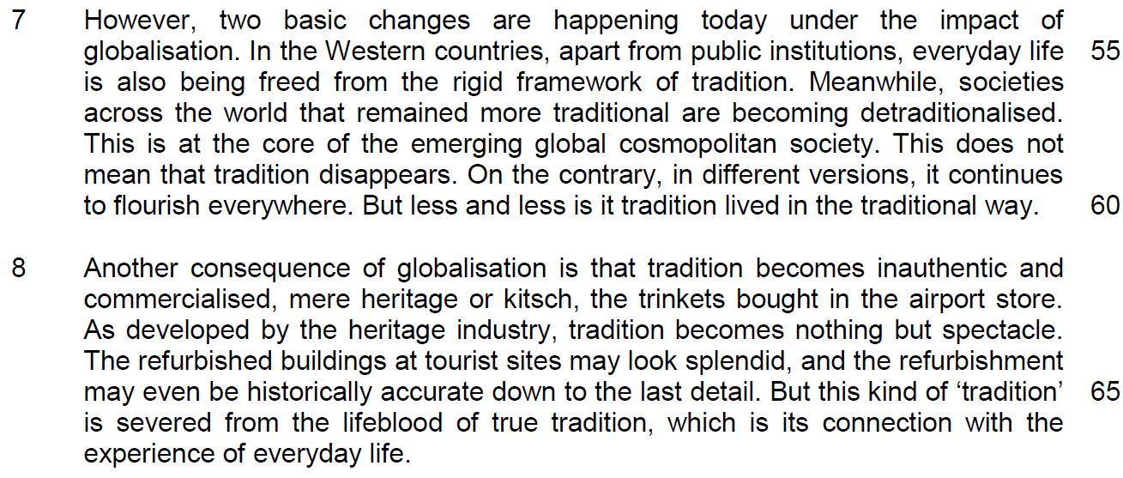

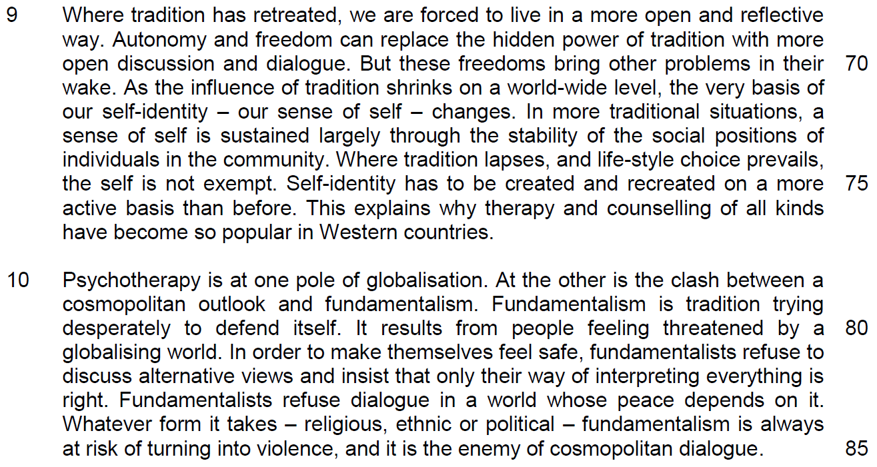
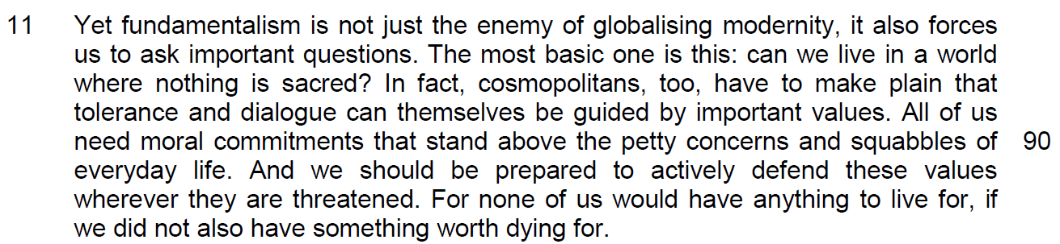

Suggested Answers

Summary Writing
Q12) Using material from paragraphs 5 – 8 only, summarise what the author has to say about the defining features of tradition, the reasons why traditions remained strong in modern society and the impact of globalisation on traditions.

Write your summary in no more than 120 words, not counting the opening words which are printed below. Use your own words as far as possible.

One defining feature of tradition is …
S/No | From the passage | Paraphrased equivalent
1 | people accept it without thinking too much about it / largely unquestioned | One defining feature of tradition is that it is blindly adhered to/followed/ followed uncritically/ no consideration of alternatives
2 | What is distinctive about tradition is that it defines a kind of truth | encapsulates a verity/constructs a form of correct understanding/ represents a worldview/form of reality.
3 | tradition provides a framework for action | and provides guidelines/norms/codes of conduct/principles for what we do
4 | Traditions usually have guardians | There will be people sworn to protect/ preserve these traditions
5 | Many traditions were reinvented | Some traditions were repeatedly modified
6 | others were newly instituted | Others were established afresh
7 | There was a concerted attempt from some sectors of society | There was joint/focused effort by various people in society
8 | to protect | To defend/prevent traditions from dying out
9 | or adapt the old traditions | Make changes to suit a new environment
10 | Changes signaled by modernity were largely confined to the government. | Modernity only affected the political sphere
11 | and the economy | And the financial domain

S/No | Points/Ideas from the passage (Essence of the point/idea in bold) | Paraphrased equivalent
12 | Traditional ways of doing things tended to persist, or be re-established, in many other areas of life, including everyday life. | Traditions remained relevant in many other aspects of life/domains
13 | there was a sort of symbiosis between modernity and tradition. | There was collaboration between old practices and new
14 | the family, sexuality, and the divisions between the sexes remained heavily saturated with tradition and custom. | Many social spheres/family and gender roles etc. were steeped in the old ways OR remained deeply/widely influenced by tradition
15 | In the Western countries, not just public institutions | Not just government/the bureaucracy/the establishment
16 | but everyday life | But also ordinary/quotidian activities
17 | being freed from the rigid framework of tradition | being loosed from the straightjacket of tradition/being liberated from uncompromising traditional norms
18 | Societies across the world that remained more traditional are becoming detraditionalised. | This trend is even taking place in countries which are predominantly more traditional
19 | in different versions | They occur in other forms
20 | It continues to flourish everywhere. | And they thrive in all places/ have spread widely
21 | But less and less is it tradition lived in the traditional way. | Traditions are practiced unconventionally
22 | tradition becomes inauthentic | Tradition has lost its true meaning/is fake/false/not genuine etc.
23 | Commercialized, mere heritage or kitsch | and has been cheapened/rendered tacky/tawdry
24 | tradition becomes nothing but spectacle | It is just superficial/ staged/ contrived/ a mere show
25 | But this kind of ‘tradition’ is severed from …connection with the experience of everyday life | it is no longer relevant to/no longer bears any strong link to quotidian/ordinary experience/activity.

Application Question

Q13) In this article, Giddens discusses the changing nature of tradition and its importance in society. How applicable do you find his observations to yourself and your society? [10] encompass the idea on whether it is agreeable into the applicability

Requirement of the question
1. To identify the changing nature of tradition and the importance of tradition that the writer has identified and applied whether these observations have occurred to you and in Singapore.
2. Need to give the reasons why they have happened to make your explanation more applicable.
Structure of discussion

1. Quote – ‘tradition becomes more inauthentic and commercialised’.
2. explanation – it changes from its original form to the modernised context where the tradition is used for business purposes – gain more profit – this implies that the society will experience cultural erosion

3. Applicability –
- why Singapore allows her cultures to become commercialised? - a source of tourist receipt – promote economic growth – employment opportunities and higher salary
3.1 why this change will occur in Singapore? Why it is important to Singapore?
- in line with modernisation, appeal to tourist for a taste of local favourites in a comfortable environment
- fast-paced life – as a result of modernisation brought about by technological advancement
consistent with efficiency and mass production
- a source of tourist attraction – cuisine like Chilli Crabs, Hainanese Chicken Rice – Singapore Food Festival

4. Example – hawker centre becomes food court, Lau Pat Sa, observe our ethnic enclaves have changed, more commercialized to attract tourist (very different from Thailand – street hawkers still remain)

5. Concluding sentence:

EOA -

2nd point
1. Quote – the influence of tradition shrinks on a world-wide level – our sense of self changes
2. – tradition is important to our self-identity – and tradition has been changed by freedom of expression and speech – and thus affect our self-identity
3. applicability – social media and the proliferation of education – society is now changing towards diversity – strengthened by attitude towards globalization
4. rise of social media – how we define ourselves in a multicultural society – transform from a cultural and ethnic identity to a modernized-cultural identity – number of facebook members in SG, modern way of life – promote individualism

3rd point – impact of change of tradition and its importance on you

According to the 2000 census of the population approximately 42% of the resident population is Buddhist, just under 15% Muslim, 14% each Christian and professing no religion, 8% Taoist, and 4% Hindu (Department of Statistics 2000aDepartment of Statistics, Singapore , 2000a . Singapore census of population 2000 advance data release no. 2: religion [online] . Available from:http://www.singstat.gov.sg[Accessed 18 May 2001] . [Google Scholar], p. 1). The 2000 census revealed “a strong correlation among ethnicity, home language and … religion among the Malays and Indians”, where “almost all Malay-speaking residents were Muslims while most Tamil-speaking residents were Hindus” (Department of Statistics 2000aDepartment of Statistics, Singapore , 2000a . Singapore census of population 2000 advance data release no. 2: religion [online] . Available from:http://www.singstat.gov.sg[Accessed 18 May 2001] . [Google Scholar], p. 7).

In this passage, the writer has expressed his concerns over the change in tradition and its importance of this impact on the society. Some of these observations are applicable to Singapore but it is only applicable to a certain degree.

According to the writer, she feels that ‘tradition becomes more inauthentic and commercialised’. This means that it has changed from its original form to the modernised context where the tradition is used for business purposes to gain more profit which will contribute to cultural erosion. This is applicable to Singapore as we recognise the significance of the tourist which will promote economic growth for us bringing us more employment opportunities and higher salary. Singapore needs to engage in this industry as it can bring more jobs for less technological inclined jobs which some segments of the working population would need, given that not all Singapore workers can gain employment in high tech industries. In line with modernisation, the government has also developed many racial enclaves like Chinatown, Geylang Serai, Little to make them appeal to the taste of the foreigners as our source of tourist attractions and capitalise on local cuisine like Chilli Crabs, Hainanese Chicken Rice in events like Singapore Food Festival to appeal to the foreigners, packaging them into our food centres like Lau Pat Sa or Newton Circle Food Centre. In a way, our hawker food culture has been accepted as UNESCO intangible cultural heritage is part of the intention to make cultural heritage a commercially viable strategy for economic development but this has adjusted our food culture into a commercial activity, losing our sense of authenticity in the way we see food centre as a way of life which reflects the Singapore culture.

However, such a move may not be completely commercialized and a cause of the loss of cultural heritage. Through the social media, many forms of traditional food have been preserved like food sites in YouTube, like Makansutra and the try guys are showcasing many local cuisines to preserve local cultural heritage. At the same time, many heart-landers in our neighbouring centre like Jurong, Geylang or Chinatown hawker centres still see the food centre as a way for them socialize, disapproving the view that our food centre culture is commercialized as they are not part of our life.

Another point that Giddens has observed is that the influence of tradition shrinks on a world-wide level which causes a change in our sense of self. She implies that tradition is important to our self-identity and the tradition has been changed by new values like freedom of expression and speech and thus, affect our self-identity.
Due to globalization and the proliferation of social media, we find this development society is also affecting Singapore as we move towards diversity, strengthened by values brought upon by social media. Singaporeans are now more modernized, accepting the values of individualism, embracing the empowerment of freedom of speech and choice which influence them to be more vocal on what kind of values do they prescribe to. Through the media, more young people are influenced by K-pop culture and are less willing to abide to their traditional ethnic cultures as they see it as archaic. Losing this ties with the traditional values expose them to a conflict in them on what determines their values that define who they are, creating more social issues like Quarter Life Crisis which may be tied to a lack of self-identity. This can be observed by an article by Todayonline.com where millennials are comfortable with ideas not to make home visits during the Chinese New Year. They are lesser understanding of the traditional cultural festive as they become more accustomed to foreign festive like Xmas, Valentine’ day and other more commercialised celebration. Consequently, many youths will experience a void on how they socialise and conduct their way of life, giving rise a sense of emptiness/

Fortunately, our youths can better define themselves as they are inspired by the education, they have received which compensate their loss of cultural heritage. Most youths are inspired and promising in their outlooks as reported by Study survey by The Strait Times. Youths are also quite attached to their family in close-knitted family in Singapore and are likely to be family educated to preserve their cultural values and rituals and this helps to negate the impact of the loss of self-identity as they lose their sense of tradition.

In sum, the various development in the world has influenced how we preserve our cultural heritage to negate the impacts of this loss. In Singapore, we do think that the world is now less culturally determined and influenced as consumerism and modernisation define us in a different way. However, our sense of family values and rootedness can crate a cultural bulwark to help us to preserve out tradition.

