GP Term 4 2018 – Comprehension Topic 2: Social Issues – Gender

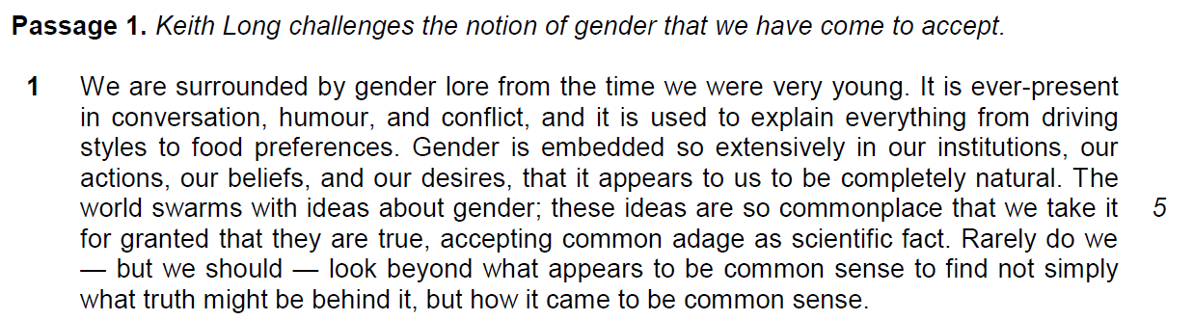

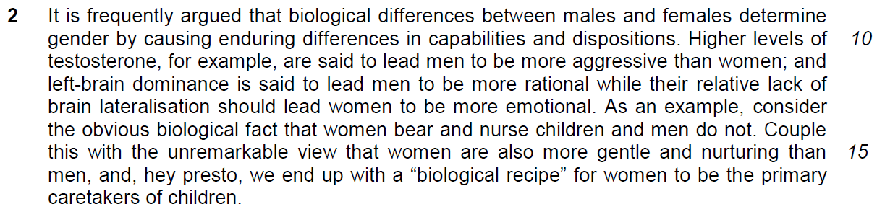

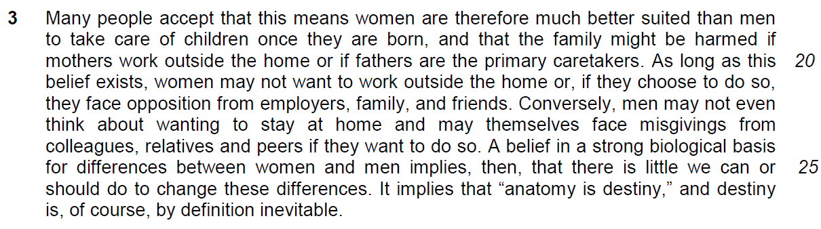

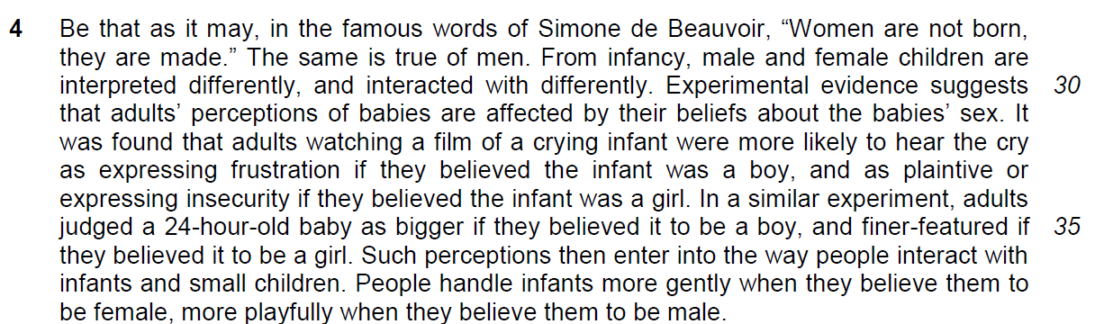

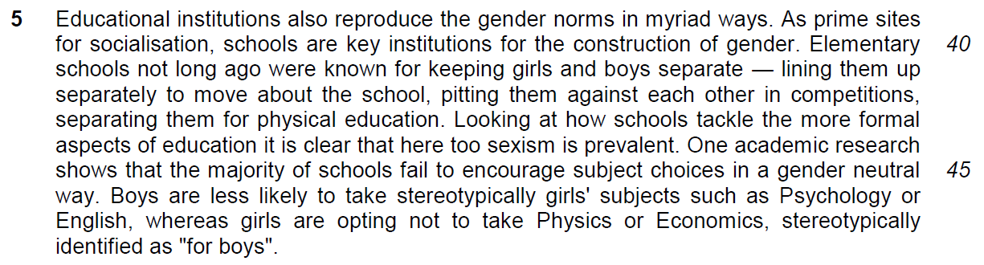

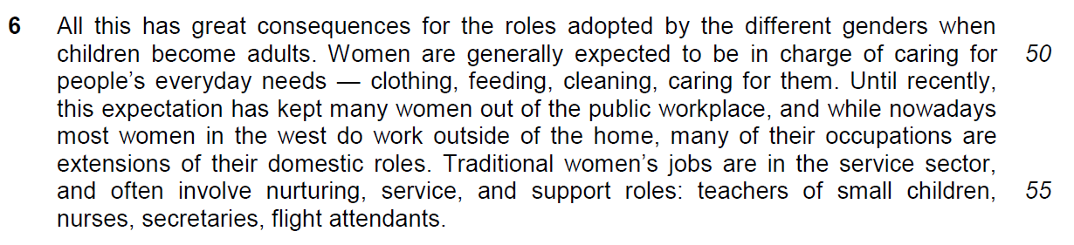

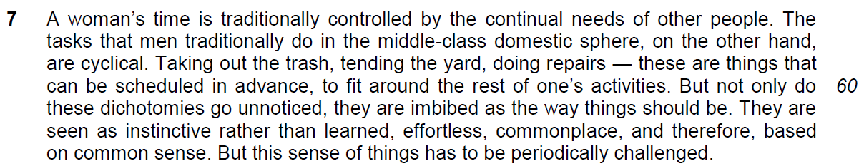

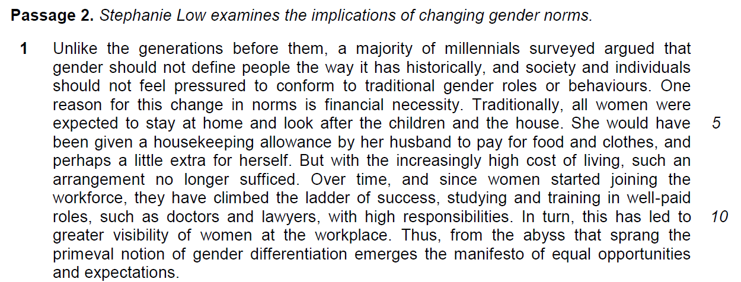

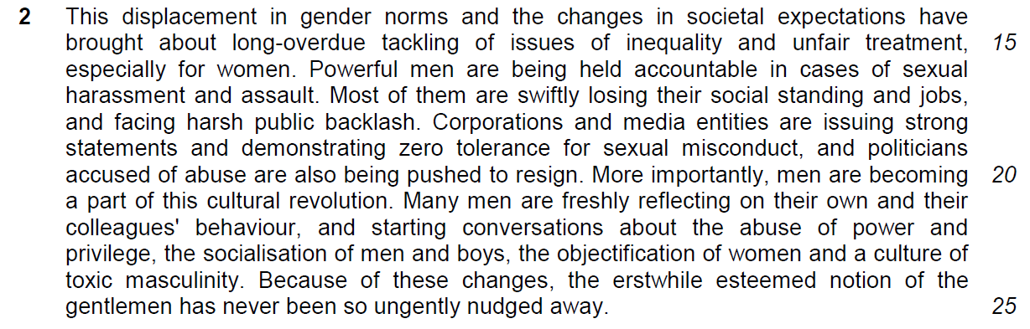

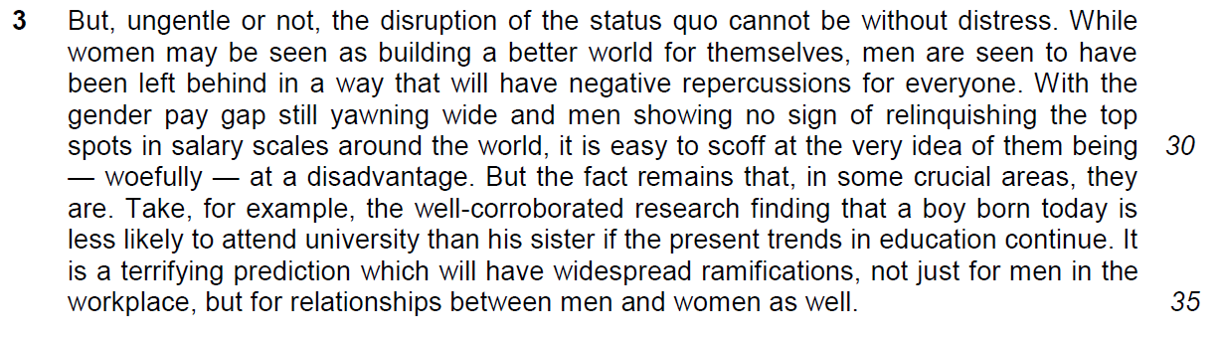

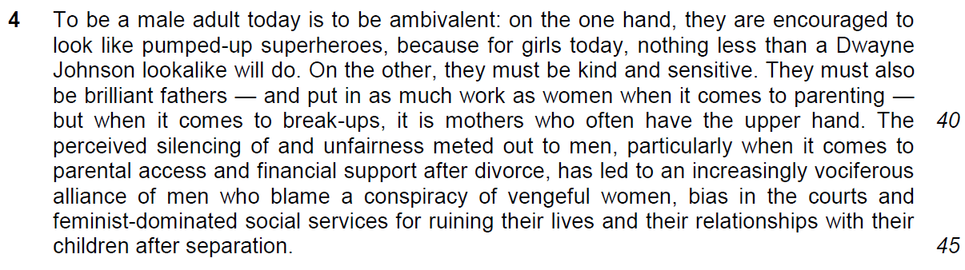

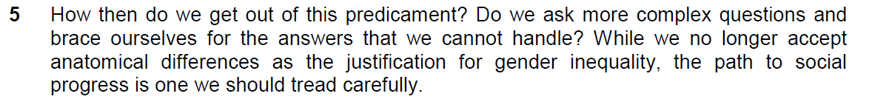

Questions
From Passage 1
Q1) Why, according to the author, does gender appear to us “to be completely natural” (line 4)? Use your own words as far as possible. [2]

…………………………………………………………………………………………………..

…………………………………………………………………………………………………..

…………………………………………………………………………………………………..

…………………………………………………………………………………………………..

Q2) Explain what the author means by “unremarkable view” in line 15. Use your own words as far as possible. [1]

…………………………………………………………………………………………………..

…………………………………………………………………………………………………..

Q3) In what ways are women’s occupations extensions of their “domestic roles” (line 54)? Use your own words as far as possible. [2]

…………………………………………………………………………………………………..

…………………………………………………………………………………………………..

…………………………………………………………………………………………………..

…………………………………………………………………………………………………..

Q4) Explain the difference between the demands on women and men in lines 57-60. Use your own words as far as possible. [3]

…………………………………………………………………………………………………..

…………………………………………………………………………………………………..

…………………………………………………………………………………………………..

Q5) Using material from Passage 1, paragraphs 3-5 (lines 18-48), summarise what the author has to say about the beliefs regarding the differences between men and women, and how these beliefs are formed.

Write your summary in no more than 120 words, not counting the opening words which are printed below. Use your own words as far as possible. [18]

People believe that ……………………………………………………………………………

…………………………………………………………………………………………………..

…………………………………………………………………………………………………..

…………………………………………………………………………………………………..

…………………………………………………………………………………………………..

…………………………………………………………………………………………………..

…………………………………………………………………………………………………..

…………………………………………………………………………………………………..

…………………………………………………………………………………………………..

…………………………………………………………………………………………………..

…………………………………………………………………………………………………..

…………………………………………………………………………………………………..

…………………………………………………………………………………………………..

…………………………………………………………………………………………………..

…………………………………………………………………………………………………..

…………………………………………………………………………………………………..

…………………………………………………………………………………………………..

…………………………………………………………………………………………………..

…………………………………………………………………………………………………..

…………………………………………………………………………………………………..

…………………………………………………………………………………………………..

From Passage 2
Q6) How did “financial necessity” (line 4) lead to the change in gender norms? Use your own words as far as possible. [2]

…………………………………………………………………………………………………..

…………………………………………………………………………………………………..

…………………………………………………………………………………………………..

…………………………………………………………………………………………………..

Q7) Explain what is meant by “primeval notion of gender differentiation” (line 12). Use your own words as far as possible. [1]

…………………………………………………………………………………………………..

…………………………………………………………………………………………………..

Q8) In paragraphs 2-3, what does the author see as concerns for men given the changes to gender norms and the status quo? Use your own words as far as possible. [3]

…………………………………………………………………………………………………..

…………………………………………………………………………………………………..

…………………………………………………………………………………………………..

…………………………………………………………………………………………………..

…………………………………………………………………………………………………..

…………………………………………………………………………………………………..

Q9) Explain why “to be a male adult today is to be ambivalent” (line 36). Use your own words as far as possible. [1]

…………………………………………………………………………………………………..

…………………………………………………………………………………………………..

…………………………………………………………………………………………………..

Q10) In the concluding paragraph, what does the author suggest we do to handle the issue of gender? [2]

…………………………………………………………………………………………………..

…………………………………………………………………………………………………..

…………………………………………………………………………………………………..

…………………………………………………………………………………………………..

From both passages
Q11) While Keith Long makes the point that we should question our common notion of gender, Stephanie Low is of the view that we should be mindful of the implications of changing gender norms.

How far would you agree or disagree with the concerns expressed in these two passages? Support your answer with examples drawn from your experience and that of your society. [10]

…………………………………………………………………………………………………..

…………………………………………………………………………………………………..

…………………………………………………………………………………………………..

…………………………………………………………………………………………………..

…………………………………………………………………………………………………..

…………………………………………………………………………………………………..

…………………………………………………………………………………………………..

…………………………………………………………………………………………………..

…………………………………………………………………………………………………..

…………………………………………………………………………………………………..

…………………………………………………………………………………………………..

…………………………………………………………………………………………………..

…………………………………………………………………………………………………..

…………………………………………………………………………………………………..

…………………………………………………………………………………………………..

…………………………………………………………………………………………………..

…………………………………………………………………………………………………..

…………………………………………………………………………………………………..

…………………………………………………………………………………………………..

…………………………………………………………………………………………………..

…………………………………………………………………………………………………..

…………………………………………………………………………………………………..

…………………………………………………………………………………………………..

…………………………………………………………………………………………………..

…………………………………………………………………………………………………..

…………………………………………………………………………………………………..

…………………………………………………………………………………………………..

…………………………………………………………………………………………………..

…………………………………………………………………………………………………..

…………………………………………………………………………………………………..

…………………………………………………………………………………………………..

…………………………………………………………………………………………………..

…………………………………………………………………………………………………..

…………………………………………………………………………………………………..

…………………………………………………………………………………………………..

…………………………………………………………………………………………………..

…………………………………………………………………………………………………..

…………………………………………………………………………………………………..

…………………………………………………………………………………………………..

…………………………………………………………………………………………………..

