GP Term 4 2017 – Comprehension – Topic 1: Reflective Issues (Positive) – Importance of Failure

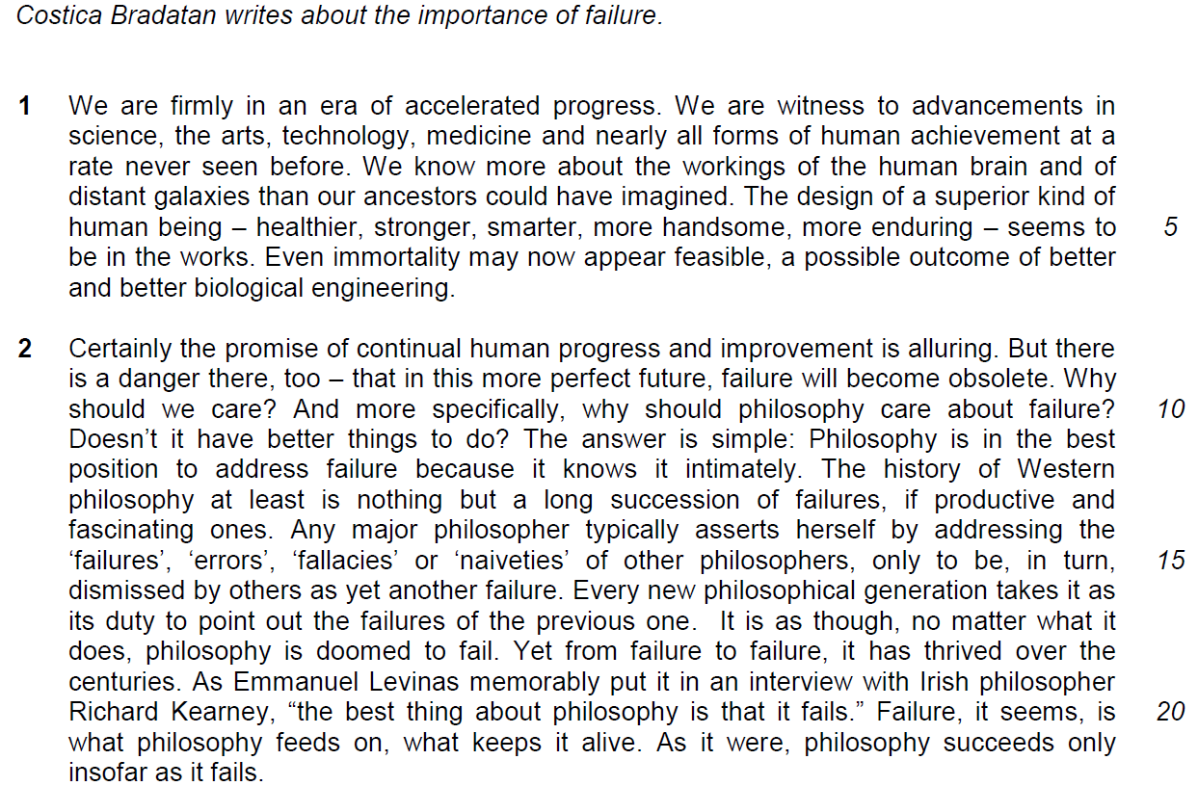

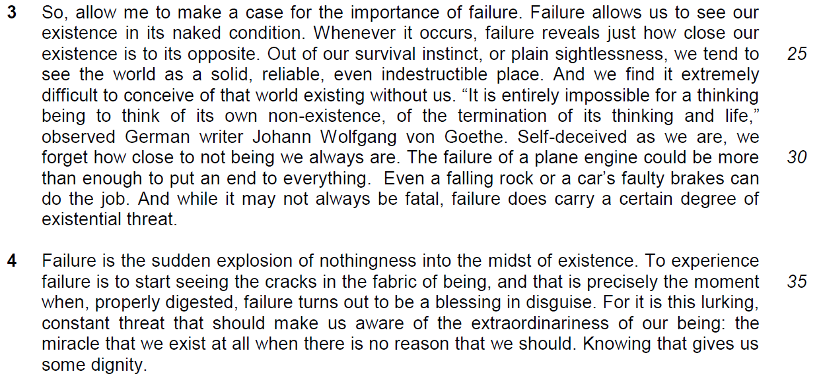

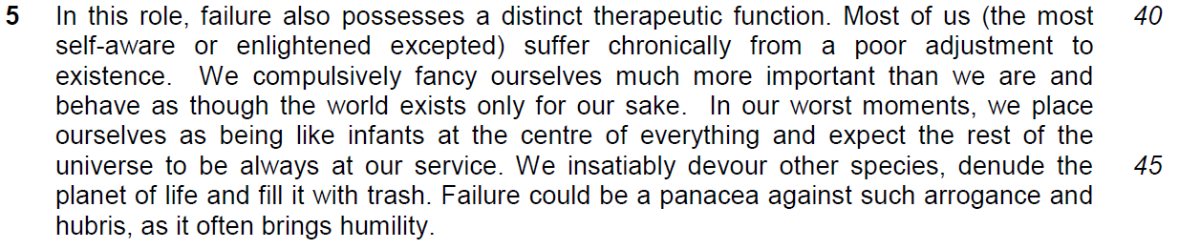

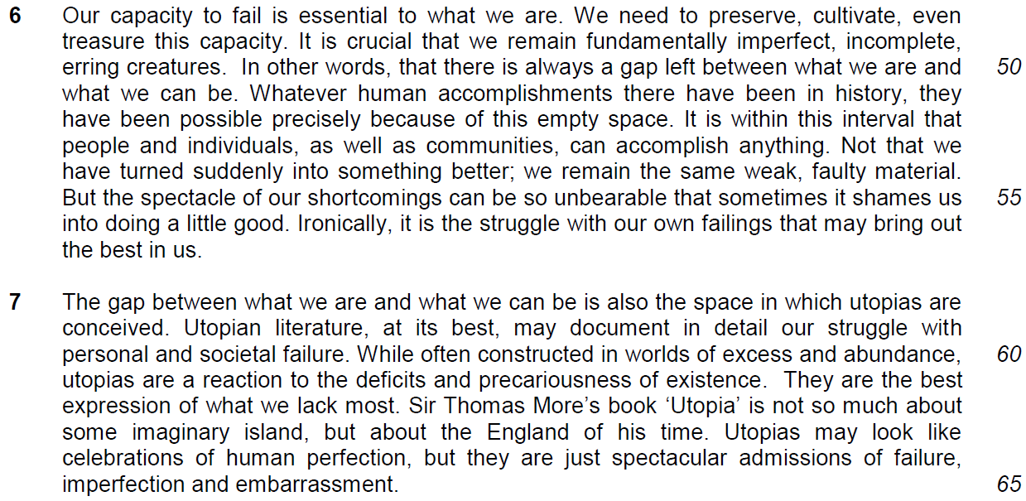

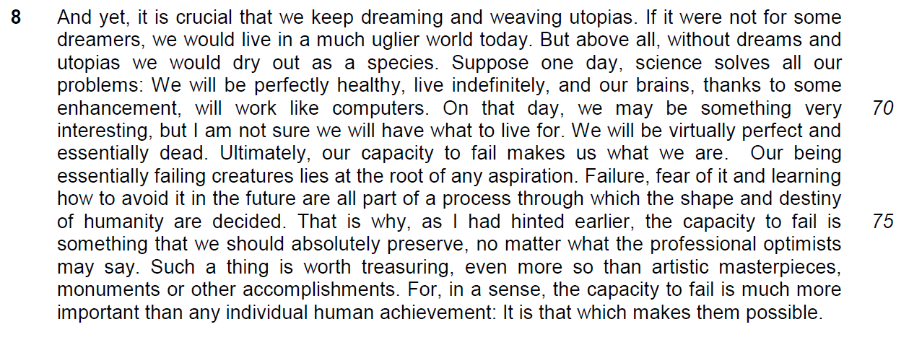

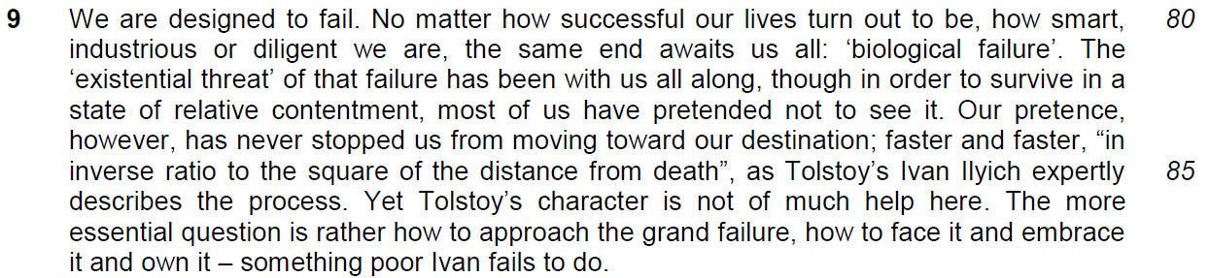

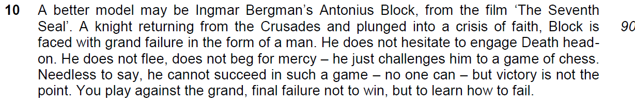

12. Costica Bradatan argues strongly in favour of failure. How applicable are the author’s observations to you and your society? Illustrate your answer by referring to the ways in which you and your society regard failure. [10]
…………………………………………………………………………………………………………………………………
……………………………………………………………………………………………………………………………………
……………………………………………………………………………………………………………………………………
……………………………………………………………………………………………………………………………………

……………………………………………………………………………………………………………………………………
……………………………………………………………………………………………………………………………………

……………………………………………………………………………………………………………………………………
……………………………………………………………………………………………………………………………………

……………………………………………………………………………………………………………………………………
……………………………………………………………………………………………………………………………………

……………………………………………………………………………………………………………………………………
……………………………………………………………………………………………………………………………………

……………………………………………………………………………………………………………………………………
……………………………………………………………………………………………………………………………………

……………………………………………………………………………………………………………………………………
……………………………………………………………………………………………………………………………………

……………………………………………………………………………………………………………………………………
……………………………………………………………………………………………………………………………………

……………………………………………………………………………………………………………………………………
……………………………………………………………………………………………………………………………………

……………………………………………………………………………………………………………………………………
……………………………………………………………………………………………………………………………………

……………………………………………………………………………………………………………………………………
……………………………………………………………………………………………………………………………………

……………………………………………………………………………………………………………………………………
……………………………………………………………………………………………………………………………………

……………………………………………………………………………………………………………………………………
……………………………………………………………………………………………………………………………………

……………………………………………………………………………………………………………………………………
……………………………………………………………………………………………………………………………………

……………………………………………………………………………………………………………………………………
……………………………………………………………………………………………………………………………………

……………………………………………………………………………………………………………………………………
……………………………………………………………………………………………………………………………………

……………………………………………………………………………………………………………………………………
……………………………………………………………………………………………………………………………………

……………………………………………………………………………………………………………………………………
……………………………………………………………………………………………………………………………………

……………………………………………………………………………………………………………………………………
……………………………………………………………………………………………………………………………………

……………………………………………………………………………………………………………………………………
……………………………………………………………………………………………………………………………………

……………………………………………………………………………………………………………………………………
……………………………………………………………………………………………………………………………………

……………………………………………………………………………………………………………………………………
……………………………………………………………………………………………………………………………………

……………………………………………………………………………………………………………………………………
……………………………………………………………………………………………………………………………………

……………………………………………………………………………………………………………………………………

