2013 T4 J2 GP – Comprehension Culture – Q2

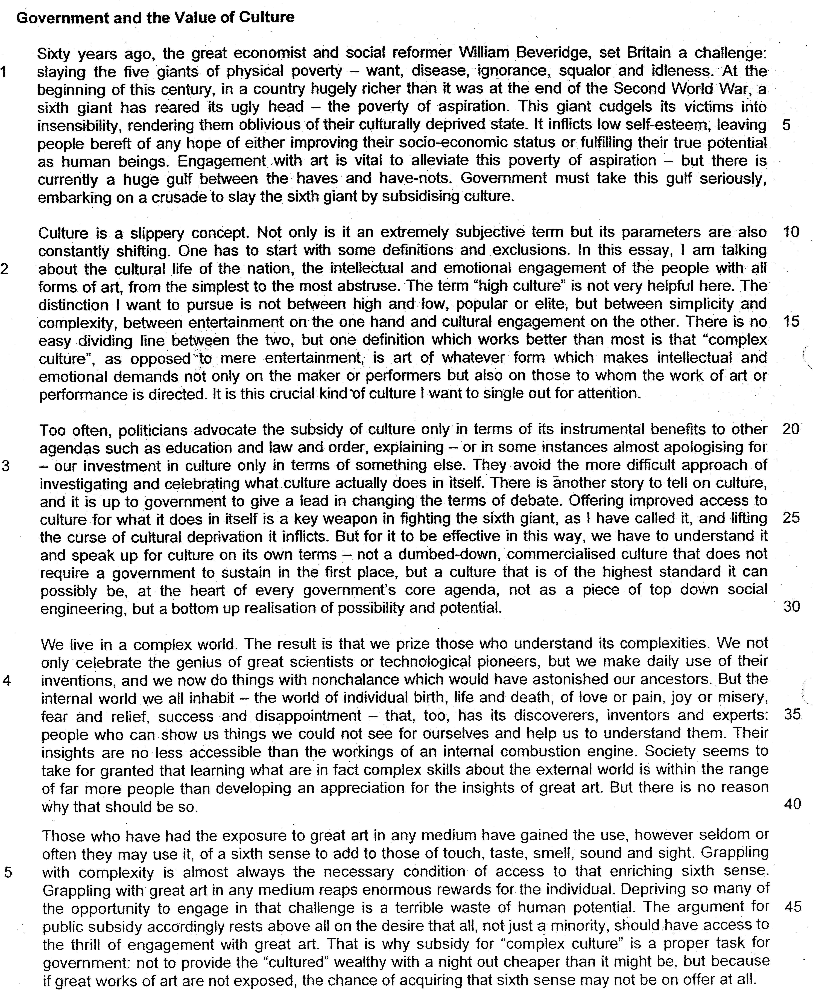

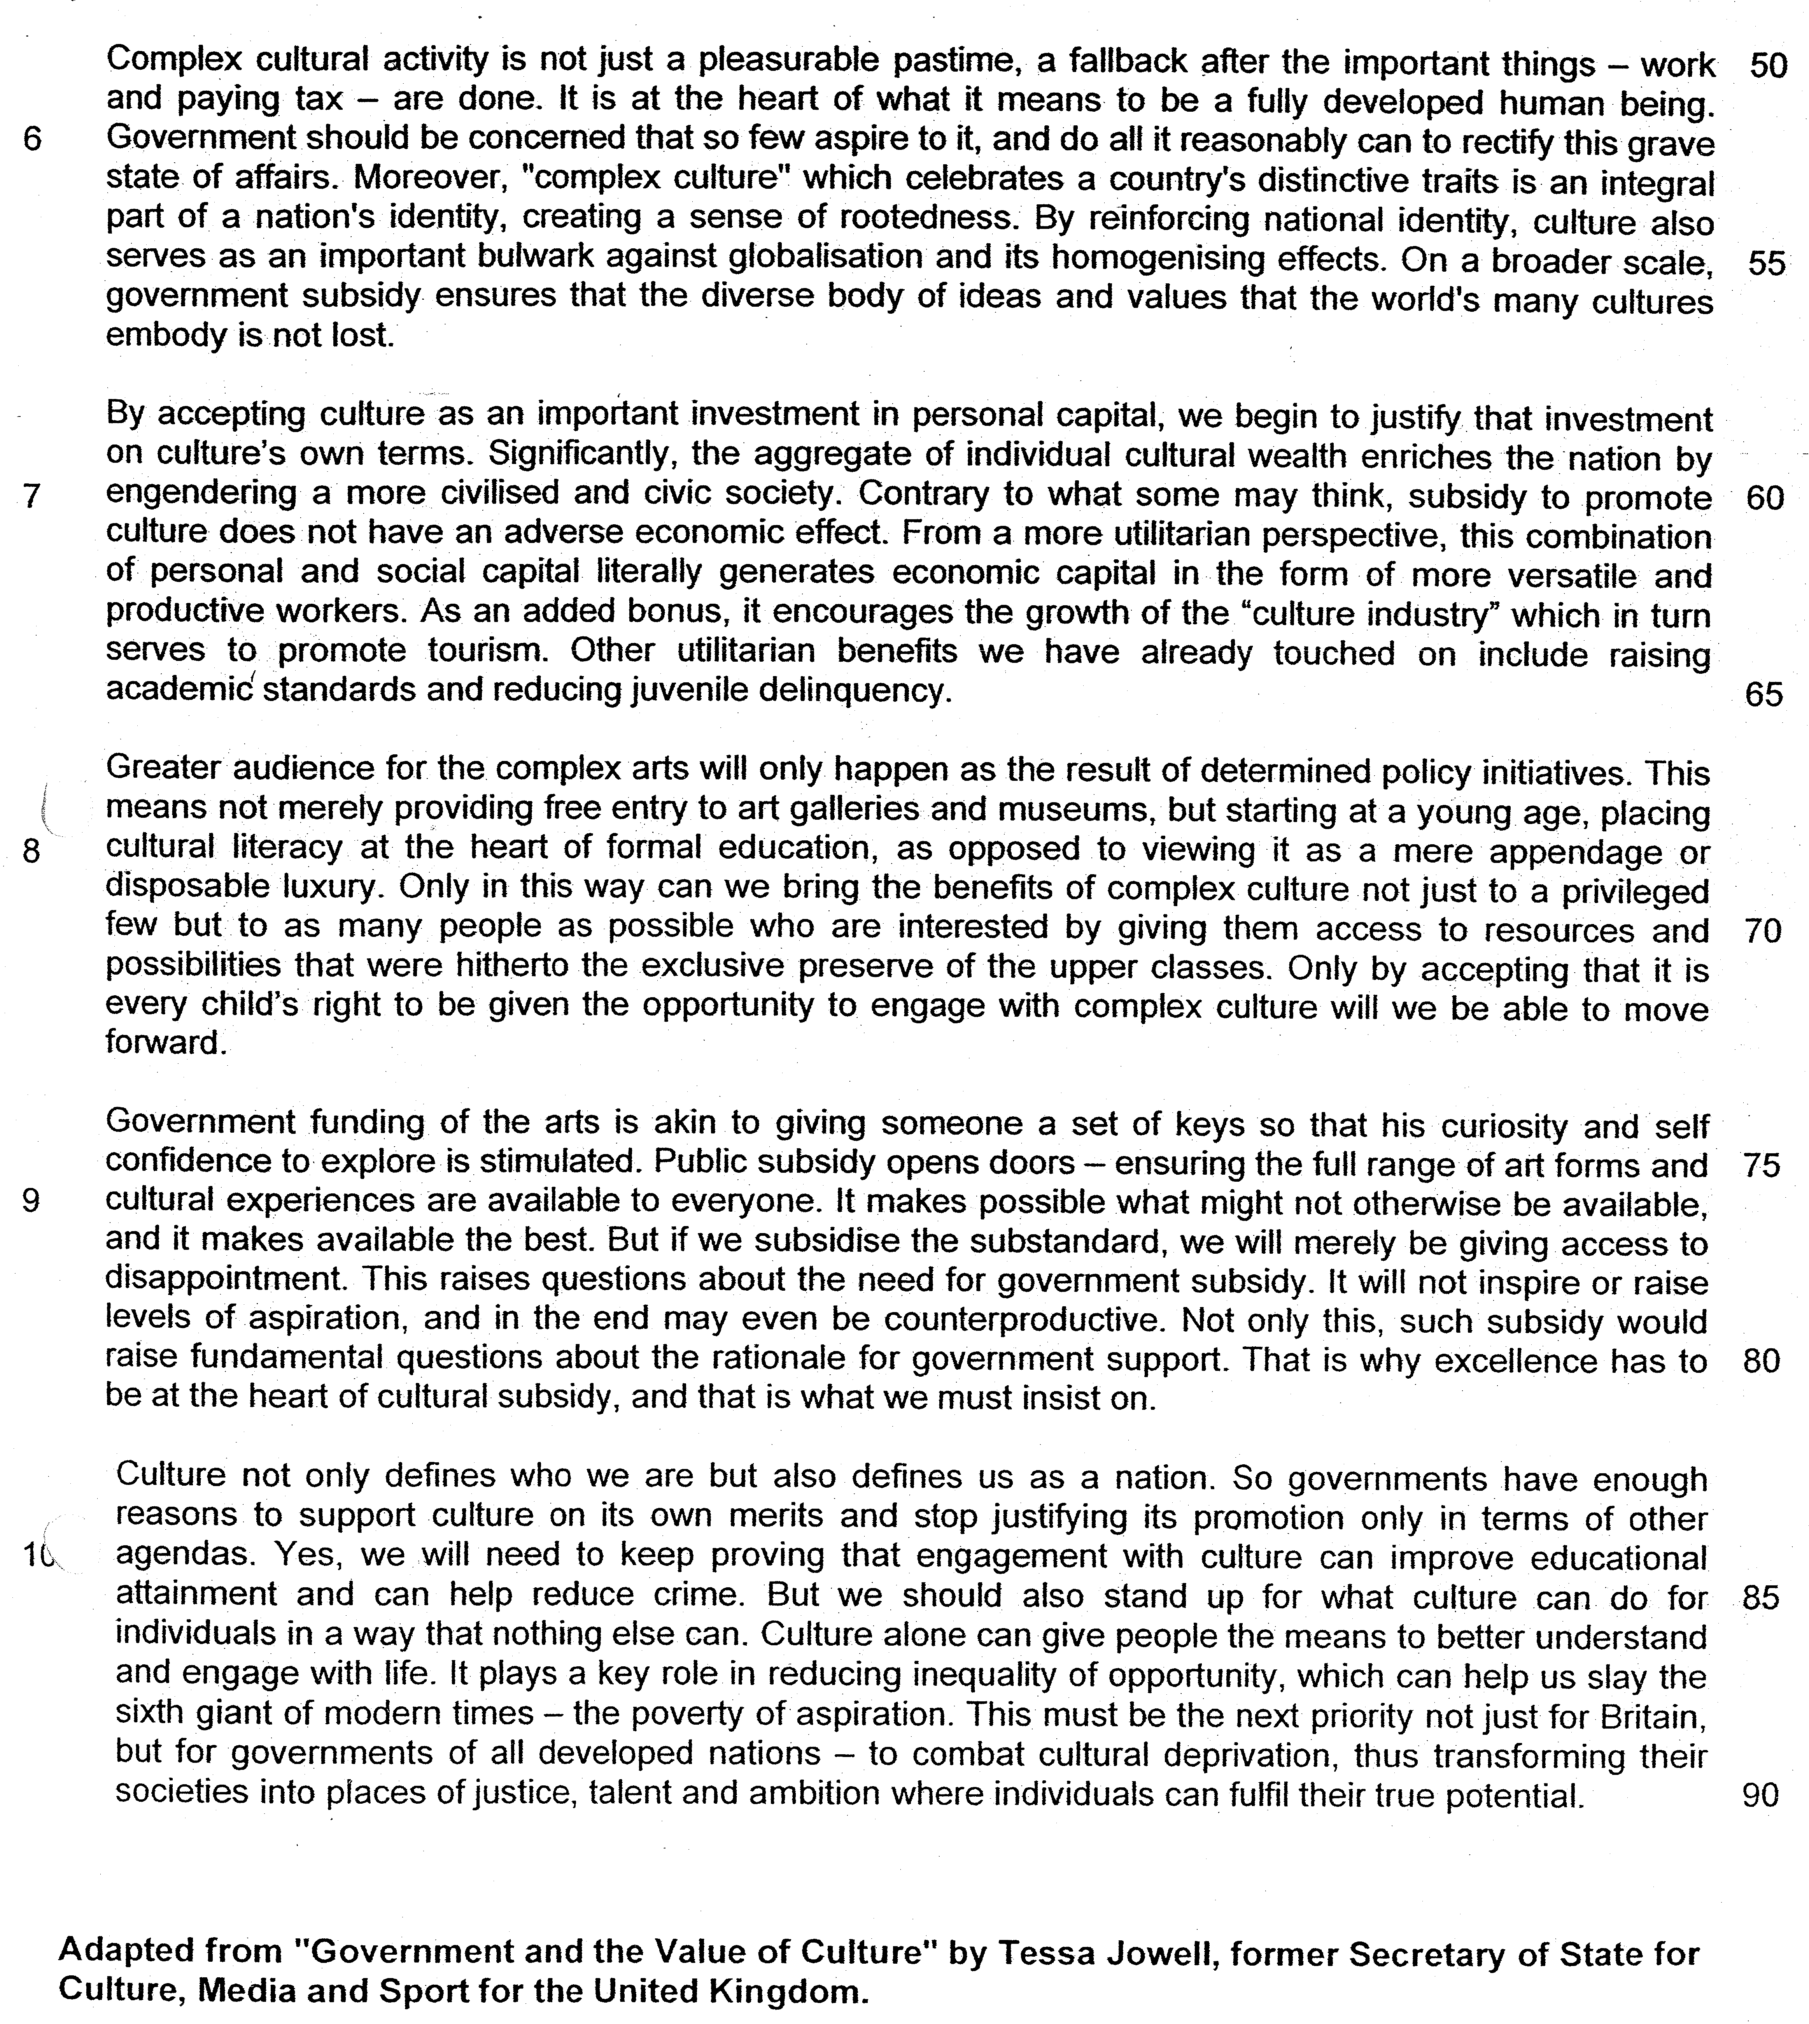

From paragraph 1

1. The writer refers to a "sixth giant" (line 4) in this paragraph. Explain carefully why she wants to "slay" this giant. Answer in your own words as far as possible. [2]

_______________________________________________________________________________________________________________________________________________________________________________________________________________________________________________________________________________________

From paragraph 2

2. Give two reasons why the writer views culture as a "slippery concept" (line 10). Answer in your own words as far as possible. [1]

_______________________________________________________________________________________________________________________________________________________________________________________________________________________________________________________________________________________

3. According to the writer, what is "complex culture" (line 16-17)? Answer in your own words as far as possible. [1]

_______________________________________________________________________________________________________________________________________________________________________________________________________________________________________________________________________________________

From paragraph 3

4. Why do politicians usually "advocate the subsidy of culture only in terms of its instrumental benefits to other agendas" (line 20-21)? Answer in your own words as far as possible. [1]
_______________________________________________________________________________________________________________________________________________________________________________________________________________________________________________________________________________________
5. Why would "commercialised culture" not require government support "in the first place" (lines 27-28)? Answer in your own words as far as possible. [1]

______________________________________________________________________________________________________________________________________________________________________________________________________________________________________________________________________________________

From paragraph 4

6. The writer tells us that "the internal world we all inhabit" has its own "discoverers, inventors and experts" (lines 34-35). Name the specific group of people that she is referring to here. [1]

______________________________________________________________________________________________________________________________________________________________________________________________________________________________________________________________________________________

7. Referring to material from paragraphs 5, 6 and 7, summarise the writer's reasons for arguing that governments should subsidise culture.

Write your summary in no more than 150 words, not counting the opening words which are printed below. Use your own words as far as possible.

The writer argues that governments should subsidise culture because …

______________________________________________________________________________________________________________________________________________________________________________________________________________________________________________________________________________________
_________________________________________________________________________________________________________________________________________________________________________________________
_______________________________________________________________________________________________________________________________________________________________________________________________________________________________________________________________________________________
______________________________________________________________________________________________________________________________________________________________________________________________________________________________________________________________________________________
_______________________________________________________________________________________________________________________________________________________________________________________________________________________________________________________________________________________
__________________________________________________________________________________________________________________________________________________________________________________________
_____________________________________________________________________________________________
_________________________________________________________________________________________[8]

From paragraph 8

8. According to the writer, what is the current role of cultural literacy in education and how does she want to change it? Answer in your own words as far as possible. [2]

______________________________________________________________________________________________________________________________________________________________________________________________________________________________________________________________________________________

9. What does the writer mean when she says the best in art and music were "hitherto the exclusive preserve of the upper classes" (line 71)? Answer in your own words as far as possible. [2]

______________________________________________________________________________________________________________________________________________________________________________________________________________________________________________________________________________________

From paragraph 9

10. Identify and explain the analogy used by the writer in this paragraph. Answer in your own words as far as possible.
[1]

______________________________________________________________________________________________________________________________________________________________________________________________________________________________________________________________________________________

11. Explain why the writer insists that governments should only subsidise cultural excellence. Use your own words as far as possible. [2]

_______________________________________________________________________________________________________________________________________________________________________________________________________________________________________________________________________________________

12. Give the meaning of the following words as they are used in the passage. You may write your answers in one word or a short phrase.

squalor (line 2) __________________________________________________________________________
alleviate (line 7) _________________________________________________________________________
curse (line 26) ___________________________________________________________________________
prize (line 31) ____________________________________________________________________________
accessible (line 37) ___________________________________________________________________[5]

13. The writer contends that it is the duty of governments of all developed nations to extensively subsidise "complex culture".

To what extent do you agree with her arguments?

Discuss the relevance of the issues and ideas raised in this passage to your own country. Refer specifically to relevant material from the passage, as well as your own knowledge and opinions to support your answer.

______________________________________________________________________________________________________________________________________________________________________________________________________________________________________________________________________________________
______________________________________________________________________________________________________________________________________________________________________________________________________________________________________________________________________________________
______________________________________________________________________________________________________________________________________________________________________________________________________________________________________________________________________________________
______________________________________________________________________________________________________________________________________________________________________________________________________________________________________________________________________________________

______________________________________________________________________________________________________________________________________________________________________________________________________________________________________________________________________________________
______________________________________________________________________________________________________________________________________________________________________________________________________________________________________________________________________________________
______________________________________________________________________________________________________________________________________________________________________________________________________________________________________________________________________________________
______________________________________________________________________________________________________________________________________________________________________________________________________________________________________________________________________________________
______________________________________________________________________________________________________________________________________________________________________________________________________________________________________________________________________________________
______________________________________________________________________________________________________________________________________________________________________________________________________________________________________________________________________________________
______________________________________________________________________________________________________________________________________________________________________________________________________________________________________________________________________________________

_________________________________________________________________________________________________________________________________________________________________________________________
______________________________________________________________________________________________________________________________________________________________________________________________________________________________________________________________________________________
______________________________________________________________________________________________________________________________________________________________________________________________________________________________________________________________________________________
______________________________________________________________________________________________________________________________________________________________________________________________________________________________________________________________________________________
______________________________________________________________________________________________________________________________________________________________________________________________________________________________________________________________________________________
______________________________________________________________________________________________________________________________________________________________________________________________________________________________________________________________________________________
______________________________________________________________________________________________________________________________________________________________________________________________________________________________________________________________________________________
_________________________________________________________________________________________[8]

Suggested Answer

From paragraph 1

1. The writer refers to a "sixth giant" (line 4) in this paragraph. Explain carefully why she wants to "slay" this giant. Answer in your own words as far as possible. [2]

Lift
This giant cudgels...oblivious to their culturally deprived state
its overall effect is to inflict low self-esteem,
of either improving their socio-economic
of fulfilling their true potential as human beings.

Paraphrase
The writer wants to do so as the poverty of aspiration makes people unaware of the fact that they are disadvantaged by their lack of culture and causes/induces/contributes to an inferiority complex and leave people bereft of any hope. This will deprive them of any ambition to better themselves [1/2] to attain a better social and financial position/state

From paragraph 2
2. What does the writer mean when she says, "Culture is a slippery concept" (line 10)? Answer in your own words as far as possible. [1]

Lift
Culture is a slippery concept. Not only is an extremely subjective term but its parameters are also constantly shifting.

Paraphrase
The notion/idea of culture is elusive and narrowly-defined because different people have different definitions of it. As the way we define culture is relative, it has no distinct and observable boundaries drawn to act as a defined concept

3. According to the writer, what is "complex culture" (line 16-17)? Answer in your own words as far as possible. [1]

Lift
"complex culture"... is art of whatever form which makes intellectual and emotional demands not only on the maker or performers but also on those to whom the work of art or performance is directed.

Paraphrase
"Complex culture" requires mental and emotional effort on both the part of its creator or artists and its audience where both its creators and audience need to make an effort to think and feel about the process of art.

From paragraph 3

4. Why do politicians "advocate the subsidy of culture only in terms of its instrumental benefits to other agendas" (line 20 - 21)? Answer in your own words as far as possible. [1]

Lift
They avoid the more difficult approach of investigating and celebrating what culture actually does in itself.

...politicians advocate the subsidy of culture only in terms of its instrumental benefits to other agendas such as education and law and order, explaining — or in some instances almost apologising for – our investment in culture only in terms of something else.

Inference
It is hard to measure/discuss/identify the inherent and intangible benefits of culture, where most of its benefits cannot be easily discerned. Hence, in order to justify their expenditure in this area, politicians have to demonstrate how their expenditure on culture leads to quantifiable benefits. To do this, they relate culture to areas where results are measurable and quantifiable.

5. Why would "commercialised culture" not require government support "in the first place" (lines 27-8)? Answer in your own words as far as possible. [1]

Lift
not a dumbed-down, commercialised culture, that does not require a government to sustain in the first place

Inference
Mainstream or popular entertainment does not need government subsidy as it is in itself profitable and can thrive independently with substantial/mass audience support from the public. (commercially viable and sustainable on its own)

From paragraph 4

6. The writer tells us that "the internal world we all inhabit" has its own "discoverers, inventors and experts" (lines 34-35). Name the specific group of people she is referring to here. [1]

Inference
Artists. They are the one who create the ideas for the mass to understand more about our experiences in life.

7. Referring to material from paragraphs 5, 6 and 7, summarise the writer's reasons for arguing that governments should subsidise culture.

Write your summary in no more than 150 words, not counting the opening words which are printed below. Use your own words as far as possible. [8]

The writer argues that governments should subsidise culture because...
Lift
- Grappling with complexity is almost always the necessary condition of access to that enriching sixth sense.

- Depriving so many of the opportunity to engage in that challenge is aterrible waste of human potential.

- all, not just a minority, should have access to the thrill of engagement with great art.

- subsidy for "complex culture" is a proper task for government

- Complex cultural activity is not just a pleasurable pastime

- It is at the heart of what it means to be a fully developed human being.

- Government should be concerned that so few aspire to it

- "complex culture" which celebrates a country's distinctive traits is an integral part of a nation's identity

- creating a sense of rootedness

- bulwark against globalisation

- its homogenising effects

- ensures that the diverse body of ideas and values that the world's many cultures embody is not lost.

- 'engendering a more civilised...

- ...and civic society

- more versatile...

- ...and productive workers.

- serves to promote tourism.

- raising academic standards

- reducing juvenile delinquency.

The writer argues that governments should subsidize culture because it is imperative to handle this difficult aspect of our society to enrich our thinking. It will also not undermine the masses from engaging in this challenging task for the society as the whole society should have this right to engage in art. Subsidy for these cultural activities is a just thing for government to do as art is not just a form of leisure but a tool to nurture the complete and civic individual. Governments should also ensure all will participate as it is an element that will shape the national identity which will create our sense of belonging to prevent the erosion of local cultures so that diversity can continue to exist to maintain a civil society. Economically, we have more adaptive workers to raise production and seek to develop tourism. Consequently, our standard of living will be raised and social problems like juvenile delinquency will be minimized.

(151 words)

From paragraph 8

8. According to the writer, what is the current role of cultural literacy in education and how does she want to change it? Answer in your own words as far as possible. [2]

Lift
as opposed to viewing it as a mere appendage or disposable luxury
placing cultural literacy at the heart of formal education

Paraphrase
At present, cultural literacy is only seen as a subordinate part of education or non-essential extravagance and indulgence. She wants it to be crucial and fundamental part of the education and be the centre of the education system

9. What does the writer mean when she says the best in art and music were "hitherto the exclusive preserve of the upper classes" (Line 71)? Answer in your own words as far as possible. [2]

Lift
hitherto
the exclusive
preserve
of the upper classes

Paraphrase/Inference
- up till the present/ until today/now [1/2]
- it was solely/purely the [1/2]
- domain/area/privilege [1/2]
- of the wealthy/those with a higher social status/in the upper echelons of society [1/2]

She means that the best form of art and music up till the present was solely still the privilege of the wealthy or those with a higher social status.

From paragraph 9
10. Identify and explain the analogy used by the writer in this paragraph. Answer in your own words as far as possible. [1]

Lift
Government funding of the arts is akin to giving someone a set of keys so that his curiosity and self confidence to explore ...Public subsidy opens doors

Explanation
Just as a set of keys can enable a person to open previously locked doors to discover what is behind them, government subsidy of the arts would allow people to gain access to what they previously may not have had access to, which, in this case, is the arts. Hence, it is a gateway to new cultural territory which opens new avenues of exploration.

11. Explain why the writer insists that governments should only subsidise cultural excellence. Use your own words as far as possible. [2]

Lift
But if we subsidise the substandard, we will merely be giving access to disappointment.
This raises questions about the need for government subsidy.
It will not inspire or raise levels of aspiration, and in the end may even be counterproductive.
It would raise fundamental questions about the rationale for government support

Paraphrase
If the government did not only subsidise cultural excellence, but second-rate culture, people will feel disenchanted and hence begin to contend the necessity for public funding of the arts. Moreover, such an act would not encourage or increase ambition and ultimately may backfire, doing more harm than good. People will also begin to doubt the reasoning behind the public funding.

12. Give the meaning of the following words as they are used in the passage. You may write your answer in one word or a short phrase.

squalor (Line 2) filthy conditions [1]

alleviate (Line 7) mitigate; reduce; lessen; make less severe

curse (Line 26) severe affliction; bane; plague; scourge

prize (line 31) value highly; treasure; cherish; hold in high regard

accessible (line 37) easily understood/intelligible/comprehensible/graspable/appreciated

13. The writer contends that it is the duty of governments of all developed nations to extensively subsidise "complex culture".

To what extent do you agree with her arguments?

Discuss the relevance of the issues and ideas raised in this passage to your own country. Refer specifically to relevant material from the passage, as well as your own knowledge and opinions to support your answer.

Thinking aspect:

- Understand the requirements of the question

To derive the extent of agreement to the proposition set by the writer on the issue that it is the duty of all developed nations to extensively subsidize ‘’complex culture”

The nature of discussion is on the extent of agreement to the view of the writer and thus the structure should first depict the writer’s reason for the proposition and why it is agreeable. After this, the evaluation will need to focus on the extent of agreement to this reason proposed by the writer.

In the process to explain why you agree and show the extent of agreement, it is essential that the context of Singapore is applied in the discussion. It is important to show how this reason given by the writer is point that Singapore and the society of Singapore will find it as a reasonable point to accept. Similarly, in the process of the evaluation of the extent of agreement, the grounds for agreement or disagreement must be discussed in the context of Singapore.

- How to make discussion on the extent of agreement for this issue

For this aspect, there are several ways to evaluate the extent of agreement to the reasons provided by the writer:

- Prove why the reason is not right as the implementation based on the reason has negative consequences.
- Prove why the reason may have certain limitations
- Prove why the reason is not acceptable in the context of Singapore

(Please observe how the argument is forged through the structure)

Structure of discussion

- Introduction

State the proposition of the writer and explain the meaning.
List the requirement of the question, stating the nature of discussion. (Extent of agreement)

For example,

To assess the extent of agreement to the writer’s proposition based on the context of Singapore, it is imperative to look at how the subsidy for cultural development in Singapore will affect the society of Singapore and her people.

- Main body

- Quote the phrase from the passage that the writer has used to support his proposition that the government should subsidize complex culture.

The phrase from the passage –

One of the reason that the writer has given to support her view is that ‘complex culture’ is ‘an integral part of national identity, creating a sense of rootedness.’ This is agreeable as the cultural development promoted by the society will create an identity for the individual that is linked to the common values and norms of the society. This will link him to a community which the individual can feel a sense of belonging and nurture his identity based on this shared cultural heritage. In Singapore, we are a young nation and this cultural development is critical to the development of a Singapore identity. Over the past years, Singapore has upgraded the building and development of museum like National Museum of Singapore and many other such cultural structures and its government funding has also increased $444.8 million in 2008 to $667.3 million in 2013 as stated by the report of Singapore Cultural Report Statistics 2014 to enrich cultural heritage.

- Identity the reason why this proposition by the writer may or may not be agreeable in the context of Singapore

However, such development may not applicable as the efforts by the government may be seen to be more commercially driven and hindered by our multi-cultural heritage. Although many have criticized the museum to be too commercially driven for tourism, the number of visits to Museum has increased tremendously as seen from Singapore Culture Statistics 2014. This has made more Singaporeans, especially the youths to understand more about their young nation and forge a sense of belonging. In this way, we have seen the positive development of greater subsidy for cultural development which will nurture a sense of rootedness for a young nation like Singapore.

