GP Term 3 2017 – Comprehension – Topic 1: Social Media/Fake News – How we respond to news

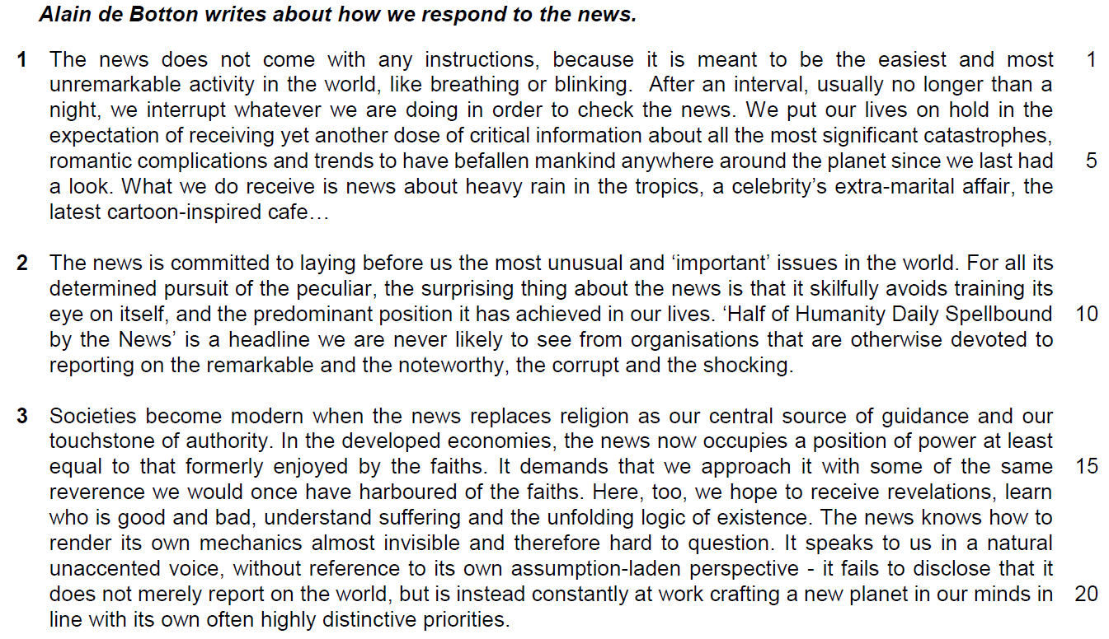

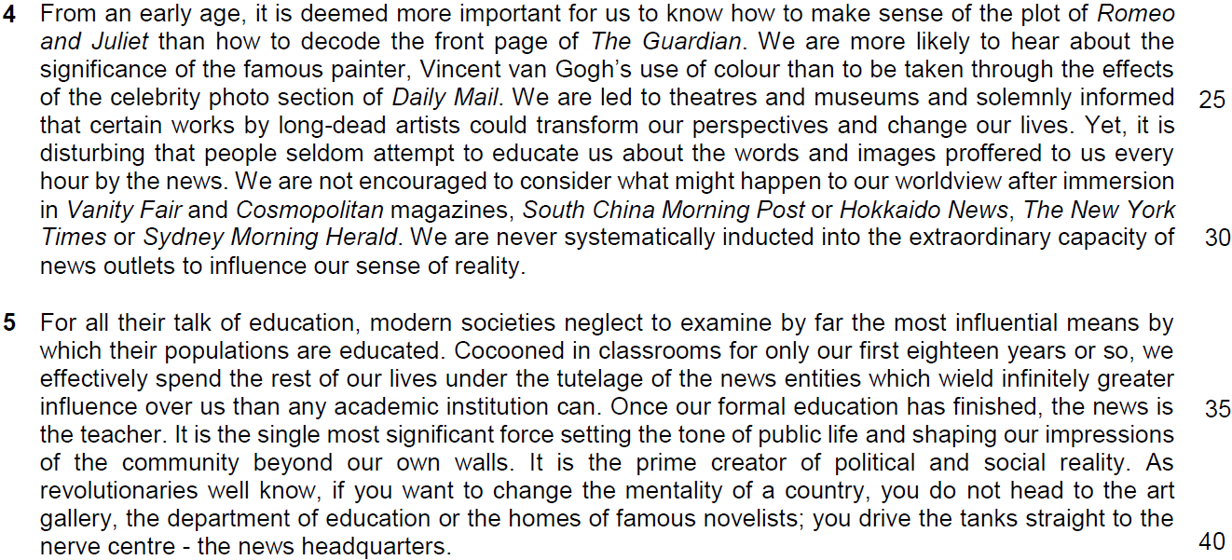

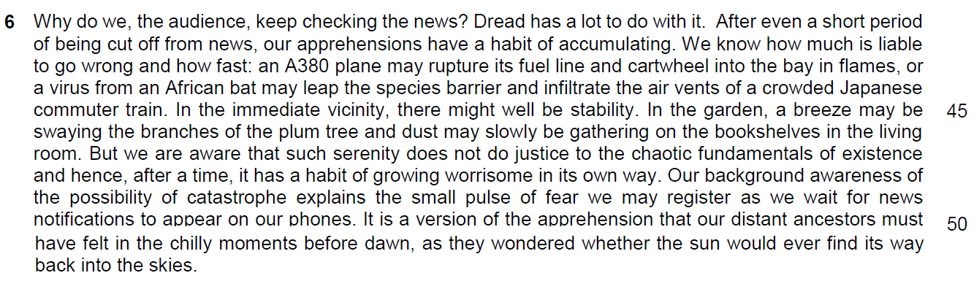

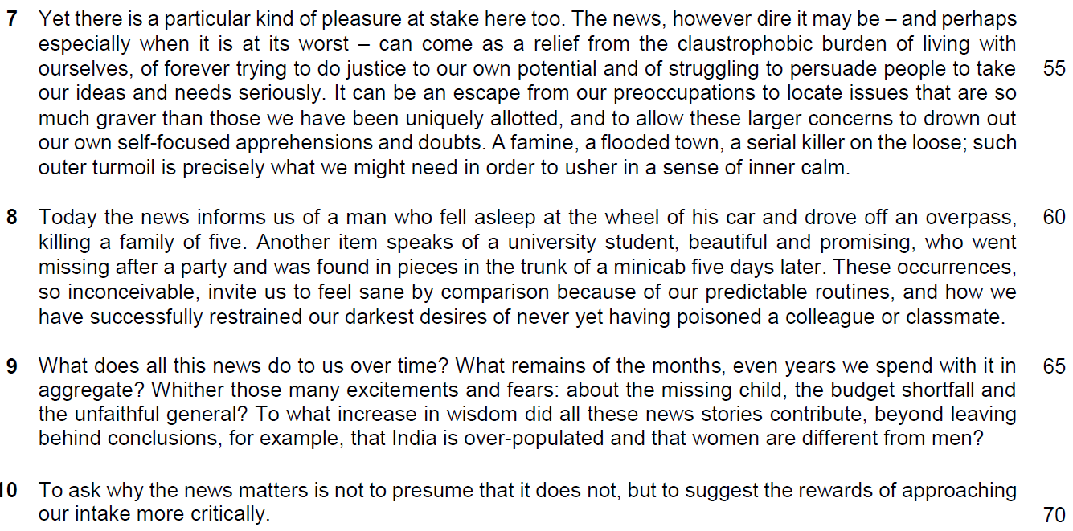

Suggested Answers
1. Which word in paragraph 1 suggests that the news is a distraction? [1]

From the Passage
After an interval, usually no longer than a night, we interrupt whatever we are doing in order to check the news.

Paraphrased Answer
The word is ‘interrupt’.

2. In paragraph 1, what are the two traits of the news that are likened to ‘breathing and blinking’? Use your own words as far as possible. [1]

From the Passage
The news does not come with any instructions, because it is meant to be the easiest and most unremarkable activity in the world, like breathing or blinking.

Paraphrased Answer
The traits are simplest, natural and insignificant (instinctive) behaviours like part of our lives.

3. Explain the irony in lines 3-7. [2]

From the Passage
We put our lives on hold in the expectation of receiving yet another dose of critical information about all the most significant catastrophes, romantic complications and trends to have befallen mankind anywhere around the planet since we last had a look. What we do receive is news about heavy rain in the tropics, a celebrity’s extra-marital affair, the latest cartoon-inspired cafe…
Expectation differs from outcome. irony is not a contradiction or camparison of difference.
Inferred Answer
We expect (look forward) the news to deliver the most important reports. In reality, we are provided with trivial news.

4. Why does the author end paragraph 1 with three dots (…) (line 7)? [1]

From the Passage expect
What we do receive is news about heavy rain in the tropics, a celebrity’s extra-marital affair, the latest cartoon-inspired cafe…

Inferred Answer (purpose of the three dots and the implications)
The three dots show that the list is not exhaustive/the possibilities are endless to prove how common these insignificant news are part of the information we have received.

5. What does the author find surprising in lines 8 to 10? Use your own words as far as possible. [2]

From the Passage
For all its determined pursuit of the peculiar, the surprising thing about the news is that
it skilfully avoids…
- training its eye on itself, (being scrutinized by the public)
- and the predominant position it has achieved in our lives. (becomes less significant)

Paraphrased Answer
If the purpose of the news is to report on everything unusual, it is surprising that news manages to evade self-scrutiny and has neglected to question its main role in our lives.

6. According to the author in paragraph 3, what are the similarities between our responses to the news and to religion? Use your own words as far as possible. [3]

From the Passage
In the developed economies, the news now occupies a position of power at least equal to that formerly enjoyed by the faiths.

It demands that we approach it with some of the same reverence we would once have harboured of the faiths. Here, too, we hope to receive revelations, learn who is good and bad, understand suffering and the unfolding logic of existence.

Paraphrased Answer
We venerate the news like a religion and we wish to be enlightened. Also, we differentiate between people who are morally upright and corrupt. We endure hardships and discover the meaning/purpose of life.

7. In paragraph 3, why does the author refer to the news as an ‘assumption-laden perspective’? Use your own words as far as possible. [3]

From the Passage
…it does not merely report on the world,
but is instead constantly at work crafting a new planet in our minds
in line with its own often highly distinctive priorities.(assumptions)

Paraphrased Answer
The news does not only document world events but actively shaping our world view/new paradigms. News often has its own agenda as it selectively reports events based on what is perceived to be important.

8. Why does the author use the examples of Romeo and Juliet and Vincent van Gogh in paragraph 4? [2]
( understand the implication of the metaphors – representing art and literature)

From the Passage
From an early age, it is deemed more important for us to know how to make sense of the plot of Romeo and Juliet than how to decode the front page of The Guardian. We are more likely to hear about the significance of the famous painter, Vincent van Gogh’s use of colour than to be taken through the effects of the celebrity photo section of Daily Mail. …Yet, it is disturbing that people seldom attempt to educate us about the words and images proffered to us every hour by the news. … We are never systematically inducted into the extraordinary capacity of news outlets to influence our sense of reality.

Inferred Answer
The examples serve as a contrast to the news by showing how we pay more attention to classical works than the news, even though the news is equally powerful in influencing/shaping our lives.

9. What does the phrase ‘cocooned in classrooms’ (line 33) suggest about our education in school? [1]

From the Passage
Cocooned in classrooms for only our first eighteen years or so …

Inferred Answer
Education shields us from reality as we are protected in school and alienated from the world.

10. How do the two conclusions about India and women in paragraph 9 support the author’s point in paragraph 10? [1]

From the Passage
To what increase in wisdom did all these news stories contribute, beyond leaving behind conclusions, for example, that India is over-populated and that women are different from men?

To ask why the news matters is not to presume that it does not, but to suggest the rewards of approaching our intake more critically.

Inferred Answer
The two conclusions reveal that our response is simplistic/shallow/superficial and supports the author’s point that we should be more evaluative when reading the news.

Summary
11. Using material from paragraphs 6 – 8 of the passage, summarise the reasons why people keep checking the news.

Write your summary in no more than 120 words, not counting the opening words which are printed below. Use your own words as far as possible. [8]

We keep checking the news because…

# | Lifted | Paraphrased
A | Dread has a lot to do with it. (line 41) | of anxiety / fear / uneasiness.
B | After even a short period of being cut off from news, our apprehensions have a habit of accumulating. (lines 41-42) | Our worries tend to grow in the absence of news updates
 | and hence, after a time, it has a habit of growing worrisome in its own way. (line 48) | Our fears build up …
C | We know how much is liable | We are aware of the severity / extent / scale / degree
D | and how fast (line 43) | and speed / rate /how quickly / rapidly
E | to go wrong (lines 42-43) | things to go awry / get out of hand
F | In the immediate vicinity, there might well be stability. (line 45)  (example: In the garden, a breeze may be swaying the branches of the plum tree and dust may slowly be gathering on the bookshelves in the living room.) | Even though we may be enjoying tranquility / peace / the calm / serenity
G | But we are aware that such serenity does not do justice to the chaotic fundamentals of existence (line 47) | we know that in reality, the world is experiencing disorder / turmoil / does not give credit to how complicated being alive is / catastrophic basis of life
H | Our background awareness of the possibility of catastrophe explains the small pulse of fear we may register as we wait for news notifications to appear on our phones. (lines 48-50) | This causes us to feel slightly uneasy whenever we anticipate updates / expect disasters to happen / subconscious acknowledgement of impending disaster
I | Inferred: It is a version of the apprehension that our distant ancestors must have felt in the chilly moments before dawn, as they wondered whether the sun would ever find its way back into the skies. (lines 50-52) | Inferred: This fear is inherited / passed down from our predecessors / fundamental instincts of…

# | Lifted | Paraphrased
J | Yet there is a particular kind of pleasure at stake here too. (line 53) | However, we experience satisfaction / joy / delight / happiness / contentment / enjoyment too.
K | The news, however dire it may be – and perhaps especially when it is at its worst – (lines 53-54) | The most unfavourable / horrific updates
L | can come as a relief (lines 54-55) | can ease our anxiety / comfort / refuge / give us a break
M | from the claustrophobic burden of living with ourselves, | as we feel trapped by the pressure of coping with our own lives,
N | of forever trying to do justice to our own potential (line 55) | of constantly proving ourselves
O | and of struggling to persuade people to take our ideas and needs seriously. (lines 55-56) | and earning the respect of / recognition / approval from others / convince people of our views / opinions / justify ourselves
P | It can be an escape from | The news distracts us / provides us with an alternative / another avenue / pathway
Q | our preoccupations (line 56) …  OR  than those we have been uniquely allotted, (line 57)  OR  to drown out our own self-focused apprehensions and doubts. (lines 57-58) | problems / concerns of our own / personal issues /  our individual struggles and insecurities / self-centered concerns
R | to locate issues that are so much graver (lines 56-57)  and to allow these larger concerns (line 57) | with issues that are more severe than
S | such outer turmoil is precisely what we might need (lines 58-59) | Such disorder in our surroundings is necessary
T | in order to usher in a sense of inner calm. (line 59) | To soothe / reassure us.

# | Lifted | Paraphrased
U | These occurrences, so inconceivable, (lines 62-63) | News that is unbelievable / unimaginable / unthinkable
V | invite us to feel sane by comparison (line 63) | help us to feel relatively normal / normal by contrast
W | because of our predictable routines, (line 63) | as we have established order / repetitive / mundane lifestyles
X | and how we have successfully restrained our darkest desires, (lines 63-64) | and control over our most sinister / evil intentions / keep our demons at bay

We keep checking the news because of anxiety. Our worries tend to grow in the absence of news updates and our fears build up. We are aware of the severity and how quickly things go awry. Although we may be enjoying the peace, we know that in reality, the world is experiencing disorder. This causes us to feel slightly uneasy whenever we expect disasters to happen. This fear is inherited from our predecessors. However, we experience joy too. The most horrific updates can ease our anxiety as we feel trapped by the pressure of coping with our own lives, of constantly proving ourselves and earning the respect from others. The news distracts us with another avenue by focusing on issues more severe than our own. Such disorder in our surroundings is necessary to reassure us. News that is unbelievable help us to feel relatively normal as we have established mundane lifestyles and control over our most evil intentions.
Application Question (AQ)
12. In this article, Alain de Botton writes about how we respond to the news. How far are his views reflective of your society? [8]

Introduction
Brief description of the requirements of the question
Main body
1. Quote: ‘Societies become modern when the news replaces religion as our centre source of guidance and our touchstone of authority’
2. Description of the quote: this implies that news has become a scared and significant source o information to guide us on how we live our lives to survive with the information aid out by news.
(inform us – guide us – make decision on our moral judgement – imbue in us the natural values we should have to conduct our lives in modern society
3. Elaboration - Why this view is reflective: it is apparent in Singapore as Singapore is a lawfully regulated society and we need news to inform us on how we conducted our lives in accordance with the regulation and rules established by the government. It has also become the source of information to shape our moral and ethical judgements
4. Example: POFMA, the Covid vaccination protocol, Additional Buyer’s Stamp Duty and other legislatures are transmitted to the people – shaping news to be the new religion that guides us on how we live our lives correctly and lawfully in this modern society. Public Journalism and reviews on social media like Stomp and news agency like The Strait Times have also shaped our views on ethical issues like our treatment on foreign workers and helpers and how we behave and drive on the road.
5. EOA
5.1 EOA sentence / Idea: However, such a view is too narrowed as religious beliefs and social values still hold great significance in modern society.
5.2 Elaboration 2: these values are significantly engrained in our mindsets, inherited through family, social communities – forge the foundations of our thinking – develop a common sense of thinking that guides us on how we eat, socialise and work – news transmitted through social media and news agency are purely the instruments in modern society and would not disestablish our cultural heritage, becoming the new divine source of values and practices
6. Example
Although people who claimed not to have a religion has risen from 17% in 2010 to 20% in 2022, 80% of Singaporeans are still holding a religion as the source of beliefs as stated by a survey done by Department of Statistics Singapore. This proves that it is not very reflective in Singapore to claim that News has become the new religion in Singapore which is a modern society.
7. Linking Sentence
We cannot deny the influence of news as the new source of information that shapes us on how we conduct our lives in modern society but we must play down this influence as modern society like Singapore is still guided by its cultural and religious beliefs.

Points to take note:
1. How do you quote your point
2. how to make it relevant to your argument – what is the basic argument behind this point?
3. how to derive the example to support your argument
4. how to write the points in these two paragraphs.

