GP Term 3 2017 – Comprehension – Topic 1: Social Media/Fake News –
How we respond to news

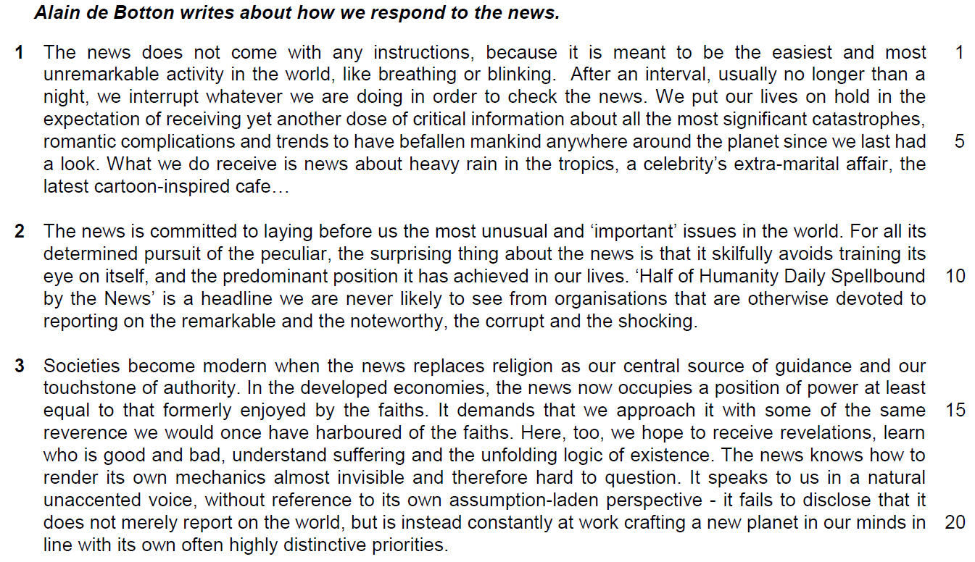

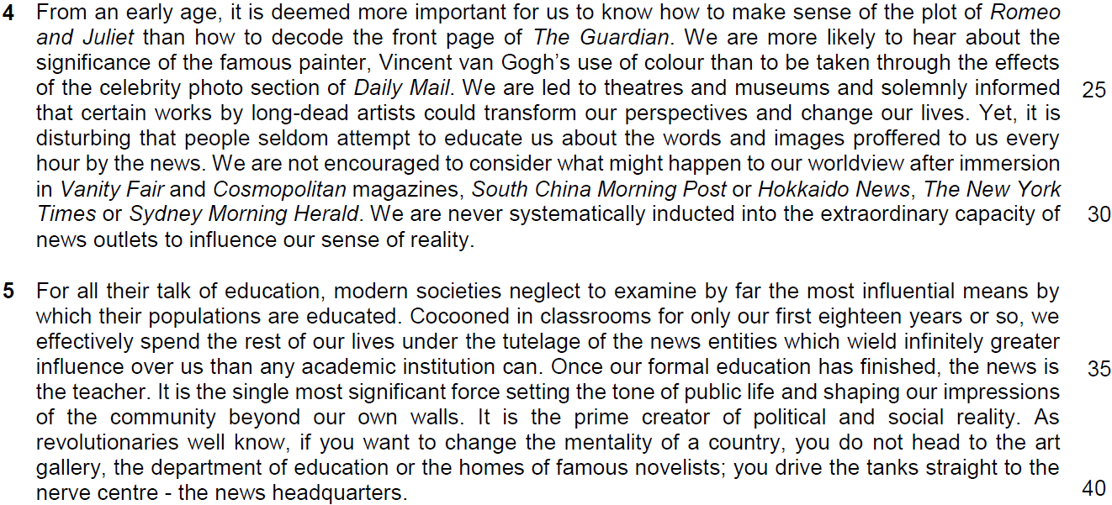

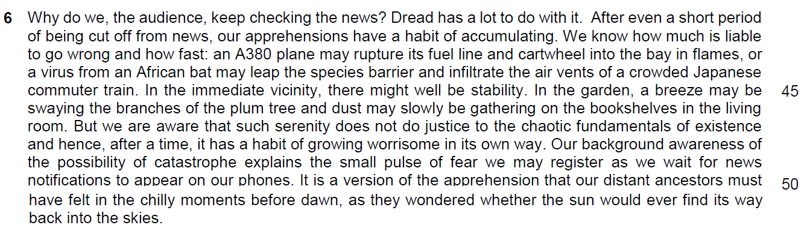

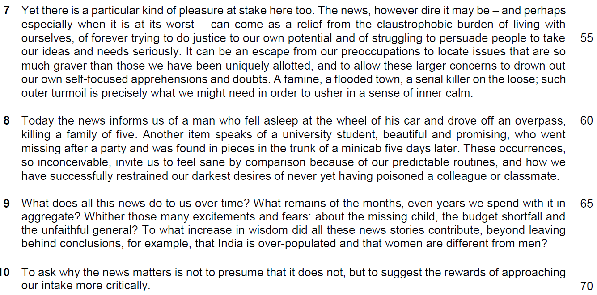

Read the passages in the insert and then answer all the questions. Note that up to fifteen marks will be given for the quality and accuracy of your use of English throughout this paper.

NOTE: When a question asks for an answer IN YOUR OWN WORDS AS FAR AS POSSIBLE and you select the appropriate material from the passage for your answer, you must still use your own words to express it. Little credit can be given to answers which only copy words and phrases from the passages.

1. Which word in paragraph 1 suggests that the news is a distraction? [1]

……………………………………………………………………………………………………………………………………
2. In paragraph 1, what are the two traits of the news that are likened to ‘breathing and blinking’? Use your own words as far as possible. [1]

……………………………………………………………………………………………………………………………………
3. Explain the irony in lines 3-7. [2]

……………………………………………………………………………………………………………………………………
……………………………………………………………………………………………………………………………………
……………………………………………………………………………………………………………………………………

4. Why does the author end paragraph 1 with three dots (…) (line 7)? [1]

……………………………………………………………………………………………………………………………………
……………………………………………………………………………………………………………………………………

5. What does the author find surprising in lines 8 to 10? Use your own words as far as possible. [2]

……………………………………………………………………………………………………………………………………
……………………………………………………………………………………………………………………………………
……………………………………………………………………………………………………………………………………

6. According to the author in paragraph 3, what are the similarities between our responses to the news and to religion? Use your own words as far as possible. [3]

……………………………………………………………………………………………………………………………………
……………………………………………………………………………………………………………………………………

……………………………………………………………………………………………………………………………………
……………………………………………………………………………………………………………………………………

7. In paragraph 3, why does the author refer to the news as an ‘assumption-laden perspective’? Use your own words as far as possible. [3]

……………………………………………………………………………………………………………………………………
……………………………………………………………………………………………………………………………………

……………………………………………………………………………………………………………………………………
……………………………………………………………………………………………………………………………………

8. Why does the author use the examples of Romeo and Juliet and Vincent van Gogh in paragraph 4? [2]

……………………………………………………………………………………………………………………………………
……………………………………………………………………………………………………………………………………

……………………………………………………………………………………………………………………………………
9. What does the phrase ‘cocooned in classrooms’ (line 33) suggest about our education in school? [1]

……………………………………………………………………………………………………………………………………
……………………………………………………………………………………………………………………………………

10. How do the two conclusions about India and women in paragraph 9 support the author’s point in paragraph 10? [1]

……………………………………………………………………………………………………………………………………
……………………………………………………………………………………………………………………………………
Summary
11. Using material from paragraphs 6 – 8 of the passage, summarise the reasons why people keep checking the news.

Write your summary in no more than 120 words, not counting the opening words which are printed below. Use your own words as far as possible. [8]

We keep checking the news because…

S/No | From the passage | Paraphrased equivalent
1 | Dread has a lot to do with it. (line 41)
2 | After even a short period of being cut off from news, our apprehensions have a habit of accumulating. (lines 41-42)
3 | and hence, after a time, it has a habit of growing worrisome in its own way. (line 48)
4 | We know how much is liable
5 | and how fast (line 43)
6 | to go wrong (lines 42-43)
7 | In the immediate vicinity, there might well be stability. (line 45)
8 | But we are aware that such serenity does not do justice to the chaotic fundamentals of existence (line 47)
9 | Our background awareness of the possibility of catastrophe explains the small pulse of fear we may register as we wait for news notifications to appear on our phones. (lines 48-50)

S/No | From the passage | Paraphrased equivalent
10 | Inferred: It is a version of the apprehension that our distant ancestors must have felt in the chilly moments before dawn, as they wondered whether the sun would ever find its way back into the skies. (lines 50-52)
11 | Yet there is a particular kind of pleasure at stake here too. (line 53)
12 | The news, however dire it may be – and perhaps especially when it is at its worst – (lines 53-54)
13 | can come as a relief (lines 54-55)
14 | from the claustrophobic burden of living with ourselves,
15 | of forever trying to do justice to our own potential (line 55)
16 | and of struggling to persuade people to take our ideas and needs seriously. (lines 55-56)
17 | It can be an escape from
18 | our preoccupations (line 56) …  OR  than those we have been uniquely allotted, (line 57)  OR  to drown out our own self-focused apprehensions and doubts. (lines 57-58)

S/No | From the passage | Paraphrased equivalent
19 | to locate issues that are so much graver (lines 56-57)  and to allow these larger concerns (line 57)
20 | such outer turmoil is precisely what we might need (lines 58-59)
21 | in order to usher in a sense of inner calm. (line 59)
22 | These occurrences, so inconceivable, (lines 62-63)
23 | invite us to feel sane by comparison (line 63)
24 | because of our predictable routines, (line 63)
25 | and how we have successfully restrained our darkest desires, (lines 63-64)

Application Question (AQ)
12. In this article, Alain de Botton writes about how we respond to the news. How far are his views reflective of your society? [8]

1st paragraph
Quote his view on how we respond to news
Explain how this view is depicted
Why this view is reflective of your society (Singapore) or why this view is not reflective of your society – show by a reason
Example

EOA – the extent of your agreement or the extent of your disagreement
EOA link – to show that this is EOA sentence as this paragraph argues for EOA.

Structure of discussion
Introduction
Brief description of the requirements of the question
Main body
1. Quote: ‘Societies become modern when the news replaces religion as our centre source of guidance and our touchstone of authority’
2. Description of the quote: this implies that news has become a scared and significant source of information to guide us on how we live our lives to survive with the information aid out by news.
(inform us – guide us – make decision on our moral judgement – imbue in us the natural values we should have to conduct our lives in modern society
3. Elaboration - Why this view is reflective: it is apparent in Singapore as Singapore is a lawfully regulated society and we need news to inform us on how we conducted our lives in accordance with the regulation and rules established by the government. It has also become the source of information to shape our moral and ethical judgements
4. Example: POFMA, the Covid vaccination protocol, Additional Buyer’s Stamp Duty and other legislatures are transmitted to the people – shaping news to be the new religion that guides us on how we live our lives correctly and lawfully in this modern society. Public Journalism and reviews on social media like Stomp and news agency like The Strait Times have also shaped our views on ethical issues like our treatment on foreign workers and helpers and how we behave and drive on the road.
5. EOA
5.1 EOA sentence / Idea: However, such a view is too narrowed as religious beliefs and social values still hold great significance in modern society.
5.2 Elaboration 2: these values are significantly engrained in our mindsets, inherited through family, social communities – forge the foundations of our thinking – develop a common sense of thinking that guides us on how we eat, socialise and work – news transmitted through social media and news agency are purely the instruments in modern society and would not disestablish our cultural heritage, becoming the new divine source of values and practices
6. Example
Although people who claimed not to have a religion has risen from 17% in 2010 to 20% in 2022, 80% of Singaporeans are still holding a religion as the source of beliefs as stated by a survey done by Department of Statistics Singapore. This proves that it is not very reflective in Singapore to claim that News has become the new religion in Singapore which is a modern society.
7. Linking Sentence
We cannot deny the influence of news as the new source of information that shapes us on how we conduct our lives in modern society, but we must play down this influence as modern society like Singapore is still guided by its cultural and religious beliefs.
Points to take note:
1. How do you quote your point
2. how to make it relevant to your argument – what is the basic argument behind this point?
3. how to derive the example to support your argument
4. how to write the points in these two paragraphs

Suggested Answer:
News is very important to individuals in modern society and they are responding differently to it. Some of the observations made by the author can be seen in Singapore but it may be totally the same.
One of the responses as stated by the author is that ‘societies become modern when the news replaces religion as our centre source of guidance and our touchstone of authority’ This implies that news has become a scared and significant source o information to guide us on how we live our lives to survive with the information aid out by news. This is apparent in Singapore as Singapore is a lawfully regulated society and we need news to inform us on how we conducted our lives in accordance with the regulation and rules established by the government. These sources of news inform and guide us to make decision on our moral judgement and imbue in us the natural values we should have to conduct our lives in modern society. Consequently, it has also become the source of information to shape our moral and ethical judgements in Singapore. For example, news provides us information about POFMA, the Covid-19 vaccination protocol, Additional Buyer’s Stamp Duty and other legislatures which are to be abided by the people, shaping news to be the new religion that guides us on how we live our lives correctly and lawfully in this modern society. Public Journalism and reviews on social media like Stomp and news agency like The Strait Times have also shaped our views on ethical issues like our treatment on foreign workers and helpers and how we behave and drive on the road.
However, such an observation does not apply to the majority as religious beliefs and social values still hold great significance in modern society. These values are significantly engrained in our mindsets, inherited through family, social communities, forging the foundations of our thinking. It develops a common sense of thinking that guides us on how we eat, socialise and work. The news transmitted through social media by the news agency are purely the instruments for propagating values in modern society and would not disestablish our cultural heritage, becoming the new divine source of values and practices for society. Although people who claimed not to have a religion has risen from 17% in 2010 to 20% in 2022, 80% of Singaporeans are still holding a religion as the source of beliefs as stated by a survey done by Department of Statistics Singapore. This proves that it is not very reflective in Singapore to claim that News has become the new religion in Singapore which is a modern society.
The author also observes that ‘modern societies neglect to examine by far the most influential means by which their populations are educated. This means that the societies fail to understand that the benefits of news as a source of education which the whole country can benefit from. This is especially true for a country like Singapore, which focuses on the academic excellence as it is an assured way for youths to gain enrolment in prestigious university to pursue a successful career. As a result of this focus on academic excellence, students are only interested in learning in subjects that help them to win in the rat race. At the same time, schools are also focusing on subjects like STEM which ignores the need to be well-read and the significance of news in educating their students. Besides this, students are also absorbed in social media like Tik Tok, YouTube and other social media for trivialised information that entertains them, cultivating an apathetic education scene in school where many students are not interested and teachers failing to recognise the significance of news as a source of education This is evidently seen in the low rate of passing for subjects like General Paper for GCE A level for some of the junior colleges like mine (SAJC). Schools are simply not tapping enough from the use of information from news to make it a productive source of learning for our students.
However, Singapore education authority, Ministry of Education, is recognising this need to make news as a form of education as they have added subjects like Project Work as part of the examination for GCE A level which requires general information from news agencies to substantiate their project work. During the General Paper and Social Studies for junior college and secondary students, news reading has become part of the class activities that promote more holistic and all-rounded education. Furthermore, the constant contact with social media has also shaped more students to be less apathetic and self-conscious of society, seeing the significance of news as a source of education beyond their cocooned education system. Fortunately, this development has prevented some educators and students from failing to see news as a source of information.
In sum, the author has made some observation on how we respond to news and they are apparent in Singapore but the agreement to his observation may vary

