Competition on Modern Society

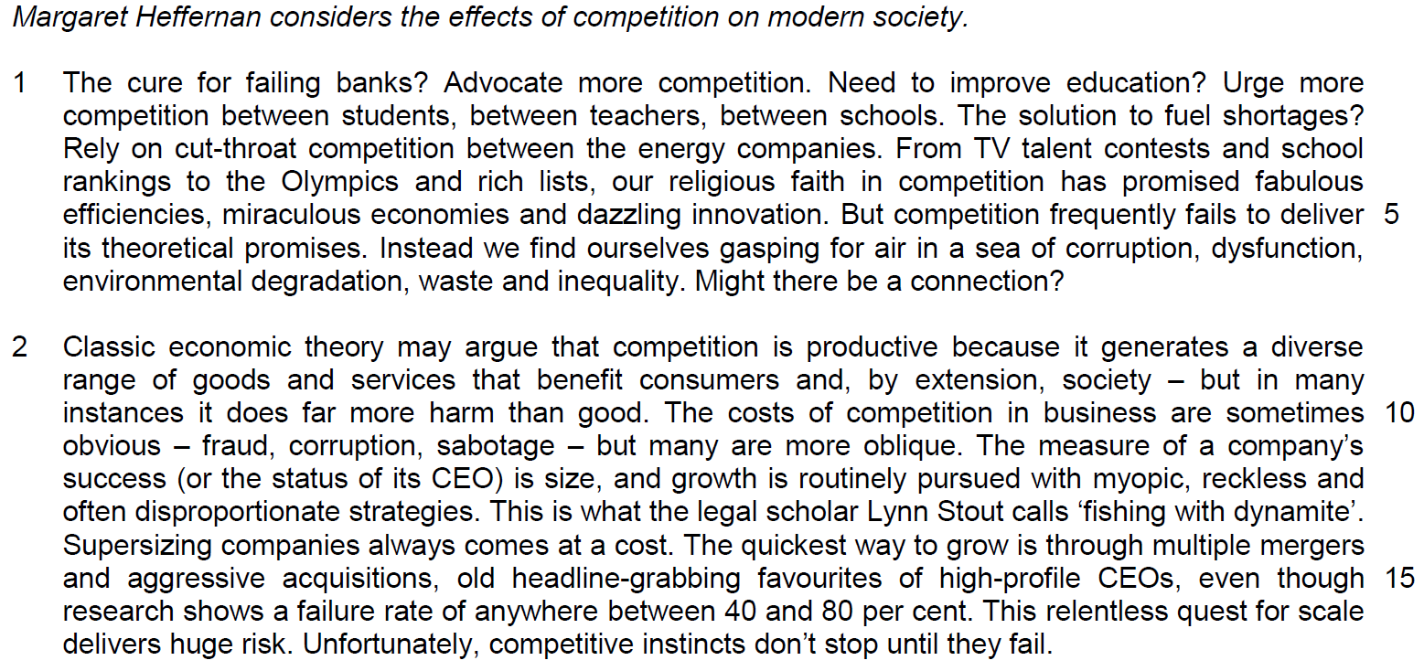

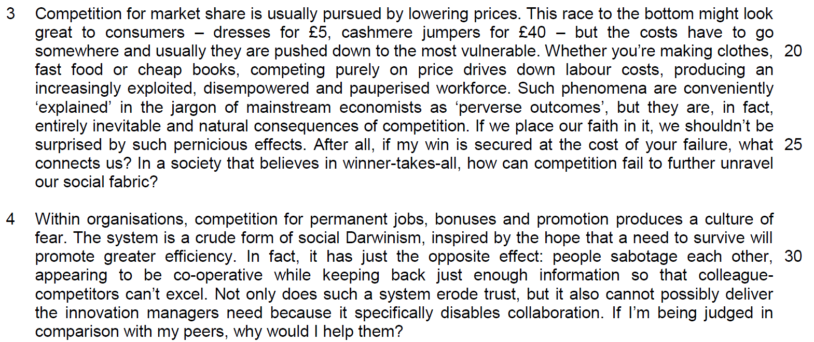

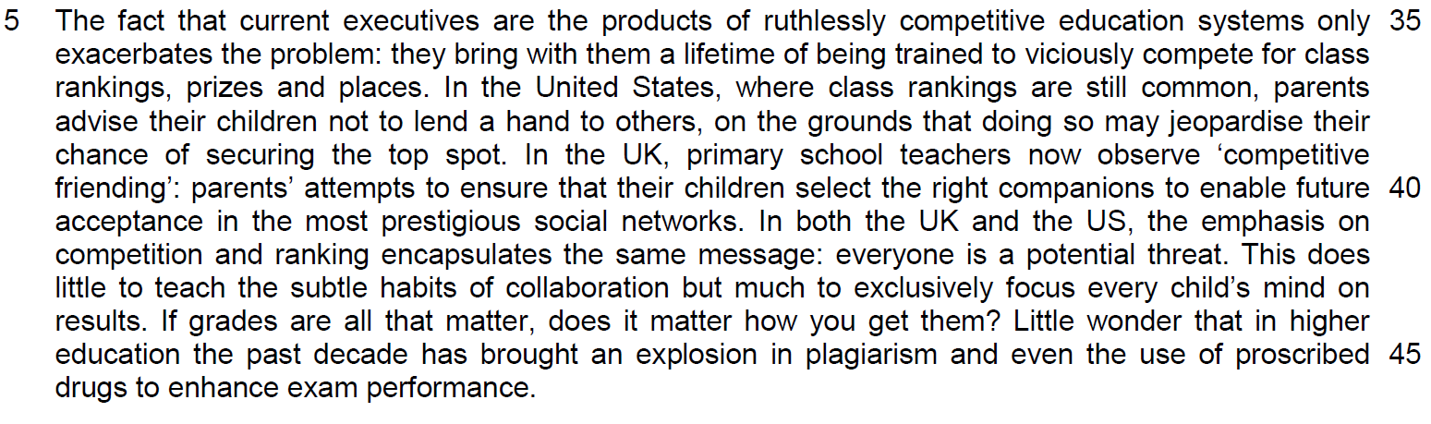

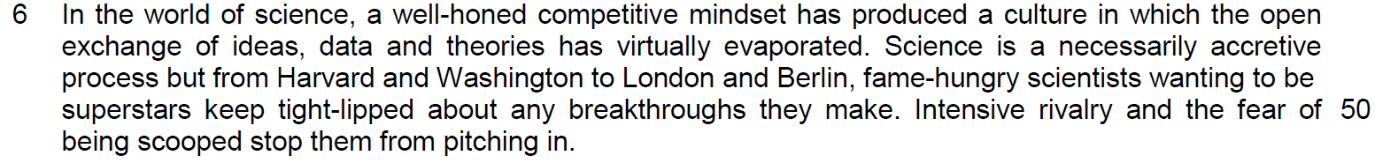

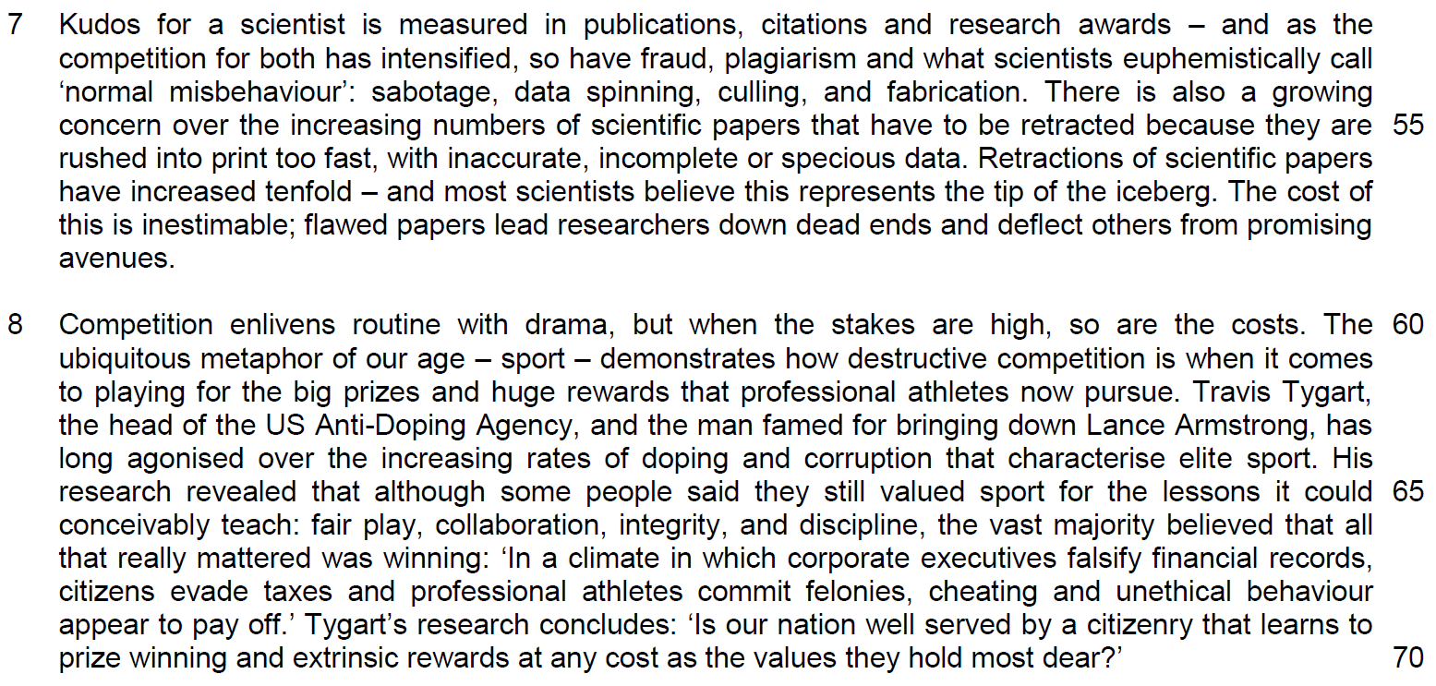

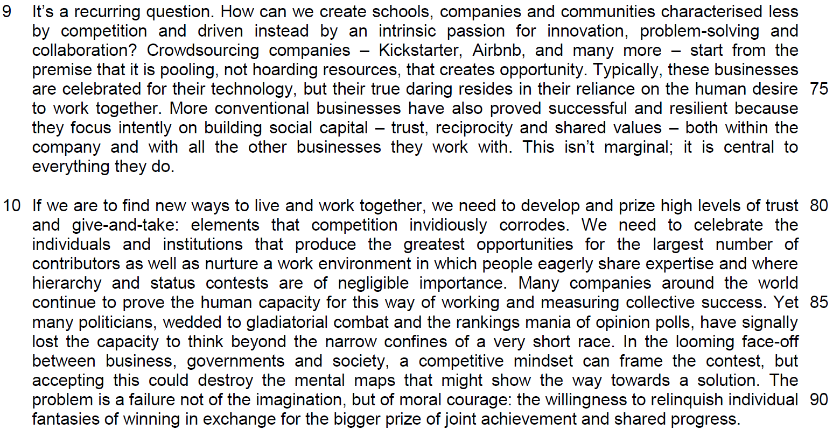

Read the passages in the insert and then answer all the questions. Note that up to fifteen marks will be given for the quality and accuracy of your use of English throughout this paper.

NOTE: When a question asks for an answer IN YOUR OWN WORDS AS FAR AS POSSIBLE and you select the appropriate material from the passage for your answer, you must still use your own words to express it. Little credit can be given to answers which only copy words and phrases from the passages.

Q1) Suggest why the author describes our faith in competition as ‘religious’ (line 4). Use your own words as far as possible. [1]

……………………………………………………………………………………………………………………………………
……………………………………………………………………………………………………………………………………

……………………………………………………………………………………………………………………………………
Q2) In the first paragraph, what does the author mean when she says we are ‘gasping for air’ (line 6)? Use your own words as far as possible. [1]

……………………………………………………………………………………………………………………………………
……………………………………………………………………………………………………………………………………

……………………………………………………………………………………………………………………………………
Q3) Why is ‘fishing with dynamite’ (line 13) an appropriate way to describe how many companies pursue growth? Use your own words as far as possible. [2]

……………………………………………………………………………………………………………………………………
……………………………………………………………………………………………………………………………………

……………………………………………………………………………………………………………………………………
……………………………………………………………………………………………………………………………………

Q4) According to the author, what are the harmful effects of companies lowering prices to increase their market share? Use material from paragraph 3 only. Use your own words as far as possible. [2]

……………………………………………………………………………………………………………………………………
……………………………………………………………………………………………………………………………………

……………………………………………………………………………………………………………………………………
……………………………………………………………………………………………………………………………………

Q5) “Such phenomena are conveniently explained in the jargon of mainstream economists as “perverse outcomes’’ (lines 22-3). What is the author implying here? Explain carefully. Use your own words as far as possible. [2]

……………………………………………………………………………………………………………………………………
……………………………………………………………………………………………………………………………………

……………………………………………………………………………………………………………………………………
……………………………………………………………………………………………………………………………………

Q6) Explain the differences between data spinning, culling, and fabrication (line 54). Use your own words as far as possible. [2]

……………………………………………………………………………………………………………………………………
……………………………………………………………………………………………………………………………………

……………………………………………………………………………………………………………………………………
……………………………………………………………………………………………………………………………………

Q7) Explain the author’s use of ‘conceivably’ in line 66. [1]

……………………………………………………………………………………………………………………………………
……………………………………………………………………………………………………………………………………
……………………………………………………………………………………………………………………………………

Q8) Why does the author refer to ‘trust, reciprocity and shared values’ as forms of ‘social capital’ (line 77)? Use your own words as far as possible. [2]

……………………………………………………………………………………………………………………………………
……………………………………………………………………………………………………………………………………

……………………………………………………………………………………………………………………………………
……………………………………………………………………………………………………………………………………

Q9) In the last paragraph, why does the author say that politicians today are failing to do a good job? Use your own words as far as possible. [2]

……………………………………………………………………………………………………………………………………
……………………………………………………………………………………………………………………………………

……………………………………………………………………………………………………………………………………
……………………………………………………………………………………………………………………………………

Q10) According to the author, what is stopping us from changing our ‘competitive mindset’ (line 88)? Use your own words as far as possible. [2]

……………………………………………………………………………………………………………………………………
……………………………………………………………………………………………………………………………………

……………………………………………………………………………………………………………………………………
……………………………………………………………………………………………………………………………………

Summary Question
Q11) Using material from paragraphs 4-6 only, summarise what the author has to say about the disadvantages of competition.

Write your summary in no more than 120 words, not counting the opening words which are printed below. Use your own words as far as possible. [8]

Competition causes problems within organisations because…
 | Passage | Paraphrase
Within Organisations:
1 | competition for permanent jobs, bonuses and promotion produces a culture of fear
2 | crude form of social Darwinism, inspired by the hope that a need to survive will promote greater efficiency
3 | In fact, it has just the opposite effect: people sabotage each other,
4 | appearing to be co-operative while keeping back just enough information so that colleague-competitors can’t excel.
5 | …erode trust
6 | …can’t deliver the creativity managers need
7 | Because it specifically disables collaboration.
8 | If I’m being judged in comparison with my peers, why would I help them?
Within Schools:
9 | The fact that current executives are the products of ruthlessly competitive education systems only exacerbates the problem:
10 | … they bring with them a lifetime of being trained to viciously compete for class rankings, prizes and places.

 | Passage | Paraphrase
Within Schools:
11 | In the US, where class rankings are still common, parents advise their children not to lend a hand to others,
12 | on the grounds that doing so may jeopardise their chance of securing the top spot.
13 | In the UK, … now observe ‘competitive friending’: parents’ attempts to ensure that their children select the right companions
14 | to enable future acceptance in the most prestigious social networks.
15 | …the emphasis on competition and ranking encapsulates the same message: everyone is a potential threat
16 | This does little to teach the subtle habits of collaboration
17 | but much to focus every child’s mind exclusively on results.
18 | If grades are all that matter, does it matter how you get them?
19 | …in higher education the past decade has brought an explosion in plagiarism and
20 | the use of proscribed drugs to enhance exam performance.

 | Passage | Paraphrase
In Science,
21 | …has produced a culture in which the open exchange of ideas, data and theories has virtually evaporated. (keep tight-lipped = R)
22 | Science is a necessarily accretive process …
23 | fame-hungry scientists wanting to be superstars
24 | Intense rivalry and
25 | the fear of being scooped stop them from pitching in.

Application Question
Q12) Margaret Heffernan argues that competition has extremely harmful effects on modern society. To what extent do you agree with her views? How applicable do you find her observations to yourself and your society? [10]

……………………………………………………………………………………………………………………………………
……………………………………………………………………………………………………………………………………

……………………………………………………………………………………………………………………………………
……………………………………………………………………………………………………………………………………

……………………………………………………………………………………………………………………………………
……………………………………………………………………………………………………………………………………

……………………………………………………………………………………………………………………………………
……………………………………………………………………………………………………………………………………

……………………………………………………………………………………………………………………………………
……………………………………………………………………………………………………………………………………

……………………………………………………………………………………………………………………………………
……………………………………………………………………………………………………………………………………

……………………………………………………………………………………………………………………………………
……………………………………………………………………………………………………………………………………

……………………………………………………………………………………………………………………………………
……………………………………………………………………………………………………………………………………

……………………………………………………………………………………………………………………………………
……………………………………………………………………………………………………………………………………

……………………………………………………………………………………………………………………………………
……………………………………………………………………………………………………………………………………

……………………………………………………………………………………………………………………………………
……………………………………………………………………………………………………………………………………

……………………………………………………………………………………………………………………………………

……………………………………………………………………………………………………………………………………

……………………………………………………………………………………………………………………………………
……………………………………………………………………………………………………………………………………

……………………………………………………………………………………………………………………………………
……………………………………………………………………………………………………………………………………

……………………………………………………………………………………………………………………………………
……………………………………………………………………………………………………………………………………

……………………………………………………………………………………………………………………………………
……………………………………………………………………………………………………………………………………

……………………………………………………………………………………………………………………………………
……………………………………………………………………………………………………………………………………

……………………………………………………………………………………………………………………………………
……………………………………………………………………………………………………………………………………

……………………………………………………………………………………………………………………………………
……………………………………………………………………………………………………………………………………

……………………………………………………………………………………………………………………………………
……………………………………………………………………………………………………………………………………

……………………………………………………………………………………………………………………………………
……………………………………………………………………………………………………………………………………

……………………………………………………………………………………………………………………………………
……………………………………………………………………………………………………………………………………

……………………………………………………………………………………………………………………………………
……………………………………………………………………………………………………………………………………

……………………………………………………………………………………………………………………………………
……………………………………………………………………………………………………………………………………

