GP Comprehension – Value of Citizenship
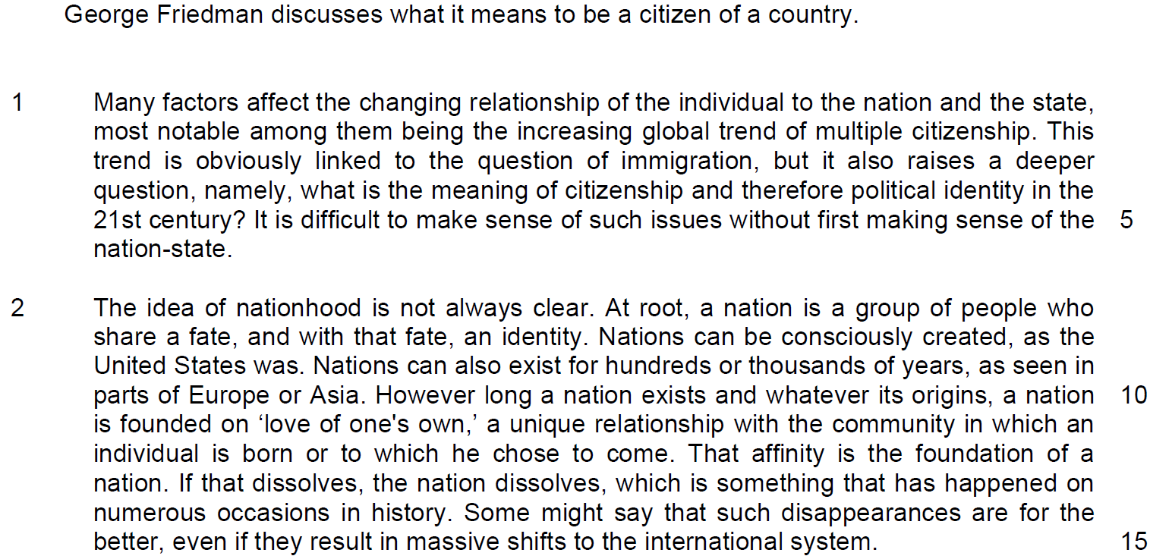

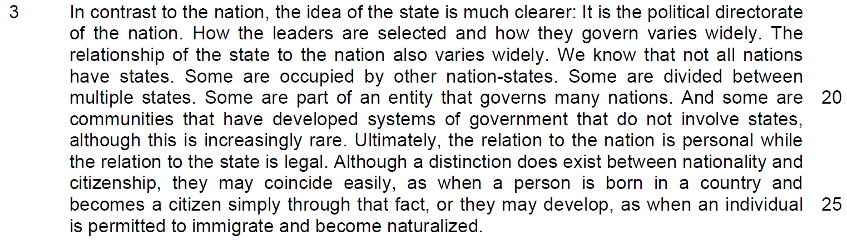

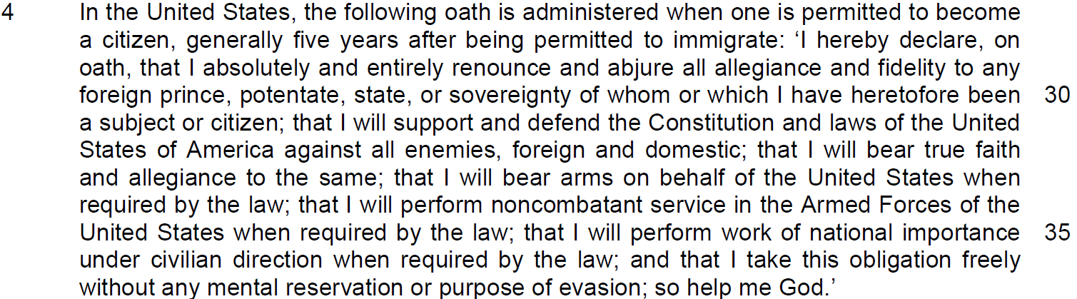

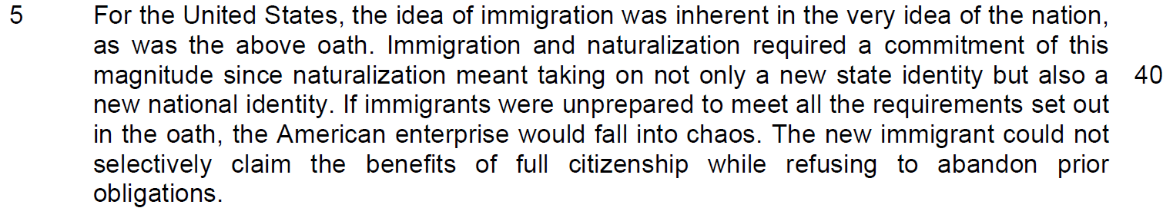

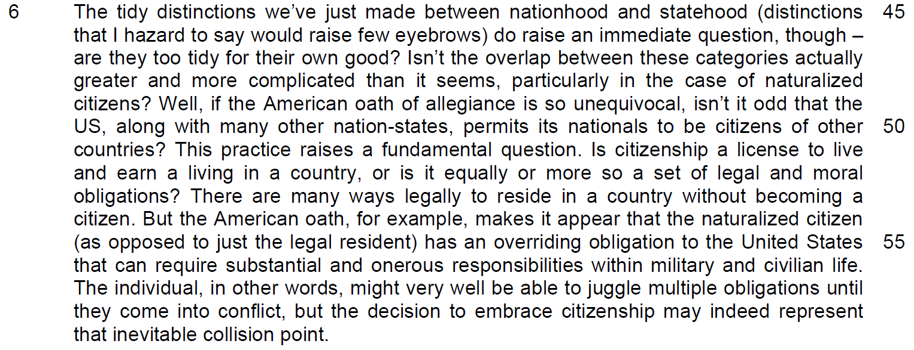

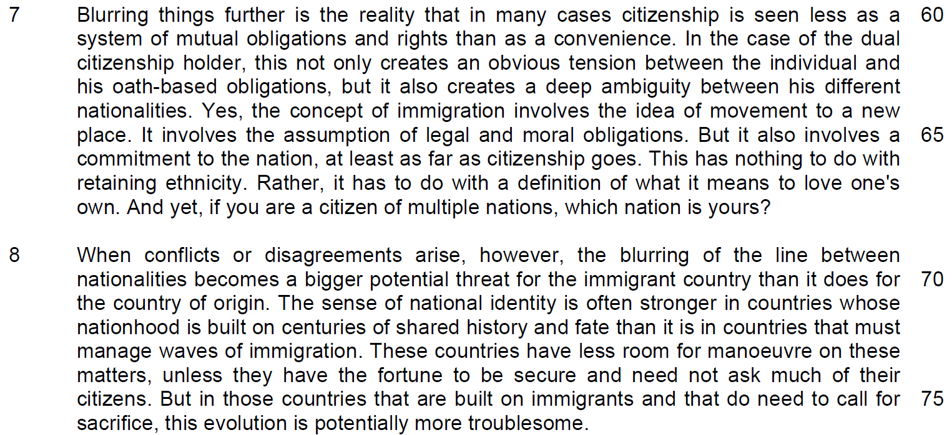

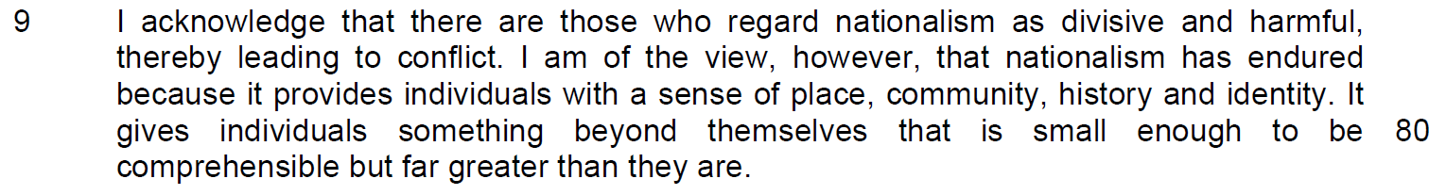

Read the passage in the Insert and then answer all the questions which follow. Note that up to 15 marks will be given for the quality and accuracy of your use of English throughout this paper.

NOTE: When a question asks for an answer IN YOUR OWN WORDS AS FAR AS POSSIBLE, and you select the appropriate material from the passage for your answer you must still use your own words to express it. Little credit can be given to answers which only copy words and phrases from the passage.

Q1) Explain why the relationship between the individual, the nation and the state is ‘changing’ (line 1). Use your own words as far as possible. [2]

……………………………………………………………………………………………………………………………………

……………………………………………………………………………………………………………………………………

……………………………………………………………………………………………………………………………………

……………………………………………………………………………………………………………………………………

Q2) What does the author mean when he says ‘love of one’s own’ (line 13)? [1]

……………………………………………………………………………………………………………………………………

……………………………………………………………………………………………………………………………………

……………………………………………………………………………………………………………………………………

……………………………………………………………………………………………………………………………………

Q3) The author states that there is ‘a distinction between nationality and citizenship’ (line 23 – 24). Using your own words as far as possible, explain how this distinction can be removed? [2]

……………………………………………………………………………………………………………………………………

……………………………………………………………………………………………………………………………………

……………………………………………………………………………………………………………………………………

……………………………………………………………………………………………………………………………………

Q4) What is the author’s purpose for including the Oath of Allegiance in paragraph 4? [1]

……………………………………………………………………………………………………………………………………

……………………………………………………………………………………………………………………………………

……………………………………………………………………………………………………………………………………

……………………………………………………………………………………………………………………………………

Q5) Why was it necessary to demand ‘a commitment of this magnitude’ (line 39 – 40)? Use your own words as far as possible. [3]

……………………………………………………………………………………………………………………………………

……………………………………………………………………………………………………………………………………

……………………………………………………………………………………………………………………………………

……………………………………………………………………………………………………………………………………

Q6) Why does the author believe that his proposed definition would ‘raise few eyebrows’ (line 46)? [1]

……………………………………………………………………………………………………………………………………

……………………………………………………………………………………………………………………………………

……………………………………………………………………………………………………………………………………

……………………………………………………………………………………………………………………………………

Q7) Why does the author find the practice of allowing multiple citizenship ‘odd’ (line 49)? [2]

……………………………………………………………………………………………………………………………………

……………………………………………………………………………………………………………………………………

……………………………………………………………………………………………………………………………………

……………………………………………………………………………………………………………………………………

Q8) From paragraph 7, explain how ‘tension’ and ‘ambiguity’ are created for dual or multiple citizenship holders. Use your own words as far as possible. [3]

……………………………………………………………………………………………………………………………………

……………………………………………………………………………………………………………………………………

……………………………………………………………………………………………………………………………………

……………………………………………………………………………………………………………………………………

……………………………………………………………………………………………………………………………………

……………………………………………………………………………………………………………………………………

Q9) What does the phrase ‘this evolution’ in line 75 refer to? [1]

……………………………………………………………………………………………………………………………………

……………………………………………………………………………………………………………………………………

……………………………………………………………………………………………………………………………………

……………………………………………………………………………………………………………………………………

Q10) In the last paragraph, how does the author respond to those who have a different view from him? [1]

……………………………………………………………………………………………………………………………………

……………………………………………………………………………………………………………………………………

……………………………………………………………………………………………………………………………………

……………………………………………………………………………………………………………………………………

Q11) Using material from paragraphs 2 – 3 only, summarise what the author has to say about the differences between ‘nation’ and ‘state’ as well as the relationship between the two.
Write your summary in no more than 120 words, not counting the opening words which are printed below. Use your own words as far as possible. [8]

There are differences between the terms ‘nation’ and ‘state’. A ‘nation’ is …

S/No | From the passage | Paraphrased equivalent
1 | a nation is a group of people who share a fate,
2 | and with that fate, an identity.
3 | Nations can be consciously created
4 | Nations can also exist for hundreds or thousands of years
5 | However long a nation exists and whatever its origins,
6 | a nation is founded on ‘love of one's own,’ a unique relationship with the community in which an individual is born
7 | or to which he chose to come.
8 | That affinity is the foundation of a nation

S/No | From the passage | Paraphrased equivalent
9 | The idea of nationhood is not always clear  the idea of the state is much clearer:
10 | It is the political directorate of the nation. How the leaders are selected and how they govern varies widely.
11 | The relationship of the state to the nation also varies widely. We know that not all nations have states. Some are occupied by other nation-states. Some are divided between multiple states. Some are part of an entity that governs many nations. And some are communities that have developed systems of government that do not involve states, although this is increasingly rare.
12 | Ultimately, the relation to the nation is personal
13 | while the relation to the state is legal.

Application Question
Q12) Friedman discusses the issues of nationalism and citizenship. To what extent are these issues of concern to you and your society? [10]

……………………………………………………………………………………………………………………………………

……………………………………………………………………………………………………………………………………

……………………………………………………………………………………………………………………………………

……………………………………………………………………………………………………………………………………

……………………………………………………………………………………………………………………………………

……………………………………………………………………………………………………………………………………

……………………………………………………………………………………………………………………………………

……………………………………………………………………………………………………………………………………

……………………………………………………………………………………………………………………………………

……………………………………………………………………………………………………………………………………

……………………………………………………………………………………………………………………………………

……………………………………………………………………………………………………………………………………

……………………………………………………………………………………………………………………………………

……………………………………………………………………………………………………………………………………

……………………………………………………………………………………………………………………………………

……………………………………………………………………………………………………………………………………

……………………………………………………………………………………………………………………………………

……………………………………………………………………………………………………………………………………

……………………………………………………………………………………………………………………………………

……………………………………………………………………………………………………………………………………

……………………………………………………………………………………………………………………………………

……………………………………………………………………………………………………………………………………

……………………………………………………………………………………………………………………………………

……………………………………………………………………………………………………………………………………

……………………………………………………………………………………………………………………………………

……………………………………………………………………………………………………………………………………

……………………………………………………………………………………………………………………………………

……………………………………………………………………………………………………………………………………

……………………………………………………………………………………………………………………………………

……………………………………………………………………………………………………………………………………

……………………………………………………………………………………………………………………………………

……………………………………………………………………………………………………………………………………

……………………………………………………………………………………………………………………………………

……………………………………………………………………………………………………………………………………

……………………………………………………………………………………………………………………………………

……………………………………………………………………………………………………………………………………

……………………………………………………………………………………………………………………………………

……………………………………………………………………………………………………………………………………

……………………………………………………………………………………………………………………………………

……………………………………………………………………………………………………………………………………

……………………………………………………………………………………………………………………………………

……………………………………………………………………………………………………………………………………

……………………………………………………………………………………………………………………………………

……………………………………………………………………………………………………………………………………

……………………………………………………………………………………………………………………………………

……………………………………………………………………………………………………………………………………

……………………………………………………………………………………………………………………………………

