GP Comprehension – Importance of Stories
https://docs.google.com/document/d/1nxS74AVjqXXpFi_shqb2TTYx2ynoveMNlDnmi2_0SOk/edit?usp=sharing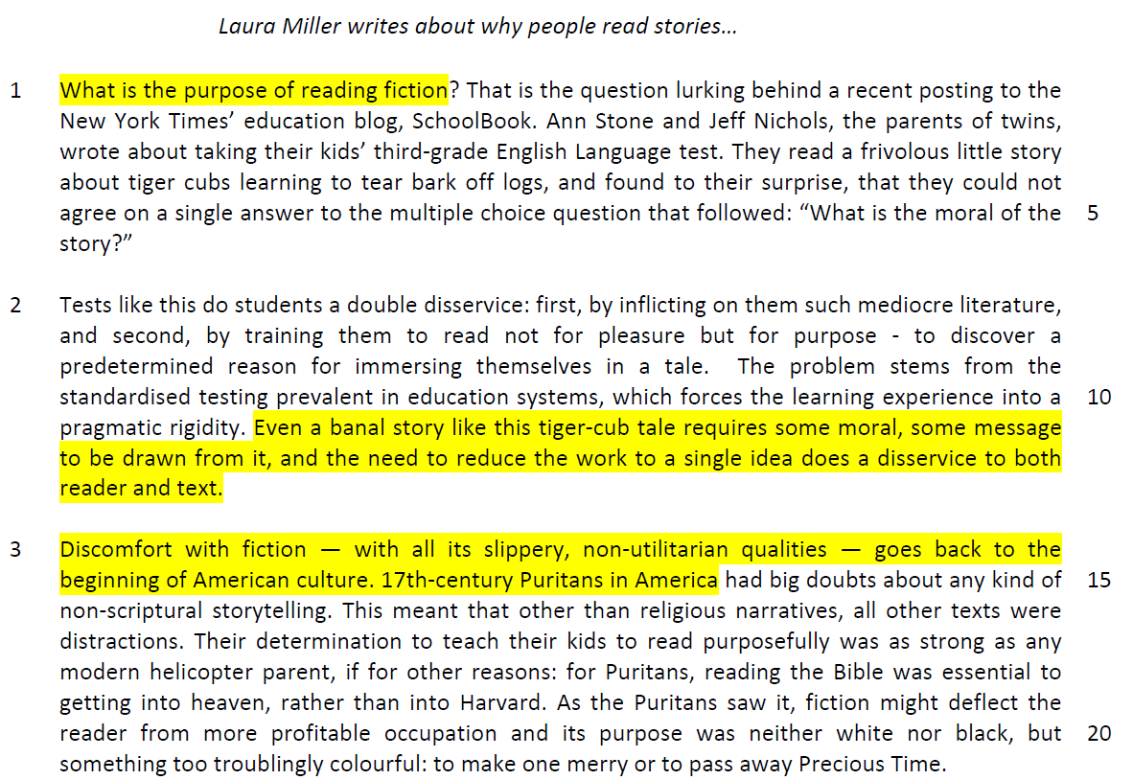

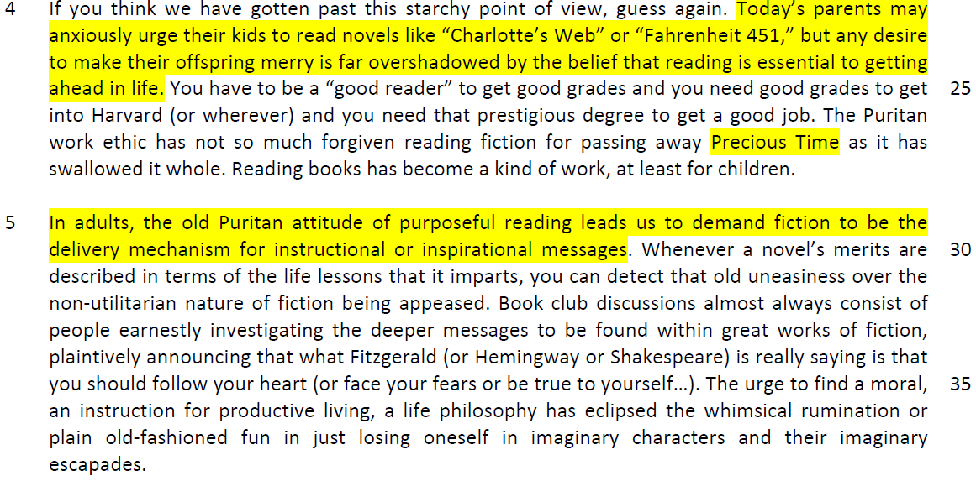

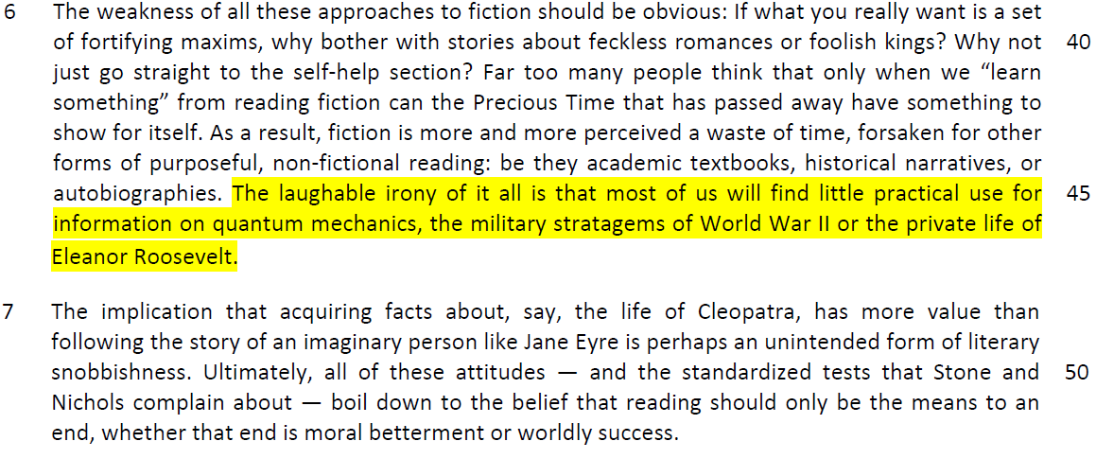
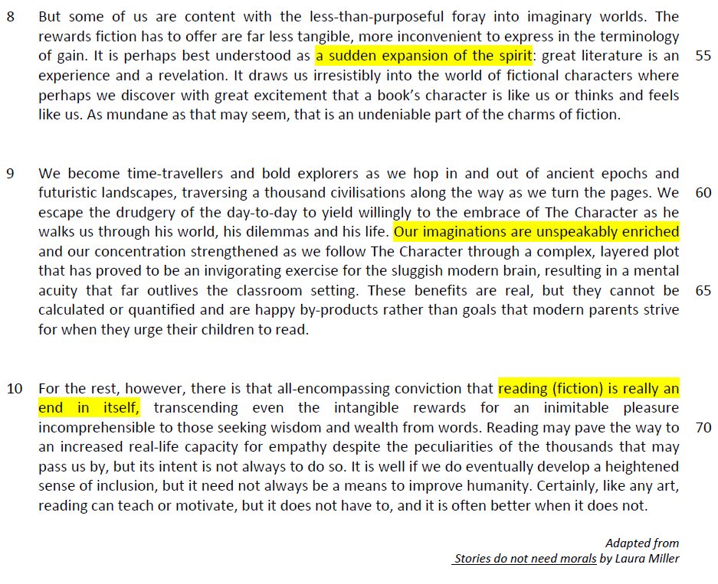

Questions
1. What does the word ‘frivolous’ (line 3) suggest about the story found in the children’s English Language test? [1]
Frivolous – meaningless content – not significant
The story does not have any serious purpose or value as it is said to be meaningless.

2. Why were the parents surprised by their inability to agree on a common answer to the multiple choice question that followed the story (lines 3-6)? [1]

From the passage
They read a frivolous little story about tiger cubs learning to tear bark off logs, and found to their surprise, that they couldn’t agree on a single answer to the multiple choice question that followed

Inferred
The parents had expected themselves to be able to understand the message from the simple/straightforward story but was surprised to find that there are many diverse answers.

3. How would students benefit if ‘standardised testing’ (line 10) were removed from the education system? Use your own words as far as possible. [2]

From the passage
The problem stems from the standardized testing prevalent in education systems, which forces the learning experience into a pragmatic rigidity.

Even a banal story like this tiger-cub tale requires some moral, some message to be drawn from it, and the need to reduce the work to a single idea does a disservice to both reader and text.

flexible education structure – enjoyable and fun - a better learning environment – creative learning experience
Paraphrased
Learning can be more fun/enjoyable/students can enjoy the process of learning, creating a more creative learning experience Students would be allowed to have greater range of interpretation/broader application of the literature/learn flexibly.

4. What is the similarity and difference between the 17th-century Puritans (line 15) and modern helicopter parents (line 18)? Use your own words as far as possible. [2]

From the passage
17th-century Puritans in America had big doubts about any kind of non-scriptural storytelling. This meant that other than religious narratives, all other texts were distractions. Their determination to teach their kids to read purposefully was as strong as any modern helicopter parent, if for other reasons: for Puritans, reading the Bible was essential to getting into heaven, rather than into Harvard.

Paraphrased
The similarity is that they both want a practical outcome from reading / reading is seen as a means to an end.

The difference is that modern helicopter parents want children to read to get into better schools/ attain higher education while 17th century Puritans wanted their children to get into heaven/paradise. (attains religious enlightenment)

OR,
Modern helicopter parents want children to read to get a better physical life while the Puritans wanted their children to grow spiritually.

5. Explain what the author means by ‘neither black nor white, but something too troublingly colourful’ (lines 20-21). Use your own words as far as possible. [3]
- phrase is describing – reading of fiction
From the passage
As the Puritans saw it, fiction might deflect the reader from more profitable occupation and its purpose was neither white nor black, but something too troublingly colourful: to make one merry or to pass away Precious Time.

Paraphrased
The author means that the purpose of fiction could not be clearly defined, and this brought unease/discomfort/anxiety as it seemed open to far too many definitions / as it seemed to encourage wasting time / having fun.

6. Explain the author’s use of capital letters in ‘Precious Time’ (line 21). [1]
(intention of the writer and the meaning of the phrase)
From the passage
As the Puritans saw it, fiction might deflect the reader from more profitable occupation and its purpose was neither white nor black, but something too troublingly colourful: to make one merry or to pass away Precious Time.

Answer
The author is mocking the idea/ being sarcastic that the reading of fiction is a mundane waste of time.
OR,
The author is emphasizing their obsession with not wasting time.
The author is mocking the puritan’s mentality seen in their obsession with not wasting time

7. According to the author in paragraph 4, why do today’s parents urge their children to read, and why do they ‘anxiously’ (line 23) do so? Use your own words as far as possible. [2]

From the passage
Today’s parents may anxiously urge their kids to read novels like “Charlotte’s Web” or “Fahrenheit 451,” but any desire to make their offspring merry is far overshadowed by the belief that reading is essential to getting ahead in life.

Answer
This is because they believe that reading will help them to succeed/get to a better school/excel in school/ get better grades as reading will improve their capacity to study. They do so anxiously because they are overly concerned/worried/fearful about their children’s success in life as the competition for education and achievement is competitive.

8. What is the author hinting at by her use of the phrase ‘old uneasiness’ (line 31)? [2]

old – traditional
uneasiness – apprehension or worry
use this phrase to describe the subject – reading fiction

From the passage
Whenever a novel’s merits are described in terms of the life lessons that it imparts, you can detect that old uneasiness over the nonutilitarian nature of fiction being appeased.

Answer
The author is hinting that people have not changed the archaic/old-fashioned idea that reading fiction is a waste of time (context) and are still feeling uncomfortable/anxious about it.

9. Explain the irony in the last sentence of paragraph 6. [2]
- irony – expectation differs from outcome, elements of contrast or contradiction
From the passage
The laughable irony of it all is that most of us will find little practical use for information on quantum mechanics, the military stratagems of World War II or the private life of Eleanor Roosevelt.

Answer
We expect reading non-fictional books will provide us with more useful knowledge and skills, yet the truth or in reality, we seldom have opportunities to apply them in real life, rendering the reading of fiction useless.

10. What answer does the author give in paragraph 10 to her opening question in line 1? [1]

From the passage
Opening Question:
What is the purpose of reading fiction?

Answer:
Fiction is really an end in itself…….an inimitable pleasure

Answer
The purpose of reading fiction is enjoyment.

Summary Writing
11. Using material from paragraphs 8-10 only, summarise what the author has to say about the benefits of reading fiction.

Write your summary in no more than 120 words, not counting the opening words which are printed below. Use your own words as far as possible. [8]

The benefits of reading fiction are…
S/No | From the passage | Paraphrased equivalent
1 | It is perhaps best understood as a sudden expansion of the spirit (line 55) | increased understanding/changed  attitude/mindset/perception
2 | great literature is an experience (line 55-56) | Reading is an adventure/encounter
3 | and a revelation (line 56) | That gives us new  insights/enlightenments/epiphanies/ discovery
4 | It draws us irresistibly into the world of fictional characters where perhaps we discover with great excitement (line 56-57) | We find with much enthusiasm/thrill/amazement
5 | that a book’s character is like us or thinks and feels like us (line 57) | that fictional personas may be similar to us in  personality and experience
6 | We become time-travellers and bold explorers as we hop in and out of ancient epochs and futuristic landscapes, (lines 59-60) | We learn about history / different time periods
7 | traversing a thousand civilisations along the way as we turn the pages. (lines 60) | (inferred to something regarding broadening horizons, learning about other cultures)  Expanding our horizons of experiences about  other cultures
8 | We escape the drudgery of the day-to-day (lines 60-61) | We are freed from the mundane (paraphrase of  ‘drudgery’ is needed) boredom of normalcy of life
9 | our concentration strengthened (line 64) | And our focus on learning is enhanced

S/No | Points/Ideas from the passage (Essence of the point/idea in bold) | Paraphrased equivalent
10 | our concentration strengthened (line 64) | Our attention span / focus increased
11 | proved to be an invigorating exercise for  the sluggish modern brain (line 64) | Rejuvenating activity for the inactive contemporary mindset
12 | resulting in a mental acuity that far outlives  the classroom setting (lines 64-65) | Develop a keenness of mind
13 | reading (fiction) is really an end in itself  (lines 68-69) | Reading has inherent rewards
14 | …. the intangible rewards (line 69) | That are impalpable/ cannot be calculated / measured
15 | for an inimitable pleasure (line 69) | gives us delight/joy/contentment
16 | increased real-life capacity for empathy  (line 71) | Increased ability to feel for others / compassion
17 | develop a heightened sense of inclusion  (lines 72-73) | Increased ability to accept others/ solidarity/increased  cohesiveness/community spirit
18 | reading can teach (line 74) | Reading can educate us
19 | or motivate (line 74) | and inspire us/spur us on

12. Application Question
In this article, Laura Miller makes a number of observations about reading fiction. How applicable do you find her observations to yourself and your own society? [10]

Category of your society – culture, values, politics, economics, individual aspect
Yourself – educational aspect
context – perception or ideas about reading fiction – observation is applicable or not applicable to your society
- quote – need to be ‘a good reader to get good grades to get into good school ‘Havard’
- need to be a good reader to be able to get a good degree and get a good job
- explain the point – reading is a study skill that will enable you to study well to get good education qualification and then develop a career.
- assess the applicability – reading improves language proficiency and expand your knowledge – study well and improve grades – good grades raise opportunities for university – raise employability due to your education qualification
- exemplary – the number of books borrowed by children, reading programmes by NLB, the popularity of reading programmes – I can read, - better grade at GCE A level examination for humanities – critical subjects for application in to certain professions like becoming a lawyer
- concluding sentence

another point that you may disagree
quote – reading is for ‘an experience and a revelation’
explanation – we are reading for exposure of events and derive reflection about things in life
applicability – we do not reflect and think about what we read as there are just simple events for us to take note – there are many forms of distraction (many forms of entertainment) – takes away your time to seek enriching thinking from reading – reading is a means to an end
examples – adult readers are decreasing, read from social media, entertained by electronic games and the movies, proliferation of HBO, Nexflix and Youtube, other forms of entertainments like traveling
LS

