GP Term 3 2017 – Comprehension – Topic 5: Science & Technology – Immortality

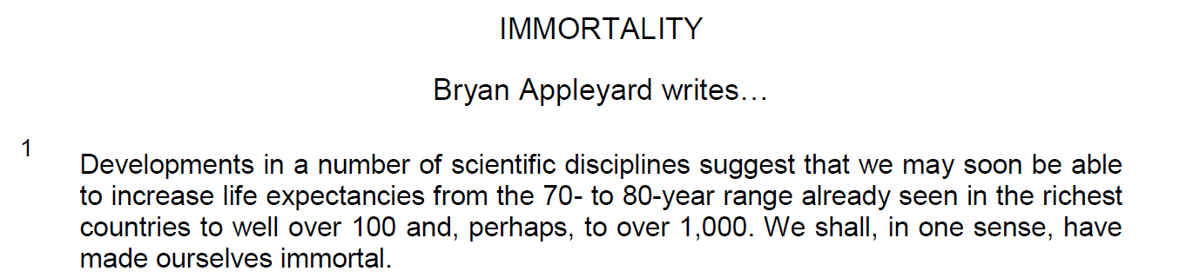

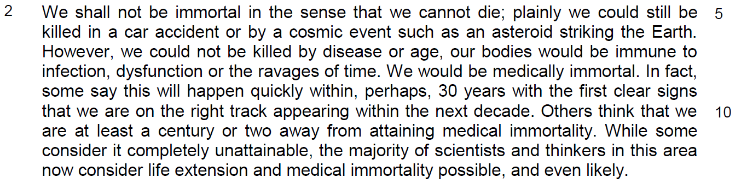

idea – the possibility of longer life expectancy – redefine immortality – medical immortality

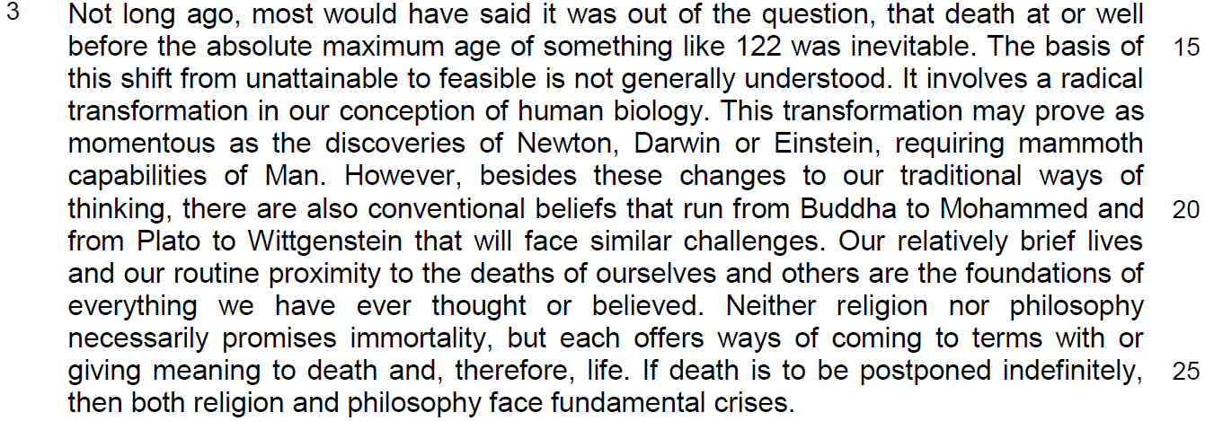

immortality will be defined or discovered by man through science – it will affect our religious and philosophical view about death – religion focuses on after-life while philosophy focuses on life
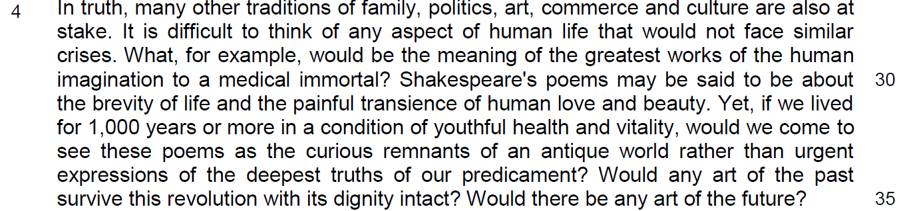
greater debate on aspect of human civilization – literature – why art will not survive – redefine the meaning of arts – archaic or meaningful – define the value of art

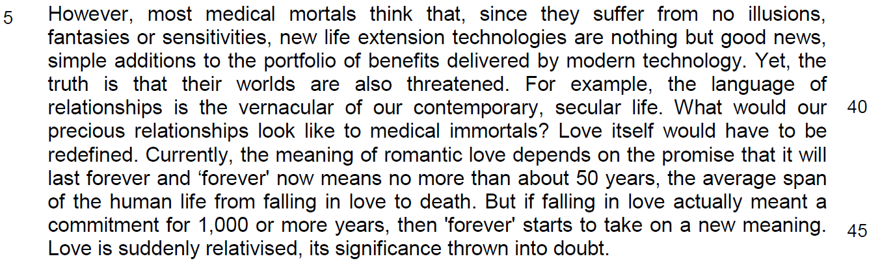
immortality will re-define our relationship and the meaning of love – duration of love will change our values of love

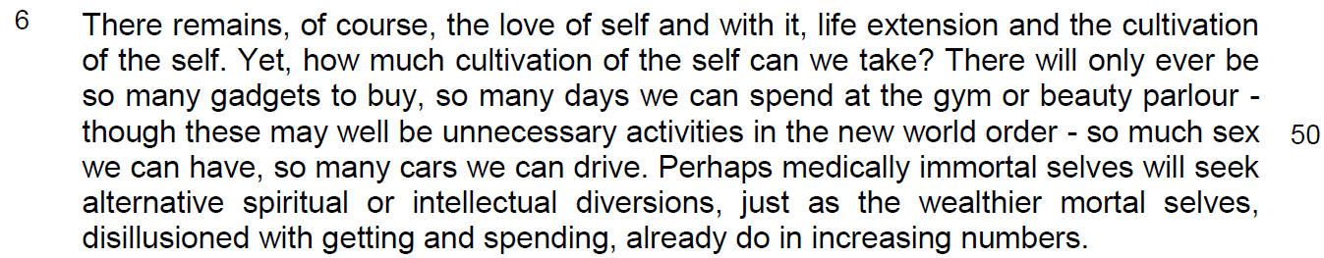
longer life span – less concern over materialism – more concerned over spiritual and intellectual development

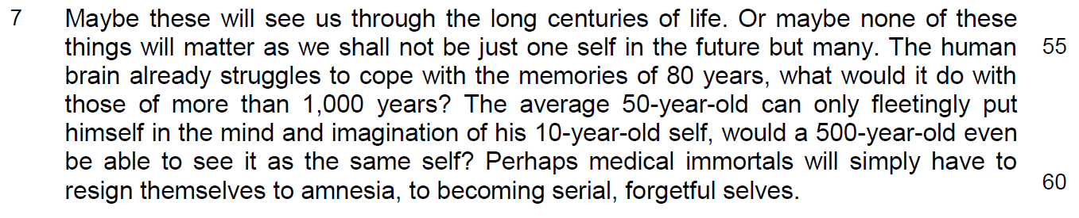
psychological impact of longer life span – to deal with our memories – positive and negative aspect of long term memories – determine our self identity

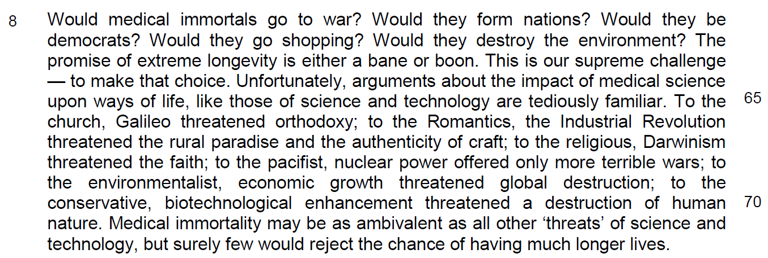

longevity will threaten the social, economic and political aspect of human civilization

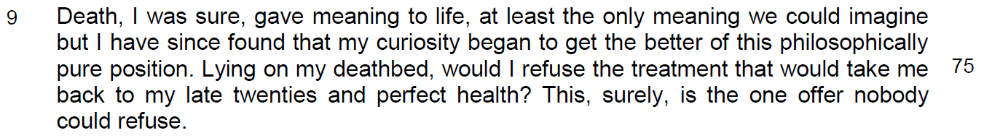

Read the passage in the insert and then answer all the questions which follow. Note that up to fifteen marks will be given for the quality and accuracy of your use of English throughout this paper.

NOTE: When a question asks for an answer IN YOUR OWN WORDS AS FAR AS POSSIBLE and you select the appropriate material from the passage for your answer, you must still use your own words to express it. Little credit can be given to answers which only copy words or phrases from the passage.

Q1) Explain how the traditions of (a) family and (b) politics (line 27) might be threatened by immortality. [2]

…………………………………………………………………………………………

…………………………………………………………………………………………

…………………………………………………………………………………………

…………………………………………………………………………………………

Q2) ‘Would we come to see these poems as the curious remnants of an antique world rather than urgent expressions of the deepest truths of our predicament’ (lines 33-34)

What do the italicized words say about the difference in our attitude towards poems in the present and the future? [2]

…………………………………………………………………………………………

…………………………………………………………………………………………

…………………………………………………………………………………………

…………………………………………………………………………………………

Q3) In paragraph 5, why would medical immortals consider the new life extension technologies nothing but good news? Use your own words as far as possible. [2]

…………………………………………………………………………………………

…………………………………………………………………………………………

…………………………………………………………………………………………

…………………………………………………………………………………………
Q4) Explain the irony of romantic love in the following sentence.

‘… but if falling in love actually meant a commitment for 1,000 or more years, then 'forever' starts to take on a new meaning’ (lines 44-46). [2]

…………………………………………………………………………………………

…………………………………………………………………………………………

…………………………………………………………………………………………

…………………………………………………………………………………………

Q5) In paragraph 6, why does the author’s repeat the word ‘so’? [1]

…………………………………………………………………………………………

…………………………………………………………………………………………

Q6) What are the two similarities between medically immortal selves and wealthier mortal selves in paragraph 6? Use your own words as far as possible. [2]

…………………………………………………………………………………………

…………………………………………………………………………………………

…………………………………………………………………………………………

…………………………………………………………………………………………

Q7) What does the phrase ‘tediously familiar’ (line 65) suggest about the impact of science and technology on our way of life? [2]

…………………………………………………………………………………………

…………………………………………………………………………………………

…………………………………………………………………………………………

Q8) Why does the author put quotation marks around ‘threats’ (line 71)? [1]

…………………………………………………………………………………………

…………………………………………………………………………………………
Summary Question
Q9) Using material from paragraphs 1 to 3 of the passage, summarize the reasons for and against the attainability of immortality.

Write your summary in no more than 120 words, not counting the opening words which are printed below. Use your own words as far as possible. [8]

Immortality can be attained because…

Pt | Immortality is attainable because… | Paraphrased answer
a | Developments in a number of scientific disciplines suggest that we may soon be able to increase life expectancies … we shall in one sense have made ourselves immortal. (Para 1)  the first clear signs that we are on the right track appearing within the next decade. (line 9)
b | We shall not be immortal in the sense that we cannot die; plainly we could still be killed in a car accident or by a cosmic event such as an asteroid striking the Earth. (line 5)
C1  C2 | However, we could not be killed by disease or age, our bodies would be immune to infection, dysfunction or the ravages of time… (line 7)
d | We would be medically immortal. (line 8)
e | Some say this will happen quickly within, perhaps, 30 years. Others think we are at least a century or two away from attaining medical immortality. (line 9)
f | the majority of scientists and thinkers in this area now consider life extension and medical immortality possible, and even likely. (line 12)

 | Immortality is NOT attainable because… | Paraphrased answer
g | We shall not be immortal in the sense that we cannot die; plainly we could still be killed in a car accident or by a cosmic event such as an asteroid striking the Earth. (line 5)
h | It involves a (radical) transformation in our conception of human biology. (line 16)
i
j | This transformation may prove as momentous as the discoveries of Newton, Darwin or Einstein, requiring mammoth capabilities of Man. (line 16)
k | There are also conventional beliefs that run from Buddha to Mohammed and from Plato to Wittgenstein that will face similar challenges (line 20)  … and others are the foundations of everything we have ever thought or believed. (line 21)  Neither religion nor philosophy necessarily promises immortality, but each offers ways of coming to terms with…. (line 24)
l | Our relatively brief lives and our routine proximity to the deaths of ourselves and others are the foundations of everything we have ever thought or believed. (line 21)
m | Neither religion nor philosophy necessarily promises immortality, but each offers ways of coming to terms with or giving meaning to death and, therefore, life. If death is to be postponed indefinitely, then both religion and philosophy face fundamental crises. (line 24)

Application Question
Q10) Besides discussing the probability of immortality, Appleyard raises his concerns regarding living forever.

Evaluate his concerns. How far do you think the possible gains would outweigh the possible consequences if immortality becomes an option? [8]

………………………………………………………………………………………………………………………………………………………………………………………………………………………………………………………………………………………………………………………………………………………………………………………………………………………………………………………………………………………………………………………………………………………………………………………………………………………………………………………………………………………………………………………………………………………………………………………………………………………………………………………………………………………………………………………………………………………………………………………………………………………………………………………………………………………………………………………………………………………………………………………………………………………………………………………………………………………………………………………………………………………………………………………………………………………………………………………………………………………………………………………………………………………………………………………………………………………………………………………………………………………………………………………………………………………………………………………………………………………………………………………………………………………………………………………………………………………………………………………………………………………………………………………………………………………………………………………………………………………………………………………………………………………………………………………………………………………………………………………………………………………………………………………
…………………………………………………………………………………………………………………………………………………………………………………………………………………………

……………………………………………………………………………………………………………………………………………………………………………………………………………………………………………………………………………………………………………………………………………………………………………………………………………………………………………………………………………………………………………………………………………………………………………………………………………………………………………………………………………………………………………………………………………………………………………………………………………………………………………………………………………………………………………………………………………………………………………………………………………………………………………………………………………………………………………………………………………………………………………………………………………………………………………………………………………………………………………………………………………………………………………………………………………………………………………………………………………………………………………………………………………………………………………………………………………………………………………………………………………………………………………………………………………………………………………………………………………………………………………………………………………………………………………………………………………………………………………………………………………………………………………………………………………………………………………………………………………………………
…………………………………………………………………………………………………………………………………………………………………………………………………………………………………………………………………………………………………………………………………………………………………………………………………………………………………………………………………………………………………………………………………………………………………
……………………………………………………………………………………………………………

……………………………………………………………………………………………………………

