GP Term 4 2017 – Comprehension – Topic 1: Reflective Issues (Negative) – Problems with Lying

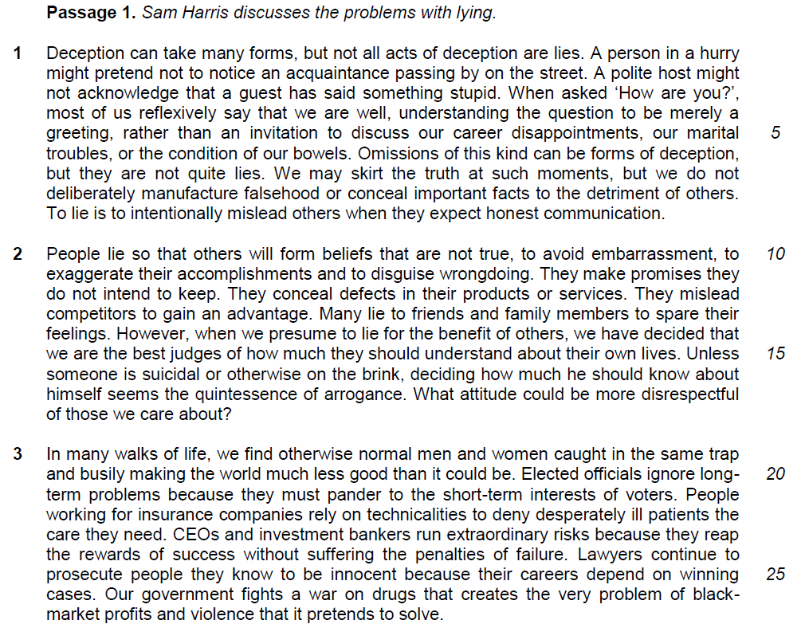

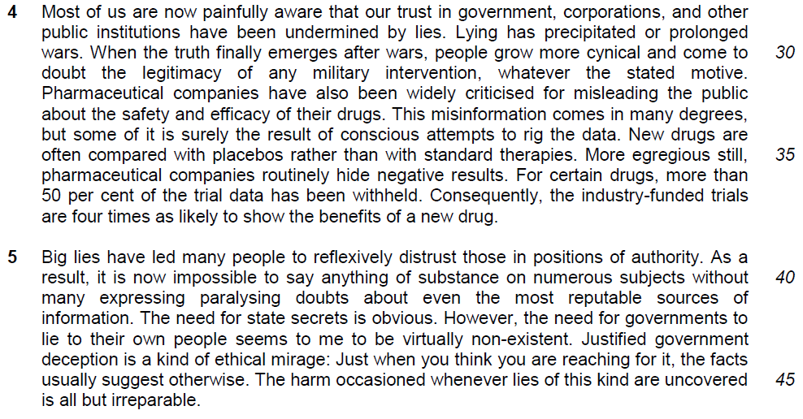

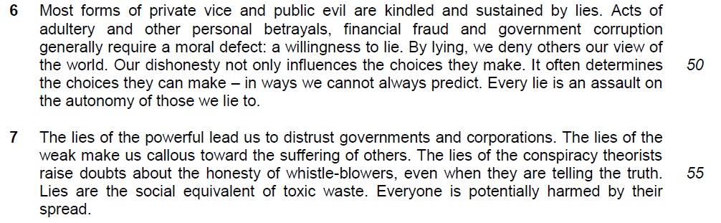

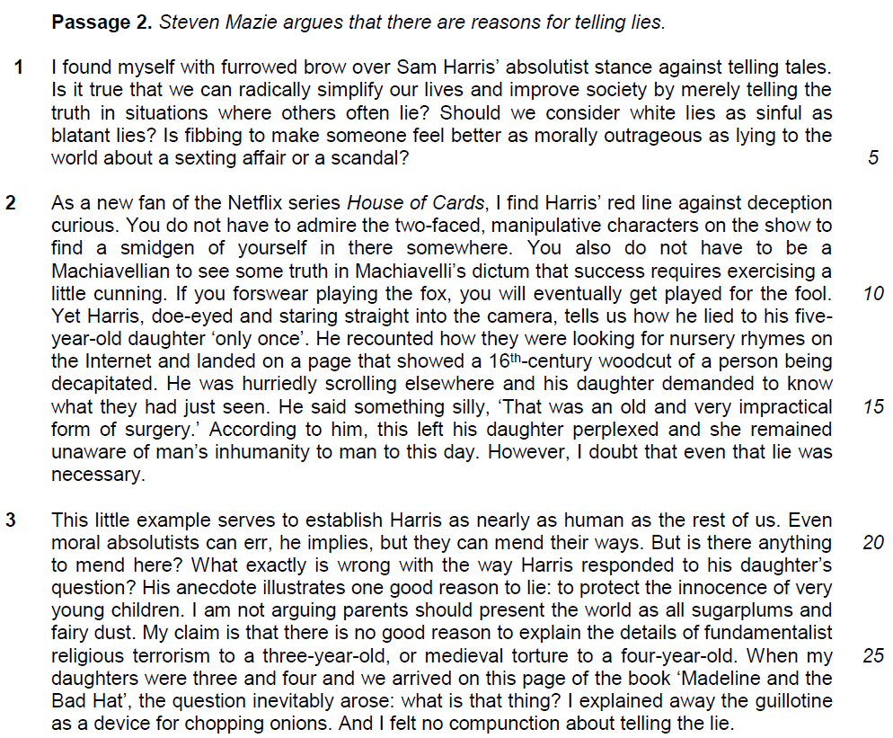

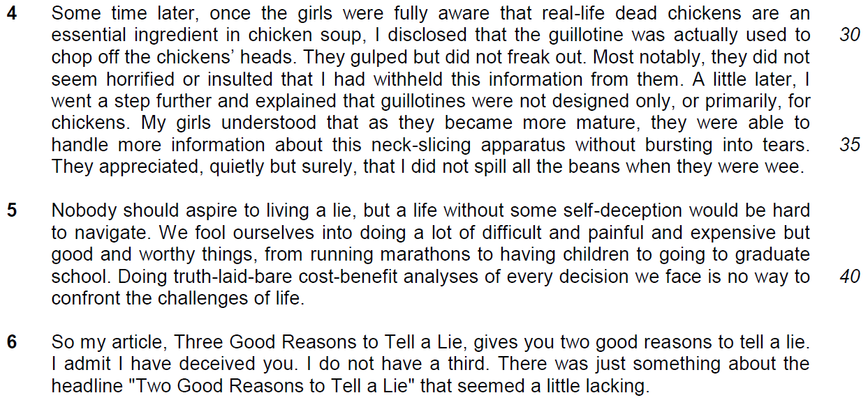

Read the passage in the insert and then answer all the questions. Note that up to fifteen marks will be given for the quality and accuracy of your use of English throughout this Paper.

NOTE: When a question asks for an answer IN YOUR OWN WORDS AS FAR AS POSSIBLE and you select the appropriate material from the passage for your answer, you must still use your own words to express it. Little credit can be given to answers which only copy words or phrases from the passage.

From Passage 1
1. Explain why the author says ‘not all acts of deception are lies’ (line 1). Use your own words as far as possible. [2]

……………………………………………………………………………………………………………………………………
……………………………………………………………………………………………………………………………………

……………………………………………………………………………………………………………………………………
……………………………………………………………………………………………………………………………………

2. Explain what the author means by ‘ethical mirage’ (line 44). Use your own words as far as possible. [2]

……………………………………………………………………………………………………………………………………
……………………………………………………………………………………………………………………………………

……………………………………………………………………………………………………………………………………
……………………………………………………………………………………………………………………………………

3. In paragraph 6, what are the three main reasons the author finds lies unacceptable? Use your own words as far as possible. [3]

……………………………………………………………………………………………………………………………………
……………………………………………………………………………………………………………………………………

……………………………………………………………………………………………………………………………………
……………………………………………………………………………………………………………………………………

4. Explain how ‘lies are the social equivalent of toxic waste’ (line 56). Use your own words as far as possible. [2]

……………………………………………………………………………………………………………………………………
……………………………………………………………………………………………………………………………………

……………………………………………………………………………………………………………………………………
……………………………………………………………………………………………………………………………………

Summary Question
Using material from paragraphs 2–4 (lines 10–38) only, summarise what the author has to say about why and how people tell lies.

Write your summary in no more than 120 words, not counting the opening words which are printed below. Use your own words as far as possible. [8]

People lie in order to

……………………………………………………………………………………………………………………………………
……………………………………………………………………………………………………………………………………

……………………………………………………………………………………………………………………………………
……………………………………………………………………………………………………………………………………

……………………………………………………………………………………………………………………………………
……………………………………………………………………………………………………………………………………

……………………………………………………………………………………………………………………………………
……………………………………………………………………………………………………………………………………

……………………………………………………………………………………………………………………………………
……………………………………………………………………………………………………………………………………

……………………………………………………………………………………………………………………………………
……………………………………………………………………………………………………………………………………

……………………………………………………………………………………………………………………………………
……………………………………………………………………………………………………………………………………

……………………………………………………………………………………………………………………………………

……………………………………………………………………………………………………………………………………

……………………………………………………………………………………………………………………………………
……………………………………………………………………………………………………………………………………

……………………………………………………………………………………………………………………………………
……………………………………………………………………………………………………………………………………

……………………………………………………………………………………………………………………………………
……………………………………………………………………………………………………………………………………

……………………………………………………………………………………………………………………………………
……………………………………………………………………………………………………………………………………

……………………………………………………………………………………………………………………………………
……………………………………………………………………………………………………………………………………

From Passage 2
6. What is the author’s intent in asking a series of questions in paragraph 1? [1]

……………………………………………………………………………………………………………………………………
……………………………………………………………………………………………………………………………………

7. Why has the author placed inverted commas around ‘only once’ (line 12)? [1]

……………………………………………………………………………………………………………………………………
……………………………………………………………………………………………………………………………………

8. Explain why the author ‘felt no compunction’ (line 28) lying to his daughters about the use of the guillotine. Use your own words as far as possible. [2]

……………………………………………………………………………………………………………………………………
……………………………………………………………………………………………………………………………………

……………………………………………………………………………………………………………………………………
……………………………………………………………………………………………………………………………………

9a. In paragraph 5, why does the author say leading ‘a life without self-deception would be hard to navigate’ (lines 37–38)? Use your own words as far as possible. [2]

……………………………………………………………………………………………………………………………………
……………………………………………………………………………………………………………………………………

……………………………………………………………………………………………………………………………………
……………………………………………………………………………………………………………………………………

9b. What is he implying about telling lies? [1]

……………………………………………………………………………………………………………………………………
……………………………………………………………………………………………………………………………………

10. Suggest one reason why the author decided to lie about the title of his article. [1]

……………………………………………………………………………………………………………………………………
……………………………………………………………………………………………………………………………………

Application Question (AQ)
Sam Harris writes about why people lie and the consequences of lying while Steven Mazie argues that there are good reasons for telling lies.

How far would you agree or disagree with the opinions expressed in these two passages? Relate your views to your own society. [10]

- Quotes
- explanation of the quote
- why you agree or disagree
- examples
- Extent of agreement or disagreement

……………………………………………………………………………………………………………………………………
……………………………………………………………………………………………………………………………………

……………………………………………………………………………………………………………………………………
……………………………………………………………………………………………………………………………………

……………………………………………………………………………………………………………………………………
……………………………………………………………………………………………………………………………………

……………………………………………………………………………………………………………………………………
……………………………………………………………………………………………………………………………………

……………………………………………………………………………………………………………………………………
……………………………………………………………………………………………………………………………………

……………………………………………………………………………………………………………………………………
……………………………………………………………………………………………………………………………………

……………………………………………………………………………………………………………………………………
……………………………………………………………………………………………………………………………………

……………………………………………………………………………………………………………………………………
……………………………………………………………………………………………………………………………………

……………………………………………………………………………………………………………………………………
……………………………………………………………………………………………………………………………………

……………………………………………………………………………………………………………………………………
……………………………………………………………………………………………………………………………………

……………………………………………………………………………………………………………………………………
……………………………………………………………………………………………………………………………………

……………………………………………………………………………………………………………………………………
……………………………………………………………………………………………………………………………………

……………………………………………………………………………………………………………………………………
……………………………………………………………………………………………………………………………………

……………………………………………………………………………………………………………………………………
……………………………………………………………………………………………………………………………………

……………………………………………………………………………………………………………………………………
……………………………………………………………………………………………………………………………………

……………………………………………………………………………………………………………………………………
……………………………………………………………………………………………………………………………………

……………………………………………………………………………………………………………………………………
……………………………………………………………………………………………………………………………………

……………………………………………………………………………………………………………………………………
……………………………………………………………………………………………………………………………………

……………………………………………………………………………………………………………………………………
……………………………………………………………………………………………………………………………………

……………………………………………………………………………………………………………………………………
……………………………………………………………………………………………………………………………………

……………………………………………………………………………………………………………………………………
……………………………………………………………………………………………………………………………………

……………………………………………………………………………………………………………………………………
……………………………………………………………………………………………………………………………………

……………………………………………………………………………………………………………………………………
……………………………………………………………………………………………………………………………………

