GP Comprehension: Globalisation, International Issues – Globalization on Cultural Change

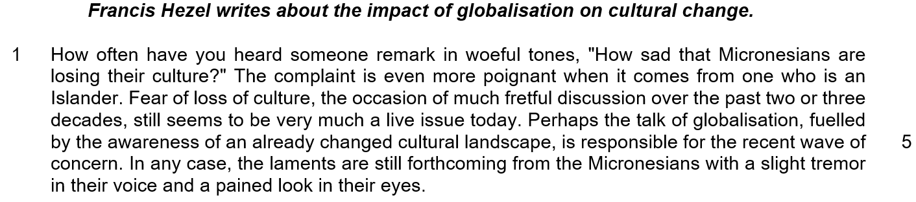

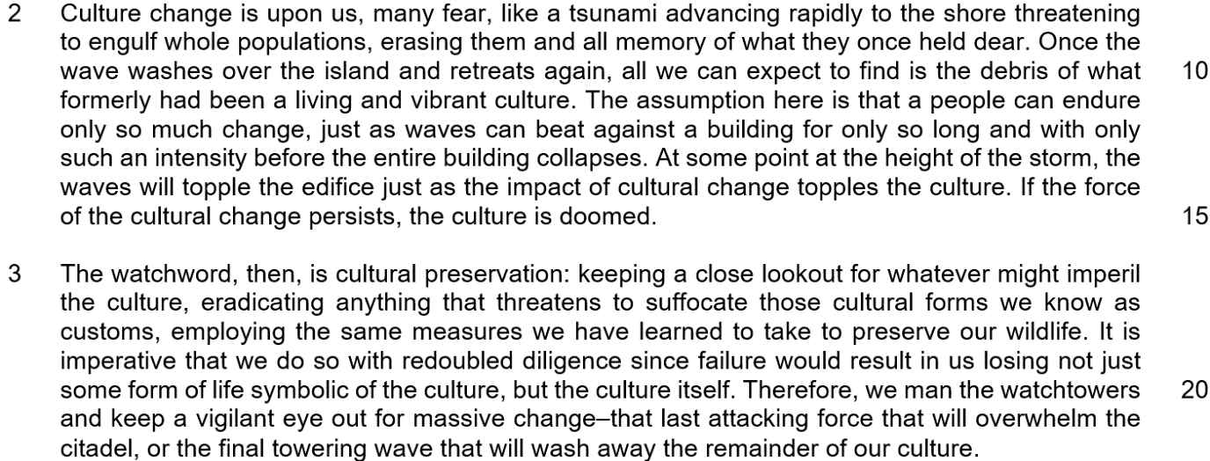

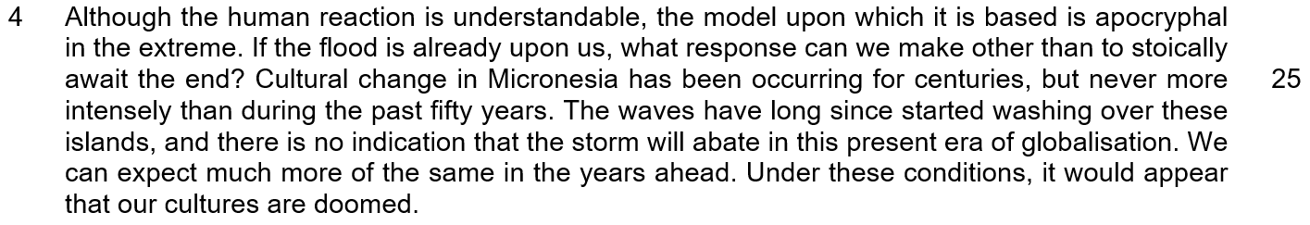

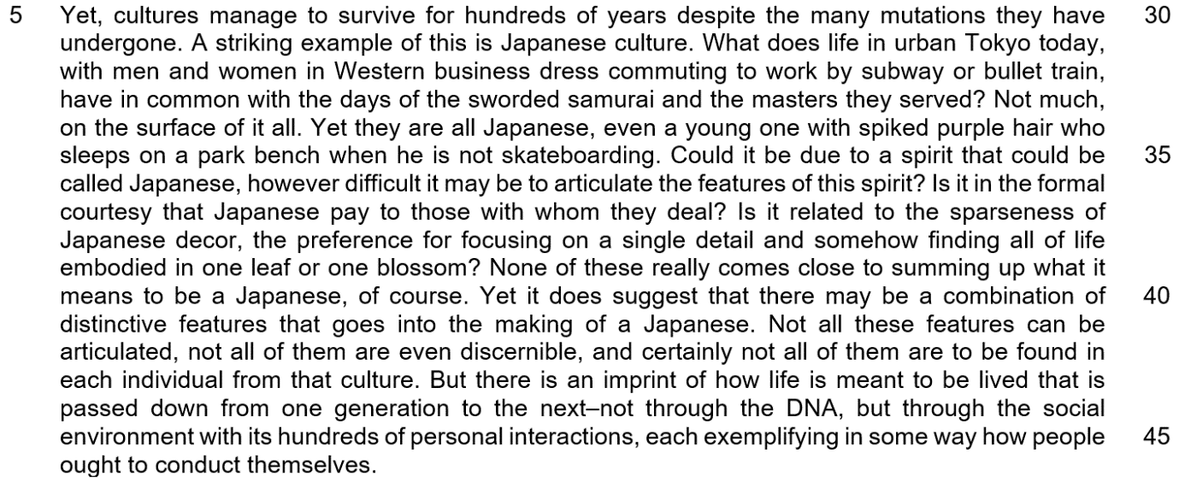

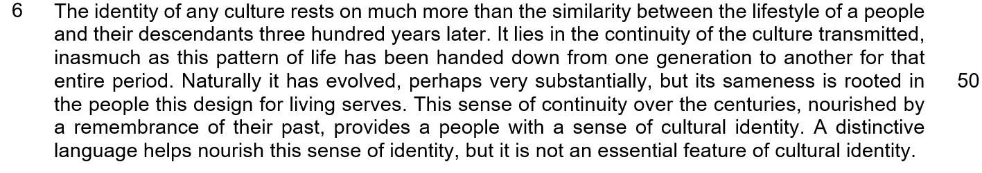

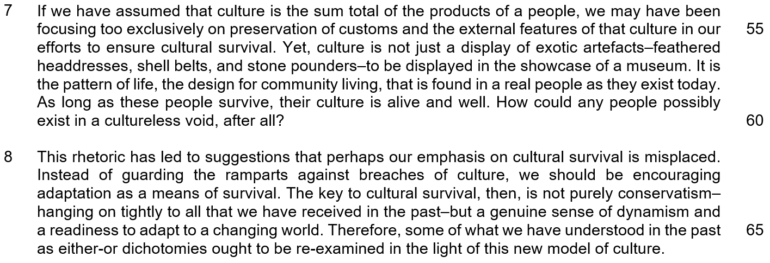

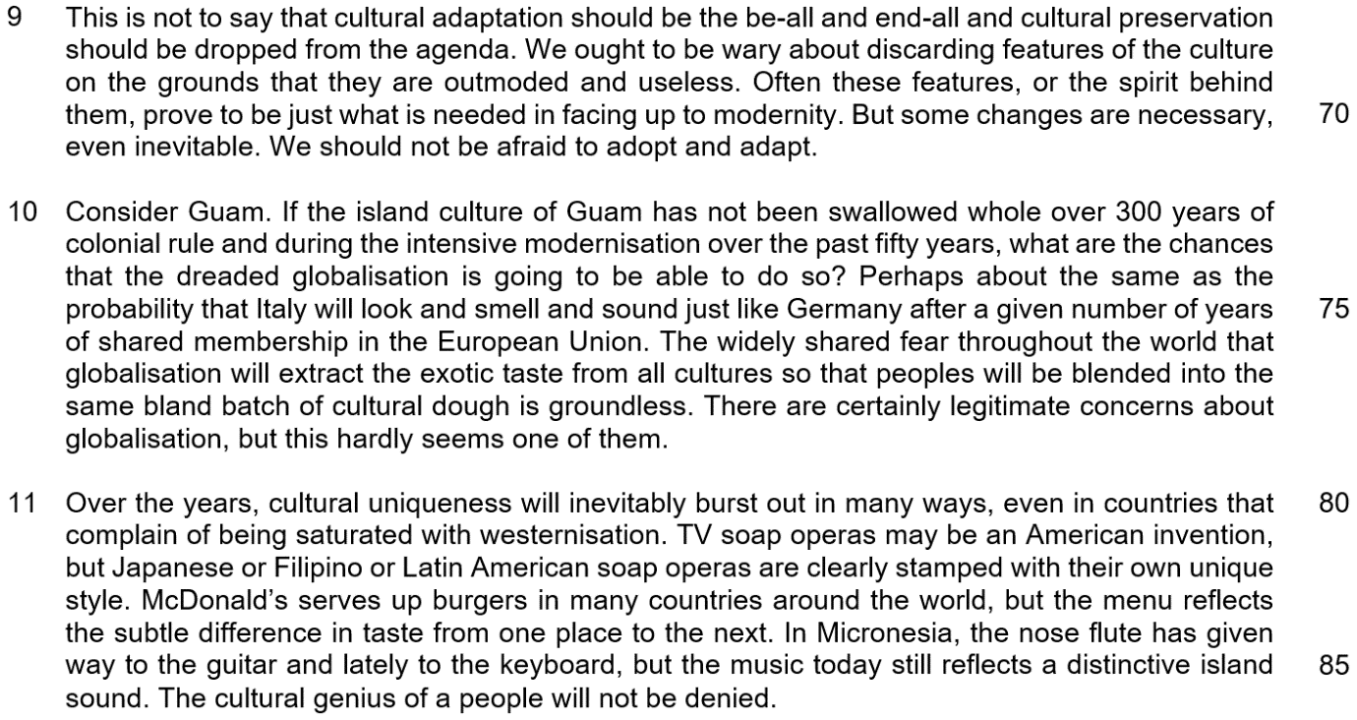

1. What does the word ‘fretful’ tell us about the ‘discussion’ in paragraph 3?
(1) The word ‘fretful’ tells us that there is much reluctance to engage in dialogue about the loss of culture.
(2) The word ‘fretful’ tells us that there is too much dialogue about the loss of culture.
(3) The word ‘fretful’ tells us that there is calm dialogue about the loss of culture.
(4) The word ‘fretful’ tells us that there is much anxious dialogue about the loss of culture.

( )

2. What is the author’s purpose in referring to the ‘citadel’ in paragraph 3?
(1) The author is emphasizing that the culture is strong enough to preserve itself even without taking any actions.
(2) The author is emphasizing that culture has a weak foundation, and it needs to be protected by the people.
(3) The author is emphasizing the need to preserve culture from internal threats to prevent it from being wiped out completely.
(4) The author is emphasizing the need to preserve culture from external threats to prevent it from being wiped out completely.

( )

3. Which of the following statement(s) is/are correct in explaining the author’s thoughts about what we need to do to preserve culture in paragraph 3?
A: We need to educate everyone to understand the importance of cultural preservation.
B: We need to be vigilant to prevent anything untoward from happening to one’s culture.
C: We need to completely remove all entities that might stifle certain historical practices.
D: We need to utilize the lessons garnered from our animal conservation endeavours.

(1) A only
(2) B and C only
(3) B, C and D only
(4) A, B, C and D

( )

4. What does the question in paragraph 4 ‘If the flood is already upon us, what response can we make other than to stoically await the end?’ suggest about the way that cultural change has been perceived?
(1) It suggests that cultural change has been perceived to be something extremely destructive.
(2) It suggests that cultural change has been perceived to be so overwhelming that we are unable to do anything about something that is inevitable.
(3) It suggests that cultural change has been perceived to be something that comes very suddenly and rapidly.
(4) It suggests that cultural change has been perceived to be something that we can take certain actions to prepare for.

( )

5. Which of the following statement(s) is/are true in explaining the author’s use of the word ‘even’ in paragraph 5?
A: The author is emphasizing that culture can be adaptable.
B: The author is emphasizing that culture is something intrinsic.
C: The author is emphasizing that culture is something rigid.
D: The author is emphasizing that culture must withstand all adaptations.

(1) C and D only
(2) B only
(3) B and D only
(4) A and B only

( )

6. In paragraph 9, what does the author consider to be unjustified reasons for discarded features of a culture.
(1) The author cautions against discarding features just because they might seem outdated and serve no practical purpose.
(2) The author cautions against discarding features simply because they conflict with modern values.
(3) The author cautions against discarding features just because they serve no economic purpose.
(4) The author cautions against discarding features of the culture even before attempting to understand it.

( )

7. What is the author implying when he refers to Italy and Germany in paragraph 10?
(1) The author is emphasizing that interaction among different global actors will strengthen their individual society’s culture.
(2) The author is emphasizing that interaction among different global actors will not automatically lead to a loss in a society’s culture.
(3) The author is emphasizing that a loss of culture will eventually happen after a given number of years of shared membership.
(4) The author is emphasizing that a shared membership can indicate a lack of compatibility between their country’s culture.

( )

8. Which of the statements below correctly show how the examples in paragraph 11 illustrate his assertion that ‘the cultural genius of a people will not be denied’?
A: The example of McDonald’s shows how Western fast-food menus have been adapted by local people to suit their local tastes to much success.
B: The example of TV soap opera shows that broadcasters steal the features of other people’s culture to call it their own.
C: The example of the guitar and the keyboard shows how locals are able to use western instruments to produce music with a local twist, that still echoes characteristics of local music.
D: The example of the guitar and the keyboard shows how manufacturers are able to alter western instruments to be able to play local music.

(1) A only
(2) A and C only
(3) A and D only
(4) A, B, C and D

( )

