\
GP Term 4 2014 – Comprehension – Lesson 1 – Culture – Cultural Heritage

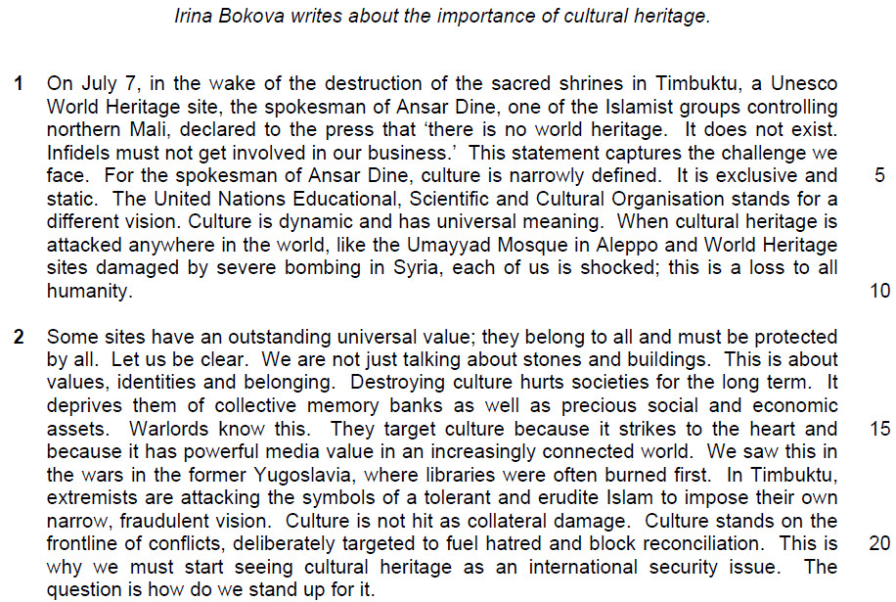

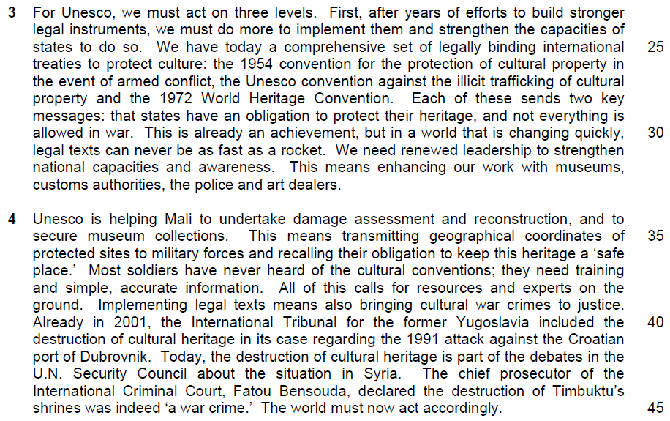

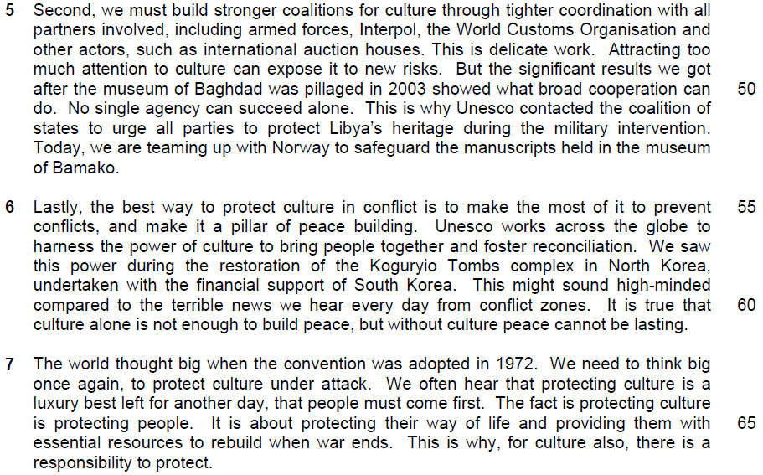

1. What is the author’s purpose in beginning with the quote from the spokesman of Ansar dine (lines 3-4)?

…………………………………………………………………………………………..
…………………………………………………………………………………………..

……………………………………………………………………………………...…..

……………………………………………………………………………………...…..

……………………………………………………………………………………….[1]

2. In paragraph 1, what contrast does the author make between the United Nation’s vision of culture and that of Ansar Dine? Use your own words as far as possible.

…………………………………………………………………………………………..
…………………………………………………………………………………………..

……………………………………………………………………………………...…..

……………………………………………………………………………………...…..

……………………………………………………………………………………….[2]

3. What does that author imply by using the words ‘not just’ to explain the value of cultural sites (line 12)? Use your own words as far as possible.

…………………………………………………………………………………………..
…………………………………………………………………………………………..

……………………………………………………………………………………...…..

……………………………………………………………………………………...…..

……………………………………………………………………………………….[2]

4. Explain what is lost when ‘collective memory banks’ are destroyed (line 14).

…………………………………………………………………………………………..
…………………………………………………………………………………………..

……………………………………………………………………………………...…..

……………………………………………………………………………………...…..

……………………………………………………………………………………….[2]

5. What is the author implying when she says that warlords’ target culture because it strikes to the heart’ (line 15)

…………………………………………………………………………………………..
…………………………………………………………………………………………..

……………………………………………………………………………………...…..

……………………………………………………………………………………...…..

……………………………………………………………………………………….[2]

6. Explain and explain how one example of the author’s use of language in lines 18-19 reflects her overall bias.

…………………………………………………………………………………………..
…………………………………………………………………………………………..

……………………………………………………………………………………...…..

……………………………………………………………………………………...…..

……………………………………………………………………………………….[1]

7. Explain what the author means by saying that targeting culture can ‘fuel hatred and block reconciliation’ (line 20)? Use your own words as far as possible.

…………………………………………………………………………………………..
…………………………………………………………………………………………..

……………………………………………………………………………………...…..

……………………………………………………………………………………...…..

……………………………………………………………………………………….[2]

8. Using material from paragraphs 3-5 only, summarise what the author has to say about what everyone needs to do to protect cultural sites and how to go about doing so.

Write your summary in no more than 120 words, not counting the opening words which are printed below. Use your own words as far as possible.

To protect cultural sites, we must…

…………………………………………………………………………………………..
…………………………………………………………………………………………..

……………………………………………………………………………………...…..

…………………………………………………………………………………………..
…………………………………………………………………………………………..

……………………………………………………………………………………...…..

…………………………………………………………………………………………..
…………………………………………………………………………………………..

……………………………………………………………………………………...…..

…………………………………………………………………………………………..
…………………………………………………………………………………………..

……………………………………………………………………………………...…..

…………………………………………………………………………………………..
…………………………………………………………………………………………..

……………………………………………………………………………………...…..

…………………………………………………………………………………………..
…………………………………………………………………………………………..

…………………………………………………………………………………………..
…………………………………………………………………………………………..

……………………………………………………………………………………...…..

…………………………………………………………………………………………..
…………………………………………………………………………………………..

…………………………………………………………………………………….....[8]

9. In paragraph 6, who might dismiss the author’s argument about the need to protect culture in conflict?

…………………………………………………………………………………………..
…………………………………………………………………………………………..

……………………………………………………………………………………...…..

……………………………………………………………………………………...…..

……………………………………………………………………………………….[1]

10. In paragraph 7, what does the author suggest would be lost if we fail to protect culture? Use your own words as far as possible.

…………………………………………………………………………………………..
…………………………………………………………………………………………..

……………………………………………………………………………………...…..

……………………………………………………………………………………...…..

……………………………………………………………………………………….[2]

11. Why does the author keep repeating the words ‘protect’ and ‘protecting’ in the last paragraph?

…………………………………………………………………………………………..
…………………………………………………………………………………………..

……………………………………………………………………………………...…..

……………………………………………………………………………………...…..

……………………………………………………………………………………….[2]

11. Irina Bokva feels that cultural heritage belongs to all and must be protected by all. To what extent do you agree or disagree with her views? How applicable do you find her observations to yourself and your own society?

…………………………………………………………………………………………..
…………………………………………………………………………………………..
…………………………………………………………………………………………..
…………………………………………………………………………………………..
…………………………………………………………………………………………..
…………………………………………………………………………………………..
…………………………………………………………………………………………..
…………………………………………………………………………………………..
…………………………………………………………………………………………..
…………………………………………………………………………………………..
…………………………………………………………………………………………..
…………………………………………………………………………………………..
…………………………………………………………………………………………..
…………………………………………………………………………………………..
…………………………………………………………………………………………..
…………………………………………………………………………………………..
…………………………………………………………………………………………..
…………………………………………………………………………………………..
…………………………………………………………………………………………..
…………………………………………………………………………………………..

…………………………………………………………………………………………..
…………………………………………………………………………………………..
…………………………………………………………………………………………..
…………………………………………………………………………………………..
…………………………………………………………………………………………..
…………………………………………………………………………………………..
…………………………………………………………………………………………..
…………………………………………………………………………………………..
…………………………………………………………………………………………..
…………………………………………………………………………………………..
…………………………………………………………………………………………..
…………………………………………………………………………………………..
…………………………………………………………………………………………..
…………………………………………………………………………………………..
…………………………………………………………………………………………..
…………………………………………………………………………………………..
…………………………………………………………………………………………..
…………………………………………………………………………………………..
…………………………………………………………………………………………..
…………………………………………………………………………………………..
…………………………………………………………………………………………..
…………………………………………………………………………………………..
…………………………………………………………………………………………..
…………………………………………………………………………………………..

…………………………………………………………………………………………..
…………………………………………………………………………………………..
…………………………………………………………………………………………..
…………………………………………………………………………………………..
…………………………………………………………………………………………..
…………………………………………………………………………………………..
…………………………………………………………………………………………..
…………………………………………………………………………………………..
…………………………………………………………………………………………..
…………………………………………………………………………………………..
…………………………………………………………………………………………..
…………………………………………………………………………………………..
…………………………………………………………………………………………..
…………………………………………………………………………………………..
…………………………………………………………………………………………..
…………………………………………………………………………………………..
…………………………………………………………………………………………..
…………………………………………………………………………………………..
…………………………………………………………………………………………..
…………………………………………………………………………………………..
…………………………………………………………………………………………..
…………………………………………………………………………………….[8]

Suggested Answers

1) What is the author's purpose in beginning with the quote from the spokesman of Ansar Dine (lines 3-4)? (1)

Quotes
a. 'there is no world heritage. It does not exist. Infidels must not get involved in our business'

OR
b.
This statement captures the challenge we face

Paraphrased
a. Her purpose is to create a negative impression of people who think in this narrow fashion /are so intolerant / to immediately elicit sympathy for her cause by presenting the opposition as fanatical

OR
b. She feels his view summarises /encapsulates / best expresses the kind of thinking she / Unesco is trying to overcome / has to change / the difficulties faced by those trying to preserve culture/problem about cultural preservation

2) In paragraph 1, what contrast does the author make between the United Nation's vision of culture and that of Ansar Dine? Use your own words as far as possible. (2)

Quotes
1a.[culture] has universal meaning ...[when cultural heritage is attacked] this is a loss to all humanity

1b. Narrowly defined ... exclusive

2a.culture is dynamic

2b. and static

Paraphrased
1a.[UN] Culture belongs to / influences /affects all of us / all culture has significance / importance for all human beings / mankind/ everyone is able to relate to culture and understand it.

1b.[AD] It only belongs to / is owned by /is the property of a single group / one people / country / place / civilisation / not inclusive to a specific community.

2a. [UN] It is fluid / evolves / develops /progresses /changes in response to changes in us / our way of thinking /perspectives / significantly impacts lives

2b. [AD] It is unchanging / fixed /does not evolve/ rigid/inflexible

3) What does the author imply by using the words 'not just' to explain the value of cultural sites (Iine12)? Use your own words as far as possible. (2)

Quotes
1 .We are not just talking about

2.stones and buildings

3.This is about values

4.ldentities and belonging

Paraphrased
1. The importance of cultural sites does not simply / merely lie / exist / is not limited / restricted to

2. in their physical form / structures /physical objects / their concrete aspects/architecture / external facade/ physical entities/ physical aspects/ physical existence

3. Other factors are / They also express /give form to our ideals / principles / what we believe in / what we consider important/ morals / morals of citizens

4. and give us a sense of who we are /remind us of our common heritage / the communities we are affiliated to / the things we all share / how we all come from the same species/ sense of rootedness/ sense of togetherness/sense of community

4) Explain what is lost when 'collective memory banks' are destroyed (line 14). (2)

Quotes
1.[Destroying culture hurts societies for the long term. It deprives them of] collective

2. memory banks

Paraphrased
1 .What is lost is the sense of togetherness /feeling of oneness with each other that comes from/ social cohesion is lost
OR
What is lost are all the group / community /shared / commonly held

2. remembrances / stored / recorded knowledge that has been passed down for generations / of their traditions / past /achievements / accomplishments / legacy/heritage / precious experiences gathered over many years / reminiscence

5) What is the author implying when she says that warlords' target culture because it strikes to the heart' (line 15)? (2)

Quotes
1 .Warlords ... target culture
2. because it strikes to the heart

Paraphrased
1 .She implies that warlords aim to destroy/ conquer /subjugate / utterly demoralise a people, by destroying their culture

2. because culture comes from / represents the soul of a people/ culture is essential /crucial to a people's identity / survival/causes the most direct and harmful destruction to the people's emotion

6) Identify and explain how one example of the author's use of language in lines 18-19 reflects her overall bias. (1)

Possible choices for identification
A) Negative bias
A1. Extremists
A2. their own narrow vision
A3. fraudulent vision
A4. are attacking
A5. to impose

B) Positive bias
B1. The symbols of tolerant
B2. and erudite Islam

Explanation of bias
A1. Her use of 'extremists' reflects her bias against people whose minds are closed /whom she sees as fanatical / those who do not share her more moderate views their own narrow vision

A2. Her use of 'narrow vision' reflects her bias against people who are unable to see beyond their own parochial interests / who do not have her broader view fraudulent vision

A3. The use of 'fraudulent' to describe their vision shows her bias / prejudice against these people as she feels their views /beliefs are lies / false / distortions of the truth / clash with / go against her own valid/ truthful beliefs are attacking

A4. Her choice of a word that means use of violence / force reflects her view that such people are violent / barbaric/ primitive must resort to force / do not use accepted means to express / propagate their beliefs/ in contrast to her own means which are rational / civilised

A5. Her use of 'impose' reflects her view that such people are violent / barbaric/primitive /must resort to force / do not use accepted means of persuasion / in contrast to her own means which are rational /civilised

B1. Her use of the very positive word 'tolerant' shows her approval of those who value open mindedness / acceptance of others' views as she does

B2. Her use of 'erudite' shows her bias in favour of those she feels love learning / knowledge / understand the importance of collected wisdom as she does

7) Explain what the author means by saying that targeting culture can 'fuel hatred and block reconciliation' (line 20)? Use your own words as far as possible (2)

Quotes
1 . [Targeting culture] can fuel hatred

2. and block

3. reconciliation

Paraphrased
1. This act can cause / provoke deep resentment /feelings of tremendous anger / animosity towards those who do the damage /

2. and can remove virtually all chances /make it next to impossible / extremely improbable for the two groups in conflict /at war / nothing can be done to stop/prevent/ hinder/ obstruct/ impede/ deter/negates opportunities

3. to ever come together / find a peaceful solution for their differences / come to terms with each other / restore their relationship/ being able to forgive/ getting together again/ compromise

8) Using material from paragraphs 3-5 only, summarise what the author has to say about what everyone needs to do to protect cultural sites and how to go about doing so.

Write your summary in no more than 120 words, not counting the opening words which are printed below. Use your own words as far as possible.
To protect cultural sites, we must...
S/N | Lifted | Paraphrased
1. | [First, after years of efforts to build stronger legal instruments] we must do more to implement them (lines 23-24)
2. | and strengthen the capacities of states to do so. (lines 24-25)
3. | We have today a comprehensive set of legally binding international treaties to protect culture… (lines 25-26) Each of these sends two key messages (lines 27-28)
4. | States have an obligation to protect their heritage… (line 29)
5. | and not everything is allowed in war (lines 29-30)
6. | … but in a world changing quickly (line 30)
7. | legal texts can be never be as fast as a rocket. (line 31)
8. | We need renewed leadership (line 31)
9. | to strengthen national capacities (line 31-2)
10. | and awareness. (line 32)
11. | This means enhancing our work with museums, custom authorities, the police and art dealers (lines 32-33)
S/N | Lifted | Paraphrased
12. | This means transmitting geographical coordinates of protected sites to military forces (lines 35-36)
13. | and recalling their obligation to keep this heritage a “safe place” (line 36-37)
14 | Most soldiers have never heard of the cultural conventions; they need training (line 37)
15 | and simple, accurate information. (line 38)
16 | All of this calls for more resources and experts on the ground. (line 38-39)
17 | implementing legal texts means also bringing cultural war crimes to justice. (line 39)
18 | …we must build stronger “coalitions for culture” through tighter coordination with all partners involved… (lines 46-47)
19 | This is delicate work (line 48)
20 | Attracting too much attention to culture can expose it to new risks. (line 48-49)

8) Using material from paragraphs 3-5 only, summarise what the author has to say about what everyone needs to do to protect cultural sites and how to go about doing so.

Write your summary in no more than 120 words, not counting the opening words which are printed below. Use your own words as far as possible.
To protect cultural sites, we must...
S/N | Lifted | Paraphrased
1. | [First, after years of efforts to build stronger legal instruments] we must do more to implement them (lines 23-24) | make more effort to consciously use/apply put into practice the laws we already have
2. | and strengthen the capacities of states to do so. (lines 24-25) | to enhance/intensify the ability of countries to carry out/use them
3. | We have today a comprehensive set of legally binding international treaties to protect culture… (lines 25-26) Each of these sends two key messages (lines 27-28) | Currently, there are global/world-wide agreements to govern/covering the protection of culture that inform/tell/warn
4. | States have an obligation to protect their heritage… (line 29) | countries/nations that they have the duty/responsibility/must be committed to preserving their culture
5. | and not everything is allowed in war (lines 29-30) | and to exercise constraint in times of conflict/battle/that they cannot use an outbreak of hostilities as an excuse to do whatever they wish.
6. | … but in a world changing quickly (line 30) | With the state of flux/uncertainty in the world/with new conflicts breaking out suddenly/unexpectedly
7. | legal texts can be never be as fast as a rocket. (line 31) | laws/policies cannot be constantly updated/laws cannot always keep up with/be enforced at the same speed/as swiftly as violence can break out
8. | We need renewed leadership (line 31) | Thus, it is necessary/essential that those in authority/those at the helm put in more effort/place more importance on/push for more action/improved management/constant political reconfiguration
9. | to strengthen national capacities (line 31-2) | to increase their countries’ ability to protect their heritage/be ready and able to enforce existing laws/improve their own means/methods of protection/new initiatives are necessary to improve countries’ abilities
S/N | Lifted | Paraphrased
10. | and awareness. (line 32) | as well as raise consciousness/knowledge about the issue/the importance of/need to protect culture
11. | This means enhancing our work with museums, custom authorities, the police and art dealers (lines 32-33) | We need to improve our liaisons/work very closely with the various organizations involved/the people responsible for watching over/handling in cultural objects/ protecting culture/experts in relevant fields relevant personnel/stakeholders
12. | This means transmitting geographical coordinates of protected sites to military forces (lines 35-36) | The armed forces need to be informed where these cultural sites are/deployed at identified sites
13. | and recalling their obligation to keep this heritage a “safe place” (line 36-37) | We need to seek the cooperation of/co-opt the army to/impress upon/remind them of their duty/responsibility to provide security/to safeguard/ to not destroy cultural sites
14 | Most soldiers have never heard of the cultural conventions; they need training (line 37) | In order to allow armies/the armed forces to do so effectively, they require coaching/instruction/drilling on how/methods to protect these sites/undertake practice
15 | and simple, accurate information. (line 38) | and be given straightforward/practical/easily applied/factual/correct/up-to-date/ recent data
16 | All of this calls for more resources and experts on the ground. (line 38-39) | This requires/needs/must be backed up by/ there must be sufficient means/capacity/facilities/equipment/useful, materials and specialized personnel/ professionals/specialists
17 | implementing legal texts means also bringing cultural war crimes to justice. (line 39) | In addition, punitive action must be taken against/punishment must be meted out to those who damage/destroy heritage must be brought to trial
18 | …we must build stronger “coalitions for culture” through tighter coordination with all partners involved… (lines 46-47) | for better/more effective protection of cultural sites, we need greater co-operation/ better teamwork among all interested parties/the various people/stakeholders/ groups concerned must work together to be effective/ work with allies
19 | This is delicate work (line 48) | Careful handling of the issue is required/ It needs to be managed in a cautious manner.
20 | Attracting too much attention to culture can expose it to new risks. (line 48-49) | as too obvious approach could put culture in danger

To protect cultural sites we must apply existing laws and enhance countries' abilities to enforce them. Currently, we have global agreements informing nations of their responsibility to protect culture, especially in times of conflict. However, with new conflicts breaking out unexpectedly, laws cannot be enforced quickly enough. Thus authorities must push harder to improve their protection and raise public consciousness. Liaisons between organisations handling cultural objects must be improved, and armies taught how to protect these sites by reminding them of their duty and providing up-to-date, practical data. We also need sufficient means and specialists, and ensure that those who damage cultural sites are punished. All those concerned must cooperate for success. This issue must be handled prudently because too obvious an approach can endanger culture.
(126 words)

9) In paragraph 6, who might dismiss the author's argument about the need to protect culture in conflict? (1)

Quotes
1. This might sound high-minded

2. compared to the terrible news we hear every day from conflict zones

3. It is true that culture alone is not enough to build peace

Paraphrased
Those who feel she's being too idealistic, too concerned with immaterial things / she is not in touch with people's needs / what the common man considers important

Those who feel that people / human lives should be put before / considered more important than mere man-made creations / what is simply I only buildings and stones / non-living objects

Those who feel that culture by itself cannot bring about harmony / resolve strife / end wars

People living in war-torn areas might dismiss the author's argument because they believe in times of war, protecting the civilians should be the priority over preventing culture.

Pessimists who believe that solely safeguarding and upholding culture is insufficient as a deterrent for cross-border attacks might dismiss the author's argument.

10) In paragraph 7, what does the author suggest would be lost if we fail to protect culture? Use your own words as far as possible. (2)

Quotes
1. Protecting culture is about protecting people

2. protecting their way of life

3. providing them with essential resources

Paraphrased
1. We would lose our concern with humanity /we forget our obligation to watch over others/ to ensure their needs are taken care of/humanity will not safeguarded

2. People's traditions / customs /lifestyles would be lost/ loss of livelihood/ everyday habits/ how we live our lives/ daily routines/traditional lifestyles/ means of living

3. There would be no tools / means/ to rebuild when war ends necessary materials left to allow a community to repair itself / recover after conflict ends/ fundamental materials to reconstruct after conflicts/ loss of necessary means for post-war reconstruction/ crucial "ingredient" for national reconstruction in the wake of war

11) Why does the author keep repeating the words 'protect' and 'protecting' in the last paragraph? (2)

Quotes
1. We need to think big once again to protect culture under attack ... protecting culture is protecting people ... protecting our way of life ... This is why, for culture also,

2. there is a responsibility to protect

Paraphrased
1 .She repeats them to reinforce / highlight /underscore /emphasise her main point /stand / view that/ draw attention to/ attract people's attention

OR
She wishes to convey a sense of urgency /to call for immediate action

2. for us to be involved with / care about / beheld accountable for / feel obligated to preserve / save / keep our culture intact /there is great importance in safeguarding cultural heritage

GP Comprehension - Topic: Culture - Cultural Heritage

Irina Bokova writes about the importance of cultural heritage

Paragraph 1
On July 7, in the wake of the destruction of the sacred shrines in Timbuktu, a Unesco World Heritage site, the spokesman of Ansar Dine, one of the Islamist groups controlling northern Mali, declared to the press that ‘there is no world heritage. It does not exist. Infidels must not get involved in our business.’ This statement captures the challenge we face. For the spokesman of Ansar Dine, culture is narrowly defined. It is exclusive and static. The United Nations Educational, Scientific and Cultural Organisation stands for a different vision. Culture is dynamic and has universal meaning. When cultural heritage is attacked anywhere in the world, like the Umayyad Mosque in Aleppo and World Heritage sites damaged by severe bombing in Syria, each of us is shocked; this is a loss to all humanity.

Paragraph 2
Some sites have an outstanding universal value; they belong to all and must be protected by all. Let us be clear. We are not just talking about stones and buildings. This is about values, identities and belonging. Destroying culture hurts societies for the long term. It deprives them of collective memory banks as well as precious social and economic assets. Warlords know this. They target culture because it strikes to the heart and because it has powerful media value in an increasingly connected world. We saw this in the wars in the former Yugoslavia, where libraries were often burned first. In Timbuktu, extremists are attacking the symbols of a tolerant and erudite Islam to impose their own narrow, fraudulent vision. Culture is not hit as collateral damage. Culture stands on the frontline of conflicts, deliberately targeted to fuel hatred and block reconciliation. This is why we must start seeing cultural heritage as an international security issue. The question is how do we stand up for it.

Paragraph 3
For Unesco, we must act on three levels. First, after years of efforts to build stronger legal instruments, we must do more to implement them and strengthen the capacities of states to do so. We have today a comprehensive set of legally binding international treaties to protect culture: the 1954 convention for the protection of cultural property in the event of armed conflict, the Unesco convention against the illicit trafficking of cultural property and in the 1972 World Heritage Convention. Each of these sends two key messages: that states have an obligation to protect their heritage, and not everything is allowed in war. This is already an achievement, but in a world that is changing quietly, legal texts can never be as fast as a rocket. We need renewed leadership to strengthen national capacities and awareness. This means enhancing our work with museums, customs authorities, the police and art dealers.

Paragraph 4
Unesco is helping Mali to undertake damage assessment and reconstruction, and to secure museum collections. This means transmitting geographical coordinates of protected sites to military forces and recalling their obligation to keep this heritage a ‘safe place.’ Most soldiers have never heard of the cultural conventions; they need training and simple, accurate information. All of this calls for resources and experts on the ground. Implementing legal texts means also bringing cultural war crimes to justice. Already in 2001, the International Tribunal for the former Yugoslavia included in the destruction of cultural heritage in its case regarding the 1991 attack against the Croatin port of Dubrovnik. Today, the destruction of cultural heritage is part of the debates in the U.N. Security Council about the situation in Syria. The chief prosecutor of the International Criminal Court, Fatou Bensouda, declared the destruction of Timbuktu’s shrines was indeed ‘a war crime’. The world must now act accordingly.

Paragraph 5
Second, we must build stronger coalitions for culture through tighter coordination with all patterns involved, including armed forces, Interpol, the World Customs Organisation and other actors, such as international auction houses. This is delicate work. Attracting too much attention to culture can expose it to new risks. But the significant results we got after the museum of Baghdad was pillaged in 2003 showed what broad cooperation can do. No single agency can succeed alone. This is why Unesco contacted the coalition of states to urge all parties to protect Libya’s heritage during the military intervention. Today, we are teaming up with Norway to safeguard the manuscripts held in the museum of Bamako.

Paragraph 6
Lastly, the best way to protect culture in conflict is to make the most of it to prevent conflict, and make it a pillar of peace building. Unesco works across the global to harness the power of culture to bring people together and foster reconciliation. We saw this power during the restoration of the Koguryio Tombs complex in North Korea, undertaken with the financial support of South Korea. This might sound high-minded compared to the terrible news we hear everyday from conflict zones. It is true that culture alone is not enough to build peace, but without culture peace cannot be lasting.

Paragraph 7
The world thought big when the convention was adopted in 1972. We need to think big once again, to protect culture under attack. We often hear that protecting cultures is a luxury best left for another day, that people must come first. The fact is protecting culture is protecting people. It is about protecting their way of life and providing them with essential resources to rebuild when war ends. This is why, for culture also, there is a responsibility to protect.

