GP Comprehension Culture – Q2

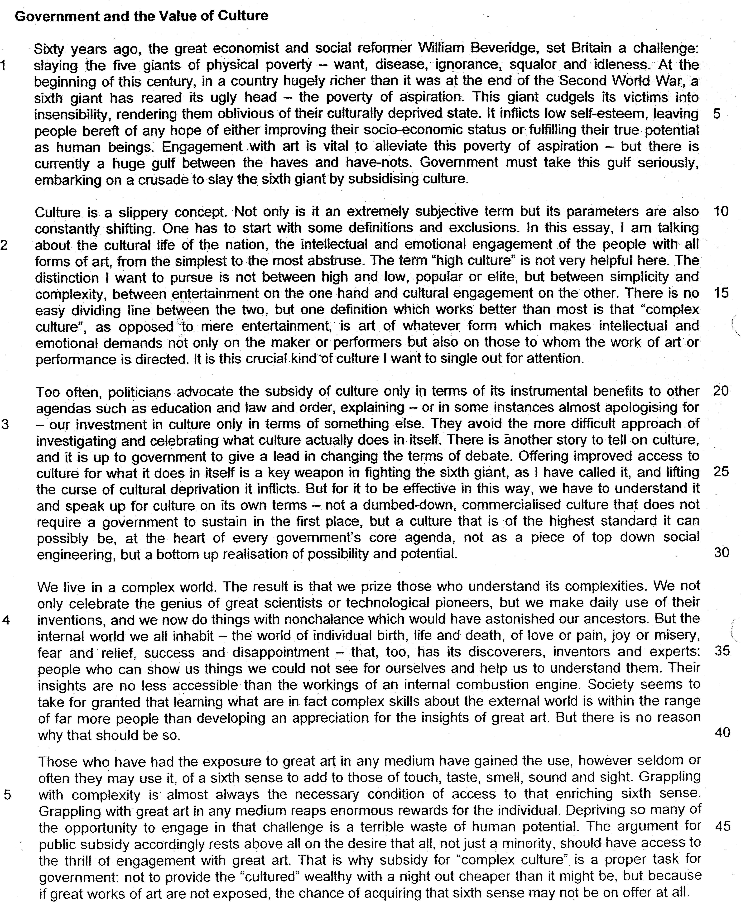

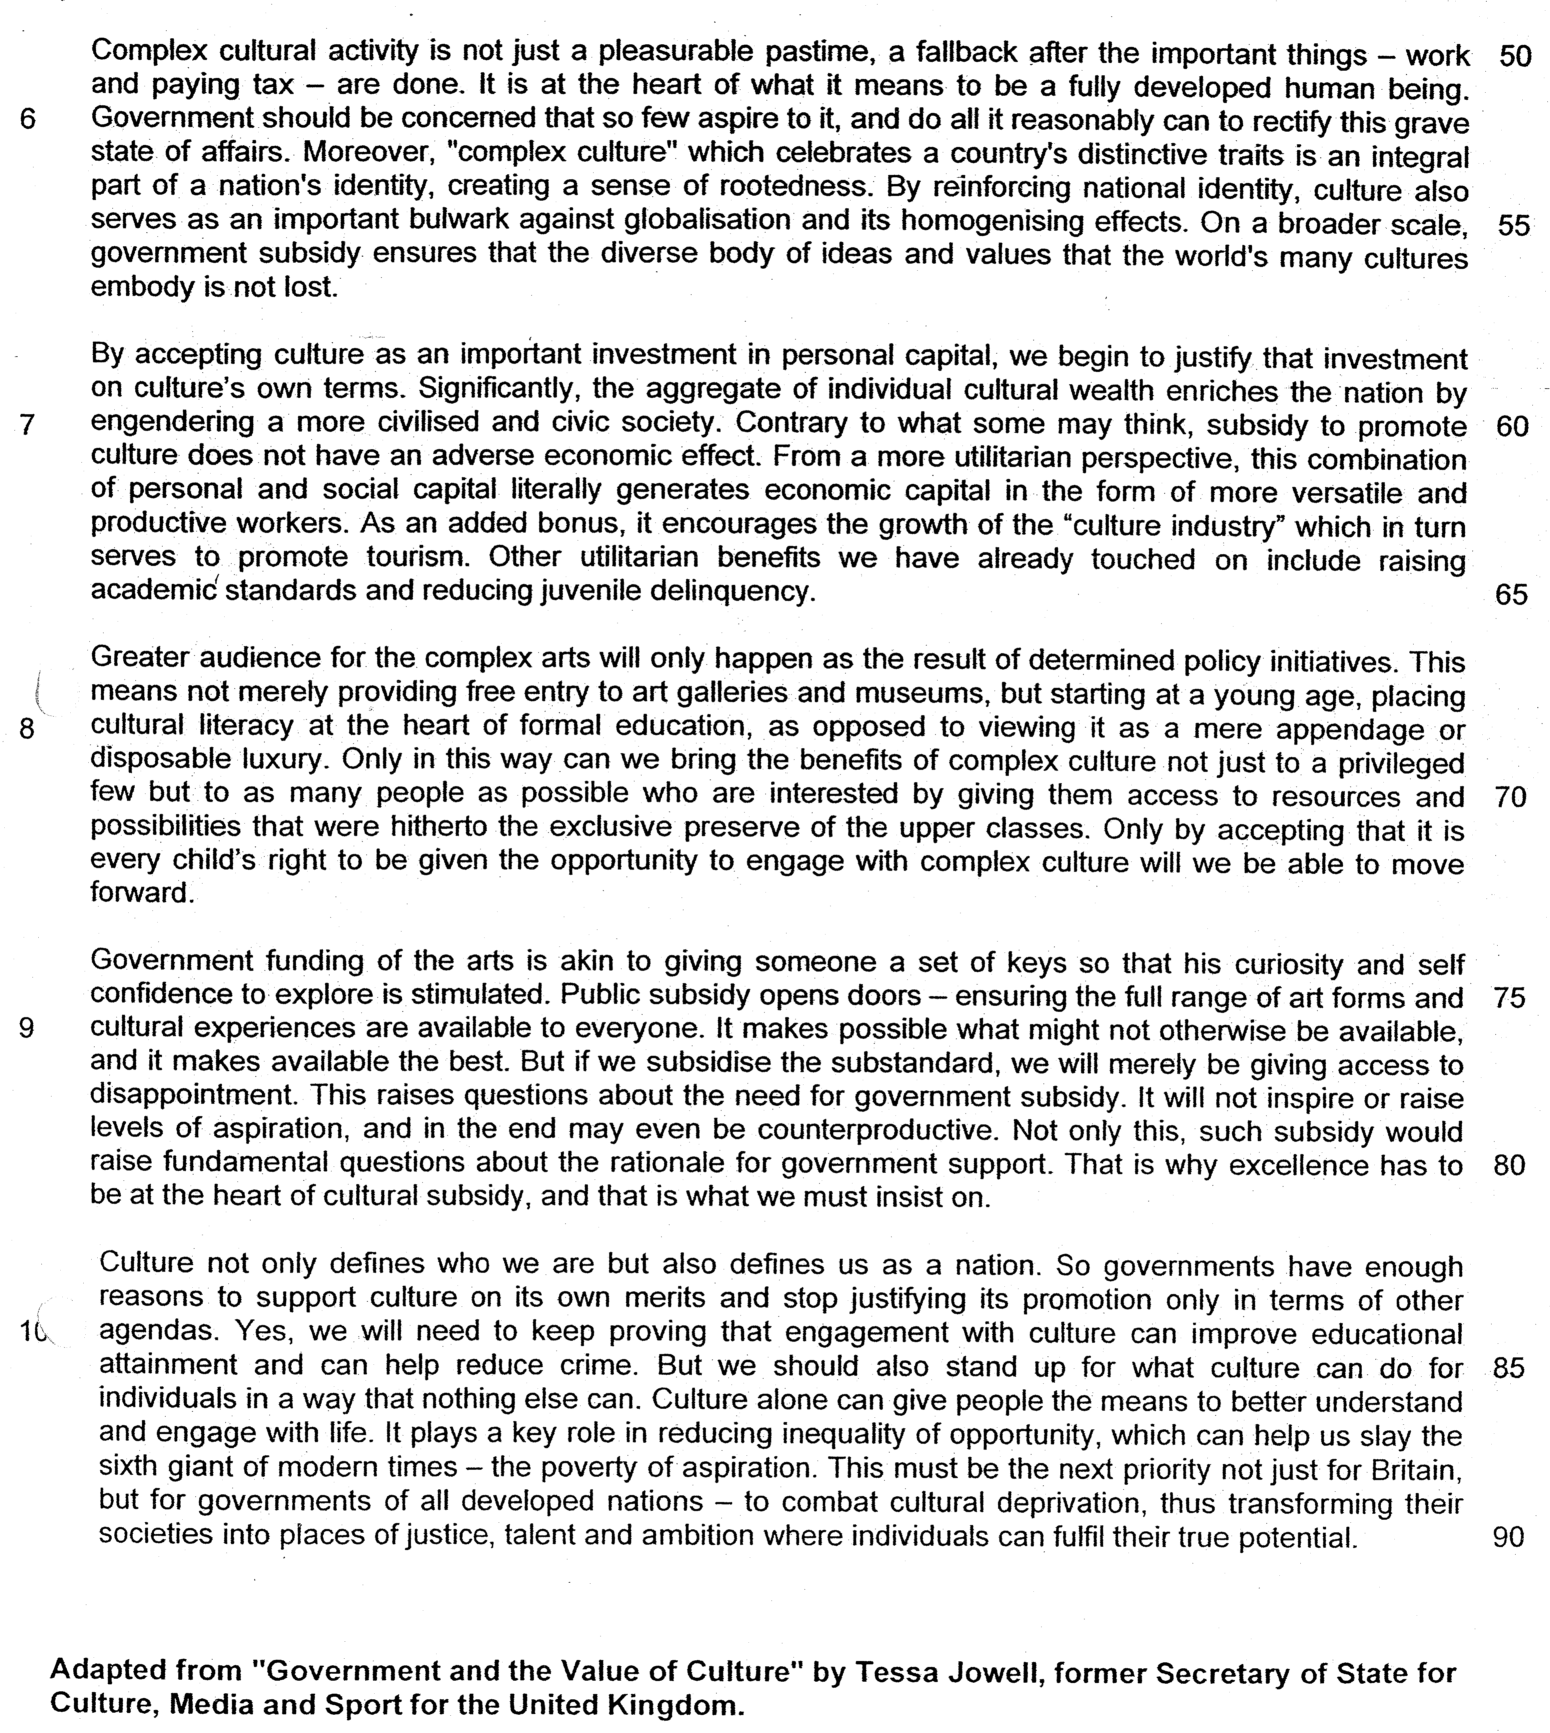

From paragraph 1

1. The writer refers to a "sixth giant" (line 4) in this paragraph. Explain carefully why she wants to "slay" this giant. Answer in your own words as far as possible. [2]

_______________________________________________________________________________________________________________________________________________________________________________________________________________________________________________________________________________________

From paragraph 2

2. Give two reasons why the writer views culture as a "slippery concept" (line 10). Answer in your own words as far as possible. [1]

_______________________________________________________________________________________________________________________________________________________________________________________________________________________________________________________________________________________

3. According to the writer, what is "complex culture" (line 16-17)? Answer in your own words as far as possible. [1]

_______________________________________________________________________________________________________________________________________________________________________________________________________________________________________________________________________________________

From paragraph 3

4. Why do politicians usually "advocate the subsidy of culture only in terms of its instrumental benefits to other agendas" (line 20-21)? Answer in your own words as far as possible. [1]
_______________________________________________________________________________________________________________________________________________________________________________________________________________________________________________________________________________________
5. Why would "commercialised culture" not require government support "in the first place" (lines 27-28)? Answer in your own words as far as possible. [1]

______________________________________________________________________________________________________________________________________________________________________________________________________________________________________________________________________________________

From paragraph 4

6. The writer tells us that "the internal world we all inhabit" has its own "discoverers, inventors and experts" (lines 34-35). Name the specific group of people that she is referring to here. [1]

______________________________________________________________________________________________________________________________________________________________________________________________________________________________________________________________________________________

7. Referring to material from paragraphs 5, 6 and 7, summarise the writer's reasons for arguing that governments should subsidise culture.

Write your summary in no more than 150 words, not counting the opening words which are printed below. Use your own words as far as possible.

The writer argues that governments should subsidise culture because …

______________________________________________________________________________________________________________________________________________________________________________________________________________________________________________________________________________________
_________________________________________________________________________________________________________________________________________________________________________________________
_______________________________________________________________________________________________________________________________________________________________________________________________________________________________________________________________________________________
______________________________________________________________________________________________________________________________________________________________________________________________________________________________________________________________________________________
_______________________________________________________________________________________________________________________________________________________________________________________________________________________________________________________________________________________
__________________________________________________________________________________________________________________________________________________________________________________________
_____________________________________________________________________________________________
_________________________________________________________________________________________[8]

From paragraph 8

8. According to the writer, what is the current role of cultural literacy in education and how does she want to change it? Answer in your own words as far as possible. [2]

______________________________________________________________________________________________________________________________________________________________________________________________________________________________________________________________________________________

9. What does the writer mean when she says the best in art and music were "hitherto the exclusive preserve of the upper classes" (line 71)? Answer in your own words as far as possible. [2]

______________________________________________________________________________________________________________________________________________________________________________________________________________________________________________________________________________________

From paragraph 9

10. Identify and explain the analogy used by the writer in this paragraph. Answer in your own words as far as possible.
[1]

______________________________________________________________________________________________________________________________________________________________________________________________________________________________________________________________________________________

11. Explain why the writer insists that governments should only subsidise cultural excellence. Use your own words as far as possible. [2]

_______________________________________________________________________________________________________________________________________________________________________________________________________________________________________________________________________________________

12. Give the meaning of the following words as they are used in the passage. You may write your answers in one word or a short phrase.

squalor (line 2) __________________________________________________________________________
alleviate (line 7) _________________________________________________________________________
curse (line 26) ___________________________________________________________________________
prize (line 31) ____________________________________________________________________________
accessible (line 37) ___________________________________________________________________[5]

13. The writer contends that it is the duty of governments of all developed nations to extensively subsidise "complex culture".

To what extent do you agree with her arguments?

Discuss the relevance of the issues and ideas raised in this passage to your own country. Refer specifically to relevant material from the passage, as well as your own knowledge and opinions to support your answer.

______________________________________________________________________________________________________________________________________________________________________________________________________________________________________________________________________________________
______________________________________________________________________________________________________________________________________________________________________________________________________________________________________________________________________________________
______________________________________________________________________________________________________________________________________________________________________________________________________________________________________________________________________________________
______________________________________________________________________________________________________________________________________________________________________________________________________________________________________________________________________________________

______________________________________________________________________________________________________________________________________________________________________________________________________________________________________________________________________________________
______________________________________________________________________________________________________________________________________________________________________________________________________________________________________________________________________________________
______________________________________________________________________________________________________________________________________________________________________________________________________________________________________________________________________________________
______________________________________________________________________________________________________________________________________________________________________________________________________________________________________________________________________________________
______________________________________________________________________________________________________________________________________________________________________________________________________________________________________________________________________________________
______________________________________________________________________________________________________________________________________________________________________________________________________________________________________________________________________________________
______________________________________________________________________________________________________________________________________________________________________________________________________________________________________________________________________________________

_________________________________________________________________________________________________________________________________________________________________________________________
______________________________________________________________________________________________________________________________________________________________________________________________________________________________________________________________________________________
______________________________________________________________________________________________________________________________________________________________________________________________________________________________________________________________________________________
______________________________________________________________________________________________________________________________________________________________________________________________________________________________________________________________________________________
______________________________________________________________________________________________________________________________________________________________________________________________________________________________________________________________________________________
______________________________________________________________________________________________________________________________________________________________________________________________________________________________________________________________________________________
______________________________________________________________________________________________________________________________________________________________________________________________________________________________________________________________________________________
_________________________________________________________________________________________[8]

