GP Term 3 2017 – Comprehension – Topic 8: Youth, Aged and Family Issues – Youth in the Western World

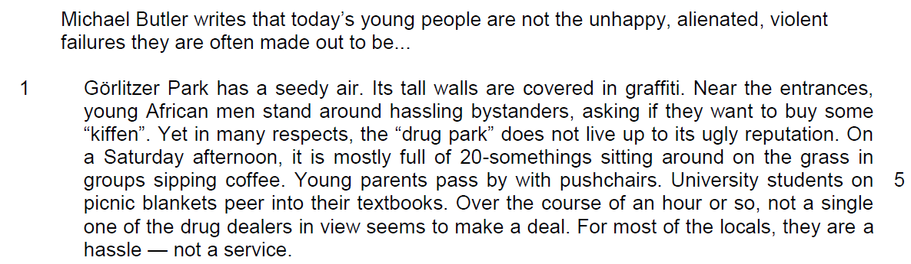

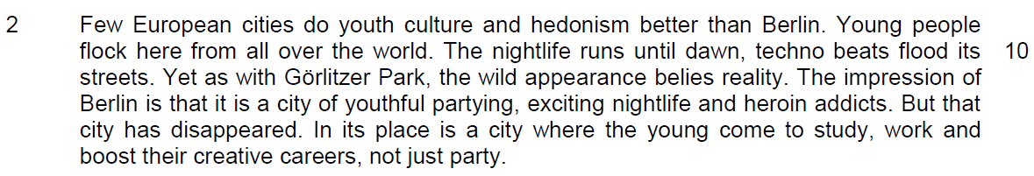

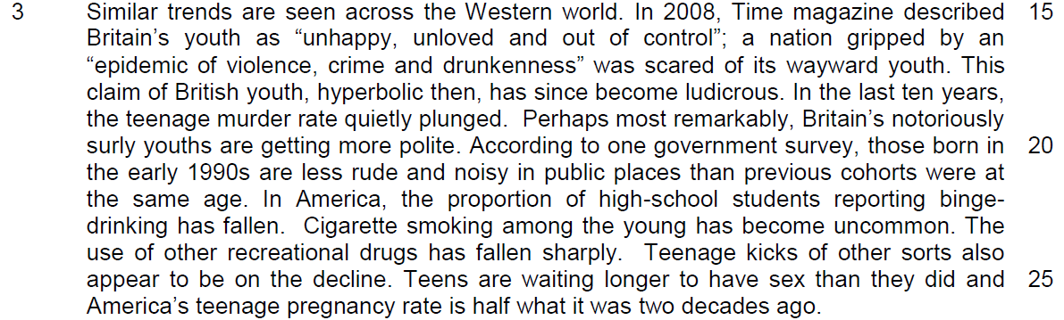

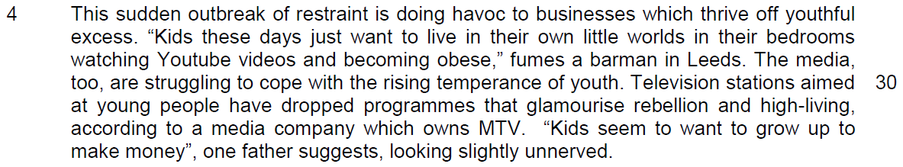

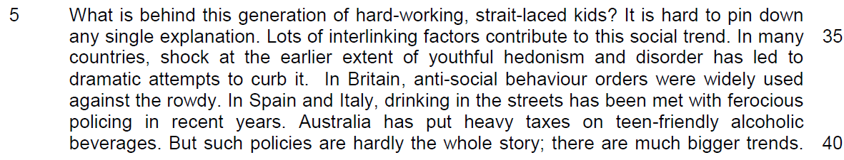

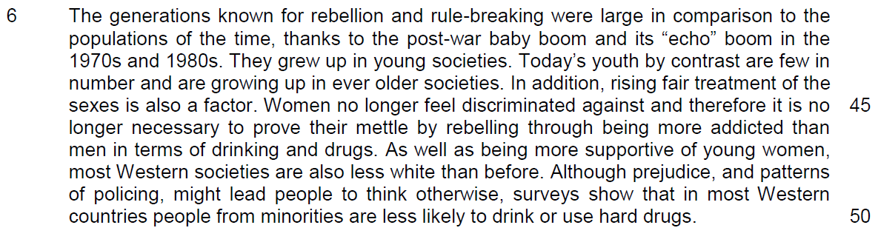

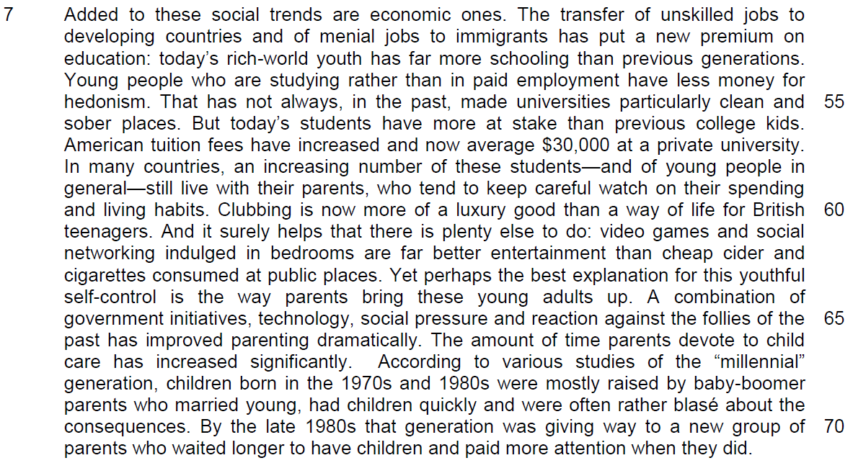

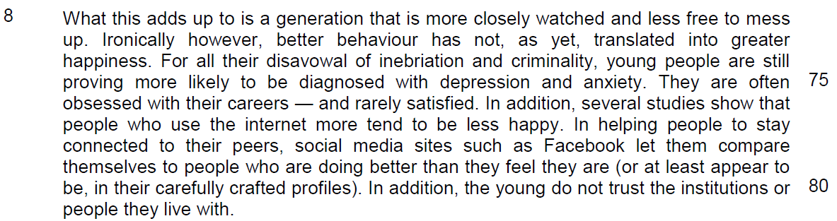

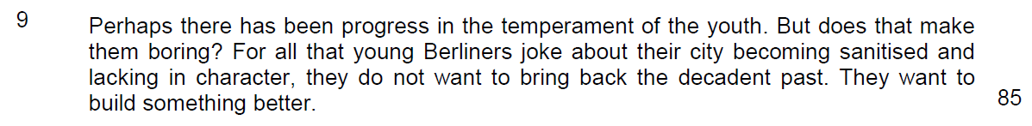

Suggested Answers
1. Give two reasons from paragraph 1 why the author says that Gorlitzer Park “has a seedy air1” (line 1). Use your own words as far as possible. [2]

From the Passage
Its tall walls are covered in graffiti…

Near the entrances, young African men stand around hassling bystanders, asking if they want to buy some “kiffen”( drugs)

Paraphrased
Its façade/outer appearance is vandalised and drug peddlers ply their trade nearby.
The park is filled up with vandalism and criminal activities

2. What are the author’s purposes in beginning his opening paragraph with the example of Gorlitzer Park? Use your own words as far as possible. [2]
to depict that there is a misconception of the youth culture
From the Passage
Yet in many aspects, the “drug park” does not live up to its ugly reputation.

Young parents pass by with pushchairs, University students on picnic blankets peer into their textbooks

Paraphrased
He wanted to show that the perception of the park as a place of drug culture / youthful rebelliousness is not correct. (purpose)

In contrast, he shows that it is only seeming so as the reality is that of respectable young people in the park doing very respectable activities in contrast to the drug dealers (idea in the purpose)

3. Explain the author’s use of the word “flock” in line 10. Use your own words as far as possible. [2]

From the Passage
Young people flock here from all over the world

Few European cities do youth culture and hedonism better than Berlin.. the wild appearances belies reality

Where the young come to study, work and boost their creative careers, not just party.

Paraphrased
Literal meaning – To gather in large numbers at a particular location.

Figurative meaning – The young all over the world seem to be lured by the city’ night-to-dawn entertainment and exciting wild happenings. Actually, they also came to fulfil serious ambitions through succeeding in studies and careers.
4. In lines 16-17, what claims about British youth are exaggerated and explain how these are now “ludicrous” (line 18). Use your own words as far as possible. [3]

From the Passage
Exaggerated claims are an epidemic of violence, crime and drunkenness, scared of its wayward youth…. (to the extent that) a nation gripped by (the above) …an epidemic

Ludicrous because the facts are… In the last ten years, the teenage murder rate quietly dropped

Surly youths are getting more polite…are less rude and noisy in public places.

Paraphrased
Fighting, inebriation arising from its aggressive/ lawless/ inebriated/ uncontrollable young.

To the extent that an entire society is paralysed by total helpless fear/held ransom by/terrorised by hooligan youths.

Not true because of the fall in violent crimes by the young. Reverse trend of social etiquette among new generation, less boorish display. Better civic-mindedness/more respectful to observe privacy/consideration for others in public places.

- claim against the youth
- why the claim is wrong and scorned by the observer

There is a untrue claim against the youths for being lawless, aggressive, uncontrollable and indulgence in vices and this is proven wrong by the writer as he has shown that there is lower crime rate among the youths, more civil and gracious, displaying proper social behaviours in society.

5. In paragraph 4, what contrasts does the author make between the youthful “excesses” (line 28) of the past and the “temperance” (line 30) of youth today? Use your own words as far as possible. [2]

From the Passage
“Kids these days just want to live in their own little worlds…watching Netflix ..” fumes a barman in Leeds.

Television stations aimed at young people have dropped programmes that glamourise rebellion and high living… Kids want o grow up to make money..”

Paraphrased
Public drinking and drunkenness is less common/ problematic/worrying/ of concern today as youths today instead enjoy stay-at-home hobbles/recreation.

Themes of teenage angst/ rebelliousness/ excessive immorality/riotous living as reflected in TV dramas have become unpopular/ unfashionable/less welcomed in contrast with serious ambitions/ adult concerns like money/ livelihood/success.

Undesirable social habits like drinking and vices are now less seen in youths as they are more willing to alienated from the society in their own places, restricting their social interaction only with social media. Their ant-social behaviours are replaced by a mindset towards achieving fame and success.
Summary Question
Q6. Using material from paragraphs 5 - 7 only, summarise the reasons for the change in the behaviour of today’s youth.

Write your summary in no more than 120 words, not counting the opening words which are printed below. Use your own words as far as possible. [8]

There are many reasons for the change in youth behaviour. First, …

# | From the Passage | Paraphrased
1 | shock at the earlier extent of youthful hedonism and disorder has led to dramatic attempts to curb it (Line 36-37)
2 | anti-social behaviour orders were widely used against the rowdy (Line 37-38)
3 | drinking in the streets has been met with ferocious policing (Line 38-39)
4 | Today’s youth by contrast are few in number and are growing up in ever older societies( Line 43-44)
5 | Women no longer feel discriminated against and therefore it is no longer necessary to prove their mettle by rebelling through being more addicted than men in terms of drinking and drugs  (Line 45-47)
6 | in most Western countries people from minorities are less likely to drink or use hard drugs. ( line 49-50)
7 | The transfer of unskilled jobs to developing countries and of menial jobs to immigrants(Line 51-52)

# | From the Passage | Paraphrased
8 | has put a new premium on education (Line 52-53)
9 | Young people who are studying rather than in paid employment have less money for hedonism (line 54-55)
10 | an increasing number of these students—and of young people in general—still live with their parents (line 58-59)
11 | who tend to keep careful watch on their spending and living habits (Line 59-60)
12 | Clubbing is now more of a luxury good than a way of life for British teenagers (line 60-61)
13 | video games and social networking indulged in bedrooms are far better entertainment (Line 61-62)
14 | perhaps the best explanation for this youthful self-control is the way parents bring these young adults up(Line 63-64)
15 | The amount of time parents devote to child care has increased significantly (line 66-67)
16 | to a new group of parents who waited longer to have children and paid more attention when they did. (line 70-71)

7. In paragraph 8, what explanations does the author offer for why better behaviour of the young has not “translated into greater happiness” (lines 73-74)? Use your own words as far as possible. [3]

From the Passage
…young people are still proving more likely to be diagnosed with depression and anxiety

They are often obsessed with their careers –and rarely satisfied.. social media sites ..let them compare themselves to people who are doing better than they feel they are

The young do not trust the institutions or people they live with

Paraphrased
More young people today have mental stress of varying seriousness/ sense of psychological wellness absent.

More and more preoccupation with work and its achievement but little happiness/contentment/ fulfilment in return for success.

Social media users subject themselves to comparison of status with peers, real or otherwise, and find dissatisfaction /discontent/disappointment with their own achievement/attainment/accomplishments.

The young have misgivings/lost faith in public establishments/bodies/state organisations and relationships with other members of society like the authority, peers, family.

8. What is the author implying by the phrase “carefully crafted profiles” in line 80? [1] (profile in social media)

From the Passage
or at least appear to be, in their carefully crafted profiles

Paraphrased
It suggests either that the profiles in the social media were fake /dreamed up/ artificially created/just a façade.

OR
The profiles may be real but has been heavily slanted/skewed/tweaked to give the best impressions rather than showing the mundane reality.

9. Perhaps there has been progress in the temperament of the youth (line 82). [1]

From the Passage
Perhaps there has been progress in the temperament of the youth

Answer
He is accepting but hesitatingly so/ partly agreeable/ not completely convinced/ has some reservations /unsure/doubtful if the change is fully positive/good.

10. Which phrase in the first paragraph echoes the author’s point in the last paragraph about Berliners not wanting to “bring back the decadent past” (line 84). [1]

Paraphrased
“does not live up to its ugly reputation”

Or
“a hassle, not a service”

Application Question
11. In this article, Michael Butler makes a number of observations about how youth in today’s Western world are no longer indulgent, aimless and rebellious. How far is this true of you and the youth in your society? [10]

