GP Term 3 2017 – Comprehension – Topic 8: Youth, Aged and Family Issues – Youth in the Western World

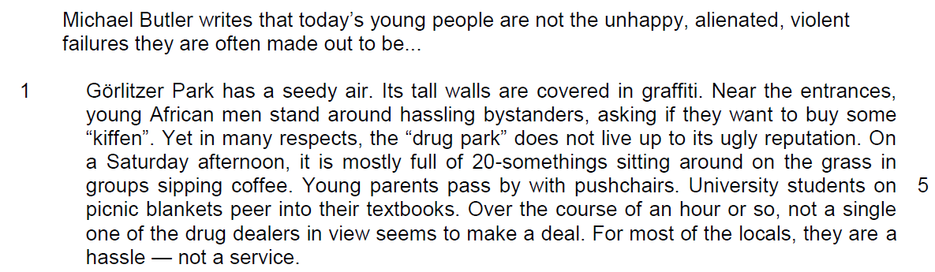

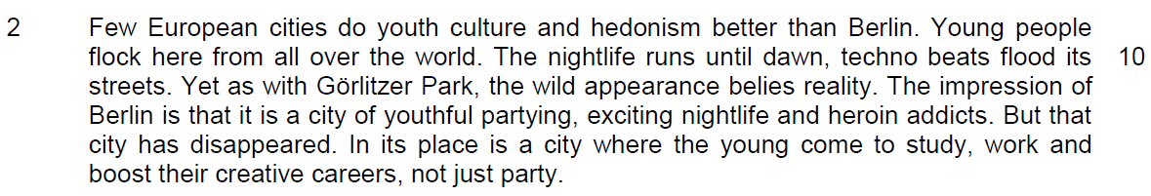

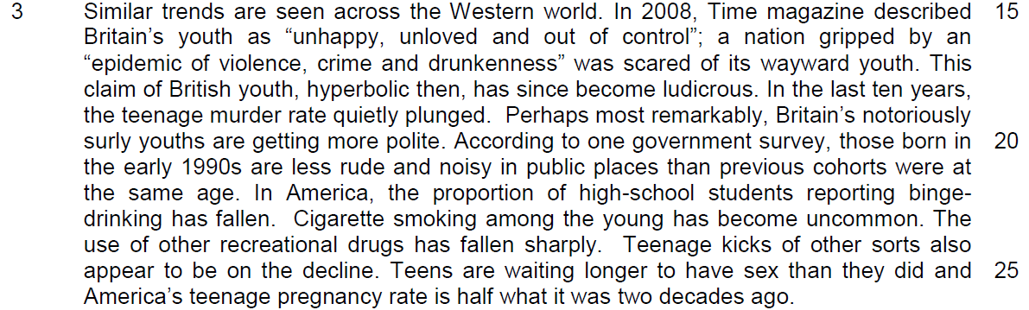

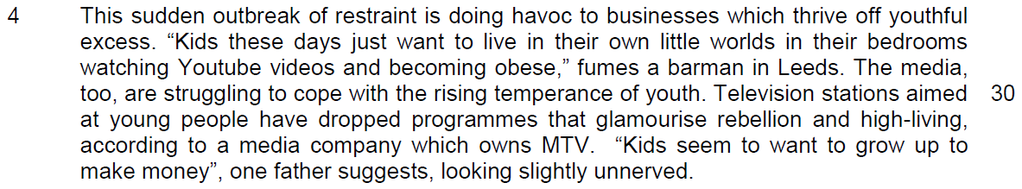

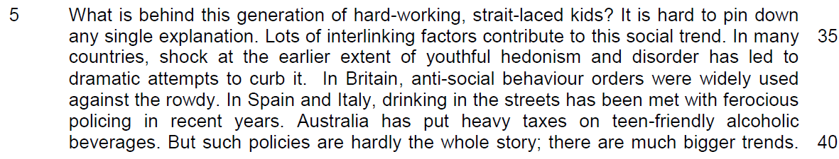

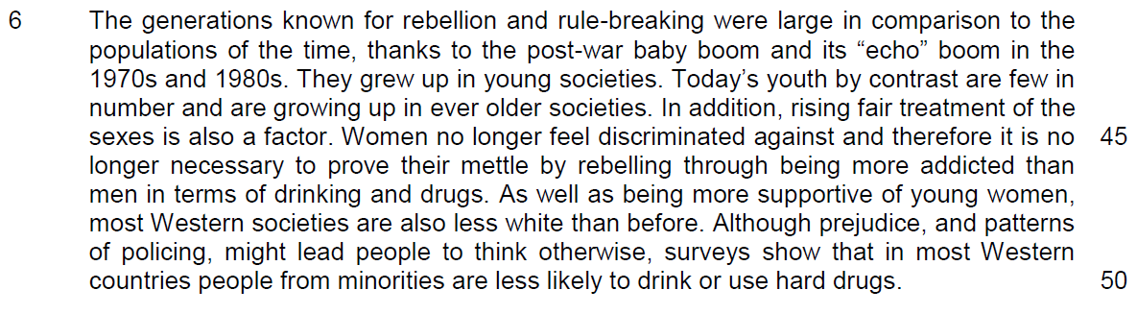

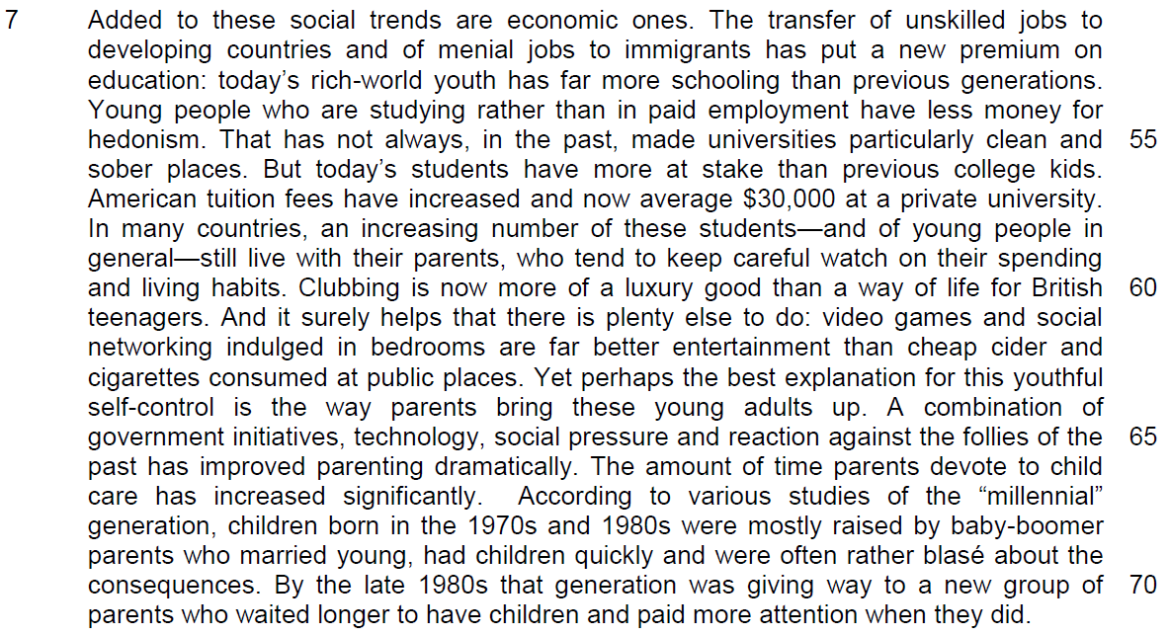

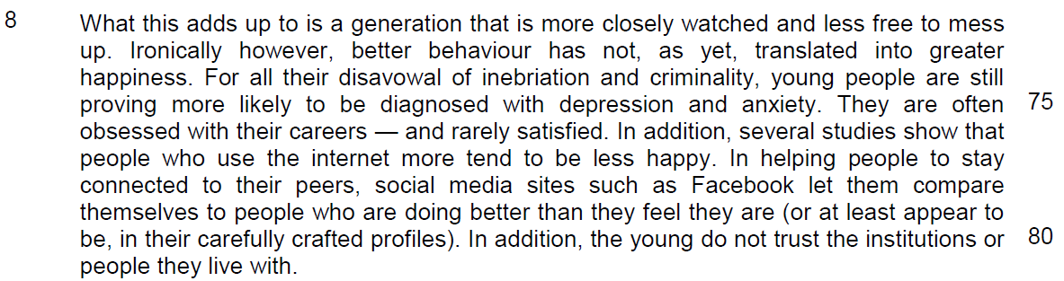

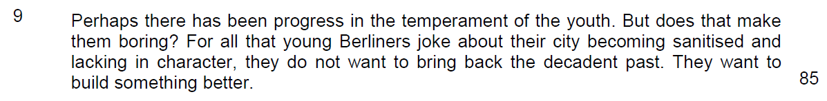

Read the passages in the insert and then answer all the questions. Note that up to fifteen marks will be given for the quality and accuracy of your use of English throughout this paper.

NOTE: When a question asks for an answer IN YOUR OWN WORDS AS FAR AS POSSIBLE and you select the appropriate material from the passage for your answer, you must still use your own words to express it. Little credit can be given to answers which only copy words and phrases from the passages.

Q1. Give two reasons from paragraph 1 why the author says that Gorlitzer Park “has a seedy air” (line 1). Use your own words as far as possible. [2]

……………………………………………………………………………………………………………………………………
……………………………………………………………………………………………………………………………………

……………………………………………………………………………………………………………………………………

……………………………………………………………………………………………………………………………………

Q2. What are the author’s purposes in beginning his opening paragraph with the example of Gorlitzer Park? Use your own words as far as possible. [2]

……………………………………………………………………………………………………………………………………
……………………………………………………………………………………………………………………………………

……………………………………………………………………………………………………………………………………

……………………………………………………………………………………………………………………………………

Q3. Explain the author’s use of the word “flock” in line 10. Use your own words as far as possible. [2]

……………………………………………………………………………………………………………………………………
……………………………………………………………………………………………………………………………………

……………………………………………………………………………………………………………………………………

……………………………………………………………………………………………………………………………………

Q4. In lines 16-17, what claims about British youth are exaggerated and explain how these are now “ludicrous” (line 18). Use your own words as far as possible. [3]

……………………………………………………………………………………………………………………………………
……………………………………………………………………………………………………………………………………

……………………………………………………………………………………………………………………………………

……………………………………………………………………………………………………………………………………

……………………………………………………………………………………………………………………………………

……………………………………………………………………………………………………………………………………

Q5. In paragraph 4, what contrasts does the author make between the youthful “excesses” (line 28) of the past and the “temperance” (line 30) of youth today? Use your own words as far as possible. [2]

……………………………………………………………………………………………………………………………………
……………………………………………………………………………………………………………………………………

……………………………………………………………………………………………………………………………………

……………………………………………………………………………………………………………………………………

Summary Question
Q6. Using material from paragraphs 5 - 7 only, summarise the reasons for the change in the behaviour of today’s youth.

Write your summary in no more than 120 words, not counting the opening words which are printed below. Use your own words as far as possible. [8]

There are many reasons for the change in youth behaviour. First, …

# | From the Passage | Paraphrased
1 | shock at the earlier extent of youthful hedonism and disorder has led to dramatic attempts to curb it (Line 36-37)
2 | anti-social behaviour orders were widely used against the rowdy (Line 37-38)
3 | drinking in the streets has been met with ferocious policing (Line 38-39)
4 | Today’s youth by contrast are few in number and are growing up in ever older societies( Line 43-44)
5 | Women no longer feel discriminated against and therefore it is no longer necessary to prove their mettle by rebelling through being more addicted than men in terms of drinking and drugs  (Line 45-47)
6 | in most Western countries people from minorities are less likely to drink or use hard drugs. (Line 49-50)
7 | The transfer of unskilled jobs to developing countries and of menial jobs to immigrants (Line 51-52)

# | From the Passage | Paraphrased
8 | has put a new premium on education (Line 52-53)
9 | Young people who are studying rather than in paid employment have less money for hedonism (line 54-55)
10 | an increasing number of these students—and of young people in general—still live with their parents (line 58-59)
11 | who tend to keep careful watch on their spending and living habits (Line 59-60)
12 | Clubbing is now more of a luxury good than a way of life for British teenagers (line 60-61)
13 | video games and social networking indulged in bedrooms are far better entertainment (Line 61-62)
14 | perhaps the best explanation for this youthful self-control is the way parents bring these young adults up(Line 63-64)
15 | The amount of time parents devote to child care has increased significantly (line 66-67)
16 | to a new group of parents who waited longer to have children and paid more attention when they did. (line 70-71)

Q7. In paragraph 8, what explanations does the author offer for why better behaviour of the young has not “translated into greater happiness” (lines 73-74)? Use your own words as far as possible. [3]

……………………………………………………………………………………………………………………………………

……………………………………………………………………………………………………………………………………

……………………………………………………………………………………………………………………………………

……………………………………………………………………………………………………………………………………

……………………………………………………………………………………………………………………………………

……………………………………………………………………………………………………………………………………

Q8. What is the author implying by the phrase “carefully crafted profiles” in line 80? [1]

……………………………………………………………………………………………………………………………………

……………………………………………………………………………………………………………………………………

Q9. Explain the author’s attitude towards the change in youthful tendencies and behaviour from the phrase “Perhaps there has been progress…” (line 82). [1]

……………………………………………………………………………………………………………………………………

……………………………………………………………………………………………………………………………………

Q10. Which phrase in the first paragraph echoes the author’s point in the last paragraph about Berliners not wanting to “bring back the decadent past” (line 84). [1]

……………………………………………………………………………………………………………………………………

……………………………………………………………………………………………………………………………………

Application Question
Q11. In this article, Michael Butler makes a number of observations about how youth in today’s Western world are no longer indulgent, aimless and rebellious. How far is this true of you and the youth in your society? [10]

……………………………………………………………………………………………………………………………………

……………………………………………………………………………………………………………………………………

……………………………………………………………………………………………………………………………………

……………………………………………………………………………………………………………………………………

……………………………………………………………………………………………………………………………………

……………………………………………………………………………………………………………………………………

……………………………………………………………………………………………………………………………………

……………………………………………………………………………………………………………………………………

……………………………………………………………………………………………………………………………………

……………………………………………………………………………………………………………………………………

……………………………………………………………………………………………………………………………………

……………………………………………………………………………………………………………………………………

……………………………………………………………………………………………………………………………………

……………………………………………………………………………………………………………………………………

……………………………………………………………………………………………………………………………………

……………………………………………………………………………………………………………………………………

……………………………………………………………………………………………………………………………………

……………………………………………………………………………………………………………………………………

……………………………………………………………………………………………………………………………………

……………………………………………………………………………………………………………………………………

……………………………………………………………………………………………………………………………………

……………………………………………………………………………………………………………………………………

……………………………………………………………………………………………………………………………………

……………………………………………………………………………………………………………………………………

……………………………………………………………………………………………………………………………………

……………………………………………………………………………………………………………………………………

……………………………………………………………………………………………………………………………………

……………………………………………………………………………………………………………………………………

……………………………………………………………………………………………………………………………………

……………………………………………………………………………………………………………………………………

……………………………………………………………………………………………………………………………………

……………………………………………………………………………………………………………………………………

……………………………………………………………………………………………………………………………………

……………………………………………………………………………………………………………………………………

……………………………………………………………………………………………………………………………………

……………………………………………………………………………………………………………………………………

……………………………………………………………………………………………………………………………………

……………………………………………………………………………………………………………………………………

……………………………………………………………………………………………………………………………………

……………………………………………………………………………………………………………………………………

……………………………………………………………………………………………………………………………………

……………………………………………………………………………………………………………………………………

……………………………………………………………………………………………………………………………………

……………………………………………………………………………………………………………………………………

……………………………………………………………………………………………………………………………………

……………………………………………………………………………………………………………………………………

……………………………………………………………………………………………………………………………………

……………………………………………………………………………………………………………………………………

