GP Term 3 2017 – Comprehension – Topic 10: International Issues – Similarities & Differences

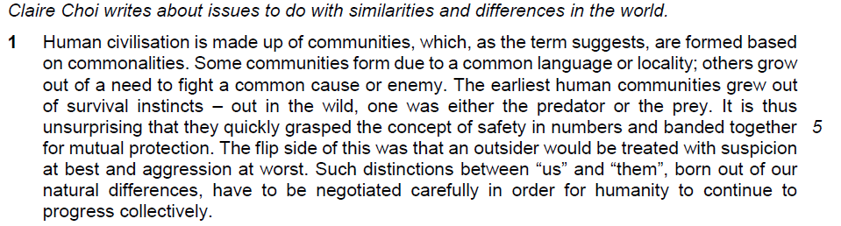

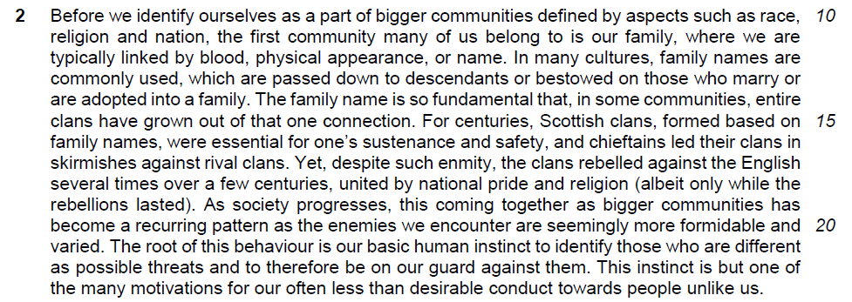

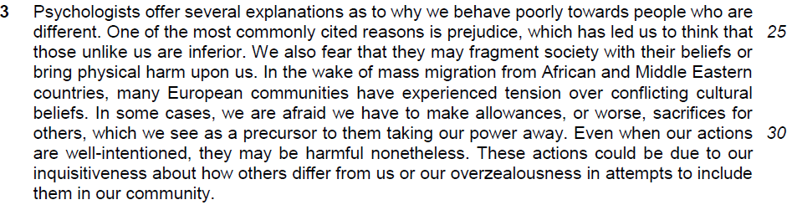

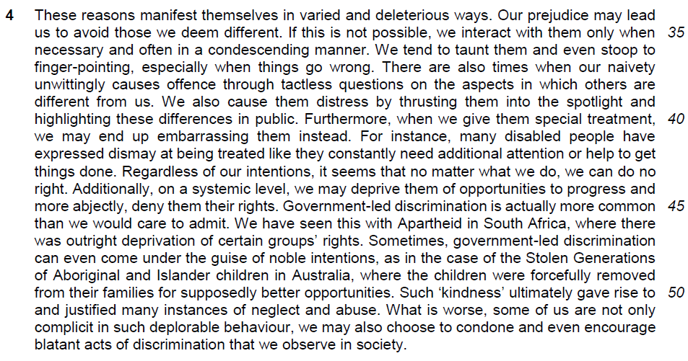

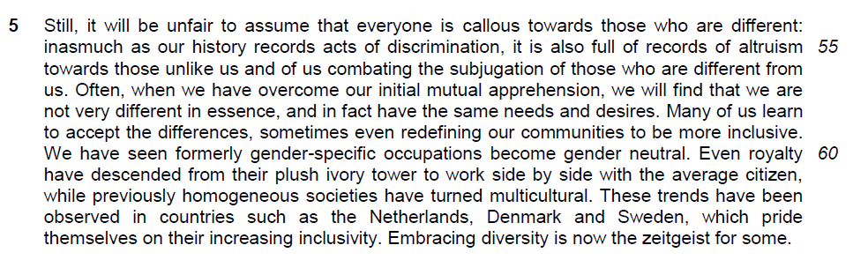

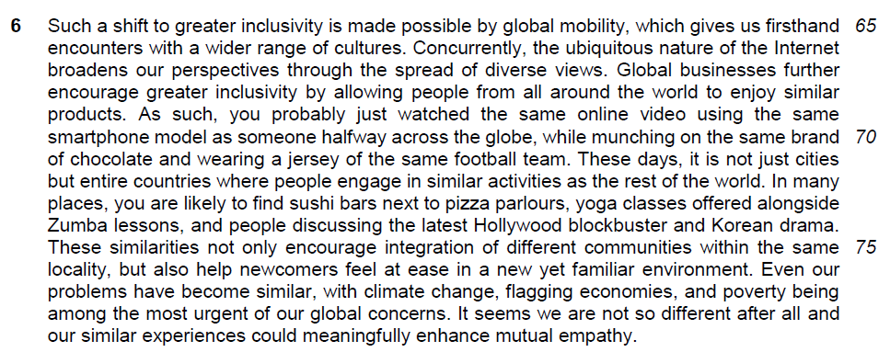

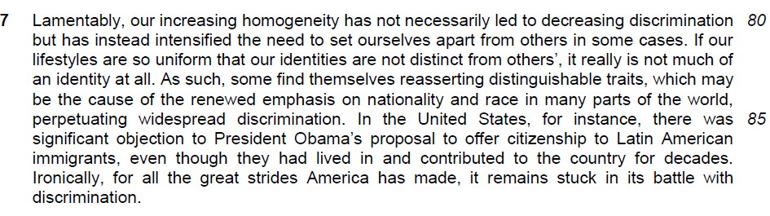

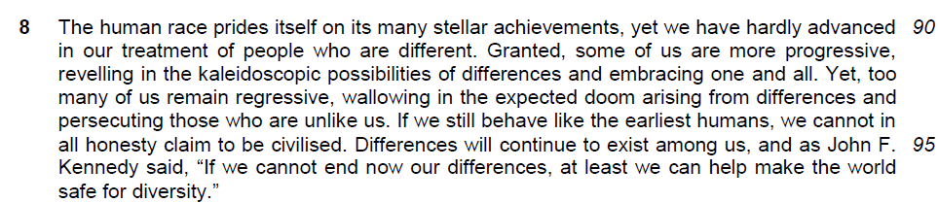

Read the passage in the Insert and then answer all the questions. Note that up to fifteen marks will be given for the quality and accuracy of your use of English throughout this Paper.

Note: When a question asks for an answer IN YOUR OWN WORDS AS FAR AS POSSIBLE and you select the appropriate material from the passage for your answer, you must still use your own words to express it. Little credit can be given to answers which only copy words and phrases from the passage.

Q1) Explain what the author means by “with suspicion at best” (lines 6-7). [2]

…………………………………………………………………………………………..

…………………………………………………………………………………………..

…………………………………………………………………………………………..

…………………………………………………………………………………………..

Q2) Why has the author placed brackets around the comment in lines 18-19? [2]

…………………………………………………………………………………………..

…………………………………………………………………………………………..

…………………………………………………………………………………………..

…………………………………………………………………………………………..

Q3) Why has the author placed the word “kindness” in inverted commas (line 50)? [1]

…………………………………………………………………………………………..

…………………………………………………………………………………………..

Q4) How does the author justify her use of the word “unfair” (line 54)? Use your own words as far as possible. [2]

…………………………………………………………………………………………..

…………………………………………………………………………………………..

…………………………………………………………………………………………..

…………………………………………………………………………………………..

Q5) What does the phrase “plush ivory tower” (line 61) suggest about the royalty? [1]

…………………………………………………………………………………………..

…………………………………………………………………………………………..

Q6) What explanations does the author offer for the “shift to greater inclusivity” (lines 65)? Use your own words as far as possible. [2]

…………………………………………………………………………………………..

…………………………………………………………………………………………..

…………………………………………………………………………………………..

…………………………………………………………………………………………..

Q7) What does the author mean by “distinguishable traits” (line 83), and what has led to the need to reassert them? Use your own words as far as possible. [2]

…………………………………………………………………………………………..

…………………………………………………………………………………………..

…………………………………………………………………………………………..

…………………………………………………………………………………………..

Q8) Using your own words as far as possible, explain the irony in lines 88-89. [2]

…………………………………………………………………………………………..

…………………………………………………………………………………………..

…………………………………………………………………………………………..

…………………………………………………………………………………………..

Q9) In paragraph 8, what contrasts does the author make between people who are “more progressive” and those who “remain regressive” in their approach towards people who are different? Use your own words as far as possible. [2]

…………………………………………………………………………………………..

…………………………………………………………………………………………..

…………………………………………………………………………………………..

…………………………………………………………………………………………..

Q10) Which idea in paragraph 1 is supported by the quotation from John F. Kennedy (lines 96-97)? [1]

…………………………………………………………………………………………..

…………………………………………………………………………………………..

…………………………………………………………………………………………..

Summary Question
Q11) Using material from paragraphs 3-4 only (lines 24-53), summarise what the author has to say about why people behave poorly towards those who are unlike them and how they act towards those who are different.

Write your summary in no more than 120 words, not counting the opening words which are printed below. Use your own words as far as possible. [8]

Firstly, people behave poorly towards those who are unlike them because…
From passage | Suggested answer
One of the most commonly cited reasons is prejudice, which has led us to think that those unlike us are inferior.
We also fear that they may fragment society with their beliefs
or bring physical harm upon us.
In some cases, we are afraid we have to make allowances,
or worse, sacrifices for others,
which we see as a precursor to them taking our power away.
Our prejudice may lead us to avoid those we deem different.
If this is not possible, we interact with them only when necessary
and often in a condescending manner.
We tend to taunt them
and even stoop to finger-pointing
our naivety unwittingly causes offence through tactless questions
We also cause them distress by thrusting them into the spotlight and highlighting these differences in public.

From passage | Suggested answer
when we give them special treatment, we may end up embarrassing them instead.
on a systemic level, we may deprive them of opportunities to progress
and more abjectly, deny them their rights.
Such ‘kindness’ ultimately gave rise to and justified many instances of neglect
and abuse.
What is worse…we may also choose to condone
and even encourage blatant acts of discrimination that we observe in society.

Application Question
Q12) In this article, Claire Choi describes some issues around the subject of differences. How applicable do you find her observations to your own society? [10]

…………………………………………………………………………………………..

…………………………………………………………………………………………..

…………………………………………………………………………………………..

…………………………………………………………………………………………..

…………………………………………………………………………………………..

…………………………………………………………………………………………..

…………………………………………………………………………………………..

…………………………………………………………………………………………..

…………………………………………………………………………………………..

…………………………………………………………………………………………..

…………………………………………………………………………………………..

…………………………………………………………………………………………..

…………………………………………………………………………………………..

…………………………………………………………………………………………..

…………………………………………………………………………………………..

…………………………………………………………………………………………..

…………………………………………………………………………………………..

…………………………………………………………………………………………..

…………………………………………………………………………………………..

…………………………………………………………………………………………..

…………………………………………………………………………………………..

…………………………………………………………………………………………..

…………………………………………………………………………………………..

…………………………………………………………………………………………..

…………………………………………………………………………………………..

…………………………………………………………………………………………..

…………………………………………………………………………………………..

…………………………………………………………………………………………..

…………………………………………………………………………………………..

…………………………………………………………………………………………..

…………………………………………………………………………………………..

…………………………………………………………………………………………..

…………………………………………………………………………………………..

…………………………………………………………………………………………..

…………………………………………………………………………………………..

…………………………………………………………………………………………..

…………………………………………………………………………………………..

…………………………………………………………………………………………..

…………………………………………………………………………………………..

…………………………………………………………………………………………..

…………………………………………………………………………………………..

…………………………………………………………………………………………..

…………………………………………………………………………………………..

…………………………………………………………………………………………..

