GP Comprehension – Loneliness
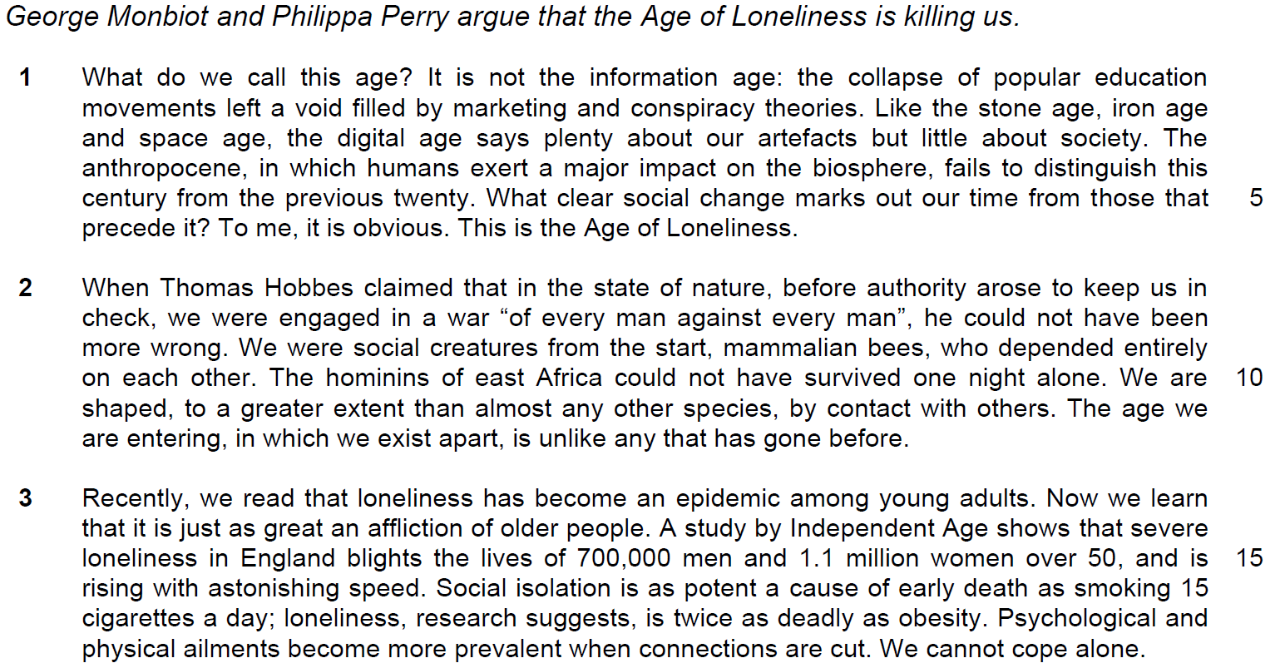
Comment 1 -
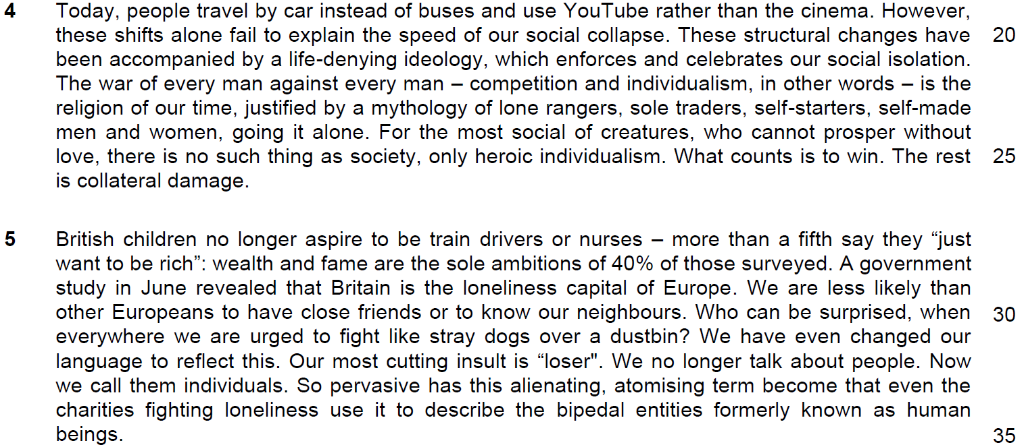

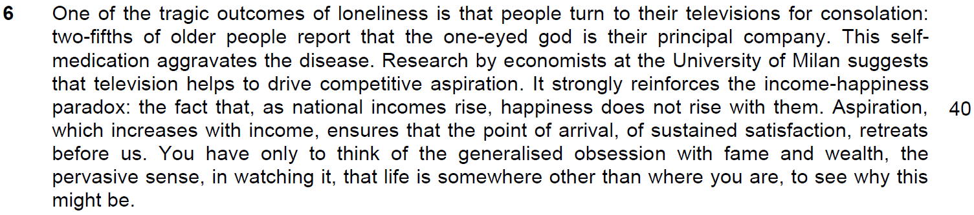

Comment 2

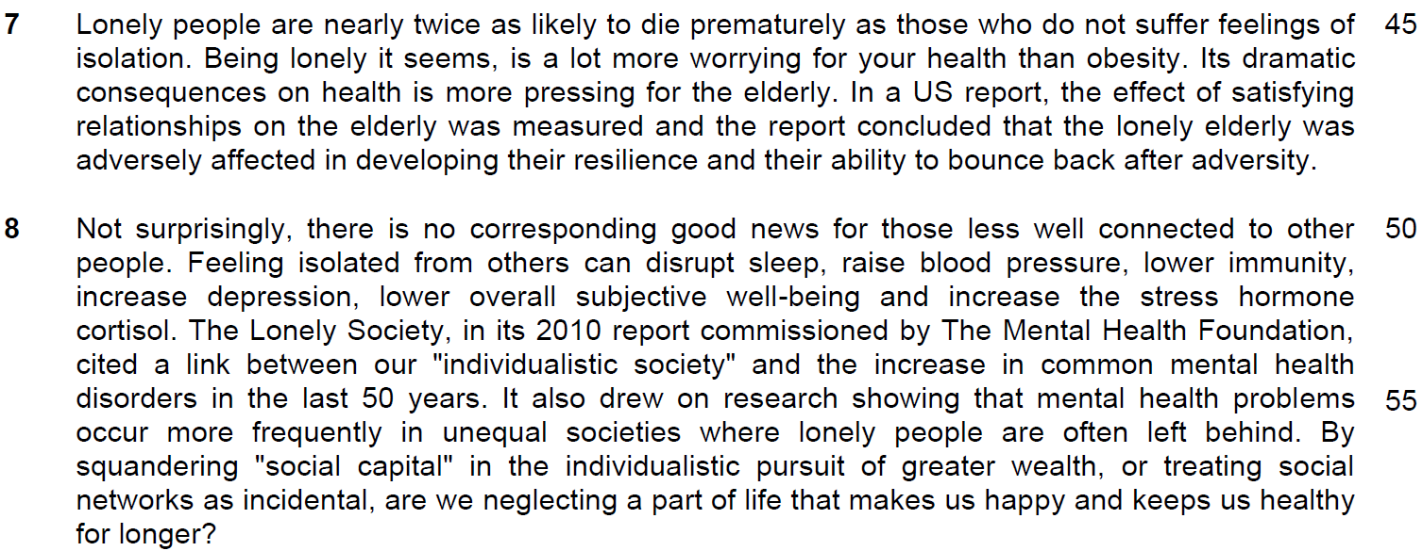
Comment 3
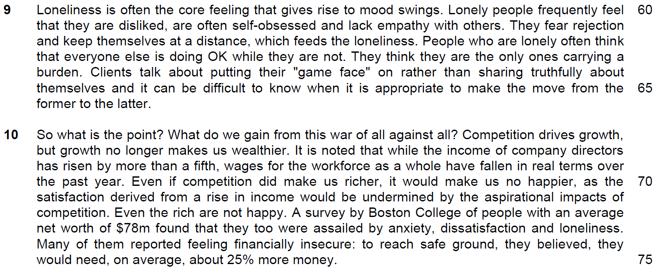
Comment 4
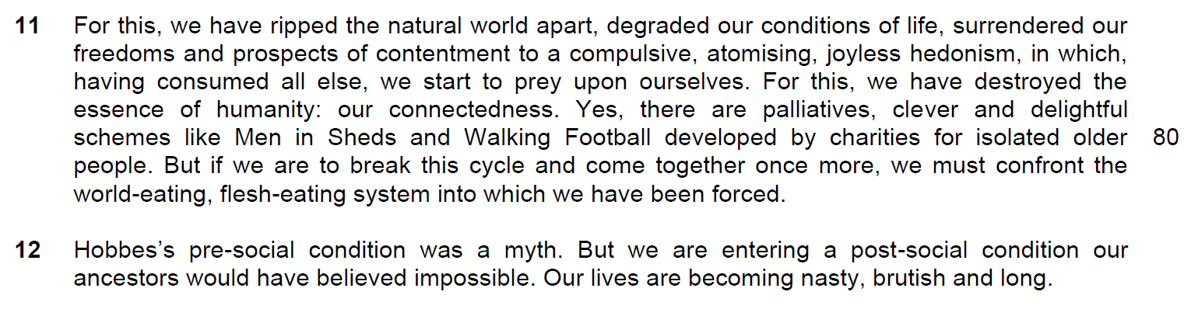
Review -

Read the passage in the Insert and then answer all the questions. Note that up to fifteen marks will be given for the quality and accuracy of your use of English throughout this Paper.

NOTE: When a question asks for an answer IN YOUR OWN WORDS AS FAR AS POSSIBLE and you select the appropriate material from the passage for your answer, you must still use your own words to express it. Little credit can be given to answers which only copy words and phrases from the passage.

1. In lines 2-3, what similarity do the authors see between the Age of Loneliness and the ages that precede it? Use your own words as far as possible. [2]

……………………………………………………………………………………………………………………………………
……………………………………………………………………………………………………………………………………

……………………………………………………………………………………………………………………………………
……………………………………………………………………………………………………………………………………

2. What is the claim made by Thomas Hobbes in lines 7-8 and why do the authors disagree with it? Use your own words as far as possible. [3]

……………………………………………………………………………………………………………………………………
……………………………………………………………………………………………………………………………………

……………………………………………………………………………………………………………………………………
……………………………………………………………………………………………………………………………………

……………………………………………………………………………………………………………………………………
……………………………………………………………………………………………………………………………………

3. In paragraph 3, what do the words ‘just as’ tell you about the effect of the epidemic on older people? [1]

……………………………………………………………………………………………………………………………………
……………………………………………………………………………………………………………………………………

4. What is implied by the ‘shifts’ (line 21) described in the sentence ‘Today people travel by car instead of buses and use YouTube rather than the cinema’ in line 20? [2]

……………………………………………………………………………………………………………………………………
……………………………………………………………………………………………………………………………………

……………………………………………………………………………………………………………………………………
……………………………………………………………………………………………………………………………………

5. Explain the phrase ‘to fight like stray dogs over a dustbin’ (line 32). [2]

……………………………………………………………………………………………………………………………………
……………………………………………………………………………………………………………………………………

……………………………………………………………………………………………………………………………………
……………………………………………………………………………………………………………………………………

6. Explain the ‘income-happiness paradox’ in lines 40-41. Use your own words as far as possible. [2]

……………………………………………………………………………………………………………………………………
……………………………………………………………………………………………………………………………………

……………………………………………………………………………………………………………………………………
……………………………………………………………………………………………………………………………………

7. What does the word ‘assailed’ in line 74 tell us about how loneliness affects the rich? [1]

……………………………………………………………………………………………………………………………………
……………………………………………………………………………………………………………………………………

8(a) What does ‘this’ in line 77 refer to? [1]

……………………………………………………………………………………………………………………………………
……………………………………………………………………………………………………………………………………

8(b) Why does the author repeat the phrase ‘for this’ in lines 77 and 79? [1]

……………………………………………………………………………………………………………………………………
……………………………………………………………………………………………………………………………………

9) What are the authors’ opinion about schemes like ‘Men in Sheds’ and ‘Walking Football’ in line 82? [1]

……………………………………………………………………………………………………………………………………
……………………………………………………………………………………………………………………………………

10) Why is Hobbes mentioned again in the first line of paragraph 12? [1]

……………………………………………………………………………………………………………………………………
……………………………………………………………………………………………………………………………………

