GP Comprehension – Addiction
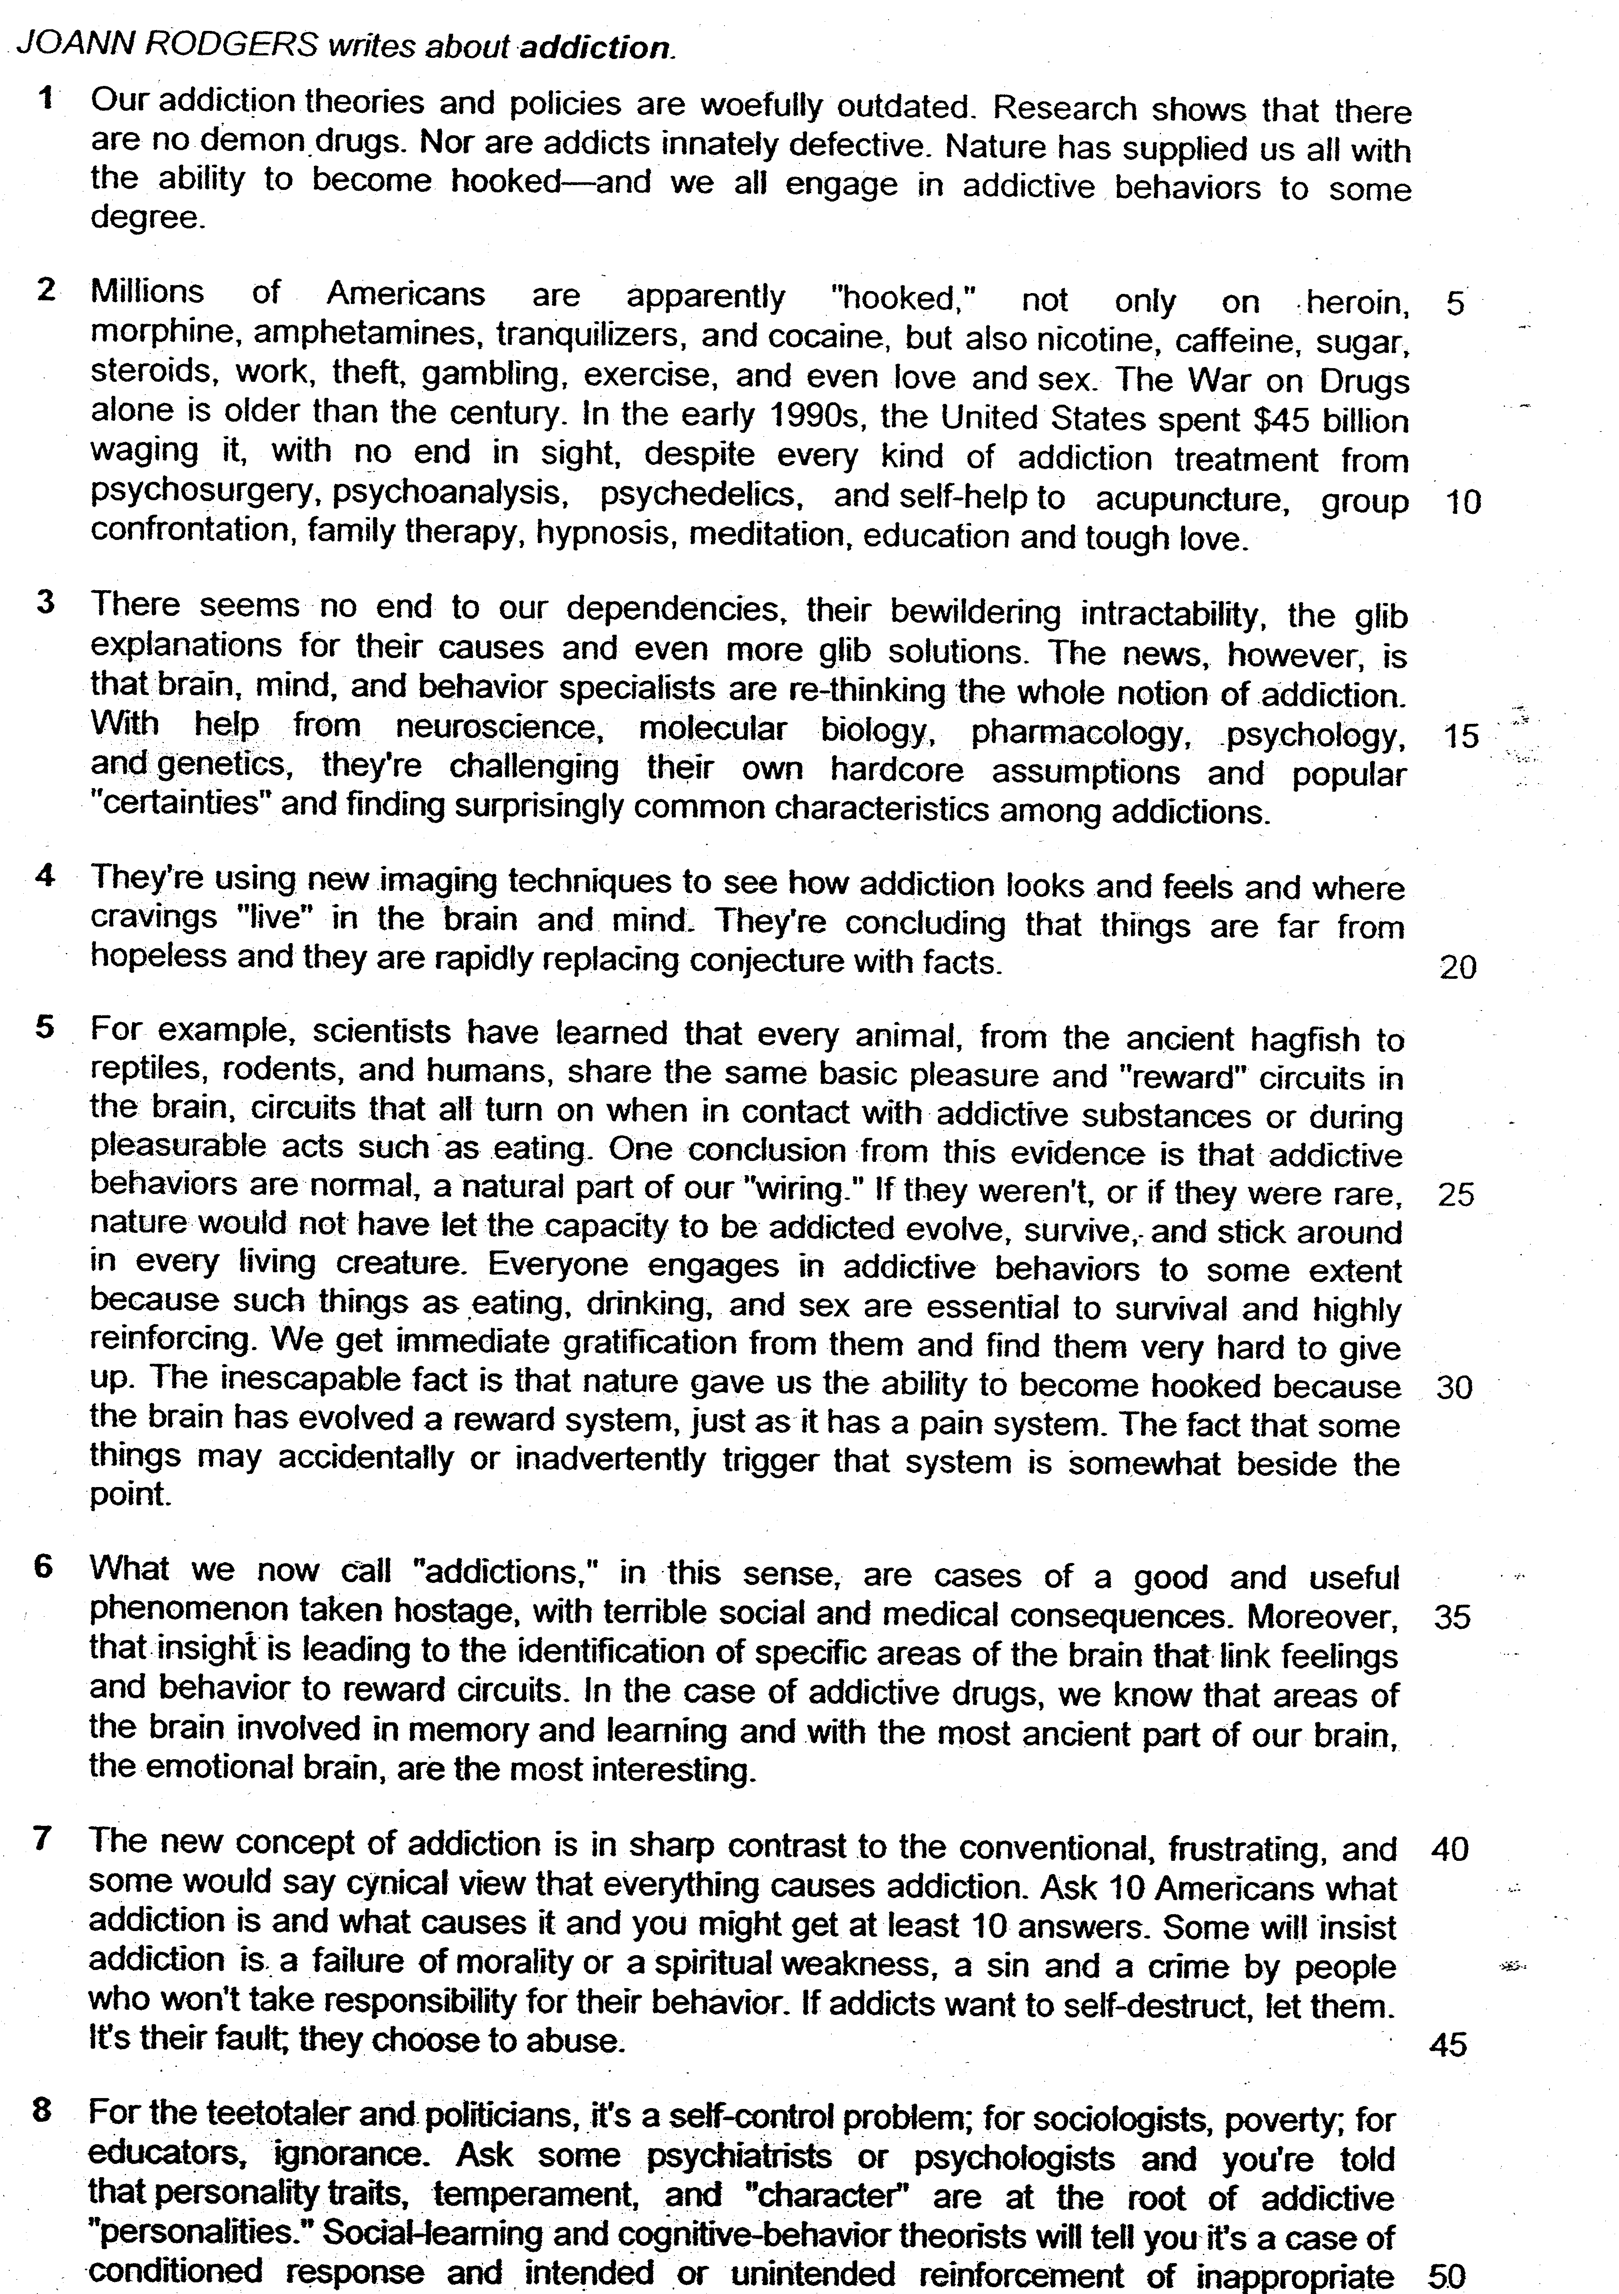

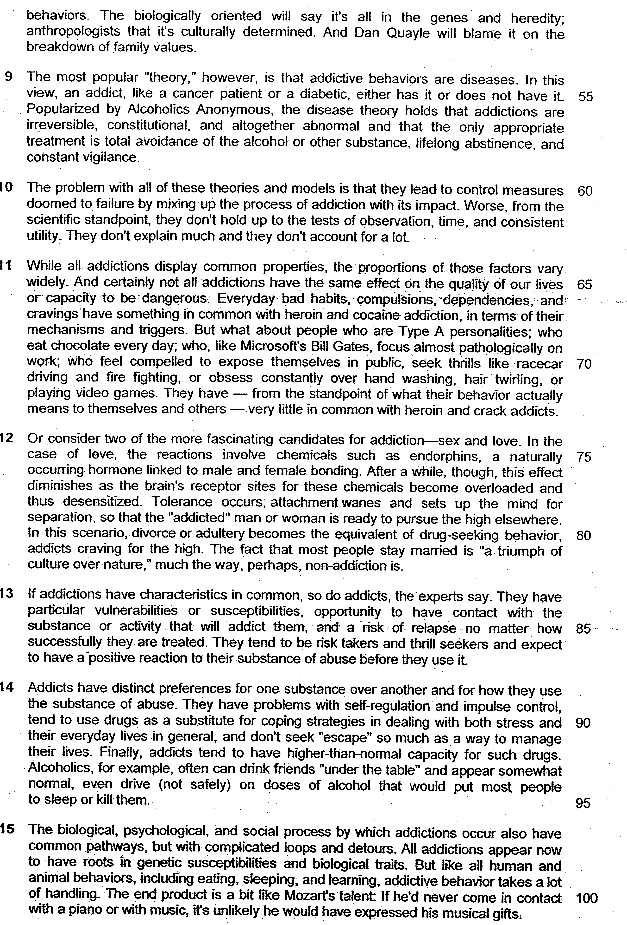

Read the passage in the insert and then answer all the questions which follow below. Note that up to fifteen marks will be given for the quality and accuracy of your use of English throughout this paper.

NOTE: When a question asks for an answer IN YOUR OWN WORDS AS FAR AS POSSIBLE and you select the appropriate material from the passages for your answer, you must still use your own words to express it. Little credit can be given to answers which only copy words or phrases from the passages.

1. Explain in your own words as far as possible how addiction theories and policies have become ‘woefully outdated’ (line 1)

…………………………………………………………………………………………

…………………………………………………………………………………………
……………………………………………………………………………………… [2]

2. From paragraph 2, explain in your own words as far as possible Americans’ efforts in dealing with addiction.

…………………………………………………………………………………………

…………………………………………………………………………………………
……………………………………………………………………………………… [2]

3. Why is the word “certainties” (line 17) in quotation marks?

…………………………………………………………………………………………

…………………………………………………………………………………………

…………………………………………………………………………………………
……………………………………………………………………………………… [2]

4. Identify the similarity and difference between ‘people who are Type A personalities’ (line 68) and ‘heroin and crack addicts’ (line 73). Use your own words as far as possible.

…………………………………………………………………………………………

…………………………………………………………………………………………

…………………………………………………………………………………………
……………………………………………………………………………………… [2]

5. Explain what the author means by staying married is “a triumph of culture over nature” (lines 81-82)?

…………………………………………………………………………………………

…………………………………………………………………………………………
……………………………………………………………………………………… [2]

6. “… even drive (not safely) …” (line 94)

Why does the author place parenthesis around “not safely”?

…………………………………………………………………………………………

…………………………………………………………………………………………

…………………………………………………………………………………………
……………………………………………………………………………………… [2]

7. What point is the author making in the last sentence (lines 100 – 101)?

…………………………………………………………………………………………

…………………………………………………………………………………………

…………………………………………………………………………………………
……………………………………………………………………………………… [2]

8. Using material from paragraphs 5 to 9, summarise how the scientific discoveries about the nature of addiction differ from other existing theories. Write your summary in no more than 120 words, not counting the opening words printed below. Use your own words as far as possible.

One of the proposed theories………...………………………………………..

…………………………………………………………………………………………

…………………………………………………………………………………………
…………………………………………………………………………………………
…………………………………………………………………………………………
…………………………………………………………………………………………

…………………………………………………………………………………………
…………………………………………………………………………………………
…………………………………………………………………………………………
…………………………………………………………………………………………

…………………………………………………………………………………………

…………………………………………………………………………………………
…………………………………………………………………………………………
…………………………………………………………………………………………
…………………………………………………………………………………………
…………………………………………………………………………………………

…………………………………………………………………………………………
…………………………………………………………………………………………
…………………………………………………………………………………………
…………………………………………………………………………………………

……………………………………………………………………………………… [8]

10. Joann Rodgers argues strongly that the theories and models of addiction ‘lead to control measures doomed to failure’ in modern society. How far do you agree with her views on addiction and its control measures?

Illustrate your answer by referring to the ways in which you and your society regard addiction and develop control measures for it.

…………………………………………………………………………………………

…………………………………………………………………………………………

………………………………………………………………………………………….

………………………………………………………………………………………….

………………………………………………………………………………………….

………………………………………………………………………………………….

…………………………………………………………………………………………..

…………………………………………………………………………………………..

…………………………………………………………………………………………

………………………………………………………………………………………….

…………………………………………………………………………………………

…………………………………………………………………………………………

………………………………………………………………………………………….

………………………………………………………………………………………….

………………………………………………………………………………………….

………………………………………………………………………………………….

…………………………………………………………………………………………..

…………………………………………………………………………………………..

…………………………………………………………………………………………

………………………………………………………………………………………….

…………………………………………………………………………………………

…………………………………………………………………………………………

………………………………………………………………………………………….

………………………………………………………………………………………….

………………………………………………………………………………………….

………………………………………………………………………………………….

…………………………………………………………………………………………..

…………………………………………………………………………………………..

…………………………………………………………………………………………

………………………………………………………………………………………….

………………………………………………………………………………………….

………………………………………………………………………………………….

…………………………………………………………………………………………..

…………………………………………………………………………………………..

………………………………………………………………………………………….

…………………………………………………………………………………………..

…………………………………………………………………………………………..

………………………………………………………………………………………….

……………………………………………………………………………………… [8]

Suggested Answers

- Explain in your own words as far as possible how addiction theories and policies have become ‘woefully outdated’ (line 1). [2m]

Lifted
Our addiction theories and policies are woefully outdated. Research shows that there are no demon drugs. Nor are
innately defective.

Nature has supplied us all with the ability to become hooked – and we all engage in addictive behaviours to some degree.

Paraphrased
Through experiments/studies, we have realized that our previous understanding/existing theories about addiction are invalid/not applicable. Instead, we now have a better/new understanding of the causes of addiction. Hence, this would suggest that our current methods to address addiction are obsolete and inadequate to deal with the problem effectively.

- From paragraph 2, explain in your own words as far as possible Americans’ efforts in dealing with addiction. [2m]

Lifted
The War on Drugs alone is older than the century.

In the early 1990s, the United States spent $45 billion waging it.

with no end in sight,

despite every kind of addiction treatment from psychosurgery, psychoanalysis…

Paraphrased
It has been on-going/through many years and vast amount of resources/money utilized. Yet, we cannot observe any visible result even though we have tried all possible forms of cure/management/means of healing.

- Why is the word “certainties” (line 17) in quotation marks? [2m]

The author questions/doubts the suitability of the word.
OR
The author does not intend the word in its original meaning.
OR
“Certainties” refer to indisputable facts. The fact that experts are challenging these facts suggest that they are actually debatable or arguable.

- Identify the similarity and difference between ‘people who are Type A personalities’ (line 68) and ‘heroin and crack addicts’ (line 73). Use your own words as far as possible. [2m]

Lifted
something in common… mechanisms and triggers

not all addictions have the same effect on the quality of our lives or capacity to be dangerous

what their behaviour actually means to themselves and others … very little in common.

Paraphrased
Similarity:
- Means/methods and
- Catalysts/stimulus/impetus

OR
- Way/process by which one becomes addicted

Difference:
- Differing impacts on our lives
- Potential to result in harm to others
- The significance of the addict’s action

People who have type A personalities and ‘heroin and crack addicts’ are similar in terms of their cause to be addict and how they get addicted. However, the degree of harm from their addiction on their families and themselves may vary and this will influence the degree of significant of the problem of addiction.

- Explain what the author means by staying married is “a triumph of culture over nature” (lines 81-82)? [2m]

Lifted
a triumph of culture over nature

Paraphrased
The author means that staying married is an indication that our social rules/regulations/conventions are able/successful in suppressing our tendencies to stray.

- “… even drive (not safely) …” (line 94)

Why does the author place parenthesis around “not safely”? [2m]

Lifted
Finally, addicts tend to have higher-than-normal capacity for such drugs. Alcoholics, for example, often can drink friends “under the table” and appear somewhat normal, even drive (not safely) on doses of alcohol that would put most people to sleep or kill them.

Paraphrased
The author wants to qualify/explain her opinion/view/trying to be tongue-in-cheek that though many would claim that addicts are still able to function under alcoholic influence, this ability will be hampered somewhat/addicts are not immune to alcohol.

Note: Parenthesis de-emphasise the content within, and are meant to supplement information, not take away emphasis from the main text.

- What point is the author making in the last sentence (lines 100 – 101)? [2m]

Lifted
The end product is a bit like Mozart’s talent: If he’d never come in contact with a piano or with music, it’s unlikely he would have expressed his musical gifts.

Paraphrased
The author’s point is that we all possess the propensity/inclination to be addicted and it only requires a trigger/catalyst/opportunity to draw it out.

OR
Addictive behaviour can be positively harnessed/ channeled so that an obsession can be turned into talent, like how Mozart might initially have been addicted to piano or music. But as a result of this addiction, he ended up with a great flair for music.

8. Using material from paragraphs 5 to 9, summarise how the scientific discoveries about the nature of addiction differ from other existing theories. Write your summary in no more than 120 words, not counting the opening words printed below. Use your own words as far as possible.

One of the proposed theories
No | From the passage | Paraphrasing
1 | Some will insist addiction is a failure of morality or a spiritual weakness, | involves people who are adamant that such patterns reflects a loss of values or feebleness in our soul/religion.
2 | A sin and a crime by people who won’t take responsibility for their behaviour. | And is a deliberate moral violation of the principle of accountability for one’s actions.
3 | For the teetotaller and politicians, it’s a self-control problem; or sociologists, poverty; for educators, ignorance. | For government officials and those who abstain from liquor, addiction is a case of self-discipline; scholars of human society blame indigence; teachers, the lack of knowledge.
4 | Ask some psychiatrists or psychologists and you’re told that personality traits, temperament, and “character” are at the root of addictive “personalities.” | Psychiatrists and psychologists attribute such obsessive behaviour to the emotional and social qualities of an individual.
5 | Social-learning and cognitive-behaviour theorists will tell you it’s a case of conditioned response and intended or unintended reinforcement of inappropriate behaviours. | Other researches may just put it down as a habit, whether deliberate or not, reaffirmed by the outcome of our actions.
6 | The biologically oriented will say it’s all in the genes and heredity; anthropologists that it’s culturally determined. | Some theories explain addiction as part of a genetic code of human behaviour while anthropologists propose that it is dependent on the environment we live in.
7 | And Dan Quayle will blame it on the breakdown of family values. | And another theory may point a finger at the erosion of kinship ties.
8 | The most popular “theory”, however, is that addictive behaviours are diseases. | The theory that has the widest acceptance is that they are medical conditions/aliments/illnesses.
9 | the disease theory holds that addictions are irreversible, constitutional, and altogether abnormal and that the only appropriate treatment is total avoidance of the alcohol or other substance, lifelong abstinence, and constant vigilance. | that are inherent, deviant and cannot be treated. The feasible/suitable solution is to abstain from objects of gratification and to be alert for possible symptoms.
10 | Scientists have learned that every animal, from the ancient hagfish to reptiles, rodents and humans, share the same basic pleasure and “reward” circuits in the brain, circuits that all turn on when in contact with addictive substances or during pleasurable acts such as eating. | Scientists however/in contrast have discovered that all animals have similar fundamental cognitive sense of gratification. It is triggered when we are hooked on something or engaged in enjoyable behaviour/indulgences.
11 | One conclusion from this evidence is that addictive behaviours are normal, a natural part of our “wiring.” | This shows that such obsessive activity patterns are a constituent/component/element of our genetic make-up/biological blueprint.
12 | If they weren’t, or if they were rare, nature would not have let the capacity to be addicted evolve, survive, and stick around in every living creature. | Otherwise, they would have been eradicated/ removed/purged from within us.  OR  These tendencies would have died out through natural selection/Darwinian processes.  OR  These tendencies would have removed via adaptation.
13 | Everyone engages in addictive behaviours to some extent because such things such as eating, drinking, and sex are essential to survival and highly reinforcing. | Humans indulge in such obsessive patterns as they reaffirm what we do and are crucial to our existence.
14 | We get immediate gratification from them and find them very hard to give up. | They also give us instant satisfaction which makes it even more difficult to renounce.
15 | The inescapable fact is that nature gave us the ability to become hooked because the brain has evolved a reward system, just as it has a pain system. | because of the pleasure we recognise from our cognitive mechanism.
16 | What we now call ‘addictions,” are cases of a good and useful phenomenon taken hostage, with terrible social and medical consequences. | Scientific discoveries show that addiction can be favourable and advantageous. However, when taken to the extreme, this would have severely impact our health and community.
17 | Moreover, that insight is leading to the identification of specific areas of the brain that link feelings and behaviour to reward | This demonstrates that there may be a correlation between our emotions and actions and what we get in return.
18 | The new concept of addiction is in sharp contrast to the conventional, frustrating, and some would say cynical view that everything causes addiction. | The novel idea of obsessive behaviour patterns is clearly distinctive from the commonly accepted, dissatisfying and even pessimistic perspective that anything can result in addiction.

