GP Term 3 2017 – Comprehension – Topic 1: Social Media/Fake News – How we respond to news

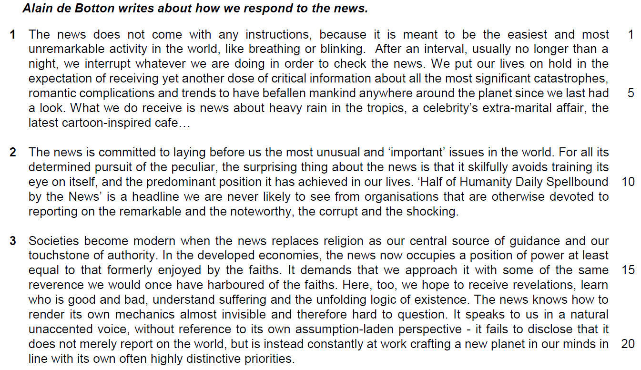

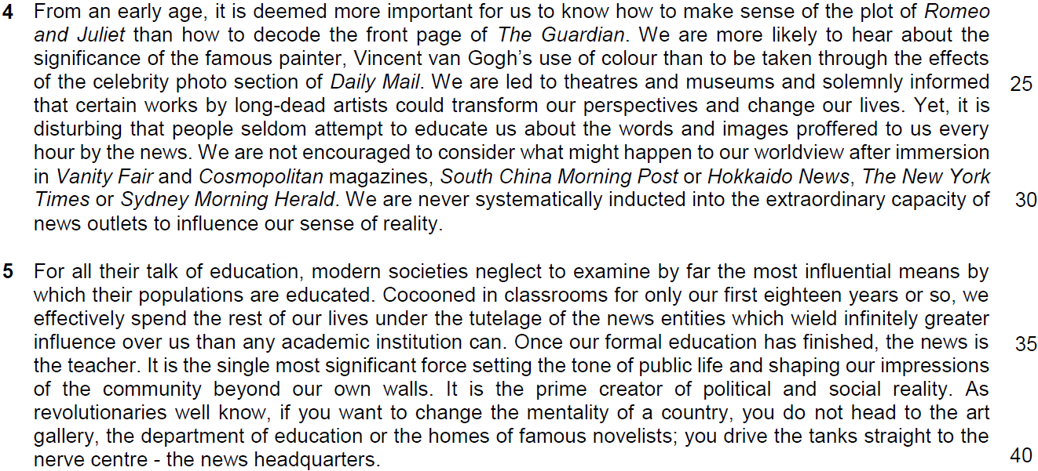

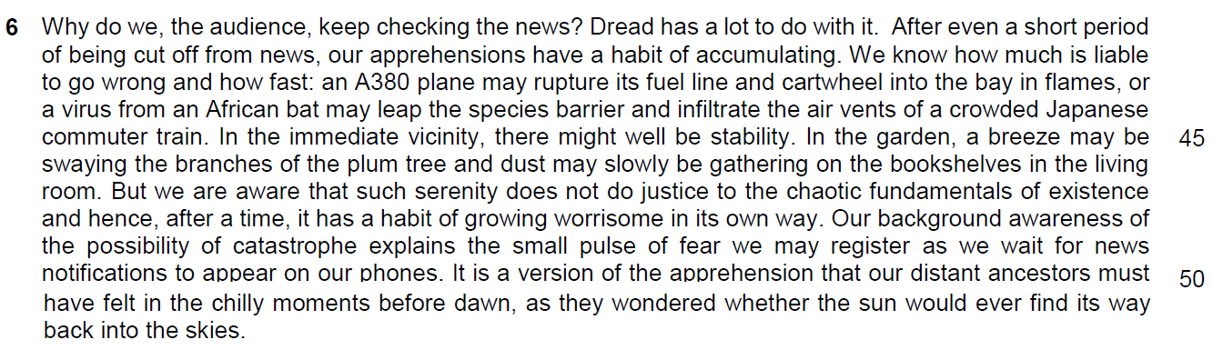

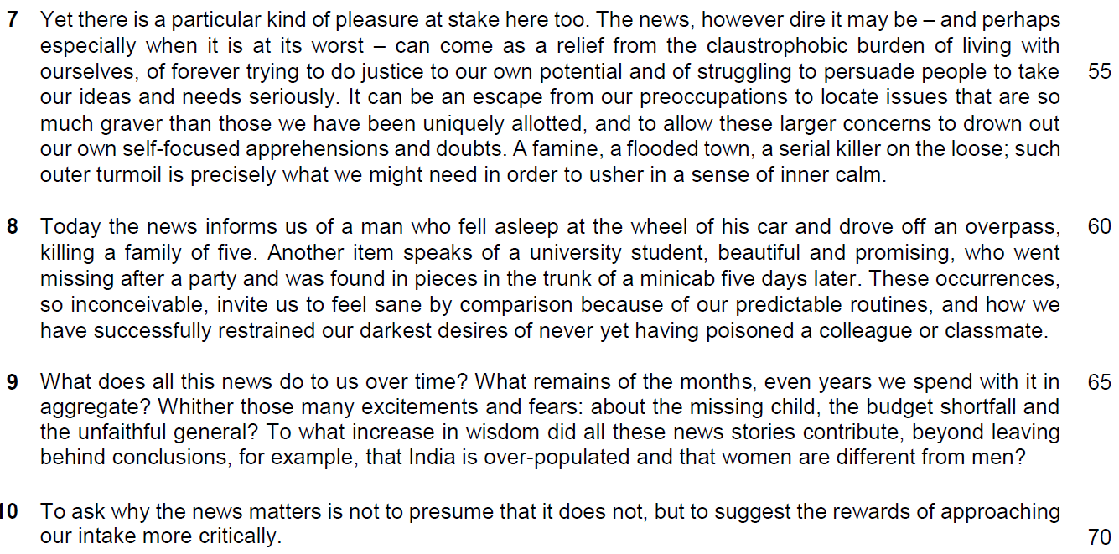

Application Question (AQ)
12. In this article, Alain de Botton writes about how we respond to the news. How far are his views reflective of your society? [8]

Introduction
Brief description of the requirements of the question
Main body
1. Quote: ‘Societies become modern when the news replaces religion as our centre source of guidance and our touchstone of authority’
2. Description of the quote: this implies that news has become a scared and significant source o information to guide us on how we live our lives to survive with the information aid out by news.
(inform us – guide us – make decision on our moral judgement – imbue in us the natural values we should have to conduct our lives in modern society
3. Elaboration - Why this view is reflective: it is apparent in Singapore as Singapore is a lawfully regulated society and we need news to inform us on how we conducted our lives in accordance with the regulation and rules established by the government. It has also become the source of information to shape our moral and ethical judgements
4. Example: POFMA, the Covid vaccination protocol, Additional Buyer’s Stamp Duty and other legislatures are transmitted to the people – shaping news to be the new religion that guides us on how we live our lives correctly and lawfully in this modern society. Public Journalism and reviews on social media like Stomp and news agency like The Strait Times have also shaped our views on ethical issues like our treatment on foreign workers and helpers and how we behave and drive on the road.
5. EOA
5.1 EOA sentence / Idea: However, such a view is too narrowed as religious beliefs and social values still hold great significance in modern society.
5.2 Elaboration 2: these values are significantly engrained in our mindsets, inherited through family, social communities – forge the foundations of our thinking – develop a common sense of thinking that guides us on how we eat, socialise and work – news transmitted through social media and news agency are purely the instruments in modern society and would not disestablish our cultural heritage, becoming the new divine source of values and practices
6. Example
Although people who claimed not to have a religion has risen from 17% in 2010 to 20% in 2022, 80% of Singaporeans are still holding a religion as the source of beliefs as stated by a survey done by Department of Statistics Singapore. This proves that it is not very reflective in Singapore to claim that News has become the new religion in Singapore which is a modern society.
7. Linking Sentence
We cannot deny the influence of news as the new source of information that shapes us on how we conduct our lives in modern society but we must play down this influence as modern society like Singapore is still guided by its cultural and religious beliefs.

Points to take note:
1. How do you quote your point
2. how to make it relevant to your argument – what is the basic argument behind this point?
3. how to derive the example to support your argument
4. how to write the points in these two paragraphs.

