GP Term 4 2018 – Comprehension – Topic 1: Reflective Issues (Positive) – Happiness

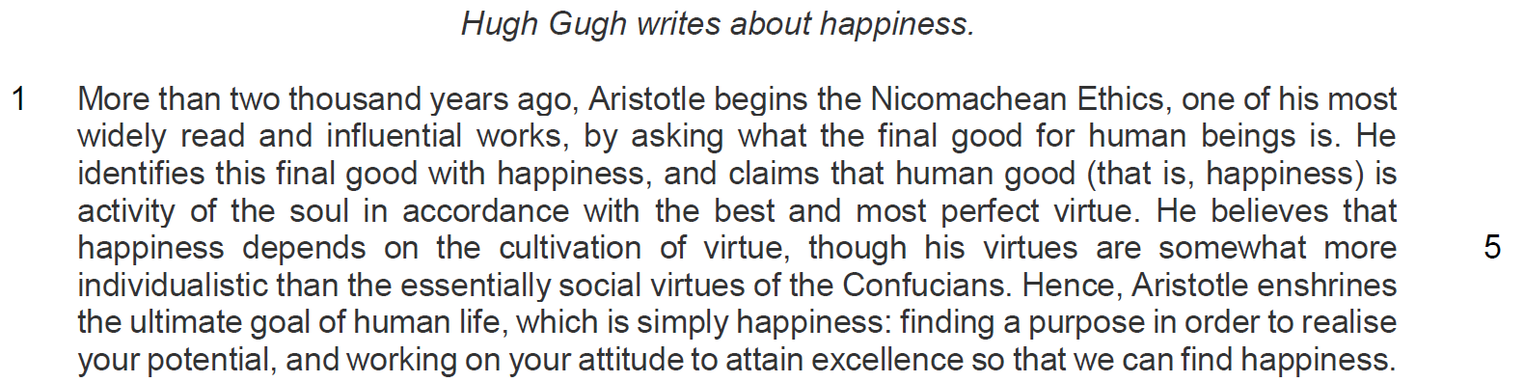
Extract 1 – nature of discussion –
Purpose -

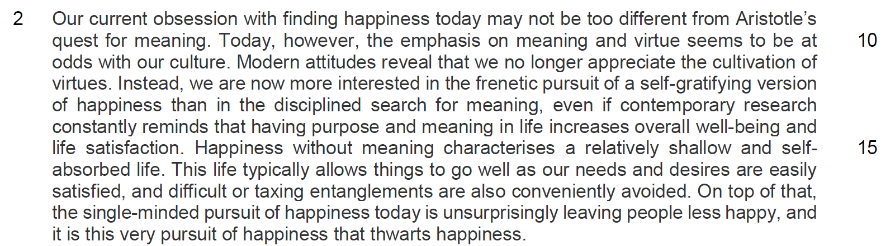
Extract 2 – nature of discussion
Purpose -

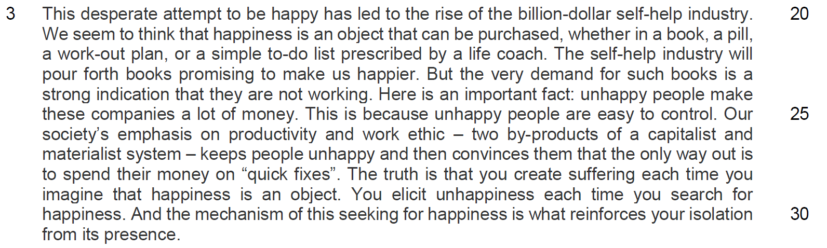

Extract 3 nature of discussion
Purpose -

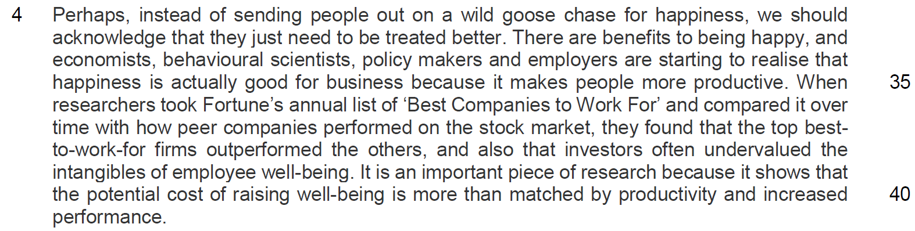
Extract 4 – nature of discussion
Purpose

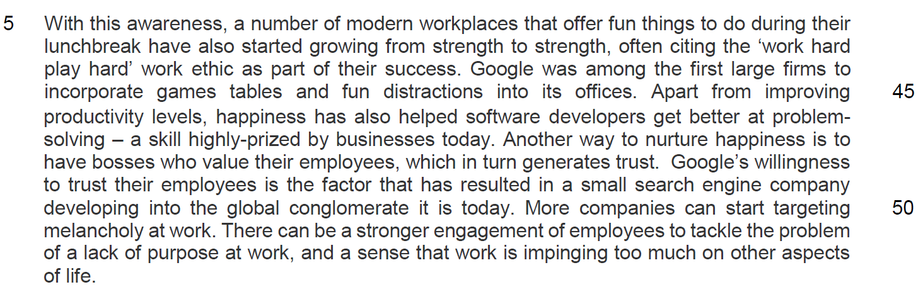
Extract 5 – nature of discussion
Purpose -

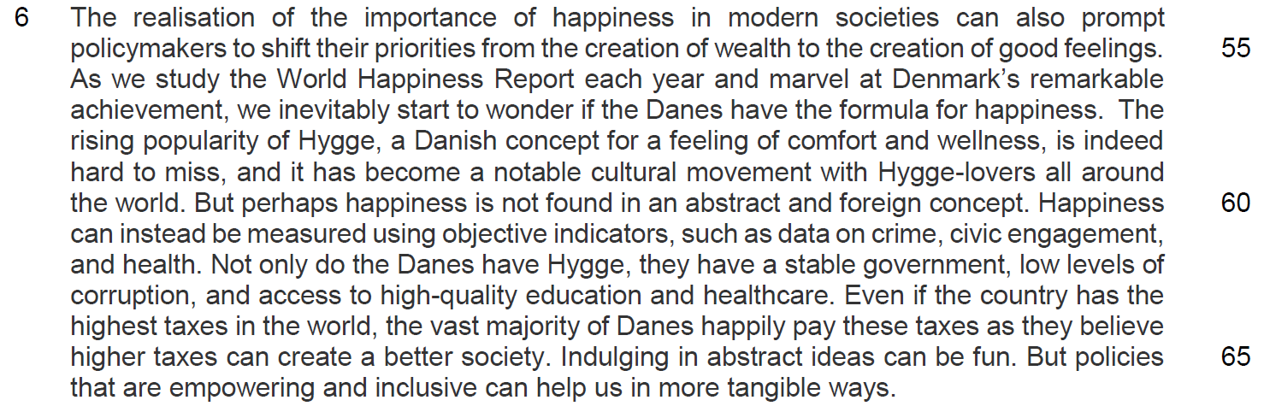
Extract 6 – Nature of discussion
Purpose –

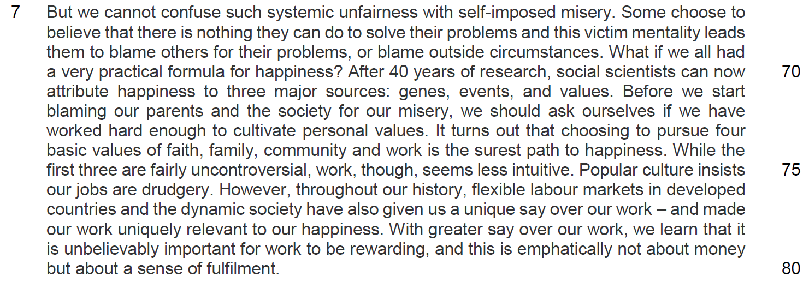
Extract 7 – nature of discussion
Purpose -

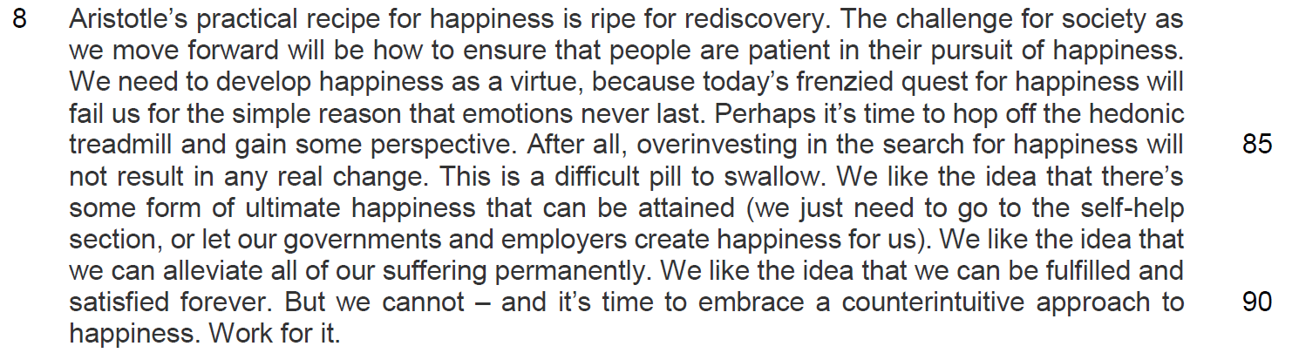
Extract 8 – nature of discussion
Purpose

Questions
Q1) Suggest reasons for the author beginning the passage with a reference to Aristotle’s Nicomachean Ethics. [2]

…………………………………………………………………………………………………..

…………………………………………………………………………………………………..

…………………………………………………………………………………………………..

…………………………………………………………………………………………………..

Q2) Why does the author use the word ‘enshrines’ (line 6) with reference to happiness? [1]

…………………………………………………………………………………………………..

…………………………………………………………………………………………………..

Q3) In lines 15-17, how does the author support his idea that people are now more interested in a ‘self-gratifying version of happiness than in the disciplined search for meaning’ (lines 12-13)? Use your own words as far as possible. [3]

…………………………………………………………………………………………………..

…………………………………………………………………………………………………..

…………………………………………………………………………………………………..

…………………………………………………………………………………………………..

…………………………………………………………………………………………………..

…………………………………………………………………………………………………..

Q4) Suggest why the author uses the word ‘unsurprisingly’ in line 18. [2]

…………………………………………………………………………………………………..

…………………………………………………………………………………………………..

…………………………………………………………………………………………………..

…………………………………………………………………………………………………..

Q5) What is the author’s purpose in using the word ‘very’ in line 23? [2]

…………………………………………………………………………………………………..

…………………………………………………………………………………………………..

…………………………………………………………………………………………………..

…………………………………………………………………………………………………..

Q6) Why has the author placed the term ‘quick fixes’ (line 28) in inverted commas? [1]

…………………………………………………………………………………………………..

…………………………………………………………………………………………………..

Q8) Explain why the author says that work is ‘less intuitive’ (line 75) than faith, family, and community in achieving happiness? Use your own words as far as possible. [2]

…………………………………………………………………………………………………..

…………………………………………………………………………………………………..

…………………………………………………………………………………………………..

…………………………………………………………………………………………………..

Q9) In lines 76-78, what reasons does the author give to explain why our work can bring about happiness today? Use your own words as far as possible. [2]

…………………………………………………………………………………………………..

…………………………………………………………………………………………………..

…………………………………………………………………………………………………..

…………………………………………………………………………………………………..

Q10) In lines 81-86, what contrasts does the author make between what happiness should be and what it is today? Use your own words as far as possible. [2]

…………………………………………………………………………………………………..

…………………………………………………………………………………………………..

…………………………………………………………………………………………………..

…………………………………………………………………………………………………..

