GP Comprehension – Intelligence, Technology & the Mind

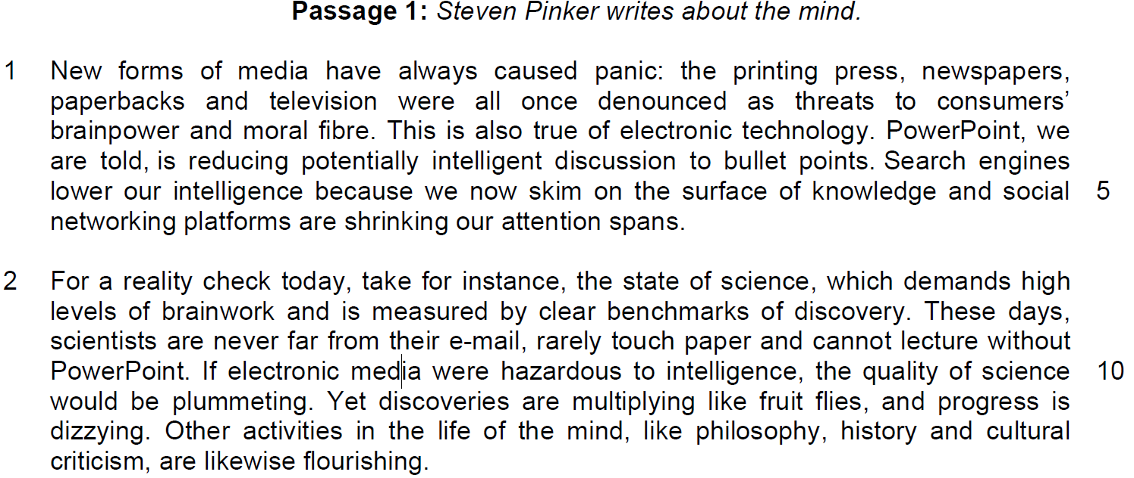

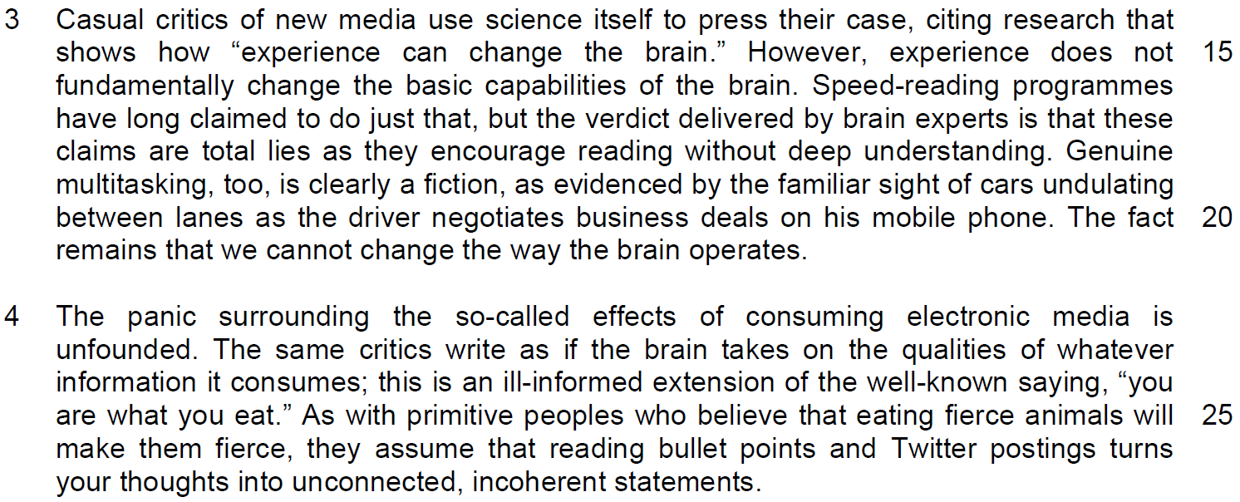

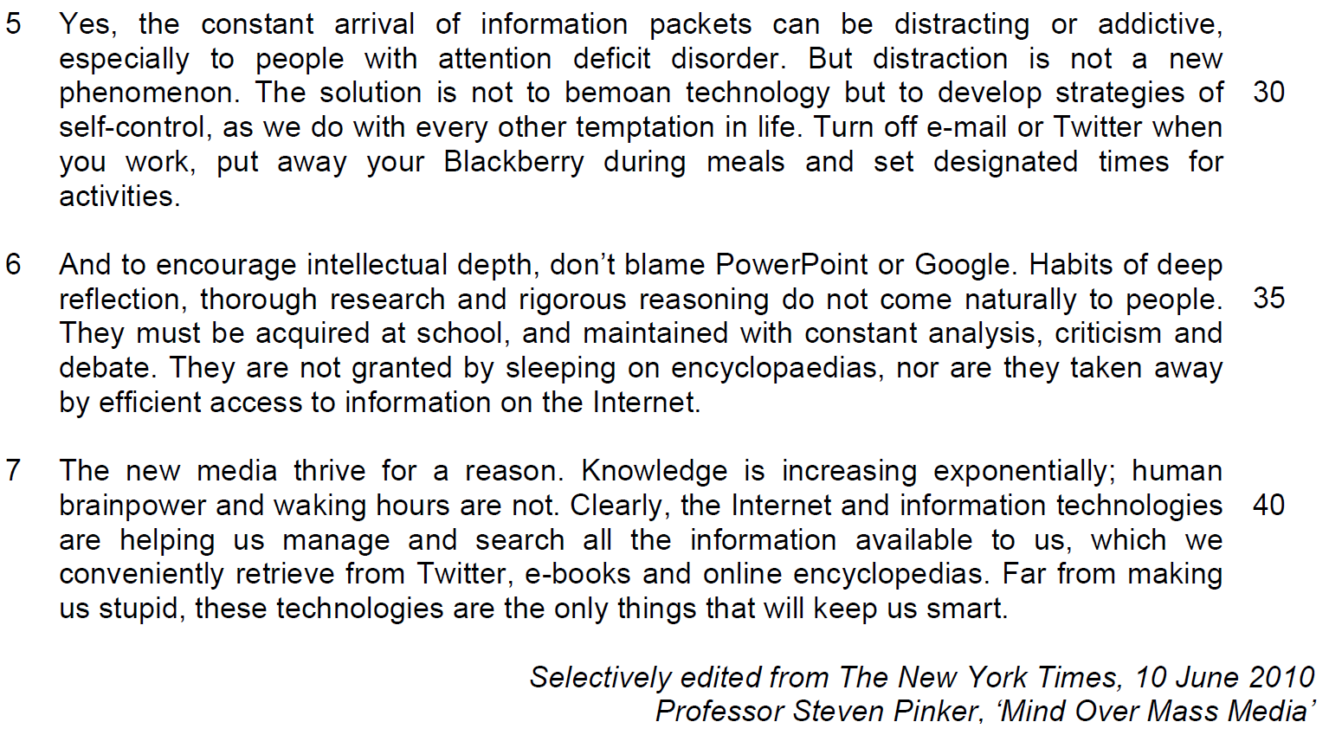

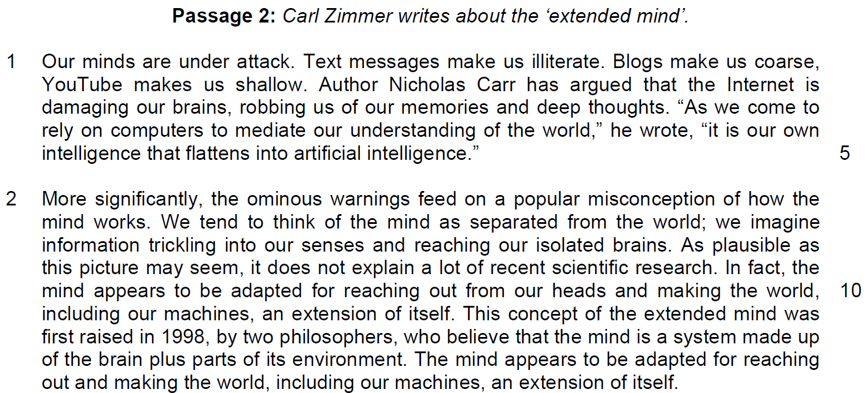

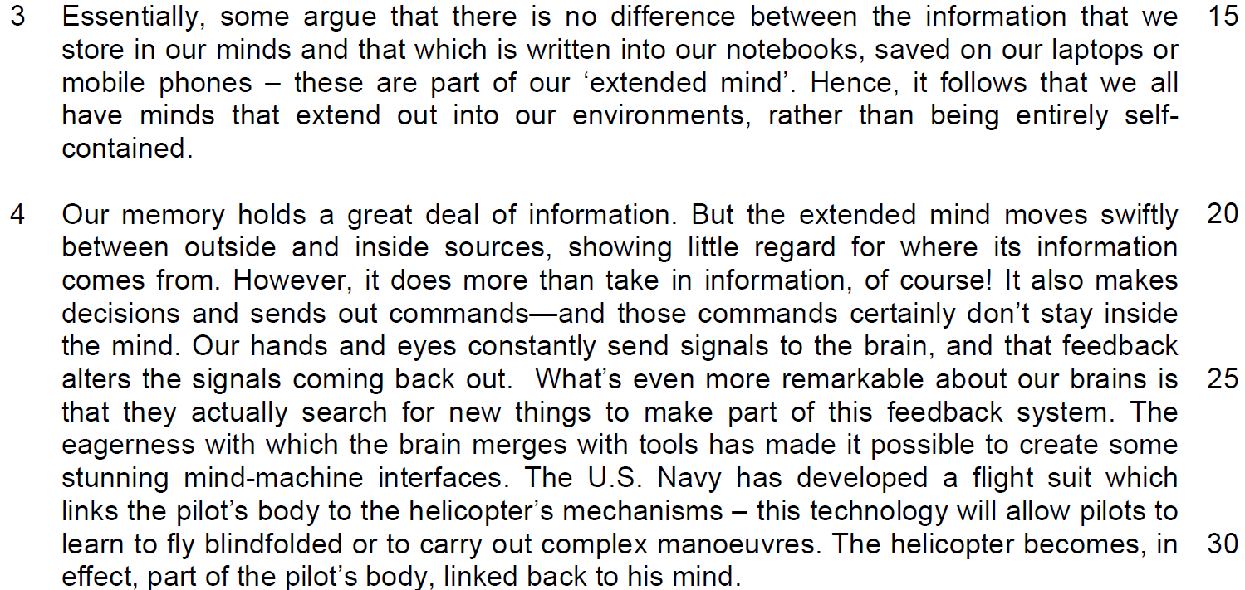

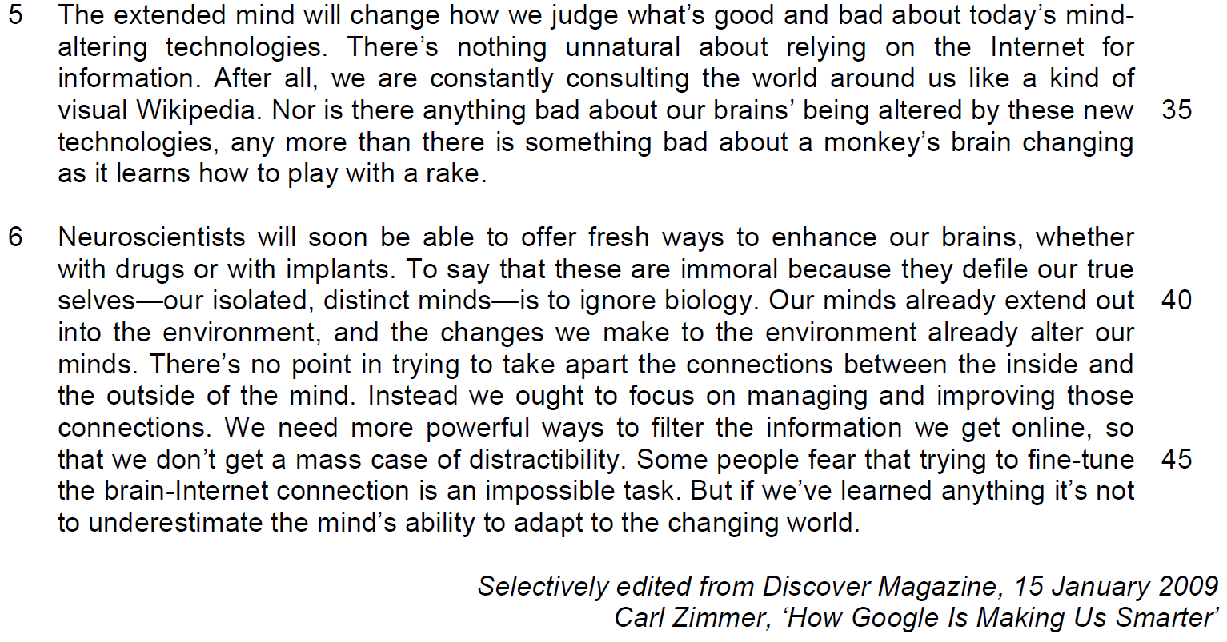
Read the passage in the Insert and then answer all the questions which follow. Note that up to 15 marks will be given for the quality and accuracy of your use of English throughout this paper.

NOTE: When a question asks for an answer IN YOUR OWN WORDS AS FAR AS POSSIBLE, and you select the appropriate material from the passage for your answer you must still use your own words to express it. Little credit can be given to answers which only copy words and phrases from the passage.

Questions from Passage 1
Q1) According to paragraph 1, why do new forms of media cause ‘panic’ (line 1)? Use your own words as far as possible. [2]

……………………………………………………………………………………………………………………………………

……………………………………………………………………………………………………………………………………

……………………………………………………………………………………………………………………………………

Q2) What does the phrase ‘progress is dizzying’ (lines 11 - 12) suggest about the effect of technology? [1]

……………………………………………………………………………………………………………………………………

……………………………………………………………………………………………………………………………………

Q3) Identify and explain two phrases that emphasise the idea that experience cannot alter the ‘basic capabilities’ (line 16) of the brain. [2]

……………………………………………………………………………………………………………………………………

……………………………………………………………………………………………………………………………………

……………………………………………………………………………………………………………………………………

Q4) What is the author’s attitude towards ‘the same critics’ (line 23)? Use your own words as far as possible. [1]

……………………………………………………………………………………………………………………………………

……………………………………………………………………………………………………………………………………

Q5) What does the author mean by ‘They are not granted by sleeping on encyclopaedias’ (line 37)? Use your own words as far as possible. [3]

……………………………………………………………………………………………………………………………………

……………………………………………………………………………………………………………………………………

……………………………………………………………………………………………………………………………………

……………………………………………………………………………………………………………………………………

Questions from Passage 2
Q6) In paragraph 1, the author illustrates the idea of our minds being ‘under attack’ (line 1). What are two ways by which he does this? Use your own words as far as possible. [2]

……………………………………………………………………………………………………………………………………

……………………………………………………………………………………………………………………………………

……………………………………………………………………………………………………………………………………

……………………………………………………………………………………………………………………………………

Q7) ‘which debatably stems from anxiety and fear’ (line 72). What does ‘debatably’ say about the suggestion made by the author? [1]

……………………………………………………………………………………………………………………………………

……………………………………………………………………………………………………………………………………

Q8) Explain in your own words why the writer refers to Wikipedia in line 35. [1]

……………………………………………………………………………………………………………………………………

……………………………………………………………………………………………………………………………………

Q9) Why does the writer place the words ‘our isolated, distinct minds’ (line 40) in between two dashes? [1]

……………………………………………………………………………………………………………………………………

……………………………………………………………………………………………………………………………………

Q10) Using material from paragraphs 4 to 6 summarise Carl Zimmer’s observations about how the extended mind functions, how it will affect technology and us and how we should respond to it.

Write your summary in no more than 120 words, not counting the opening words, which are printed below. Use your own words as far as possible.

According to Carl Zimmer, the extended mind… [8]
S/No | From the passage | Paraphrased equivalent
How the extended mind works
1 | the extended mind moves swiftly between outside and inside sources  OR  Our minds already extend out to the environment, (line 40)
2 | Little regard for where its information comes from.
3 | also make(s) decisions and
4 | send(s) out commands  (“Our hands and eyes… …signals coming back out” line 24 is the example)
5 | *to actually search for new things to make part of this feedback system
How it affects technology
6 | The eagerness… merges with tools
7 | (it will be) possible to create some stunning mind-machine  interface OR  …[machines become] linked back to [the] mind
8 | will change how we judge what’s good and bad about today’s  mind-altering technologies

S/No | From the passage | Paraphrased equivalent
How should we respond
9 | [we will realize that] there’s nothing unnatural about relying on the Internet for information.
10 | Nor is there anything bad about our brains’ being altered by these new technologies,
11 | [we will see] There’s no point in trying to take apart the connections between the inside and the outside of the mind.
12 | [Instead] we ought to focus on managing and improving those  connections
13 | we need to develop] more powerful ways to filter the information we get online,
14 | so that we don’t get a mass case of distractibility
15 | not to underestimate the mind’s ability to adapt to the changing world.

Application Question
Q11) Both writers discuss the impact that technology is having on human intelligence.

How persuasive do you find their arguments? In your assessment, how far does technology assist in making your generation smarter? [8]

……………………………………………………………………………………………………………………………………

……………………………………………………………………………………………………………………………………

……………………………………………………………………………………………………………………………………

……………………………………………………………………………………………………………………………………

……………………………………………………………………………………………………………………………………

……………………………………………………………………………………………………………………………………

……………………………………………………………………………………………………………………………………

……………………………………………………………………………………………………………………………………

……………………………………………………………………………………………………………………………………

……………………………………………………………………………………………………………………………………

……………………………………………………………………………………………………………………………………

……………………………………………………………………………………………………………………………………

……………………………………………………………………………………………………………………………………

……………………………………………………………………………………………………………………………………

……………………………………………………………………………………………………………………………………

……………………………………………………………………………………………………………………………………

……………………………………………………………………………………………………………………………………

……………………………………………………………………………………………………………………………………

……………………………………………………………………………………………………………………………………

……………………………………………………………………………………………………………………………………

……………………………………………………………………………………………………………………………………

……………………………………………………………………………………………………………………………………

……………………………………………………………………………………………………………………………………

……………………………………………………………………………………………………………………………………

……………………………………………………………………………………………………………………………………

……………………………………………………………………………………………………………………………………

……………………………………………………………………………………………………………………………………

……………………………………………………………………………………………………………………………………

……………………………………………………………………………………………………………………………………

……………………………………………………………………………………………………………………………………

……………………………………………………………………………………………………………………………………

……………………………………………………………………………………………………………………………………

……………………………………………………………………………………………………………………………………

……………………………………………………………………………………………………………………………………

……………………………………………………………………………………………………………………………………

……………………………………………………………………………………………………………………………………

……………………………………………………………………………………………………………………………………

……………………………………………………………………………………………………………………………………

……………………………………………………………………………………………………………………………………

……………………………………………………………………………………………………………………………………

……………………………………………………………………………………………………………………………………

……………………………………………………………………………………………………………………………………

……………………………………………………………………………………………………………………………………

……………………………………………………………………………………………………………………………………

……………………………………………………………………………………………………………………………………

