GP Comprehension – Intelligence, Technology & the Mind

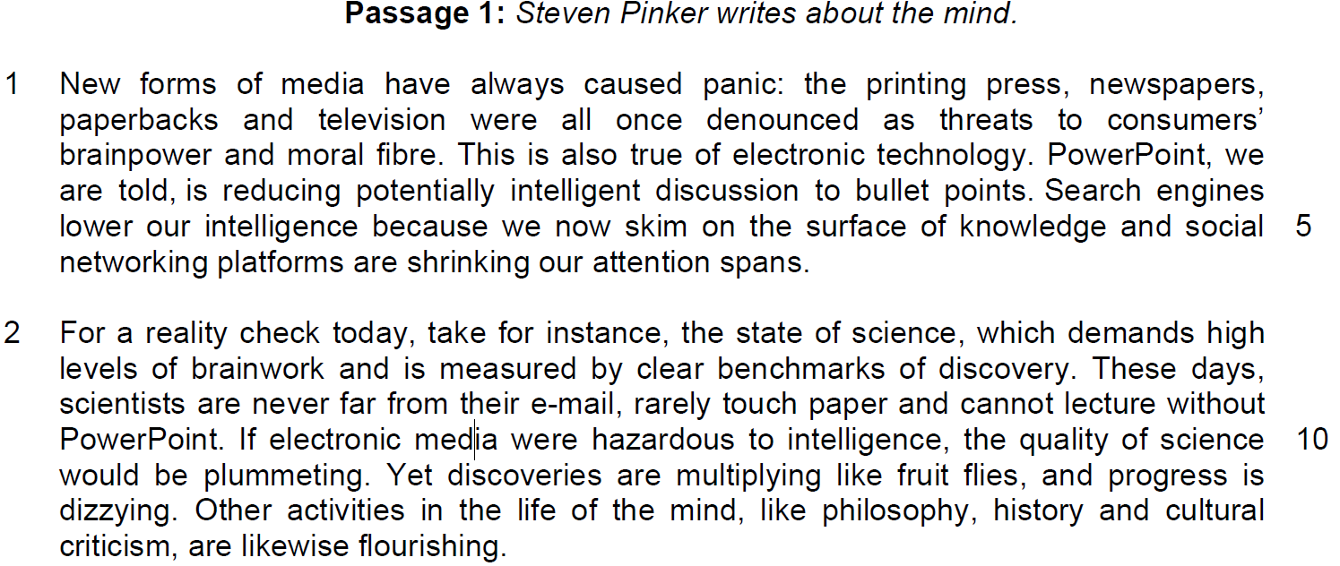

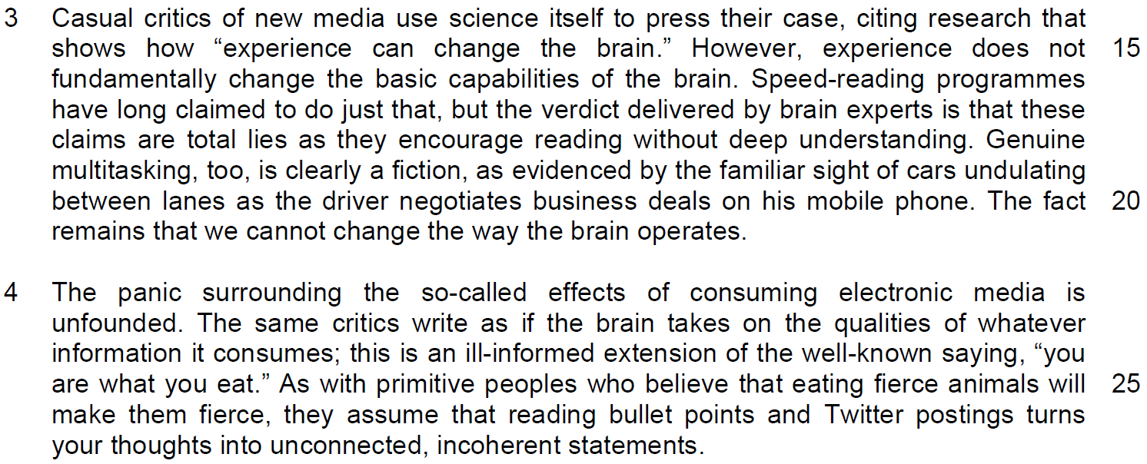

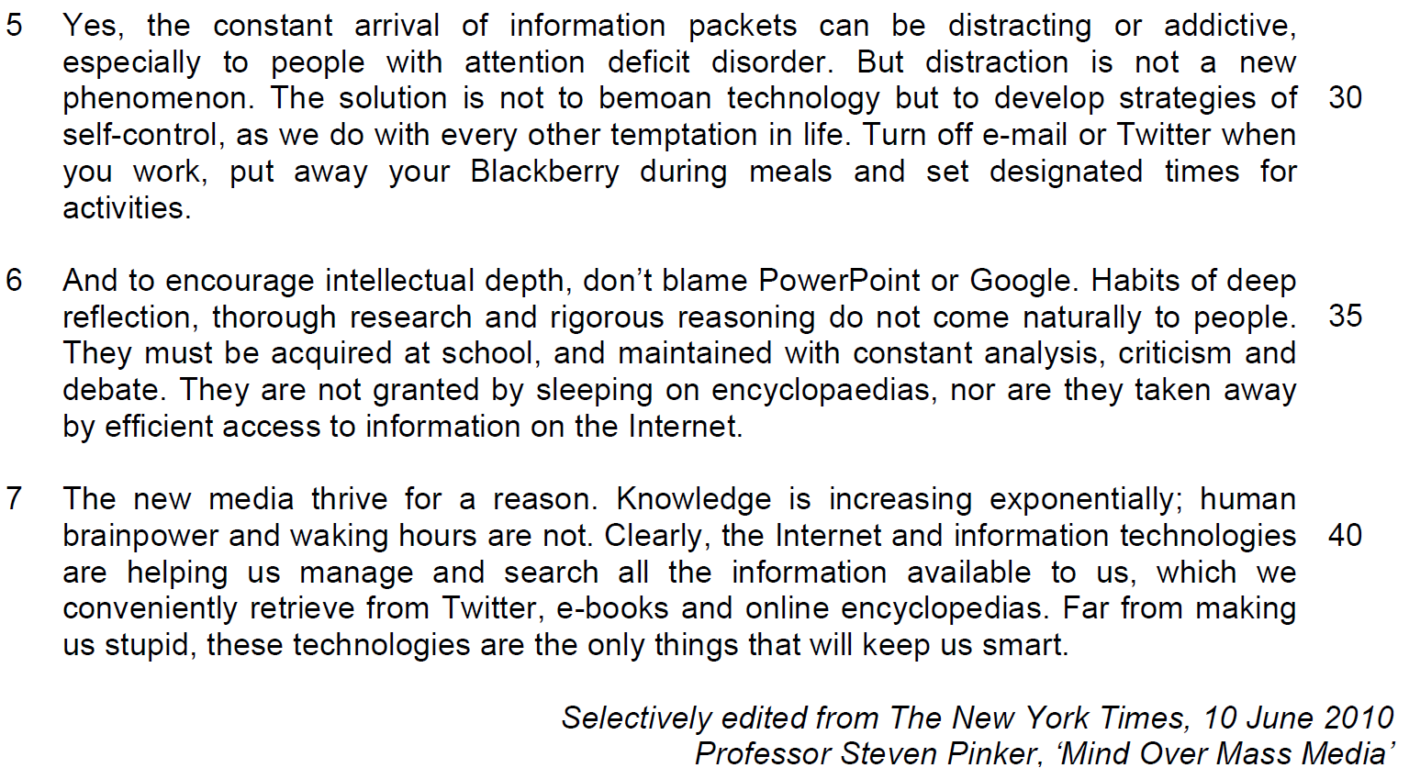

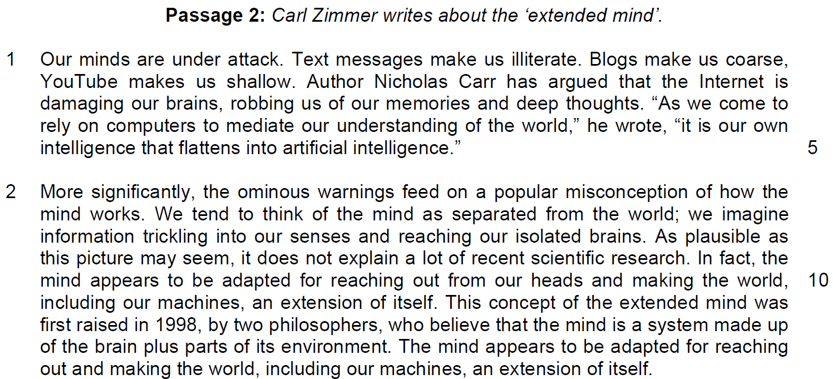

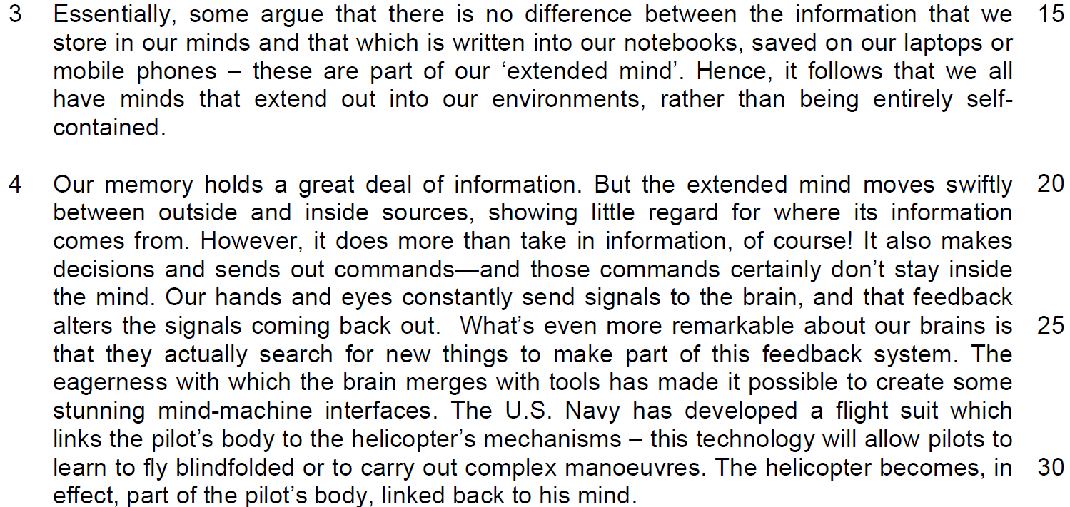

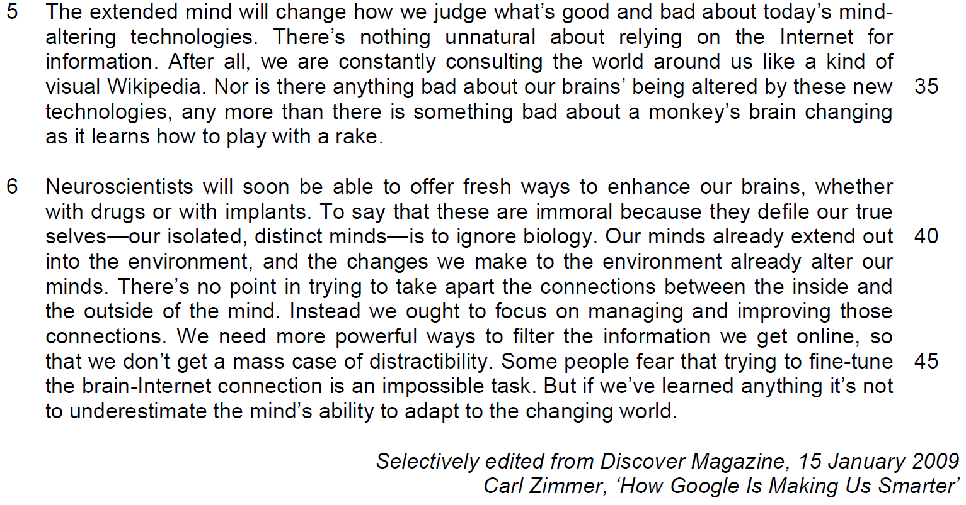
Suggested Answers
Questions from Passage 1
Q1) According to paragraph 1, why do new forms of media cause ‘panic’ (line 1)? Use your own words as far as possible. [2]

From the Passage
‘threats to consumers’ brainpower…

…and moral fibre’

Suggested Answer
They are seen as dangerous to our intelligence and sense of right and wrong. (capacity to judge what is right and wrong)

Q2) What does the phrase ‘progress is dizzying’ (lines 11 - 12) suggest about the effect of technology? [1]

It is so rapid and complex that it is hard to keep track of it.

Q3) Identify and explain two phrases that emphasise the idea that experience cannot alter the ‘basic capabilities’ (line 16) of the brain. [2]
(language-based question – choose the phrase that indicate the intention or how the writer reflects this intention
From the Passage
(a) ‘long claimed’
(b) ‘total lies’
(c) ‘clearly a fiction’
(d) ‘the fact remains’

Suggested Answer
(a) assumed to be true but not proven to be so (conventional wisdom that is assumed to be true
(b) absolute word/ indicates how the belief is “completely” wrong.
(c) Emphasises how the critics’ idea is not true
(d) the idea is to stay unchanged/ has withstood the test of time as it has been unchanged over time and will stay unchanged.

The writer uses the phrase ‘long claimed’ to emphasize the idea by showing that the conventional wisdom is assumed to be the truth.

The writer uses the phrase ‘total lies’ to show that the experiences of speed reading is not capable to change the basic capabilities.

lies – cannot improve comprehension – cannot change the capabilities of the brain to comprehend more.

Q4) What is the author’s attitude towards ‘the same critics’ (line 23)? Use your own words as far as possible. [1]

From the Passage
‘the same critics write as if the brain… ill-informed extension of the well-known saying… As with primitive peoples’

Suggested Answer
The author expresses a critical/ derisive/ cynical/ doubtful / skeptical attitude towards them, given that they have such simple ideas about the media.

Tone, attitude, behaviours
Tone affects how you feel about the statements
attitude reflects how the writer’s intention and feeling

Q5) What does the author mean by ‘They are not granted by sleeping on encyclopaedias’ (line 37)? Use your own words as far as possible. [3]
(language-based question – explain the meaning of the figurative phrase
From the Passage
Habits of deep reflection, thorough research and rigorous reasoning

do not come naturally to people

must be acquired at school, and maintained

They are not granted by sleeping on encyclopaedias

Suggested Answer:
Deep thinking is not the result of derivation of information. These practices to cultivate higher order thinking skills cannot be formed without effort. Instead, one must recognise that they are not innate, hence they have to be learnt through education, and conscientiously sustained through practice.

- explain the phrase
- show the process of the meaning

Questions from Passage 2
Q6) In paragraph 1, the author illustrates the idea of our minds being ‘under attack’ (line 1). What are two ways by which he does this? Use your own words as far as possible. [2]

From the Passage
‘text messages…blogs…YouTube…’

The Internet

Author Nicholas Carr

Text messages make us illiterate. Blogs make us coarse, YouTube makes us shallow.

Internet is damaging our brains, robbing us…flattens into artificial intelligence

Suggested Answer
Point 1
He uses examples of how technology causes harm to our minds.
He cites everyday examples such as text messages… to argue that they are harmful our intelligence. (less capable to read and comprehend, less polite, less reflective, superficial)

Point 2
By quoting an acclaimed author to support and strengthen this opinion/ to give credibility.

Parallel phrasing as emphasis to indicate the direct, undesirable consequences that are inflicted upon human beings, as a result of these forms of technology.

The use of highly negative verbs justify that our minds are “under attack” because the Internet severely incapacitates the way our minds function.

Has turned our human brain which has reflective thinking into unreal thinking which is rudimentary and logical, erasing our human features in our brain.

Q7) Explain in your own words why the writer refers to Wikipedia in line 35. [1]

From the Passage
‘we are constantly consulting the world around us like a kind of visual Wikipedia’

Suggested Answer
The writer wants to show that individuals of the modern society constantly refers to Wikipedia as it can provide a wealth of information for them to function effectively in the society. We rely on the external environment for information to conduct our lives,

Q8) Why does the writer place the words ‘our isolated, distinct minds’ (line 40) in between two dashes? [1]

From the Passage
To say that these are immoral because they defile our true selves—our isolated, distinct minds—is to ignore biology

Suggested Answer
The writer wants to point out that the words in between the dashes refer to the public’s general misconception that brain is independent.

parenthesis – brackets ( )

- wants to explain the real or intended idea

Q9) Using material from paragraphs 4 to 6 summarise Carl Zimmer’s observations about how the extended mind functions, how it will affect technology and us and how we should respond to it.

Write your summary in no more than 120 words, not counting the opening words, which are printed below. Use your own words as far as possible.

According to Carl Zimmer, the extended mind… [8]
S/No | From the passage | Paraphrased equivalent
How the extended mind works
1 | the extended mind moves swiftly between outside and inside sources  OR  Our minds already extend out to the environment, (line 40) | Transcends the boundaries of the mind/  travels/switches(odd expression) between internal and external pools of information  reaches out to the external world  (interacts with the environment)
2 | Little regard for where its information comes from. | Doesn’t discriminate/ doesn’t pick and choose/ no limits to where the facts come from/collecting information from everything/without caring about the origins of the data.
3 | also make(s) decisions and | It makes choices
4 | send(s) out commands  (“Our hands and eyes… …signals coming back out” line 24 is the example) | Propagating signals and processes signals that are sent back/passing down instructions/directs instructions outwards/relays instructions/how to carry out the actions
5 | to actually search for new things to make part of this feedback system | Looks for novel/ fresh information to integrate/ internalize/ include
How it affects technology
6 | The eagerness… merges with tools | It readily/ enthusiastically/willingly joins/ melds/ with technology/anticipation to integrate with these technologies
7 | (it will be) possible to create some stunning mind-machine  interface OR  …[machines become] linked back to [the] mind | So we can manufacture/ make amazing mind-machine systems/ programmes [bond them] that integrates with the mind to develop mind-machine technology
8 | will change how we judge what’s good and bad about today’s  mind-altering technologies | It will alter how we decide what technology is beneficial or detrimental/influences our principles/alter our moral values

S/No | From the passage | Paraphrased equivalent
How should we respond
9 | [we will realize that] there’s nothing unnatural about relying on the Internet for information. | And we will realize dependency on the Internet for knowledge is not bad/it is fine and normal to make use of them
10 | Nor is there anything bad about our brains’ being altered by these new technologies, | Or that our brains are being changed/ tweaked/ refined/make us open to our mind being enhanced/improved/changed drastically
11 | [we will see] There’s no point in trying to take apart the connections between the inside and the outside of the mind. | We should relinquish attempts to sever the link between the external and internal mind/environment and the mind/we are inextricably connected to our environment
12 | [Instead] we ought to focus on managing and improving those  connections | And work on manipulating/ caring for/ operating and enhancing/ augmenting/ making better/empowering this bond/ link/ attachment (odd expression) concerted effort made to cope with and develop this interdependence
13 | we need to develop] more powerful ways to filter the information we get online, | Create stronger/ effective methods of discernment/ sorting/ sifting/sieving information/find methods to properly process this information
14 | so that we don’t get a mass case of distractibility | so we would not be sidetracked
15 | not to underestimate the mind’s ability to adapt to the changing world. | We learn not to belittle/ undervalue the mind’s ability to accommodate/ acclimatize/minds are strong enough to cope with the external world.

Q9) Using material from paragraphs 4 to 6 summarise Carl Zimmer’s observations about how the extended mind functions, how it will affect technology and us and how we should respond to it.

Write your summary in no more than 120 words, not counting the opening words, which are printed below. Use your own words as far as possible.

According to Carl Zimmer, the extended mind… [8]
S/No | From the passage | Paraphrased equivalent
How the extended mind works
1 | the extended mind moves swiftly between outside and inside sources  OR  Our minds already extend out to the environment, (line 40)
2 | Little regard for where its information comes from.
3 | also make(s) decisions and
4 | send(s) out commands  (“Our hands and eyes… …signals coming back out” line 24 is the example)
5 | *to actually search for new things to make part of this feedback system
How it affects technology
6 | The eagerness… merges with tools
7 | (it will be) possible to create some stunning mind-machine  interface OR  …[machines become] linked back to [the] mind
8 | will change how we judge what’s good and bad about today’s  mind-altering technologies

S/No | From the passage | Paraphrased equivalent
How should we respond
9 | [we will realize that] there’s nothing unnatural about relying on the Internet for information.
10 | Nor is there anything bad about our brains’ being altered by these new technologies,
11 | [we will see] There’s no point in trying to take apart the connections between the inside and the outside of the mind.
12 | [Instead] we ought to focus on managing and improving those  Connections
13 | we need to develop] more powerful ways to filter the information we get online,
14 | so that we don’t get a mass case of distractibility
15 | not to underestimate the mind’s ability to adapt to the changing world.

Application Question
Q10) Both writers discuss the impact that technology is having on human intelligence.

How persuasive do you find their arguments? In your assessment, how far does technology assist in making your generation smarter? [8]
part A) Do you agree?
Part b) extent of agreement (1st para – why you think that technology will make your generation smarter(youths)? 2nd para – extent of agreement
Strategy of development:

Paragraph 1
- quote the phrase from passage A
- explain the phrase
- why it is not persuasive
- examples

Paragraph 2
- Quote the phrase from passage B
- Explain the phrase
- Why it is persuasive
- examples

How to quote the phrase and explain?

As stated by Pinker, technology has provided us a lot of information that has made it ‘distracting and addictive’ but we will not be affected by it if we exercise discipline and control over the use of technology. However, this is easier said than done.

Practising control over technology is not easy as we rely a lot on technology to conduct our lives and it is difficult for us not to be taken over by it. Addiction is the result of social behaviours. It is not easy for us to set restriction over technology as we revolve around the use of technological gadgets like handphones for most of the time and most of the activities. It has become part of our lives and it will become routine and behavioural.

In a recent article in the Strait Times, it has shown that Singaporeans averagely spent 4.3 hours on their handphones and it has become one of the main items that they come in to contact with the very first thing in the day.

Thus, it can be observed that what Pinker sees as non-detrimental to our social lives as we can exercise control over technology is not persuasive as it is not easy to exercise restriction over technology that we heavily rely on to conduct our lives.

Part B – Why it will make youths smarter?

As stated by Pinker, technology helps us to gather knowledge more efficiently as ‘knowledge is increasing exponentially; human brain power and working hours are not’. The use of technology will help us to retrieve information that is useful in making better discussion and decision easy and applicable. Search engine like Googles and database sites like Wikipedia will ease the workload and this will be productive in our education process for the youths. Teaching will focus on the discussion and reflection as there is lesser need for teachers to focus on explanation of information as students can find out more on their own. Our Ministry of Education’s emphasis on the education methodology of ‘Teach Less, Learn More’ clearly supports this form of education which they believe will make students smarter and better learner in the future.

How far do you agree? (Extent of agreement based on the depending factor – how well do we use technology to teach)

However, the overwhelming influx of information may not be helpful if schools do not help students in their methodology of learning in extraction of data and making information relevant to study. Students are still not capable in making their information objective and relevant and this is also agreed by Pinker as he feels that the skills of deep reflections must be acquired at school through ‘constant analysis, criticism and debate’’. In Singapore, as stated by state minister for education, Ng Chee Ming, education must have applied learning programme and the pure reliance on technology without discourse on application will not be enough to make the youths smarter.

Passage 1
Possible reference/argument
‘Powerpoint … is reducing potentially intelligent discussion to bullet points.’

OR
Pinker is critical of these claims

‘develop strategies of self-control’

‘these technologies are the only things that will keep us smart’

Analysis – is it persuasive?
We learn not to belittle/ undervalue the mind’s ability to accommodate/ acclimatize/minds are strong enough to cope with the external world.

YES – Pinker suggests that the key is managing this technology, not eschewing it. Agreed, managing such ‘new’ technology is much like how the world adapted to the advent of the television, Internet etc. Many schools today have support programs for youths to deal with cyber-addiction.

NO – Pinker’s suggestion is too simplistic. Internet-addiction purportedly afflicts 1 in 8 Americans today, as the Center for Online and Net Addiction reports and cases are increasingly hard to identify as Internet and related technological usage usually occurs in the confines of the home/ office/

YES – The information boom today necessitates that we harness technology to keep updated. Every minute, 24 hours of video footage is uploaded to YouTube; while a lot of it will never be seen by the vast population of netizens, this just shows what volume of information is available today. Twitter, Facebook are not just social networking platforms but also useful ways for us to keep abreast of current affairs. Good candidates may wish to comment that the claim that technology is the ‘only’ way to stay smart by Pinker is an exaggeration but not entirely unfounded.

NO – A gross exaggeration Pinker’s part (use of ‘only’) as presentation tools and social networking platforms and SMS may allow us greater access to information and grow our knowledge base, but they do not fundamentally make us more critical or insightful by their mere existence. The volume of information also necessitates that we are more discerning of information online – possible examples include, Censorship Issues, Multiple Perspectives on certain issues

Passage 2
Possible reference/argument
‘There’s nothing unnatural about relying on the Internet for information’‘

OR
‘We need more powerful ways to filter the information we get online’

‘PowerPoint … reducing potentially intelligent discussion to bullet points’ OR ‘Genuine multitasking… is clearly a fiction’

OR
‘knowledge is increasing exponentially’

Analysis – Is it persuasive?
YES – Internet penetration rates are as high as 90% (Norway) and 50% for the Top 30 countries for Internet Penetration (approx for the Worldwide Top 30 2010). Internet is the norm and hence we should embrace it. Students can give examples of IT use in schools today, especially Singapore. A popular example is Crescent Girls’ Secondary School. However, the access to information doesn’t bring with it better understanding or critical thinking skills, which is why educational institutions around the world are rallying for boosting students critical thinking skills.

NO – While it is normal these days to rely on the Internet for research, the reality is that a lot of this research is not carefully done nor critically presented. There have been more cases of plagiarism occurring in schools and universities. In May this year, Scholastic (a publishing company specializing in educational material) found itself at the heart of a controversy when a young lady passed off the work of another amateur artist as her own in a competition for young artists. The artwork went on to win 2 Gold awards. While the matter was eventually resolved, it did cast the spotlight on the flimsy terms of use in Scholastic’s Terms of Use regarding copyright. Clearly, we need much more than methods to filter information, which may not be accurate, but also to tighten legal measures and netizens understanding of intellectual property.

Passage 1 and 2
Possible reference/argument
PowerPoint … reducing potentially intelligent discussion to bullet points’

OR
‘Genuine multitasking… is clearly a fiction’

OR
‘knowledge is increasing exponentially’

Does technology make your generation smarter?
YES – A study by California State University suggests that ‘Gen Y’ is rewired to multitask better than their Gen X counterparts. Many people can indeed not multi-task well and at the same time, a whole generation of youth fundamentally better this way. Technology today is also built around the principle of multi-tasking. The oft-cited iPhone, for example, now features an operating system which (in addition to its many other appealing features) allows the user to multi-task.

NO – Platforms like Twitter are inhibiting user’s ability to express themselves clearly, which is an important aspect of intelligence. Recently it was found that fewer and fewer young people in Hong Kong are able to express themselves in written Chinese/ Mandarin because of their reliance on Hanyu Pinyin (a romanized system of Chinese).

