GP Term 3 2017 – Comprehension – Topic 4: Culture – Effects of Competition on Modern Society

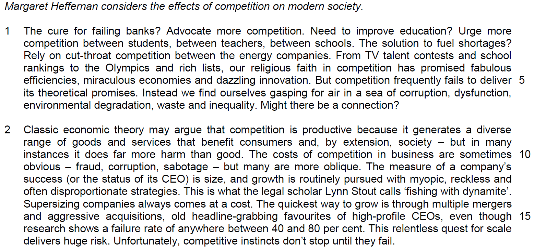

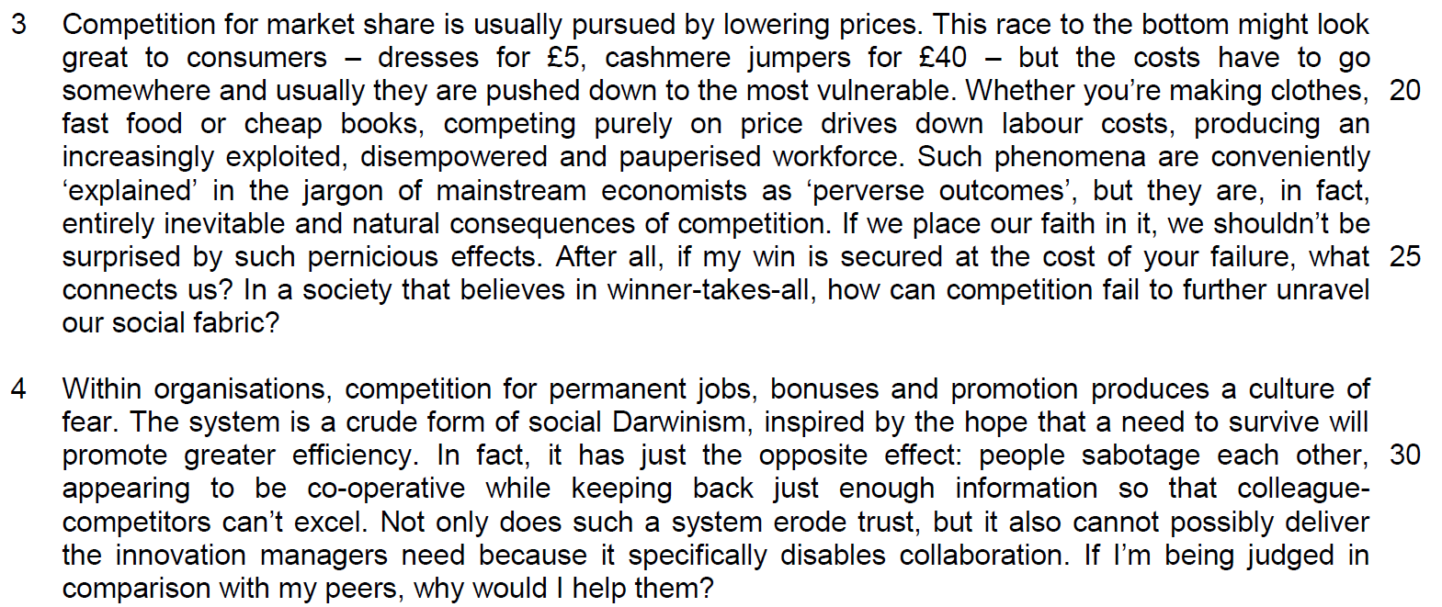

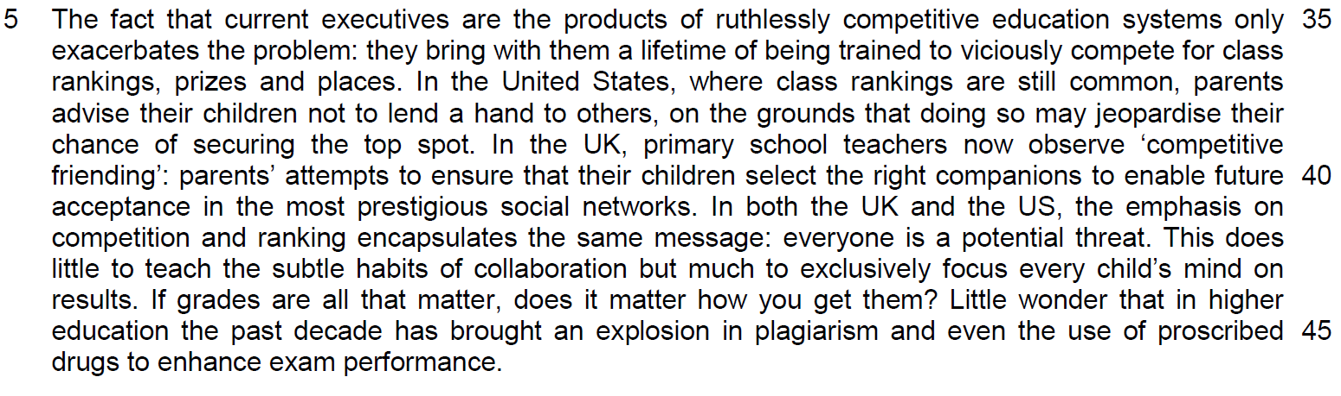

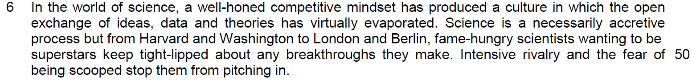

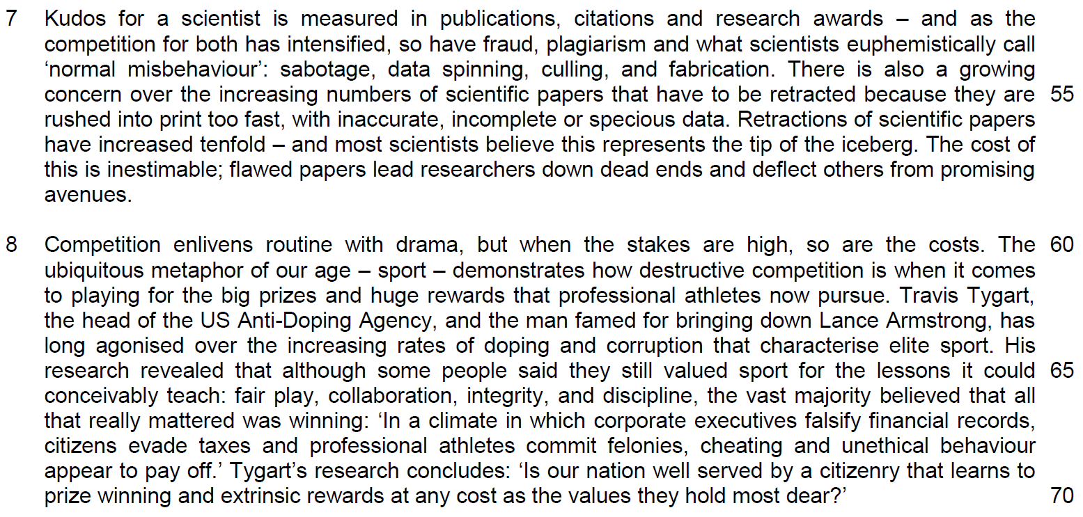

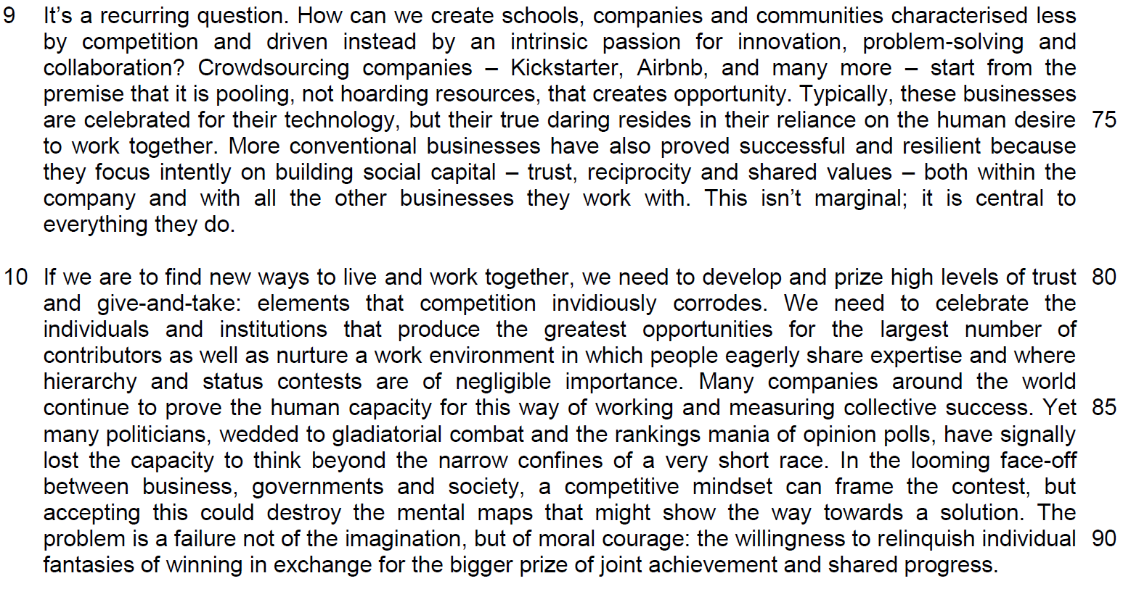

Suggested Answers
Q1) Suggest why the author describes our faith in competition as ‘religious’ (line 4). Use your own words as far as possible. [1]

From the Passage
Our religious faith in competition has promised fabulous efficiencies, miraculous economies and dazzling innovation.

Paraphrased
The author is suggesting that our belief in competition is analogous to that of the faith of a religious disciple that will have complete devotion to the teaching of the belief.

Q2) In the first paragraph, what does the author mean when she says we are ‘gasping for air’ (line 6)? Use your own words as far as possible. [1]

From the Passage
…we find ourselves gasping for air in a sea of corruption, dysfunction, environmental degradation, waste and inequality.

Paraphrased
The author means that the engagement in competition will create so much pressure and swarmed us into an environment plagued with innumerable grievous problems and difficulties that will stiffen our survivals.

Q3) Why is ‘fishing with dynamite’ (line 13) an appropriate way to describe how many companies pursue growth? Use your own words as far as possible. [2]

From the Passage
The measure of a company’s success (or the status of its CEO) is size, and growth is routinely pursued with myopic, reckless and often disproportionate strategies. This is what the legal scholar Lynn Stout calls “fishing with dynamite”.

Paraphrased
It is an appropriate analogy as both companies and fishermen employ short-sighted, dangerous and often unnecessary tactics to achieve their immediate and selfish goals without considering the wider implications or long-term destructive consequences of their actions. In short, it is considered a reckless business strategy.

Q4) According to the author, what are the harmful effects of companies lowering prices to increase their market share? Use material from paragraph 3 only. Use your own words as far as possible. [2] (process explanation)

From the Passage
… usually they are pushed down to the most vulnerable… producing an increasingly exploited, disempowered and pauperised workforce…unravel social fabric

Paraphrased
The expenses involved in the production will be passed on to the lowest groups of the production chain which are the workers as they are unfairly taken advantage by the firm when their wage is lowered. As a result, they become more disenfranchised and impoverished, thus weakening social cohesion.

Q5) “Such phenomena are conveniently explained in the jargon of mainstream economists as “perverse outcomes’’ (lines 22-3). What is the author implying here? Explain carefully. Use your own words as far as possible. [2]

From the Passage
Such phenomena are conveniently ‘explained’ in the jargon of mainstream economists as ‘perverse outcomes’, but they are, in fact, entirely inevitable and natural consequences of competition.

Paraphrased
The author is suggesting that economists are deliberately using specialized terms which are difficult for the public to understand to defend the present system. They are trying to excuse the inexcusable, as they suggest, merely an unfortunate side-effect, but an inherent and unavoidable result of the system itself.

Q6) Explain the differences between data spinning, culling, and fabrication (line 54). Use your own words as far as possible. [2]

Paraphrased
‘Data spinning’ refers to manipulation of information to present a favourable perspective of the issue. ‘Culling’ refers to the selective removal of unfavourable information. ‘Fabrication’ refers to the deliberate falsification of information.

Q7) Explain the author’s use of ‘conceivably’ in line 66. [1]

From the Passage
His research revealed that although some people said they still valued sport for the lessons it could conceivably teach: fair play, collaboration, integrity, and discipline, the vast majority believed that all that really mattered was winning.

Paraphrased
The author is implying that some in this society might still illusively believe that sports can instil positive values but the majority of us do not necessarily agree to this proposition.

Q8) Why does the author refer to ‘trust, reciprocity and shared values’ as forms of ‘social capital’ (line 77)? Use your own words as far as possible. [2]

From the Passage
…they focus intently on building social capital – trust, reciprocity and shared values

Paraphrased
Social capital refers to the non-monetary ‘resources’ of a company in terms of the ‘profitable’ interpersonal relationships which facilitate cooperation and forge bonds. The qualities of mutual trust and shared values are all forms of social capital in that they are examples of such intangible qualities, which enhance harmony and promote efficiency to build a cohesive and connected society.

Q9) In the last paragraph, why does the author say that politicians today are failing to do a good job? Use your own words as far as possible. [2]

From the Passage
… wedded to gladiatorial combat and … the rankings mania of opinion polls, … have signally lost the capacity to think beyond the narrow confines of a very short race.

Paraphrased
Politicians today are committed to waging aggressive battle with their political rivals as they are obsessed with the public’s perception of their policies. Their vision is myopic because they are focused on their immediate goal, which is to win the next election.

Q10) According to the author, what is stopping us from changing our ‘competitive mindset’ (line 88)? Use your own words as far as possible. [2]

From the Passage
The problem is a failure …of moral courage: …the willingness to relinquish individual fantasies of winning…in exchange for the bigger prize of …joint achievement and shared progress.

Paraphrased
A lack of moral strength to give up one’s own selfish dreams of individual success for the greater good and common accomplishment.

Summary Question
Q11) Using material from paragraphs 4-6 only, summarise what the author has to say about the disadvantages of competition.

Write your summary in no more than 120 words, not counting the opening words which are printed below. Use your own words as far as possible. [8]

Competition causes problems within organisations because…
 | Passage | Paraphrase
Within Organisations:
1 | competition for permanent jobs, bonuses and promotion produces a culture of fear | Creates/manufactures/generates a pervasive atmosphere of anxiety
2 | crude form of social Darwinism, inspired by the hope that a need to survive will promote greater efficiency | A primitive system based on the principle of ‘survival of the fittest’, ‘dog eat dog’, ‘law of the jungle’ which is expected to produce better/superior results/productivity
3 | In fact, it has just the opposite effect: people sabotage each other, | But does just the reverse by causing everyone to subvert/undermine/ obstruct/hinder/stymie everyone else
4 | appearing to be co-operative while keeping back just enough information so that colleague-competitors can’t excel. | Seeming/pretending to be collaborative/helpful/collegial while holding back sufficient material/facts/data to ensure rivals cannot shine/be outstanding
5 | …erode trust | Corrode/wear away/wear down faith/confidence/belief in each other
6 | …can’t deliver the creativity managers need | Cannot produce the innovation/inventiveness/imagination/ingenuity bosses/companies require
7 | Because it specifically disables collaboration. | As it prevents co-operation/teamwork
8 | If I’m being judged in comparison with my peers, why would I help them? | Since it makes no sense/would be to aid/assist others in such an invidious/competitive/’dog-eat-dog’ system
Within Schools:
9 | The fact that current executives are the products of ruthlessly competitive education systems only exacerbates the problem: | The reality that present/existing/modern/today’s managers are the results of merciless/cutthroat schooling only worsens/aggravates/compounds the problem
10 | … they bring with them a lifetime of being trained to viciously compete for class rankings, prizes and places. | As they see the system as natural/normal/acceptable  OR:  They perpetuate/condone such a (merciless/cut-throat…) system

 | Passage | Paraphrase
Within Schools:
11 | In the US, where class rankings are still common, parents advise their children not to lend a hand to others, | Parents tell/instruct their children to not help others/ to be selfish
12 | on the grounds that doing so may jeopardise their chance of securing the top spot. | So they do not risk/endanger/threaten their prospects/opportunity of becoming the best/coming first
13 | In the UK, … now observe ‘competitive friending’: parents’ attempts to ensure that their children select the right companions | Children choose appropriate/suitable friends
14 | to enable future acceptance in the most prestigious social networks. | To facilitate their eventual admittance into the most distinguished/highly-regarded/influential groups
15 | …the emphasis on competition and ranking encapsulates the same message: everyone is a potential threat | Everybody is viewed a possible/likely rival/danger/enemy/opponent/adversary/antagonist
16 | This does little to teach the subtle habits of collaboration | Which militates against the possibility of learning/instilling/inculcating the value of teamwork/co-operation
17 | but much to focus every child’s mind exclusively on results. | But concentrates/directs/fixes/centers every child’s attention wholly/solely/completely/entirely/totally on attainment /the final outcome.
18 | If grades are all that matter, does it matter how you get them? | Creating an ‘ends justify the means’ mentality/ a ruthless attitude.
19 | …in higher education the past decade has brought an explosion in plagiarism and | At a tertiary level, there has been a huge increase/ upsurge in copying/stealing other people’s work
20 | the use of proscribed drugs to enhance exam performance. | And consumption of prohibited/banned/forbidden/illegal/illicit substances to improve/augment/boost/increase academic results/achievements

 | Passage | Paraphrase
In Science,
21 | …has produced a culture in which the open exchange of ideas, data and theories has virtually evaporated. (keep tight-lipped = R) | …the ethos/principle/philosophy of sharing/communicating discoveries/findings has practically/effectively/essentially vanished/disappeared
22 | Science is a necessarily accretive process … | Scientific progress is cumulative
23 | fame-hungry scientists wanting to be superstars | Scientists seeking celebrity status
24 | Intense rivalry and | Powerful/strong/severe competition and
25 | the fear of being scooped stop them from pitching in. | Dread of/anxiety about being ‘pipped at the post’ by rivals/ coming second/not coming first prevents/precludes co-operation/collaboration

Competition causes problems within organisations because

instead of stimulating productivity and innovation, it creates an anxiety-ridden, ‘dog eat dog’ environment where subversion and suspicion belie ostensible collaboration, destroying teamwork as workmates withhold facts to block rivals and gain competitive advantage. Today’s managers, molded by a similarly cut-throat schooling paradigm, compound the problem by condoning the system. Parents tell children not to help others to ensure first place and choose suitable friends to join influential cliques. Everybody is a possible rival and teamwork is neglected. Students fixate on achieving top marks by hook or by crook. Copying and the consumption of prohibited substances has proliferated at tertiary level. Scientific progress is cumulative, but celebrity-seeking scientists don’t share because of severe competition and their dread of coming second.

(120 words)
Application Question
Q12) Margaret Heffernan argues that competition has extremely harmful effects on modern society. To what extent do you agree with her views? How applicable do you find her observations to yourself and your society? [10]

Agree with her views: (2)
- quote (1)
- explanation (1)
- why you agree? (2 to 3 sentences)
- example (1)
- extent of your agreement (2 to 3)

applicable to your society

- features of his explanation about competition
- why your society has features or reasons to suit to this development

In this passage, Margaret Heffernan has made many observations about the negative impact of competition from many aspects of the society. Some of her views are agreeable to me and applicable to my society and me but not all for her views.
1. Quote / Explanation
First, Margaret has made her observation that firms become reckless and put themselves in dangerous position as they adopt competitive strategy in business like ‘fishing with dynamite’, focusing on mergers to raise market share to raise competitiveness. In this strategy, the growth of the firm may outweigh other smaller firms as the bigger the firm, the more resources they can have to compete. However, there are many failures as they are likely to overstretch themselves.

2. Agreement to the observation
This is true to me as we can observe how concepts like what economists termed as diseconomies of scale will set in and raise the cost of operation of the firms. Firms will be over-stretched in finances and manpower which will make lose their edge in certain markets and this is a natural business laws that is hard to evade.

3a. Applicability to the issue
In Singapore, the desire to be internationally competitive has led to SIA’s engagement in Virgin Airlines which was a flop as the rationale for merging fails to take into diverse corporate culture and operational feasibility which are some of the reasons identified as the causes of diseconomies of scale.

3b. Extent of agreement
On the other hand, mergers between different banks like UOB with OUB, Tat Lee Bank and OCBC and POSB and DBS, have shown some successes as they were merged to compete more internationally with other foreign banks as the banking market becomes more liberalised and open. This is done with careful planning and the guidelines from the government on how the banking industry will be developed.
4. Concluding sentence
This proves that competition in business world may lead to failures although we can observe some degree of success.
1. Quote / Explanation
Another observation made by her author is that ‘there is the increasing rates of doping and corruption that characterise elite sport’ as sports is now an industry with extensive commercial gains which are difficult to ignore. The case of ‘Lance Armstrong’ is a good example identified by the author to explain why unfair play has become a strategy for competition.

2. Agreement to the observation

I find this observation agreeable as the commercial interest is difficult to ignore as athletes are engaged in a very highly competitive market and the career life-span is very short. It is critical for them perform at their best and beat the competition within their times. A good example is seen from the career of Ben Johnson who has doped his performance in the Olympics to out run Carl Lewis.

3a. Applicability to Singapore
However, this corruption at the elite level in Singapore is not seen in the sports scene as Singapore athletes are trained with the right proper values such as Values and Principle programmes by Singapore Sport Council which are teaching coaches to inculcate the proper sports values in our sports men and women.

Our focus to make sure that our youths excel in sports ethically has led to the formation of Singapore Sports School and our home-grown talents like Joseph Schoolings who has excelled based on merits.

4. Concluding statement

As such, it is hard to deny that competition will lead to the proliferation of doping and cases on corruption. However, it is hard to uncover these cases in Singapore, given our stance on corruption and unethical practices.

In sum, I agree to the observation that the harmful impact of competition do exist but the extent of its applicability to Singapore is limited as Singapore understands how to apply the merits of competition while negating the demerits of competition in different aspects of development.

Quote - ‘there is the increasing rates of doping and corruption that characterise elite sport’

Explanation – what the author has stated

Why I agree? –

This is not applicable to Singapore
- values in sports programme
- ‘low tolerance towards corruption’ 3rd for corruption index
Extent of applicability – still cases of doping and corruprion

Margaret Heffernan takes the extreme position that the presence of competition in modern life is having a deleterious effect on both the individual and her society. You can disagree with the author’s arguments by identifying and criticizing the inherent flaws present in the passage. You can also disagree/agree with the author’s arguments by examining the relevance of her arguments to their society.

- Demonstrate a nuanced appreciation of the writer’s arguments.
- Evaluate the persuasiveness of the writer’s claims by considering their credibility.
- Provide balance. If you adopt the perspective that competition has deleterious effects on their society, you should articulate why in certain circumstances, competition can be healthy for society and serves as a motivating force for an otherwise, lethargic populace. If you adopt the perspective that healthy competition plays a positive role in our lives, you need to consider why competition might not be desirable under certain circumstances.

The passage contains a number of flaws that you can critique.
- Heffernan is guilty of making over-generalizations/sweeping statements about the pernicious effects of competition. She assumes that all forms of competition are inherently unhealthy. However, she fails to differentiate between healthy and unhealthy competition.
- She is exceptionally one-sided and does not give balance to her arguments. Her case against guilt is built on nothing more than an incomplete, myopic and biased understanding of competition. She never acknowledges any possible benefits of competition. By conveniently omitting the opposing viewpoint, Heffernan is viewed as less credible.
- She distorts the truth with sins of omission. You can disagree with her arguments on the grounds that she totally neglects the very real possibility that the lack of competition also makes people complacent and lackadaisical, leading to mediocre performance.
- She adopts a Panglossian view of Collectivist cultures which emphasize family and work group goals above individual needs or desires and ignores the failings of Collectivist cultures (e.g the reluctance for open confrontation). She is an Idealist who naively assumes that all humans will be ‘glad to share expertise’.
- She trivializes the importance of hierarchy and status contests in most modern societies, and clings onto to her overly optimistic hope that their influence will be diminished one day (“We need to celebrate the individuals and institutions that produce the greatest opportunities for the largest number of contributors as well as nurture a work environment in which people eagerly share expertise and where hierarchy and status contests are of negligible importance”).
- She constructs a false dichotomy by treating competition and collaboration as mutually exclusive concepts, when in reality, they can co-exist. In order to push technologies and processes to the next level, a company may choose to reach out to other companies – even their competitors – and form collaborations so that it can handle a major innovation. Over the past few years, many companies have given up the anachronistic, first-to-market ideal to help propel their industry through the innovation cycle, and survive the competitive market. Collaboration is the key to staying competitive.
You can agree/disagree with the author’s arguments by examining the relevance of her arguments to their society.

Competition as a Growth Strategy
Paragraph 2: Companies achieve growth through myopic, reckless and disproportionate strategies e.g mergers and acquisitions (M&A)…

This relentless quest for scale delivers huge risk. Unfortunately, competitive instincts don’t stop until they fail.

We can perhaps take Heffernan’s words as a warning that competition in the business arena can lead to business leaders pursuing M&A without sufficient planning or paying a disproportionate amount of money for the transaction. Hence, the pursuit of growth by a company is appropriately compared to the practice of some fishermen who use dynamite to catch fish as it can result in long-term destructive consequences for the company.

Agree
Mergers are a mechanism used by businesses to restructure in order to compete and prosper. Companies are taking a lot of risk in adopting M&A as a strategy to keep their competitive edge. Mergers can have a downside as conflicts arise when two firms merge e.g cultural clashes, discontent over new leadership, decreased employee motivation and reduced productivity etc.

Examples of merger failures:
SIA sold its 49% stake in Virgin Atlantic to Delta Airlines in 2012. Delta paid US$360 million, only a fraction of the 600 million pounds that SIA paid for the stake in 2000. One of the reasons for the merger failure was the difficulty of merging with Virgin’s corporate culture (Richard Branson is known to be notoriously difficult to work with). Critics claimed that the details of the alliance were not carefully worked out before the
deal was sealed.

Disagree
M&A, if successful, leads to a healthy expansion of business firms, increase in value and efficiency of firms, and the opportunity to move resources to optimal use. This results in long-term benefits. While Heffernan might argue that companies pursue growth with ‘myopic, reckless and often disproportionate' strategies, these strategies are a means to establish a corporate global presence as they allow a company to penetrate new markets to grow its market share. The reluctance to take risks may sound the death knell for a company, and Heffernan fails to take this into consideration. She also fails to take into account the extensive groundwork done by the companies before a merger is proposed, deliberately ignoring their efforts in research and preparation. Preparing for a transaction requires a full analysis of the business, assets, liabilities, and human resources of the target.

Examples of successful mergers:
Keppel Bank and Tatlee Bank

Keppel TatLee Bank was a Singapore-based financial services organisation formed through a merger of Keppel Bank and Tat Lee Bank in 1998. Keppel Bank and Tat Lee Bank were small in comparison to the Big Four, and a merger would give the new entity to meet the new competitive realities in the banking sector.After the 1998 merger, Keppel TatLee Bank achieved a record 390% improvement in Net profits from $53 million to $260 million. Return on average shareholders’ funds more than trebled. These results were achieved after the first year of successful merger of Keppel Bank and Tat Lee Bank.

LVMH: Luxury retail group’s shopping spree in Singapore

Acquisitions by foreign powerhouses can help local companies expand their market share. LVMH acquired Crystal Jade Group and this helped to boost CJG’s expansion plans. CJG plans to open 18 outlets this year as well as a 20,000 sq-ft restaurant in San Francisco. LVMH also acquired KuDeTa (expanding to Hong Kong),Charles and Keith (expanding to China), and Heng Long Tannery (enabling it to get advance contracts from crocodile farmers to improve its inventory). Another benefit of the acquisition: lower funding cost for the Singapore company due to improved credit rating (strong parent company).

Competition and the Exploitation of the Marginalised
Paragraph 3: In the retail industry, competing purely on price drives down labour costs, producing an increasingly exploited, disempowered and pauperized workforce.

Agree
Heffernan believes that corporations, in their never-ending search for profits, pay workers as low a wage as possible. However, people who work in these factories may have no other way to provide for their families. These companies provide jobs for these people who might have no other choice. Since many poor countries compete for international investment by keeping the minimum wage low, the minimum wage is often below a subsistence income. It is not only the competition between companies that pauperizes the workforce to create tense competition at the workplace but also, the competition for foreign investment among countries.

E.g In China, Walmart has raised the exploitation of poverty stricken foreign workers to a fine and spectacularly remunerative art. Human rights organizations, labor unions, and other civic societies around the world criticize Walmart for worker exploitation, abuses, excessive overtime, and inadequate wages.

E.g Singapore Labour chief Lim Swee Say rejected renewed calls from Members of Parliament for a minimum wage system in Singapore. MPs have shared concerns that wages at the bottom are not rising fast enough. It is feared that the minimum wage will become an additional cost of business paid by employers who will in turn either pass on the cost of the business to their customers, or become more cautious in hiring those who are less able or skilled.

Disagree
Yet, what Heffernan misses is that the same thirst to outdo competitors in the quest for profit will push companies to source for more workers expand their markets. To get these workers, a business will need to outbid its competitors. She has neglected a positive outcome of competition in business by focusing on only one of the strategies used by companies to increase market share—competing on price. She is overstating the harm in the use of price-cutting as a strategy in keeping a business as a going concern. Afterall, price-cutting may just be a temporary strategy to raise brand awareness or acquire market share. In addition, she exaggerates the negative effects of corporations operating factories in developing countries. Their presence can be mutually beneficial, and the workers’ needs can be addressed by NGOs, unions, and governments. (Note: it can also be argued that the flow of migrants has far outpaced their progress in winning protections. Reports of exploitation by employers and agencies are rife; rights are limited). In developed countries, workers may be protected by strong unions that are able to pressurize the governments to investigate alleged mistreatment. E.g The National Labor Relations Board (of the USA government) found merit in charges that Walmart had unlawfully threatened employees in California and Texas with reprisal if they engaged in strikes and protests ahead of Black Friday, the big shopping day after Thanksgiving. If complaints are filed, the cases would go before an administrative law judge. Wal-Mart could be subject to penalties and required to inform its employees about their legally protected rights. Workers could be awarded back pay, reinstatement and reversal of any disciplinary action.

Competition in the Workplace
Paragraph 4: Competition produces a culture of fear. The system is a crude form of social Darwinism, inspired by the hope that a need to survive will promote greater efficiency.

Paragraph 4: Competition erodes trust and it cannot deliver innovation because it disables collaboration.

Paragraph 6: In the world of Science, a well-honed mindset has produced a culture in which the open exchange of ideas, data and theories has virtually evaporated.
Agree
In today’s meritocratic workplace, ranking talent is nothing new. With the increase in emphasis on efficiency and productivity as global economies engage in keen competition, contemporary work practices reward output and performance. Meritocracy advocates fierce competition which pushes people to achieve the best that they can; regardless of class, race or creed they may find success if they get to the finishing line first. In Singapore, the Performance Based Evaluation System and the Performance Bonus Scheme are institutionalized to encourage employees to realize their potential. However, in the absence of clear indicators of what ‘good’ performance is, it only serves to create tense competition at the workplace. As a rise in base income is modest, many employees have come to depend on the performance bonus as part of their regular income. To strive towards the coveted ‘A’ grade, colleagues are entangled in a fierce annual competition with one another as each strives to out-perform the rest. While it cannot be denied that a meritocratic system has been indispensable in the rapid rise of Singapore as a prosperous city-state, Singapore must also tackle the inequalities that the system currently fails to address. It must understand that the concept of “merit” will also evolve with the times. It is about striking the right balance, and using a transparent yardstick to evaluate the performance of the workers or the companies.

Disagree
Heffernan fails to recognize that competition drives the search for competitive advantage, produces fresh ideas and actions. It is through such innovation that the great breakthroughs in applied engineering, technology and public policy have been made. The Singapore government drives an innovation agenda in order for Singapore companies to turn ideas into repeatable, consistent products or services, and bring the innovation into new markets. This is deemed necessary for the survival in a competitive world.

E.g Singapore was identified by the Boston Consultancy Group as the country with the most encouraging government policies to innovation in 2009. Examples of Singapore’s innovations include X-Minicapsule speakers (created by Singapore company XMI Pte Ltd), MTech FeverScan S3000 (created by MTech Imaging) and Trek Technology Thumb Drive (created by Singapore based Trek Technology).

Innovation driven by competitive juices lead to sustainable innovative solutions.

E.g Hyflux is a Singapore company that aims to develop the most cost-effective and versatile membrance systems that can be used in a wide variety of environmental and water applications. To keep ahead of its competitors (e.g United Envirotech Ltd, Advanced Emissions Solutions Ltd.), Hyflux keeps its knowledge base up-to-date by tapping into ongoing membrane developments through linkages and collaborations with internationally-recognised research experts, reputable universities and renowned research institutions worldwide.

Competition and Education
Paragraph 5: A ruthlessly competitive school system produces executives who are trained to viciously compete. In schools, they were discouraged from helping others in order to retain the top spot for themselves or encouraged to form alliances with the ‘right’ friends.

Agree
Heffernan claims that the spirit of competition in the workplace has its roots in the education system. This is largely true of the Asian education landscape. Asian schools produce world-leading test scores and schools do all they can to outperform other schools on test scores. National exams (e.g the A Levels) are a long-established method to identify leaders for the community. The pressure to outperform competitors exists at every level of the education system and produces feelings of jealousy, distrust and animosity among students. In 2013, Singapore’s Prime Minister Lee announced his intention to revamp Singapore's education system to become a more open, holistic and less over-competitive one. He acknowledged concerns from Singaporeans that the Primary School Leaving Examination (PSLE) has become excessively competitive and a cause of huge stress to young students and their parents.

Disagree
Competition ignites motivation to boost performance and productivity in schools. The end goal for places in prestigious universities or scholarships can also give the individual a sense of self-validation and a ticket to a more comfortable life. There are also sweeping changes in Singapore's education landscape. The ministry has made a conscious effort to shift the emphasis away from just grades. In pursuit of its vision of 'Every School is a Good School', the ministry has abolished secondary school banding -- a system that ranks schools based on academic results at the 'O' Levels. MOE also started the Leadership Development Programme (LDP) which focuses on developing the capacity of participants for servant-leadership through a mentorship attachment with an adult leader from a community organisation. It seeks to develop the capacity of participants for servant-leadership in a diverse society.

Competition and Science
Paragraph 7: Kudos for a scientist is measured in publications, citations and research awards – and as the competition for both has intensified, so have fraud, plagiarism and what scientists euphemistically call ‘normal misbehaviour’: sabotage, data spinning, culling and even fabrication. There is also a growing concern that the increasing numbers of scientific papers that have to be retracted because they are rushed into print too fast, with inaccurate, incomplete or specious data.

Agree
In the competition to gain recognition for their work, research misconduct occurs. This results in damage to researchers’ careers, institutional costs of investigating suspected fraud, the misdirection of public policy, and the misleading of other scientists who pursue false leads. Money, status and impatience are some of the reasons why some scientists commit scientific misconduct flagrantly.

E.g 2002 Simon Shorvon, chief of National Neuroscience Institute, was found guilty of putting Parkinson’s disease patients through tests without their informed consent.

E.g Dr Melendez, a former NUS professor had published 2 papers in journals Nature Immunology, and Science. The piece in Nature Immunology was retracted following some irregularities identified in the Science paper. Questions were also raised about the validity of findings in the Science paper, which was soon retracted as well. The papers claimed to have made breakthroughs that would lead to better treatments of generalized blood infections.

E.g In China, research grants and promotions are awarded on the basis of the number of articles published, not on the quality of the original research. This has fostered an industry of plagiarism, invented research and fake journals that Wuhan University estimated in 2009 was worth $150m. In 2010, Nature (a science journal) had also noted rising concerns about fraud in Chinese research, reporting that in one Chinese government survey, a third of more than 6,000 scientific researchers at six leading institutions admitted to plagiarism, falsification or fabrication.

Disagree
Heffernan appears to be poorly informed regarding the prevalence of scientific fraud, stating that scientific misconduct has intensified. In reality, scientific fraud is relatively uncommon and happens in less than 10 percent of the scientific papers published. Heffernan’s scaremongering tactics are intended to mislead her audience into believing that scientific fraud is rampant in the scientific community.

Competition and Sport
Paragraph 8: While it is acknowledged that sport can teach the values of fair play, collaboration, integrity and discipline, most people believed that all that mattered was winning.

Agree
In competitions, all that matters is winning. People only remember the results and it's very important that a sportsman comes off being a winner. Coaches in Singapore have been accused of pushing their young charges too hard. These coaches claim that the schools /clubs push the coaches and the coaches have to push their young athletes, or risk the termination of their employment contracts. Hence, the win-at-all-cost mentality. Singapore’s table-tennis squad has also been heavily criticised for its foreign talent policy. Some Singaporeans claim that the nation was tarnishing the spirit of the Games with its glut of naturalised paddlers. A SEA Games champion claimed that the ‘buying’ of athletes was similar to doping. It is perceived that both serve the same purpose: to win at all costs, except that the former is legal.

Disagree
In the past, the Singapore Sports Council developed strategies targeted at winning medals. It has been rebranded this year as ‘Sport Singapore’ and it aims to develop a more inclusive identity that empowers people to live through sport. It has also come up with initiatives like ‘ActiveSG’ to encourage all Singaporeans to sign up for sports programmes and utilise facilities at the various ActiveSG Sports Centres islandwide. The long-term blueprint for sports in Singapore aims to create a sporting ecosystem that provides innovative and experiential sports-related programmes. Thus, the emphasis has shifted from its original strong emphasis on competitive sport to the new emphasis of developing healthy and resilient people with positive attitudes. E.g A student from Dunman High School was lauded by Minister for Education Heng Swee Keat for exemplifying the value of honesty when he informed the umpire that the shuttlecock had touched him before it went out of play. This resulted in him losing the match but earned him the Sportsmanship Award instead.

Paragraph 10: Many politicians, wedded to gladiatorial combat and the rankings mania of opinion polls, have signally lost the capacity to think beyond the narrow confines of a very short race.

Agree
Critics of the Singapore government accuse the ruling party of pandering to popular sentiment after the 2011 elections. They point to ‘Populist’ policies which cater to almost the entire population offer all sorts of grants. An increasing and inexhaustive list of grants i.e. additional CPF Housing Grant, Special CPF Housing Grant, CPF Housing Grant for Family, CPF Housing Grant for Singles/ CPF Housing Grant for Singles (living with parents) and CPF Top-Up Grant. In response to Singaporeans’ concerns over the Foreign Talent issue after the 2011 elections, the Singapore government also announced its intention to slow the inflow of foreign talent by imposing a tighter criterion on PRs and citizenship and tightening the issuing of work permits and employment passes to foreigners. These moves are often to the detriment of businesses already reeling from the worldwide economic downturn and the greed of local landlords. Business leaders fear the cascading effects on the economy of businesses forced to scale down or close altogether, because they cannot find sufficient workers. Deemed as a myopic and short-term move to appease the populace, some business leaders worry that this shift in immigrant policies may be damaging to the Singapore economy in the long run.

Disagree
Singaporeans, who seem still to trust the PAP to do an efficient job, want not an alternative government but a stronger opposition. They appear to welcome the Workers Party which triumphed in the opposition's first-ever GRC victory, in the Aljunied constituency in the 2011 elections. They believe that an alternative government can see a problem and its solution from a different perspective. The increasingly vocal Singapore electorate appears to signal that they would never again be apathetic, timid and silent about issues that affect their lives. Hence the ‘gladiatorial combat’ may be perceived as a welcome change to the Singaporeans and it does not signal a ‘loss in the capacity to think beyond the narrow confines of a very short race’.

