GP Term 3 2017 – Comprehension – Topic 7: Social Issues – Capitalism & Greed
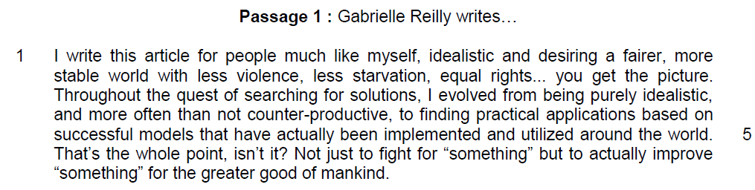
- what he wants to achieve – to improve the world
- the author is defending the system of capitalism, proving that capitalism has been wrongly accused for the faults and problems in our modern society

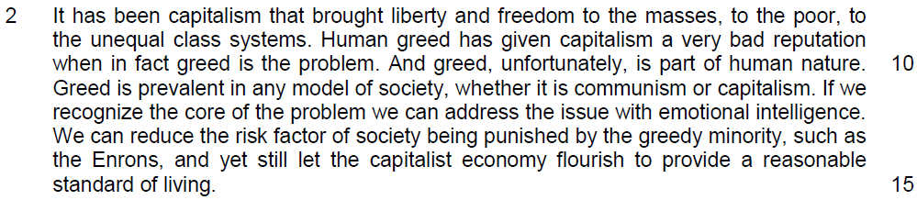
- there are flaws in human nature and capitalism but it is still useful in the betterment of life
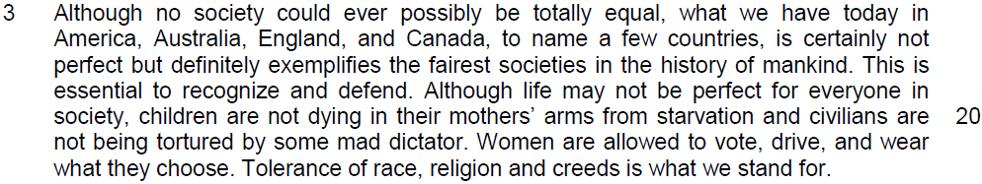
using the examples to prove that capitalism works

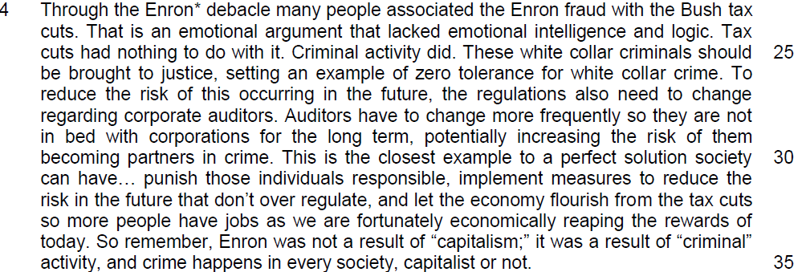

prove that capitalism is not at fault but the element of human greed which will lead criminal activities that lead many to think capitalism is at fault

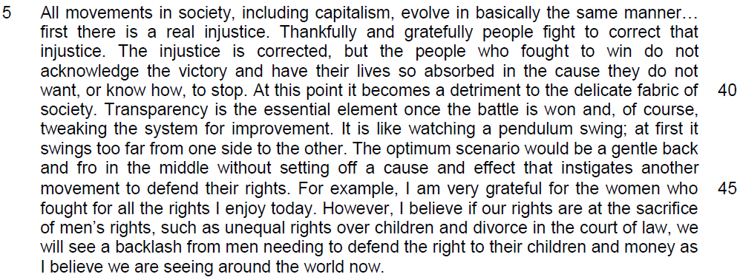

capitalism eradicate feudal class system – but they fail to recognize the flaws – undermine society – reflect through understanding without compromising others

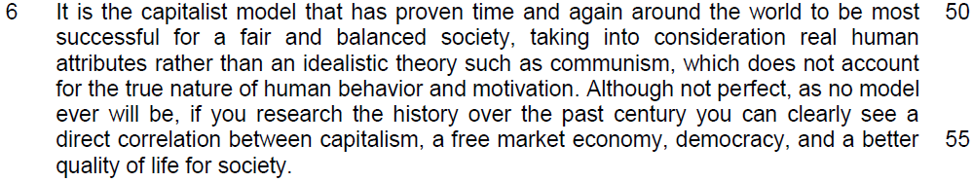

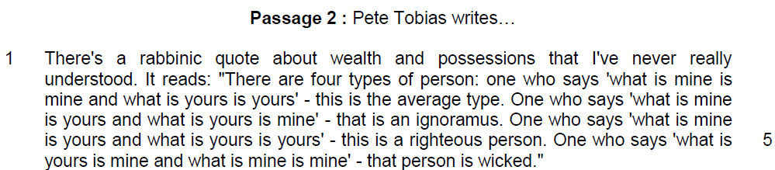

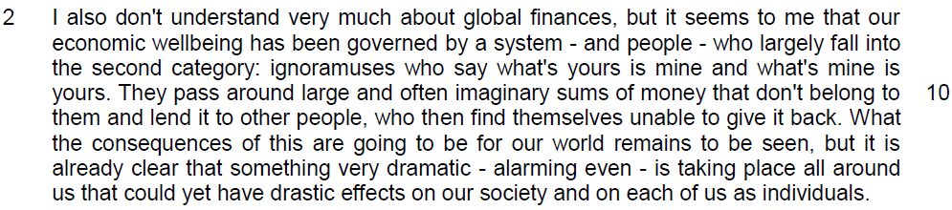

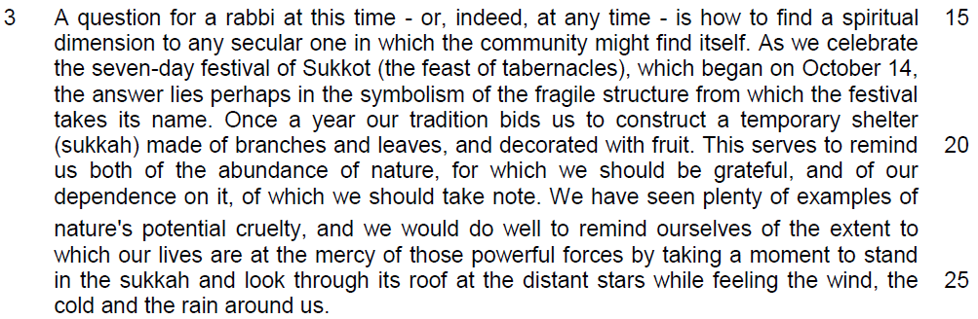

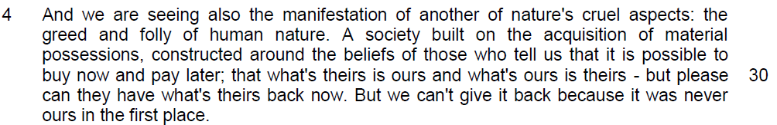

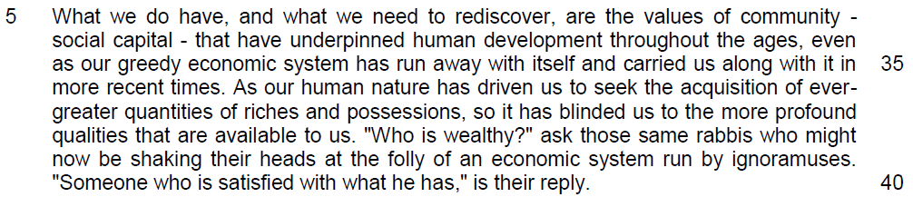

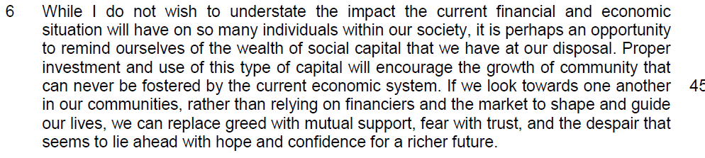

Suggested Answers
Questions on Passage 1
Q1. What is the difference between having to ‘fight for “something” ’ in line 6 and ‘to actually improve “something” ’ in lines 6 - 7? [2]

Inferred Answer
To ‘fight for “something” ‘ means to have an ideal (utopian) goal in mind.

‘To actually improve “something” ‘ means to have a pragmatic/feasible approach to solve problems and benefit mankind.

To fight for something, one is trying to attain an idea in life while to improve on something is seen a pragmatic or direct way to achieve a beneficial result in life.

Q2. According to the writer, why is it unfortunate that greed is ‘part of human nature’ (line 10)? Use your own words as far as possible. [2]
(show how greed affects the society negatively)
Lifted
a) Greed is prevalent in any model of society, whether it is communism or capitalism. (line 11)

b) society being punished by the greedy minority (line 13)

Paraphrased
It is unfortunate because greed, being an innate quality, is widespread, regardless of the socio-political system and therefore the few who are extremely greedy will gain at the expense of the rest.

Q3. Explain how the examples in lines 20 - 22 show that the 4 countries mentioned in paragraph 3 are “the fairest societies in the history of mankind” (line 18). [2]

Inferred
These countries enjoy a higher standard of living. They are relatively free from social injustices. There is good governance and respect for diversity.

Summary Question
4. In paragraph 4, the writer states that “many people associated the Enron fraud with the Bush tax cuts.” (lines 23 - 24)

Using material from paragraphs 4 to 5 of the passage (lines 23 - 49), summarise the writer’s rebuttal of this view and her recommendations to address the flaws in the capitalist system.

Write your summary in no more than 120 words, not counting the opening words which are printed below. Use your own words as far as possible. [8]

The writer disagrees with this view because

Lifted | Paraphrased
- That is an emotional argument that lacked emotional intelligence and logic. (line 24) | it is irrational.
- let the economy flourish from the tax cuts so more people have jobs (lines 32 – 33) | Tax reductions promote economic growth and employment.
- Tax cuts had nothing to do with it. Criminal activity did. (lines 24 -25) | Corruption/embezzlement should be seen as an illegal/dishonest act/a legal offence
- These white collar criminals should be brought to justice  (lines 25 -26)  OR  punish those individuals  responsible (line 31) | and thus, legal action should be taken against the culprits/felons
- To reduce the risk of this occurring in the future, the regulations also need to change regarding corporate auditors. (lines 26 -28)  OR  Auditors have to change more  frequently (line 28) | To prevent further abuses of the system, companies need to be audited by different people/  checked by different auditors.

Lifted | Paraphrased
- so they are not in bed with  corporations for the long term,  potentially increasing the risk of  them becoming partners in crime. (lines 28 – 30) | so that they will not collude with the companies.
- Transparency is the essential  element once the battle is won  (line 41) | Corporate information should be freely available once the system has been corrected.
- tweaking the system for  improvement (line 42) | We should only make minor/small adjustments to the system
- The optimum scenario would be a gentle back and fro in the middle without setting off a cause and effect that instigates another movement to defend their rights. (lines 43 - 45)  OR  implement measures to reduce the risk in the future that don’t over regulate… (lines 31 – 32) | and not over-compensate/over-correct it as this will cause further unfairness which will require further correction.  OR  The ideal situation is to strike a balance without leading to further measures to fight injustice/unfairness.

Suggested Answer:
The writer disagrees with this view because it is irrational as tax reductions promote economic growth and employment. According to the writer, corruption should be seen as illegal and thus, legal action should be taken against the culprits. To prevent further abuses of the system, companies need to be audited by different people so that they will not collude with the companies. The writer also recommends that corporate information should be freely available. Furthermore, she suggests that once the system has been corrected, we should only make minor adjustments and not over-correct the system as this will cause more unfairness, which will require further correction.

(98 words)

Questions on Passage 2
Q5. What does the phrase ‘dramatic – alarming even’ in line 13 tell you about the possible consequences of the global financial system? [2]
(consequential / the damaging impact)
The phrase ‘dramatic – alarming even’ tells us that the global financial system is facing collapse and people are likely to be in debt. Thus, the urgency of the situation requires immediate action to be taken.

Q6. Explain the consequences of the two aspects of nature’s cruelty the writer refers to in paragraphs 3 and 4. Use your own words as far as possible. [3]

Lifted
… constructed around the beliefs of those who tell us that it is possible to buy now and pay later… (lines 29– 30

Paraphrased/Inferred Answer
The writer wishes to convey the idea that nature can destroy property and lives and that human nature can lead to unsustainable consumption. Nature can also give a false sense of security due to the misconception that there is an abundance of resources.

Q7. According to the author, why is ‘Someone who is satisfied with what he has’ (line 40) considered wealthy? [1]

This is because a person can only be said to be genuinely wealthy when he does not see the need to pursue greater wealth.

Q8. In paragraph 6, why did the author say that we should rely on social capital rather than material wealth to encourage the growth of community? [2]

This is because material wealth needs to be acquired, whereas social capital, referring to the spirit of togetherness and sharing, is within all of us/inherent.

Social capital will inculcate the values and behaviours to nurture relationship among different members of the community while the pursuit of materials wealth will undermine our social relationship with people as there will be higher degree of competition.

Application Question
9. Reilly feels that capitalism has become the scapegoat for greed. Tobias feels capitalism itself breeds greed.

Which view is a more accurate reflection of society today? In your opinion, would a society without greed be a better one?

In your answer, develop some of the points made by the authors, and give your own views and some account of the experiences which have helped you to form them. [8]

Passage 1: Reilly – Capitalism has become the scapegoat for greed
(a) Quote from the passage
It has been capitalism that brought liberty and freedom to the masses, to the poor, to the unequal class systems. (lines 8 -9)

children are not dying in their mothers’ arms from starvation and civilians are not being tortured by some mad dictator. (lines 20-21)

Women are allowed to vote, drive, and wear what they choose. Tolerance of race, religion and creeds is what we stand for. (lines 21 – 22)

b) Explanation
Capitalism has led to freedom from social injustices and an increase in the standard of living of people. It is not true that it has bough adverse impact on the society.

(b) Application of the question

It is the reflection of our society, but this is not accurate.

C. Example – Prove that it
- The collapse of Russian communism was due to rise of the middle class which demanded more rights and freedoms for the people.
- China has adopted the open-door policy and capitalism. This has led to the economic growth of the cities of Shanghai and Beijing. Moreover, China also tolerates HK, despite it not being communist. Thus, China’s adoption of the capitalist system has made it possible for her to have the potential to become an economic giant, as opposed to North Korea, where the refusal to adopt capitalism has resulted in famine.

Why this is not applicable and it is not a scapegoat?

However, The basis of capitalism is profit-making, and greed is the driving force. Unchecked greed leads to corporate scandals and scams.
- E.g. Bernard Lawrence "Bernie" Madoff’s ponzi scheme - Madoff, an American businessman and former non-executive chairman of the NASDAQ stock exchange, was convicted of operating a Ponzi scheme that has been called the largest investor fraud ever committed by a single person. Client losses were estimated at almost $65 billion.
- $165 million in bonuses were paid out to top executives at AIG — the insurance giant that received more than $180 billion in federal money;
- Corruption at NKF in Singapore.

Capitalism needs to be regulated to keep greed at healthy levels and not result in abuses of the system.
- Singapore – CPIB investigates corruption
  - TT Durai – brought to justice and NKF had to implement measures to ensure transparency.
- On March 12, 2009, Bernard Lawrence "Bernie" Madoff pleaded guilty to an 11-count criminal complaint, admitting to defrauding thousands of investors. He was given a 150-year jail sentence.

Passage 2: Tobias – Capitalism breeds greed
(a) From the passage
They pass around large and often imaginary sums of money that don't belong to them and lend it to other people, who then find themselves unable to give it back. (lines 10-11)

A society built on the acquisition of material possessions, constructed around the beliefs of those who tell us that it is possible to buy now and pay later (lines 28- 30)

b) Explanation

c) Application – why it is applicable
The financial system in modern society allows people to possess what they cannot afford.
- All banks lend money based on credit rating. However, the economic crisis occurred due to irresponsible lending practices because the banks were greedy and made loans to people who could not pay.
- The sub-prime mortgage crisis occurred due to loans being made to people with bad credit history and who lacked collateral. When these people failed to pay back the loans, the banks were saddled with debt.

d) Example

The modern financial system has also led to the preoccupation with buying things on credit/spending money we do not have. This has resulted in credit card debts and bankruptcy.
- Many Singaporeans prefer to buying things on instalment / higher purchase.
- Between 2002 & 2007, there was a credit card debt of 7 trillion dollars in the US.
- An increasing number of young Singaporeans declare bankruptcy due to credit card debt.

The competitive nature of society has resulted in a highly materialistic lifestyle.
- Instead of being prudent in the current crisis, Singaporeans seize the opportunity to buy private property, to take advantage of cheaper deals offered at travel fairs (NATAS) and to spend on consumer goods in the IT show in 2009.

.
Would a society without greed be a better one?
(a) Society is better off without greed:
- Society would be free from corruption.
- People would be less selfish, doing more charitable work and caring for the less fortunate.
- People would be more concerned with the environment.
- People would focus on long term needs rather than instant gratification (saving the environment instead of destroying it for economic progress).
- People would suffer from less stress and thus, mental and physical wellbeing would be enhanced.

(b) Society is better off with greed
- Enterprise, innovation and progress are made possible with greed because of the profit motivation.
- With no financial reward or incentive, people would see no reason to pursue growth. (This is one of the reasons why the Chinese communist system is opening up China to capitalism and jumping onto the free market bandwagon).
- Greed also spurs knowledge growth due to the desire to learn more. This has led to breakthroughs, for example, in science and technology.

(c) Conclusion
There should be a balance between greed and prudence.

