GP Term 3 2017 – Comprehension – Topic 7: Social Issues – Capitalism & Greed
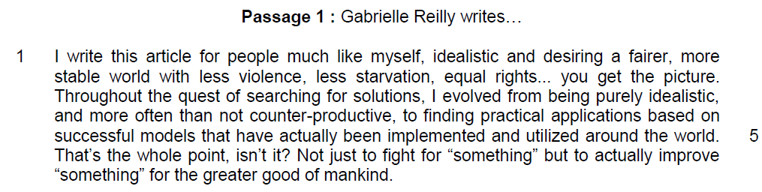

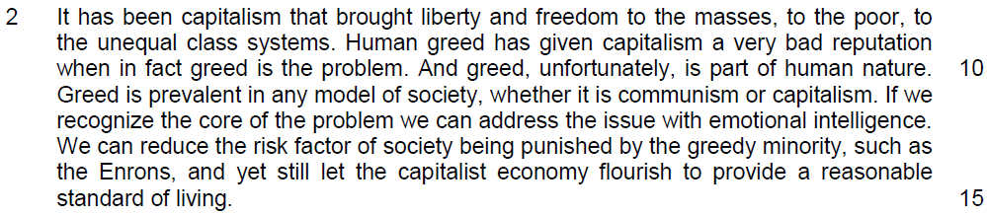

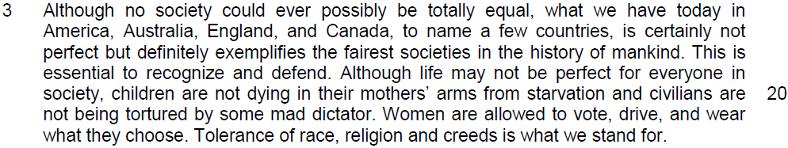

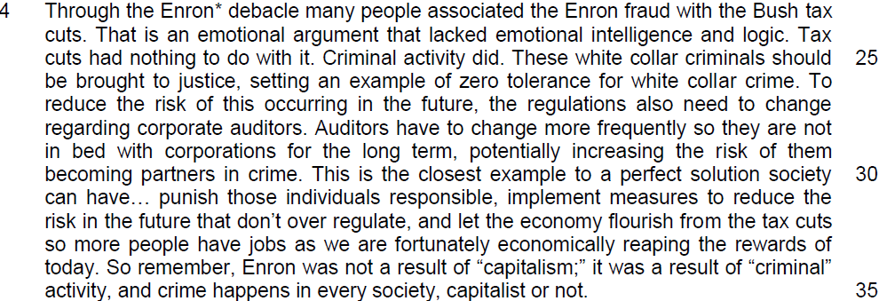

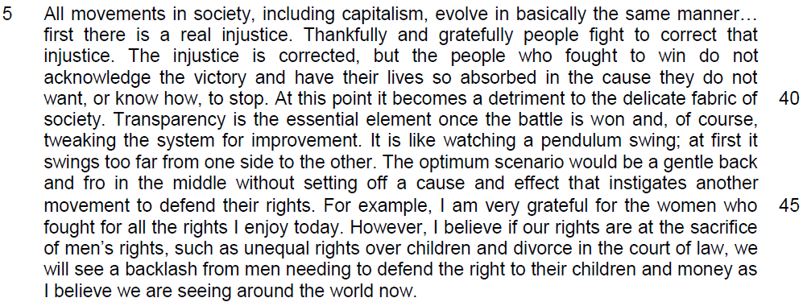

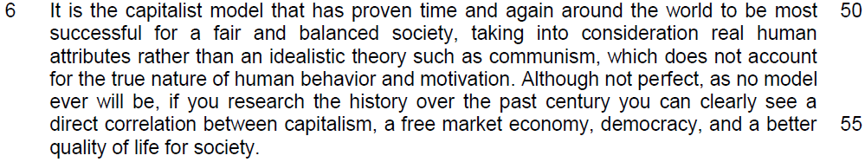

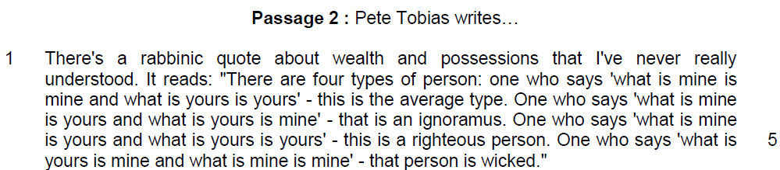

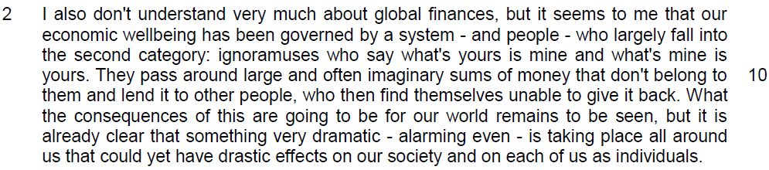

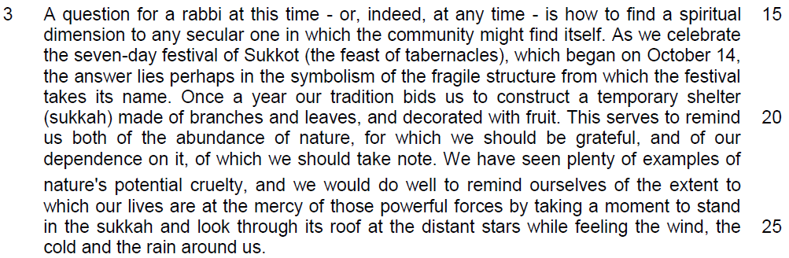

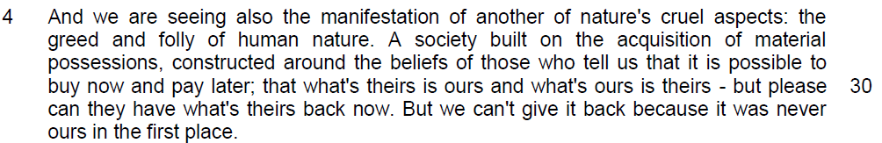

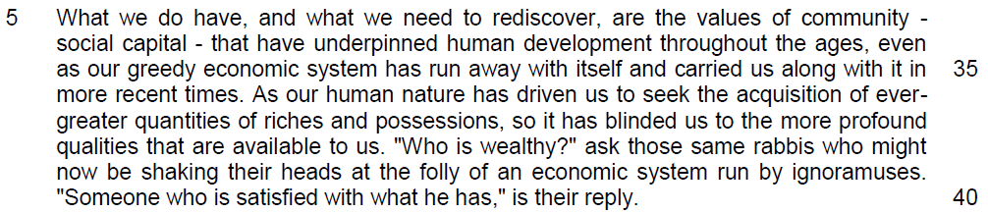

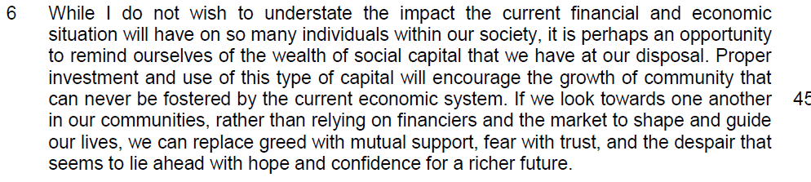

Read the passages in the insert and then answer all the questions. Note that up to fifteen marks will be given for the quality and accuracy of your use of English throughout this paper.

NOTE: When a question asks for an answer IN YOUR OWN WORDS AS FAR AS POSSIBLE and you select the appropriate material from the passage for your answer, you must still use your own words to express it. Little credit can be given to answers which only copy words and phrases from the passages.

Questions on Passage 1
1. What is the difference between having to ‘fight for “something” ’ in line 6 and ‘to actually improve “something” ’ in lines 6 - 7? [2]

……………………………………………………………………………………………………………………………………
……………………………………………………………………………………………………………………………………

……………………………………………………………………………………………………………………………………
……………………………………………………………………………………………………………………………………

2. According to the writer, why is it unfortunate that greed is ‘part of human nature’ (line 10)? Use your own words as far as possible. [2]

……………………………………………………………………………………………………………………………………
……………………………………………………………………………………………………………………………………

……………………………………………………………………………………………………………………………………
……………………………………………………………………………………………………………………………………

3. Explain how the examples in lines 20 - 22 show that the 4 countries mentioned in paragraph 3 are “the fairest societies in the history of mankind” (line 18). [2]

……………………………………………………………………………………………………………………………………
……………………………………………………………………………………………………………………………………

……………………………………………………………………………………………………………………………………
……………………………………………………………………………………………………………………………………

Summary Question
4. In paragraph 4, the writer states that “many people associated the Enron fraud with the Bush tax cuts.” (lines 23 - 24)

Using material from paragraphs 4 to 5 of the passage (lines 23 - 49), summarise the writer’s rebuttal of this view and her recommendations to address the flaws in the capitalist system.

Write your summary in no more than 120 words, not counting the opening words which are printed below. Use your own words as far as possible. [8]

The writer disagrees with this view because…

Lifted | Paraphrased
- That is an emotional argument that lacked emotional intelligence and logic. (line 24)
- let the economy flourish from the tax cuts so more people have jobs (lines 32 – 33)
- Tax cuts had nothing to do with it. Criminal activity did. (lines 24 -25)
- These white collar criminals should be brought to justice
(lines 25 -26)
OR
punish those individuals
responsible (line 31)
- To reduce the risk of this occurring in the future, the regulations also need to change regarding corporate auditors. (lines 26 -28)
OR
Auditors have to change more
frequently (line 28)

Lifted | Paraphrased
- so they are not in bed with
corporations for the long term,
potentially increasing the risk of
them becoming partners in crime. (lines 28 – 30)
- Transparency is the essential
element once the battle is won
(line 41)
- tweaking the system for
improvement (line 42)
- The optimum scenario would be a gentle back and fro in the middle without setting off a cause and effect that instigates another movement to defend their rights. (lines 43 - 45)
OR
implement measures to reduce the risk in the future that don’t over regulate… (lines 31 – 32)

Questions on Passage 2
5. What does the phrase ‘dramatic – alarming even’ in line 13 tell you about the possible consequences of the global financial system? [2]

……………………………………………………………………………………………………………………………………
……………………………………………………………………………………………………………………………………

……………………………………………………………………………………………………………………………………
……………………………………………………………………………………………………………………………………

6. Explain the consequences of the two aspects of nature’s cruelty the writer refers to in paragraphs 3 and 4. Use your own words as far as possible. [3]

……………………………………………………………………………………………………………………………………
……………………………………………………………………………………………………………………………………

……………………………………………………………………………………………………………………………………
……………………………………………………………………………………………………………………………………

……………………………………………………………………………………………………………………………………
……………………………………………………………………………………………………………………………………

7. According to the author, why is ‘Someone who is satisfied with what he has’ (line 40) considered wealthy? [1]

……………………………………………………………………………………………………………………………………
……………………………………………………………………………………………………………………………………

8. In paragraph 6, why did the author say that we should rely on social capital rather than material wealth to encourage the growth of community? [2]

……………………………………………………………………………………………………………………………………
……………………………………………………………………………………………………………………………………

……………………………………………………………………………………………………………………………………
……………………………………………………………………………………………………………………………………

Application Question
9. Reilly feels that capitalism has become the scapegoat for greed. Tobias feels capitalism itself breeds greed.

Which view is a more accurate reflection of society today? In your opinion, would a society without greed be a better one?

In your answer, develop some of the points made by the authors, and give your own views and some account of the experiences which have helped you to form them. [8]

……………………………………………………………………………………………………………………………………
……………………………………………………………………………………………………………………………………

……………………………………………………………………………………………………………………………………
……………………………………………………………………………………………………………………………………

……………………………………………………………………………………………………………………………………
……………………………………………………………………………………………………………………………………

……………………………………………………………………………………………………………………………………
……………………………………………………………………………………………………………………………………

……………………………………………………………………………………………………………………………………
……………………………………………………………………………………………………………………………………

……………………………………………………………………………………………………………………………………
……………………………………………………………………………………………………………………………………

……………………………………………………………………………………………………………………………………
……………………………………………………………………………………………………………………………………

……………………………………………………………………………………………………………………………………
……………………………………………………………………………………………………………………………………

……………………………………………………………………………………………………………………………………
……………………………………………………………………………………………………………………………………

……………………………………………………………………………………………………………………………………
……………………………………………………………………………………………………………………………………

……………………………………………………………………………………………………………………………………
……………………………………………………………………………………………………………………………………

……………………………………………………………………………………………………………………………………
……………………………………………………………………………………………………………………………………

……………………………………………………………………………………………………………………………………
……………………………………………………………………………………………………………………………………

……………………………………………………………………………………………………………………………………
……………………………………………………………………………………………………………………………………

……………………………………………………………………………………………………………………………………
……………………………………………………………………………………………………………………………………

……………………………………………………………………………………………………………………………………
……………………………………………………………………………………………………………………………………

……………………………………………………………………………………………………………………………………
……………………………………………………………………………………………………………………………………

……………………………………………………………………………………………………………………………………
……………………………………………………………………………………………………………………………………

……………………………………………………………………………………………………………………………………
……………………………………………………………………………………………………………………………………

……………………………………………………………………………………………………………………………………
……………………………………………………………………………………………………………………………………

……………………………………………………………………………………………………………………………………
……………………………………………………………………………………………………………………………………

……………………………………………………………………………………………………………………………………
……………………………………………………………………………………………………………………………………

……………………………………………………………………………………………………………………………………

