GP Comprehension – Reflective Issues – Pessimism & Optimism (ACJC 2014)

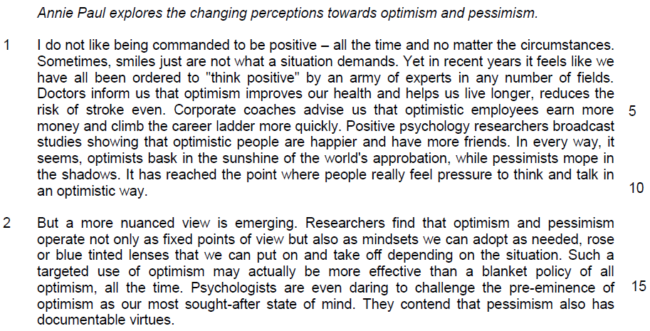

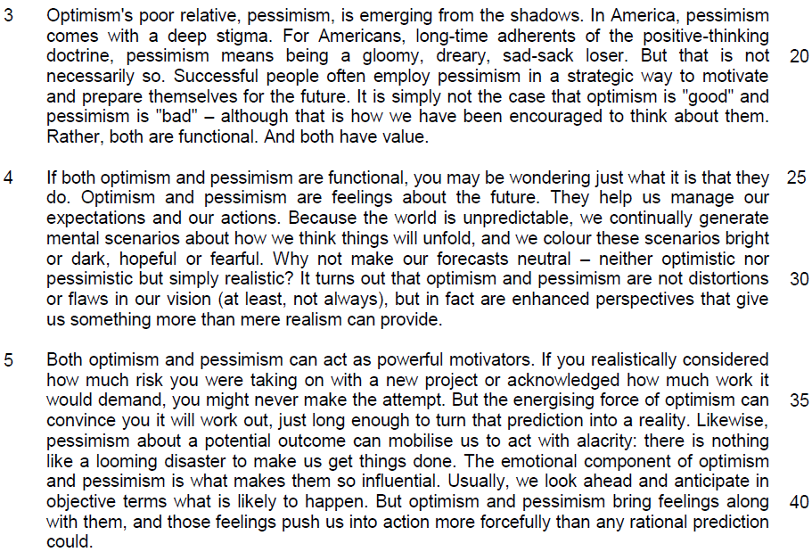

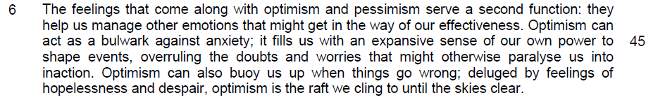

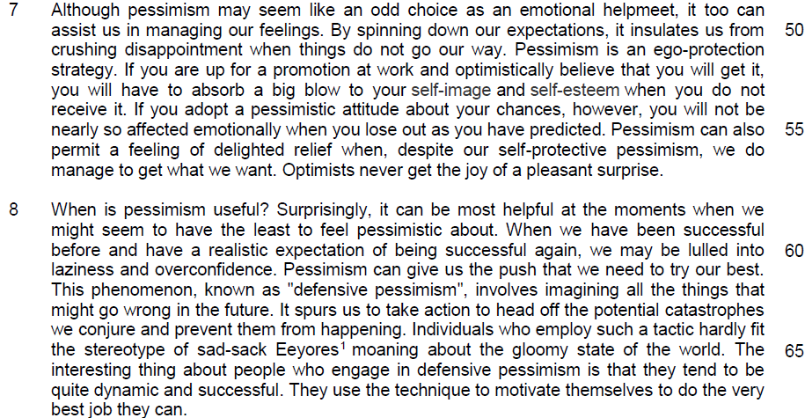

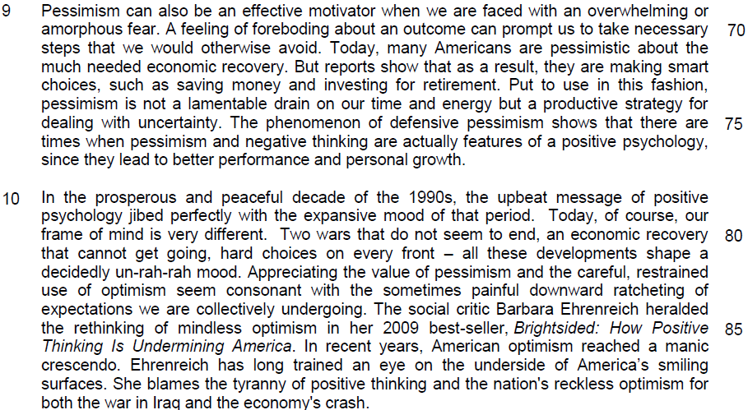

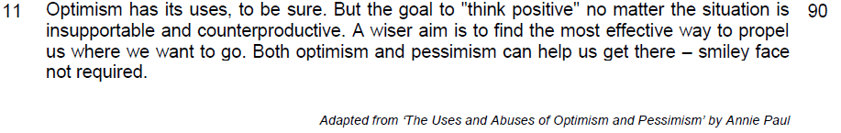

Read the passage in the insert and then answer all the questions which follow below. Note that up to fifteen marks will be given for the quality and accuracy of your use of English throughout this paper.

NOTE: When a question asks for an answer IN YOUR OWN WORDS AS FAR AS POSSIBLE and you select the appropriate material from the passages for your answer, you must still use your own words to express it. Little credit can be given to answers which only copy words or phrases from the passages.

1. Explain why the author disapproves of complying with positive thinking ‘all the time’ (line 1). Use your own words as far as possible.

…………………………………………………………………………………………

…………………………………………………………………………………………
………………………………………………………………………………………[1]

2. According to the author, what contrasting perceptions do people have about optimists and pessimists as stated in lines 8-9? Use your own words as far as possible.

…………………………………………………………………………………………

…………………………………………………………………………………………

…………………………………………………………………………………………
……………………………………………………………………………………….[2]

3. Explain how a ‘targeted’ use of optimism differs from its ‘blanket’ use (line 14). Use your own words as far as possible.

…………………………………………………………………………………………

…………………………………………………………………………………………

…………………………………………………………………………………………
………………………………………………………………………………………[2]

4. What does the phrase ‘optimism’s poor relative’ (line 18) imply about pessimism?

…………………………………………………………………………………………

…………………………………………………………………………………………

…………………………………………………………………………………………
………………………………………………………………………………………[2]

5. Why has the author placed the phrase “at least, not always” (line 31) inside brackets?

…………………………………………………………………………………………

…………………………………………………………………………………………

…………………………………………………………………………………………
………………………………………………………………………………………[2]

6. Explain why the author uses the word “surprisingly” in line 58. Use your own words as far as possible.

…………………………………………………………………………………………

…………………………………………………………………………………………

…………………………………………………………………………………………
………………………………………………………………………………………[2]

7. Explain why the author thinks that people who engage in defensive pessimism cannot be labelled as ‘sad-sack Eeyores’ (line 65). Use your own words as far as possible.

…………………………………………………………………………………………

…………………………………………………………………………………………

…………………………………………………………………………………………

…………………………………………………………………………………………

…………………………………………………………………………………………
………………………………………………………………………………………[3]

8. In paragraph 10, what explanation does Barbara Ehrenreich offer for the problems America is facing? Use your own words as far as possible.

…………………………………………………………………………………………

…………………………………………………………………………………………

…………………………………………………………………………………………
………………………………………………………………………………………[2]

9. Suggest one reason for the author ending the passage with the phrase “smiley face not required” (lines 92-93).

…………………………………………………………………………………………

…………………………………………………………………………………………
………………………………………………………………………………………[1]

=

10. Using material from paragraphs 4-7, summarise the benefits of pessimism. Write your summary in no more than 120 words, not counting the opening words which are printed below. Use your own words as far as possible.

Pessimism is beneficial because ……………………………….…………………

…………………………………………………………………………………………

…………………………………………………………………………………………
…………………………………………………………………………………………

…………………………………………………………………………………………

…………………………………………………………………………………………

…………………………………………………………………………………………

…………………………………………………………………………………………

…………………………………………………………………………………………

…………………………………………………………………………………………

…………………………………………………………………………………………

…………………………………………………………………………………………

…………………………………………………………………………………………

…………………………………………………………………………………………

…………………………………………………………………………………………

…………………………………………………………………………………………

…………………………………………………………………………………………

…………………………………………………………………………………………

…………………………………………………………………………………………

…………………………………………………………………………………………
………………………………………………………………………………………[8]

[Number of words: …………..]

11. Annie Paul explores the changing perceptions towards both optimism and pessimism. How applicable are the ideas raised by the author to you and your society?

Justify your answer with ideas from the passage and your knowledge of your own society.

…………………………………………………………………………………………

…………………………………………………………………………………………
…………………………………………………………………………………………

…………………………………………………………………………………………

…………………………………………………………………………………………

…………………………………………………………………………………………

…………………………………………………………………………………………

…………………………………………………………………………………………

…………………………………………………………………………………………

…………………………………………………………………………………………

…………………………………………………………………………………………

…………………………………………………………………………………………

…………………………………………………………………………………………

…………………………………………………………………………………………

…………………………………………………………………………………………

…………………………………………………………………………………………

…………………………………………………………………………………………

…………………………………………………………………………………………

…………………………………………………………………………………………

…………………………………………………………………………………………

…………………………………………………………………………………………

…………………………………………………………………………………………

…………………………………………………………………………………………
…………………………………………………………………………………………

…………………………………………………………………………………………

…………………………………………………………………………………………

…………………………………………………………………………………………

…………………………………………………………………………………………

…………………………………………………………………………………………

…………………………………………………………………………………………

…………………………………………………………………………………………

…………………………………………………………………………………………

…………………………………………………………………………………………

…………………………………………………………………………………………

…………………………………………………………………………………………

…………………………………………………………………………………………

…………………………………………………………………………………………

…………………………………………………………………………………………

…………………………………………………………………………………………

…………………………………………………………………………………………

…………………………………………………………………………………………

…………………………………………………………………………………………

…………………………………………………………………………………………

…………………………………………………………………………………………

…………………………………………………………………………………………

…………………………………………………………………………………………

…………………………………………………………………………………………
…………………………………………………………………………………………

…………………………………………………………………………………………

…………………………………………………………………………………………

…………………………………………………………………………………………

…………………………………………………………………………………………

…………………………………………………………………………………………

…………………………………………………………………………………………

…………………………………………………………………………………………

…………………………………………………………………………………………

…………………………………………………………………………………………

…………………………………………………………………………………………

…………………………………………………………………………………………

…………………………………………………………………………………………

…………………………………………………………………………………………

…………………………………………………………………………………………

…………………………………………………………………………………………

…………………………………………………………………………………………

…………………………………………………………………………………………

…………………………………………………………………………………………

…………………………………………………………………………………………
……………………………………………………………………………………..[10]

