2013 Term 3 GP Comprehension – Science & Technology – Impacts of Modern Technology on our Minds

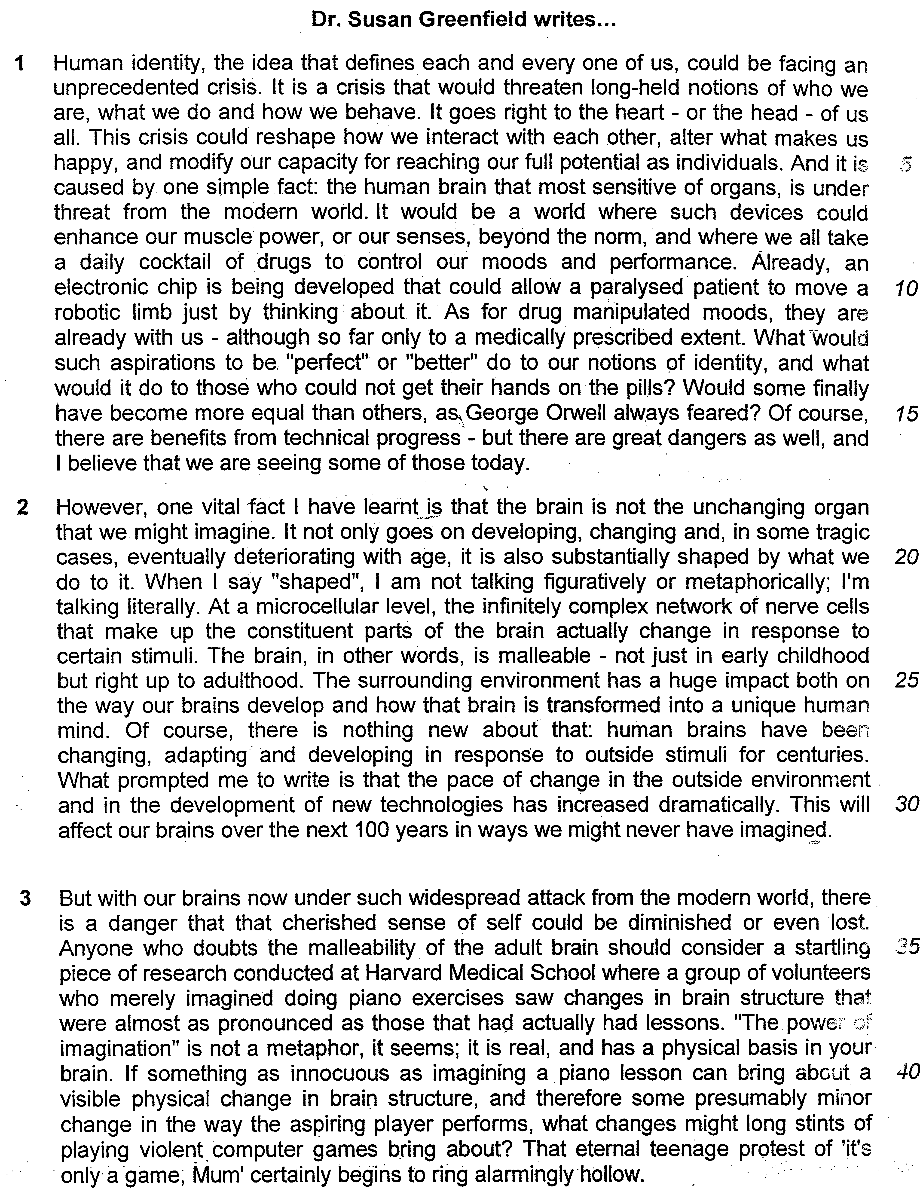

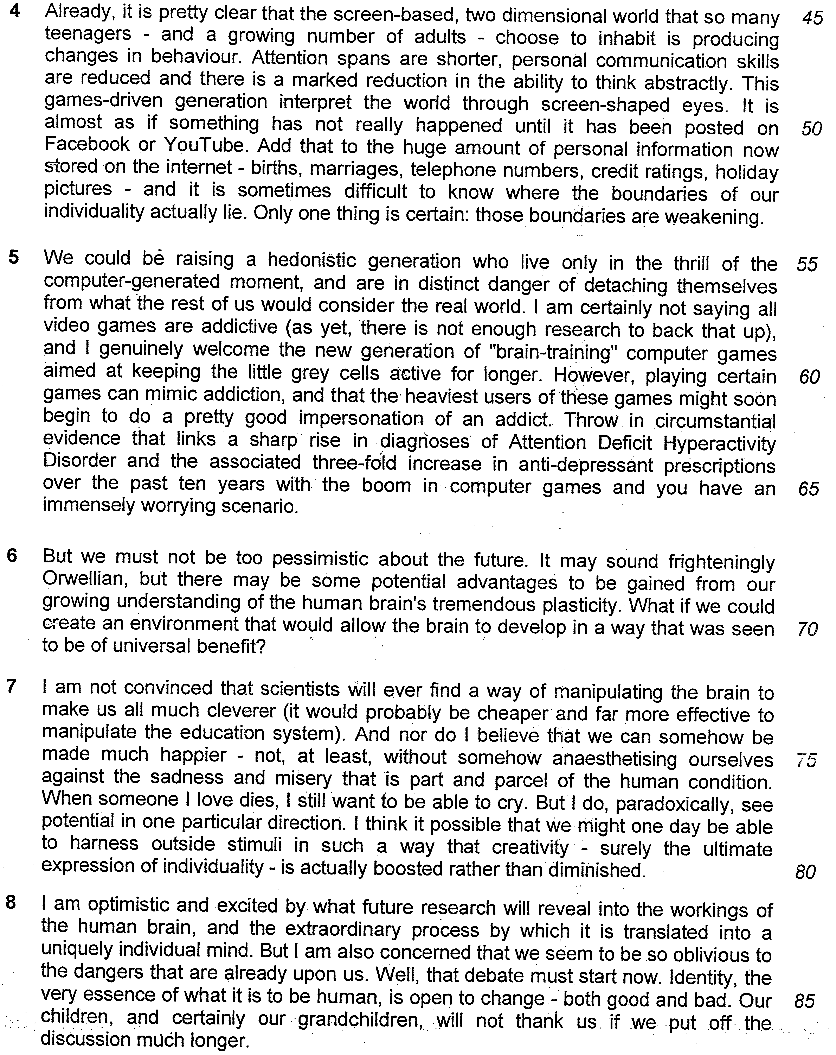

Read the passage in the insert and then answer all the questions which follow below. Note that up to fifteen marks will be given for the quality and accuracy of your use of English throughout this paper.

NOTE: When a question asks for an answer IN YOUR OWN WORDS AS FAR AS POSSIBLE and you select the appropriate material from the passages for your answer, you must still use your own words to express it. Little credit can be given to answers which only copy words or phrases from the passages.

1. From paragraph 1, explain what the writer means by ‘It goes right to the heart’.

……………………………………………………………………………………...…
………………………………………………………………………………………[1]

2. According to lines 4-5, what are the impacts of the crisis? Answer in your own words as far as possible.

…………………………………………………………………………………………

…………………………………………………………………………………………

……………………………………………………………………………………...…
………………………………………………………………………………………[2]

3. In paragraph 2, why did Dr. Greenfield describe the brain as ‘malleable’? Answer in your own words as far as possible.

…………………………………………………………………………………………

…………………………………………………………………………………………

……………………………………………………………………………………...…
………………………………………………………………………………………[2]

4. Why did the author use the word ‘dramatically (line 30)?

……………………………………………………………………………………...…
………………………………………………………………………………………[1]

5. What does the author mean by “The power of imagination” is not a metaphor…’ (line 38-39)? Answer in your own words as far as possible.

…………………………………………………………………………………………

…………………………………………………………………………………………

……………………………………………………………………………………...…
………………………………………………………………………………………[2]

6. Why does the author use the term “alarmingly hollow” (line 44)?

…………………………………………………………………………………………

…………………………………………………………………………………………

……………………………………………………………………………………...…
………………………………………………………………………………………[2]

7. In paragraph 5, what is the writer’s purpose in using the parathesis?

……………………………………………………………………………………...…
………………………………………………………………………………………[1]

8. ‘When someone I love dies, I still want to be able to cry’ (line 77) What is the author’s intention when she makes the statement?

……………………………………………………………………………………...…
………………………………………………………………………………………[1]

9. Explain how the idea of ‘representative democracy’ (lines 49-50) is practiced during the vetting process. Answer in your own words as far as possible.

…………………………………………………………………………………………

…………………………………………………………………………………………

……………………………………………………………………………………...…
………………………………………………………………………………………[2]

10. Give the meaning of the following words as they are used in the passage. You may write your answer in one word or a short phrase.

a) unprecedented (line 2) …………………………….…..……….…………………

b) malleable (line 24)……………………….….……………….…………………….

c) innocuous (line 40)…..……….……………….…………………….……………..

d) immensely (line 66)………….……………………..……………………………..

e) essence (line 85)….………………………….………….…. ………………….[5]

11. Using material from paragraphs 4 and 5, summarise the concerns Dr. Greenfield has for the future of mankind.

Write your summary in no more than 120 words not counting the opening words which are printed below. Use your own words far as possible.

The first concern is ………………………………………………………………..

…………………………………………………………………………………………

…………………………………………………………………………………………
…………………………………………………………………………………………
…………………………………………………………………………………………
…………………………………………………………………………………………

…………………………………………………………………………………………
…………………………………………………………………………………………
…………………………………………………………………………………………
…………………………………………………………………………………………

…………………………………………………………………………………………

…………………………………………………………………………………………
…………………………………………………………………………………………
…………………………………………………………………………………………
…………………………………………………………………………………………
…………………………………………………………………………………………

…………………………………………………………………………………………

…………………………………………………………………………………………
……………………………………………………………………………………… [8]

12. Dr. Greenfield claims that modern technology has changed the way our brains work and is concerned about this development. How far are her concerns valid for you and your generation?

…………………………………………………………………………………………

…………………………………………………………………………………………

………………………………………………………………………………………….

………………………………………………………………………………………….

………………………………………………………………………………………….

………………………………………………………………………………………….

…………………………………………………………………………………………..

…………………………………………………………………………………………..

…………………………………………………………………………………………

………………………………………………………………………………………….

…………………………………………………………………………………………

…………………………………………………………………………………………

………………………………………………………………………………………….

………………………………………………………………………………………….

………………………………………………………………………………………….

………………………………………………………………………………………….

…………………………………………………………………………………………..

…………………………………………………………………………………………..

…………………………………………………………………………………………

………………………………………………………………………………………….

…………………………………………………………………………………………

…………………………………………………………………………………………

………………………………………………………………………………………….

………………………………………………………………………………………….

………………………………………………………………………………………….

………………………………………………………………………………………….

…………………………………………………………………………………………..

…………………………………………………………………………………………..

…………………………………………………………………………………………

………………………………………………………………………………………….

………………………………………………………………………………………….

………………………………………………………………………………………….

…………………………………………………………………………………………..

…………………………………………………………………………………………..

…………………………………………………………………………………………

…………………………………………………………………………………………

…………………………………………………………………………………………

………………………………………………………………………………………….

………………………………………………………………………………………….

………………………………………………………………………………………….

………………………………………………………………………………………….

…………………………………………………………………………………………..

…………………………………………………………………………………………..

………………………………………………………………………………………[8]

control of us.

