\
GP Term 4 2014 – Comprehension – Lesson 1 – Culture – Cultural Heritage

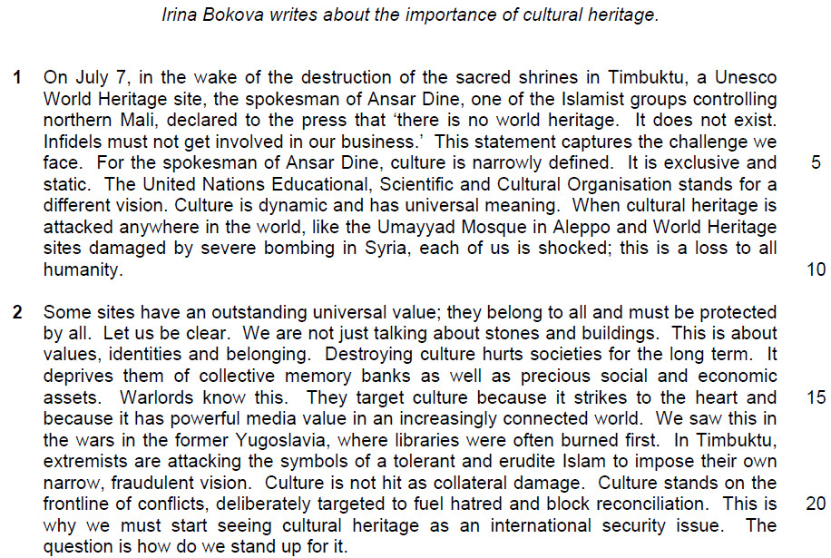

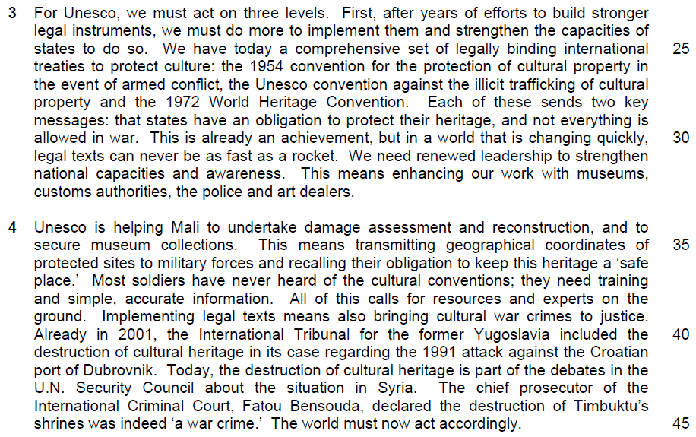

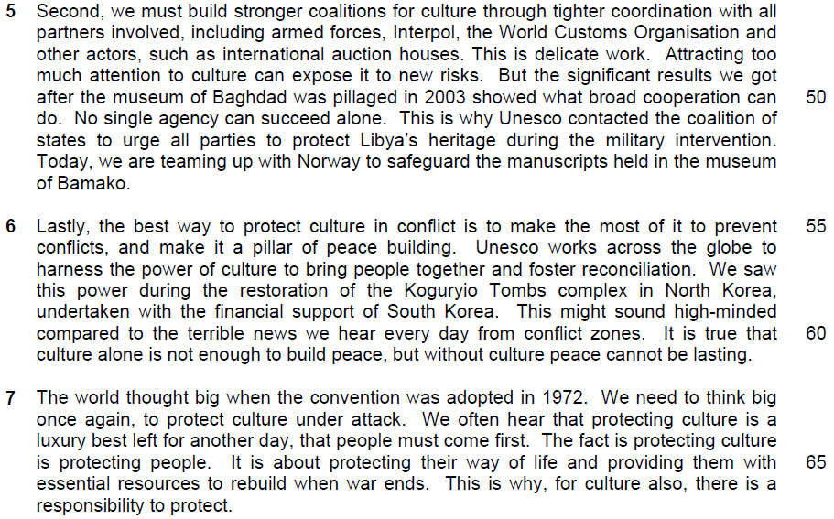

11. Irina Bokva feels that cultural heritage belongs to all and must be protected by all. To what extent do you agree or disagree with her views? How applicable do you find her observations to yourself and your own society?

…………………………………………………………………………………………..
…………………………………………………………………………………………..
…………………………………………………………………………………………..
…………………………………………………………………………………………..
…………………………………………………………………………………………..
…………………………………………………………………………………………..
…………………………………………………………………………………………..
…………………………………………………………………………………………..
…………………………………………………………………………………………..
…………………………………………………………………………………………..
…………………………………………………………………………………………..
…………………………………………………………………………………………..
…………………………………………………………………………………………..
…………………………………………………………………………………………..
…………………………………………………………………………………………..
…………………………………………………………………………………………..
…………………………………………………………………………………………..
…………………………………………………………………………………………..
…………………………………………………………………………………………..
…………………………………………………………………………………………..

…………………………………………………………………………………………..
…………………………………………………………………………………………..
…………………………………………………………………………………………..
…………………………………………………………………………………………..
…………………………………………………………………………………………..
…………………………………………………………………………………………..
…………………………………………………………………………………………..
…………………………………………………………………………………………..
…………………………………………………………………………………………..
…………………………………………………………………………………………..
…………………………………………………………………………………………..
…………………………………………………………………………………………..
…………………………………………………………………………………………..
…………………………………………………………………………………………..
…………………………………………………………………………………………..
…………………………………………………………………………………………..
…………………………………………………………………………………………..
…………………………………………………………………………………………..
…………………………………………………………………………………………..
…………………………………………………………………………………………..
…………………………………………………………………………………………..
…………………………………………………………………………………………..
…………………………………………………………………………………………..
…………………………………………………………………………………………..

…………………………………………………………………………………………..
…………………………………………………………………………………………..
…………………………………………………………………………………………..
…………………………………………………………………………………………..
…………………………………………………………………………………………..
…………………………………………………………………………………………..
…………………………………………………………………………………………..
…………………………………………………………………………………………..
…………………………………………………………………………………………..
…………………………………………………………………………………………..
…………………………………………………………………………………………..
…………………………………………………………………………………………..
…………………………………………………………………………………………..
…………………………………………………………………………………………..
…………………………………………………………………………………………..
…………………………………………………………………………………………..
…………………………………………………………………………………………..
…………………………………………………………………………………………..
…………………………………………………………………………………………..
…………………………………………………………………………………………..
…………………………………………………………………………………………..
…………………………………………………………………………………….[8]

Suggested Answers

GP Comprehension - Topic: Culture - Cultural Heritage

Irina Bokova writes about the importance of cultural heritage

Paragraph 1
On July 7, in the wake of the destruction of the sacred shrines in Timbuktu, a Unesco World Heritage site, the spokesman of Ansar Dine, one of the Islamist groups controlling northern Mali, declared to the press that ‘there is no world heritage. It does not exist. Infidels must not get involved in our business.’ This statement captures the challenge we face. For the spokesman of Ansar Dine, culture is narrowly defined. It is exclusive and static. The United Nations Educational, Scientific and Cultural Organisation stands for a different vision. Culture is dynamic and has universal meaning. When cultural heritage is attacked anywhere in the world, like the Umayyad Mosque in Aleppo and World Heritage sites damaged by severe bombing in Syria, each of us is shocked; this is a loss to all humanity.

Paragraph 2
Some sites have an outstanding universal value; they belong to all and must be protected by all. Let us be clear. We are not just talking about stones and buildings. This is about values, identities and belonging. Destroying culture hurts societies for the long term. It deprives them of collective memory banks as well as precious social and economic assets. Warlords know this. They target culture because it strikes to the heart and because it has powerful media value in an increasingly connected world. We saw this in the wars in the former Yugoslavia, where libraries were often burned first. In Timbuktu, extremists are attacking the symbols of a tolerant and erudite Islam to impose their own narrow, fraudulent vision. Culture is not hit as collateral damage. Culture stands on the frontline of conflicts, deliberately targeted to fuel hatred and block reconciliation. This is why we must start seeing cultural heritage as an international security issue. The question is how do we stand up for it.

Paragraph 3
For Unesco, we must act on three levels. First, after years of efforts to build stronger legal instruments, we must do more to implement them and strengthen the capacities of states to do so. We have today a comprehensive set of legally binding international treaties to protect culture: the 1954 convention for the protection of cultural property in the event of armed conflict, the Unesco convention against the illicit trafficking of cultural property and in the 1972 World Heritage Convention. Each of these sends two key messages: that states have an obligation to protect their heritage, and not everything is allowed in war. This is already an achievement, but in a world that is changing quietly, legal texts can never be as fast as a rocket. We need renewed leadership to strengthen national capacities and awareness. This means enhancing our work with museums, customs authorities, the police and art dealers.

Paragraph 4
Unesco is helping Mali to undertake damage assessment and reconstruction, and to secure museum collections. This means transmitting geographical coordinates of protected sites to military forces and recalling their obligation to keep this heritage a ‘safe place.’ Most soldiers have never heard of the cultural conventions; they need training and simple, accurate information. All of this calls for resources and experts on the ground. Implementing legal texts means also bringing cultural war crimes to justice. Already in 2001, the International Tribunal for the former Yugoslavia included in the destruction of cultural heritage in its case regarding the 1991 attack against the Croatin port of Dubrovnik. Today, the destruction of cultural heritage is part of the debates in the U.N. Security Council about the situation in Syria. The chief prosecutor of the International Criminal Court, Fatou Bensouda, declared the destruction of Timbuktu’s shrines was indeed ‘a war crime’. The world must now act accordingly.

Paragraph 5
Second, we must build stronger coalitions for culture through tighter coordination with all patterns involved, including armed forces, Interpol, the World Customs Organisation and other actors, such as international auction houses. This is delicate work. Attracting too much attention to culture can expose it to new risks. But the significant results we got after the museum of Baghdad was pillaged in 2003 showed what broad cooperation can do. No single agency can succeed alone. This is why Unesco contacted the coalition of states to urge all parties to protect Libya’s heritage during the military intervention. Today, we are teaming up with Norway to safeguard the manuscripts held in the museum of Bamako.

Paragraph 6
Lastly, the best way to protect culture in conflict is to make the most of it to prevent conflict, and make it a pillar of peace building. Unesco works across the global to harness the power of culture to bring people together and foster reconciliation. We saw this power during the restoration of the Koguryio Tombs complex in North Korea, undertaken with the financial support of South Korea. This might sound high-minded compared to the terrible news we hear everyday from conflict zones. It is true that culture alone is not enough to build peace, but without culture peace cannot be lasting.

Paragraph 7
The world thought big when the convention was adopted in 1972. We need to think big once again, to protect culture under attack. We often hear that protecting cultures is a luxury best left for another day, that people must come first. The fact is protecting culture is protecting people. It is about protecting their way of life and providing them with essential resources to rebuild when war ends. This is why, for culture also, there is a responsibility to protect.

