GP June Intensive Revision
Comprehension Learning Skills 2 – Extraction of Ideas

The skills on how to extract ideas will enhance the comprehension of the passage and improve the reading speed. It also improves our abilities to identify the key words or sentences to aid the reader to answer the various questions posed in the comprehension test.

The steps are as follow:

- Identifying topic sentence

By identifying the topic sentence, it will be easier for the reader to identify the ideas depicted by the writer in the respective paragraphs. However, it may be difficult to do so as the writers use sub-paragraphing to elaborate his point of view.
(category – economic point of discussion, health)
- Draw implications

Make implications of the intent of the writer and understand what the writer is trying to imply. Readers need to make both intra- and extra-connection of the points. (questions focus on the intent of the writer

- Conceptualization of ideas

The task of conceptualization is to coin the whole idea of the paragraph into a noun phrase or verbial clause.

- Linking of paragraphs

After the ideas of the respective paragraphs are drawn, the reader can attempt to link the various points of the discussion written by the writer. Usually, these main points in the passage are the areas of focus required in summary writing and your application question.

Causes of the formation of fear in society
- fear is created by the social interaction and values
- fear is the product of social media

- Derive the main idea of the topic and its sub-points into a mind-map

Create a flow or mind-map to draw meaning conclusion of the writer’s essay.

Har Ridley considers the pace of life in the modern world.

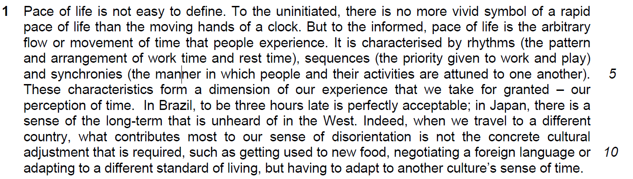

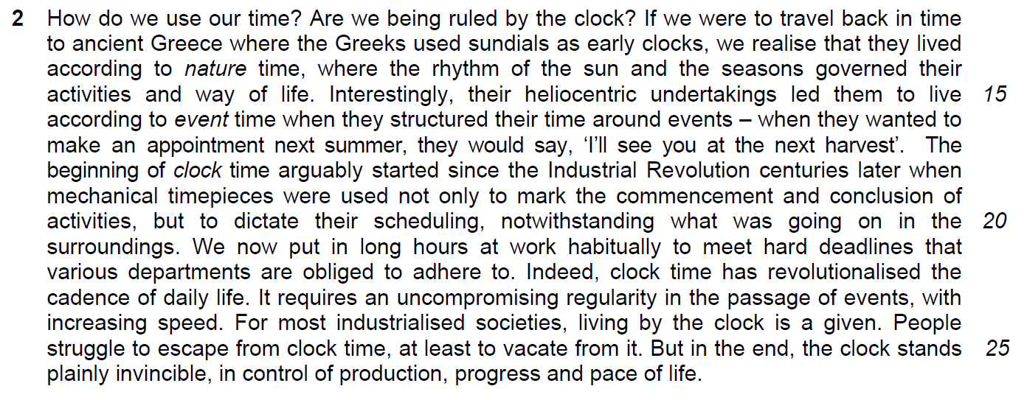

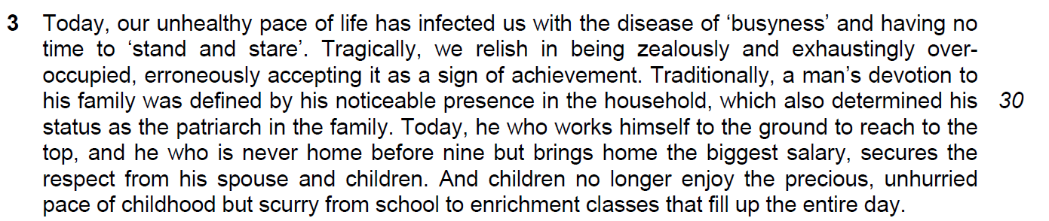

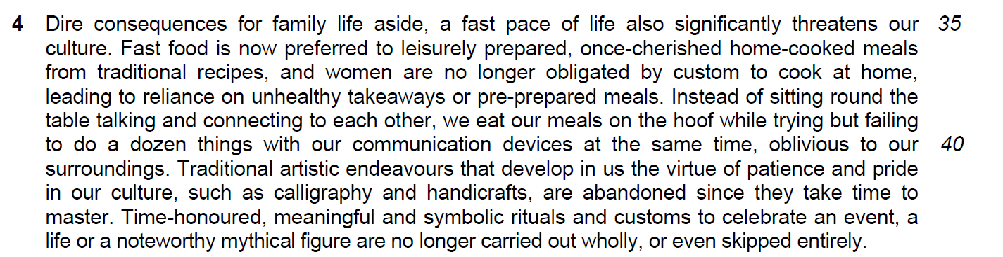

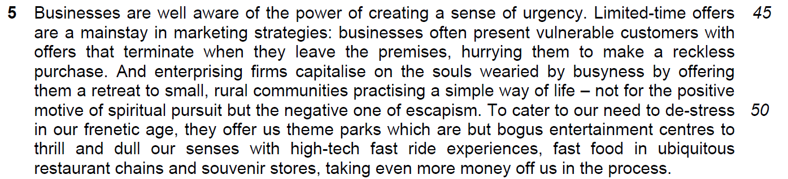

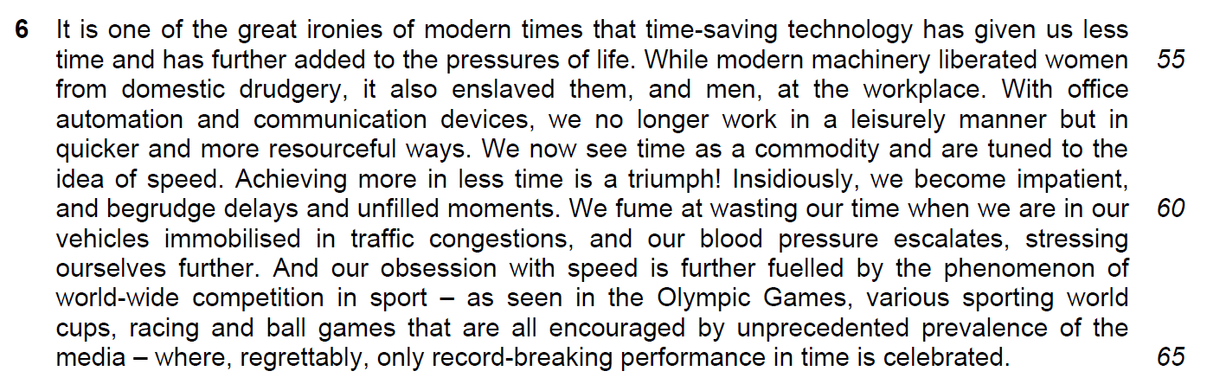

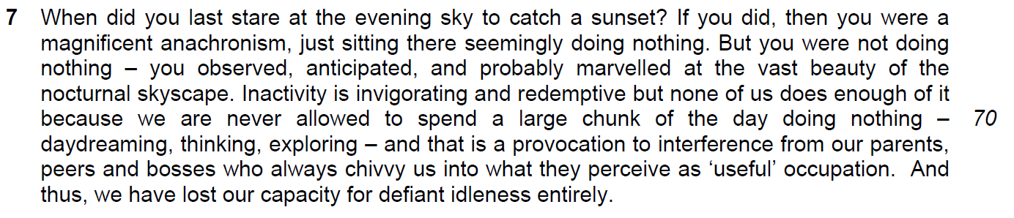

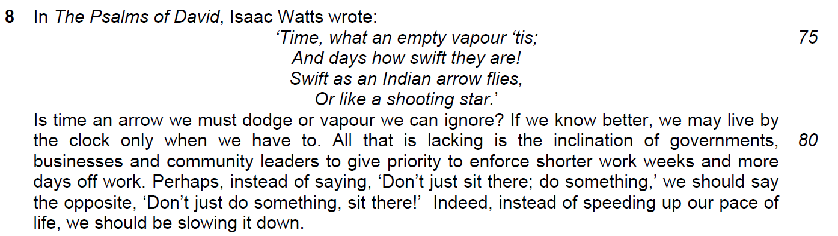

Practice
1. Identify the main areas of discussion

Theme: Evolution of Pace of Life

Main perspectives of discussion:

Perspective 1 – How pace of life is defined by traditional activities and culture

Perspective 2 –

Perspective 3 –

2. Based on one main point of discussion that you have identified, explain how this main point is developed.

