GP Term 4 2017 – Comprehension Topic 2: Social Issues – Non-Violence & Civil Societies

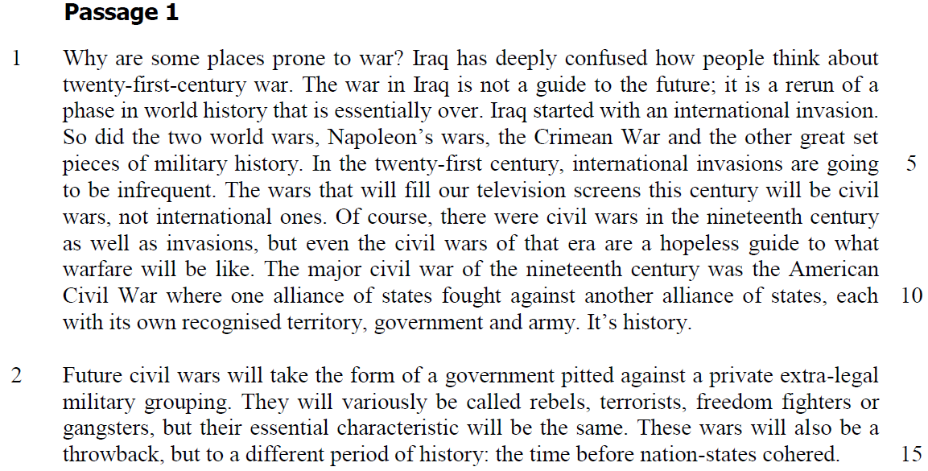

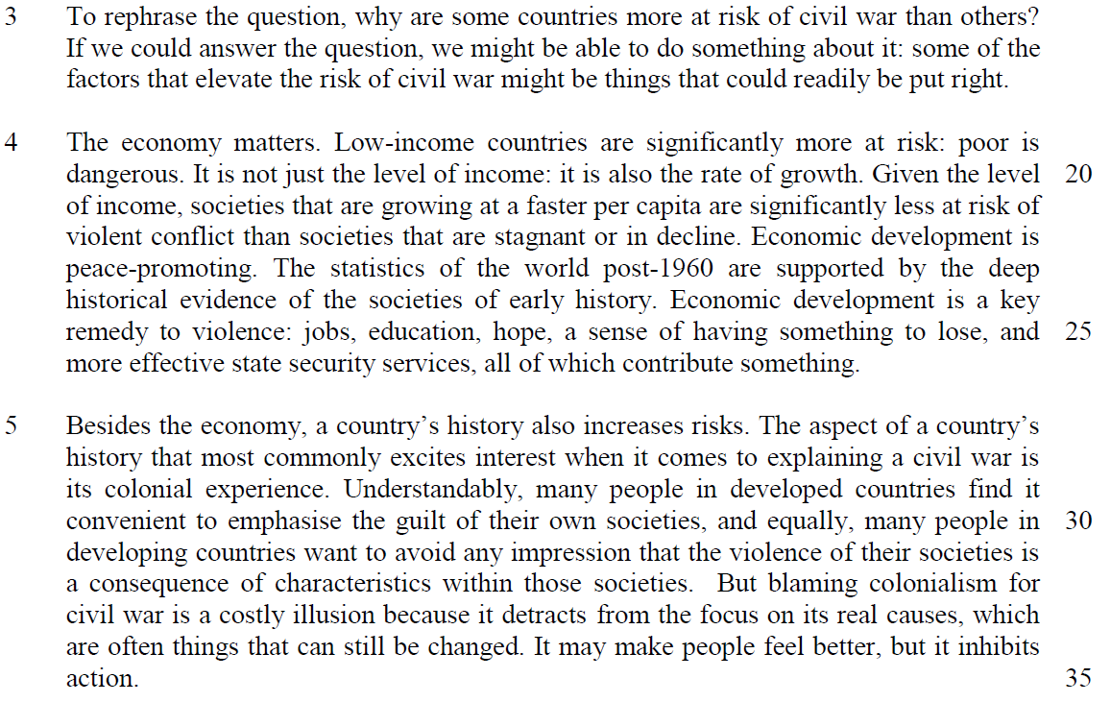

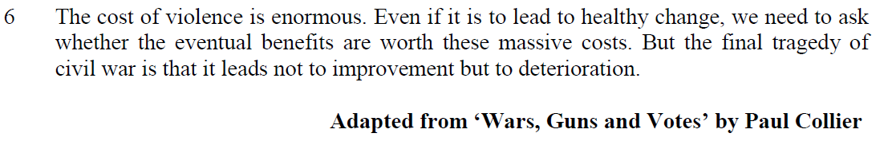

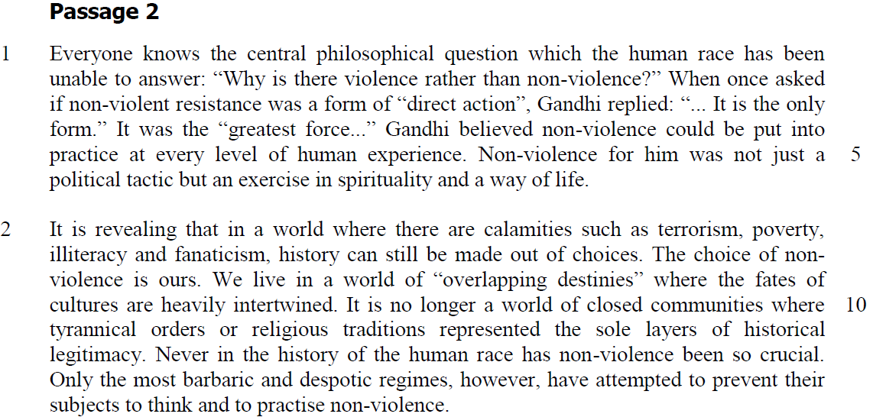

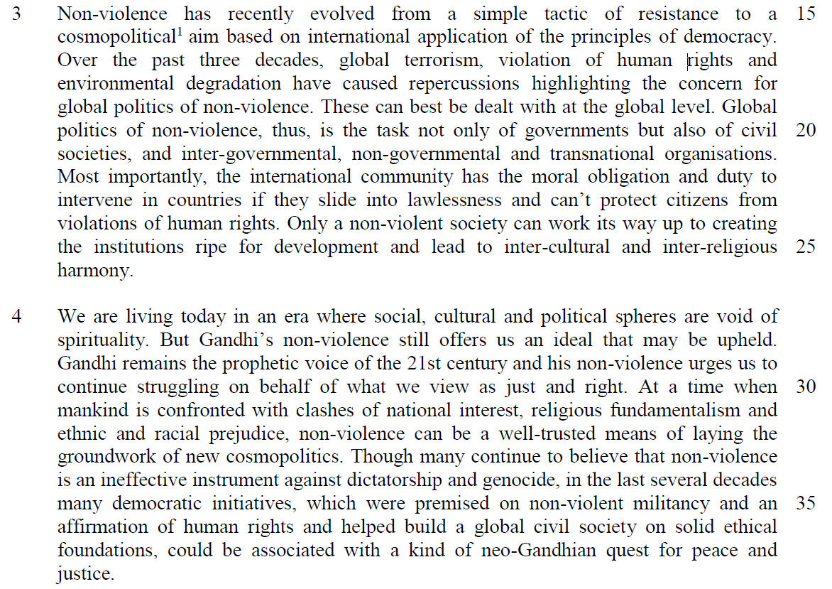

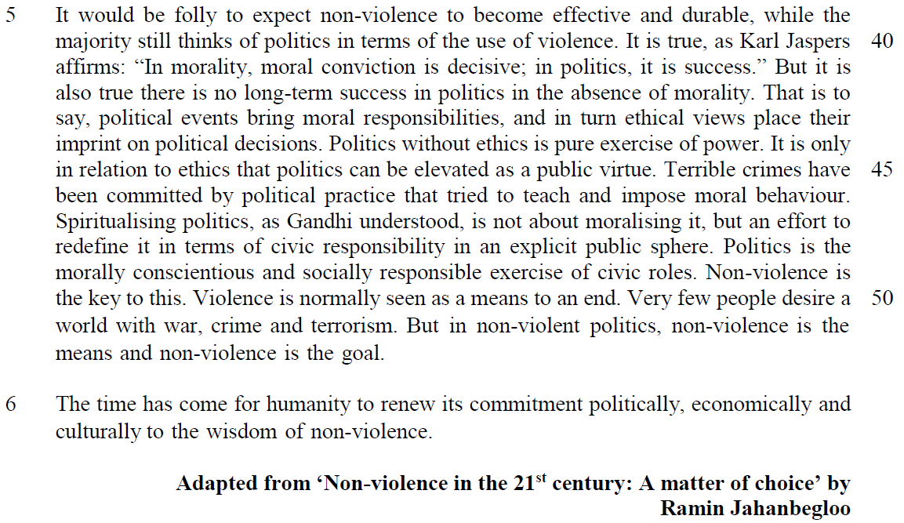

Application Question (AQ)
11. Both passages deal with the importance of promoting peace to help build a global civil society.

How far do you agree with the writers’ views? Using material from both passages, discuss how your view has been challenged or confirmed by these passages. You must also rely on your own ideas and knowledge of today’s world. [8]

Introduction
- writers have discussed about how peace is to be promoted to build a global civil society
- their views are in lined with my perspective except for some

Main Body

- quote
- explanation of the writer’s point
- Writer A’s view confirmed by my belief that …….
- justify your view
- example
- extent of agreement

1) Quote -low income countries are significantly more at risk of being engaged in violent and instability

2) Explanation - economic development is a solution to violence as it can provide employment and employment opportunities to give me the sense of commitment to make society more stable

3. Agreement- this confirmed my view as the economic benefits that individuals can derive from the society will make them willing to agree to social codes of the society and they will be willing to abide the law. As a result, the society will be more stable and less violent

why income inequality will be a source of tension? progress for respective individuals will be different – a sense of injustice – alienated certain individuals – forms social class – social divide – dissatisfaction that fuel social unrest and crime

4. Example -SEA countires – real GDP per capita and low unemployment rate – more stable and less violent

5. EOA – widen income inequality – SEA countries -possible risk of social and political instability – Thailand red and yellow shirt political rivalry – reflection of income equality between rural and city region

Point 2

there is no long-term success in politics in the absence of ethics
we need ethics to exercise political virtue to rule as decision in politics should be based moral responsibilities and values – this will ensure civic and moral behaviours in the society
this challenges my view - ethical values of society do not encourage social and political stability – diverse view of ethics will invite more contradictions and debates that undermine society – different factions of the society have diverse opinions and view to constitute what is the standard ethics of society – disagreements often leads to social controversy and extreme disturbance in terms of riots – the social stigmas and dogmatism is part of this belief that leads discrimination and social conflicts – therefore my belief follows the majority that there is a need of strong governmental force to ensure stability and peace instead of the use of yardstick of ethics

Amos Yee’s youtube racial and religious slurs will create social disturbance and must not be considered as exercise of freedom of speech for diversity to set as ethical yardstick for the society

EOA – ethics and morality is still needed to influence the behaviours and values of the individuals – strong governmental rule is imposed along with certain national or social values to inculcate proper social behaviour to promote a civic order society – racial harmony is part of the idea to promote social stability in a multiracial society in Singapore but we Sedition Act as part of laws to impose social stability

