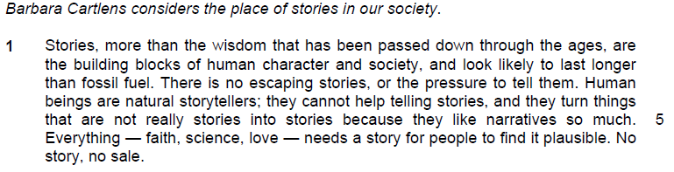

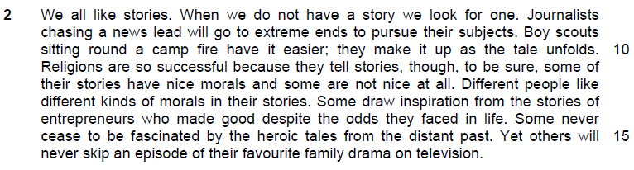

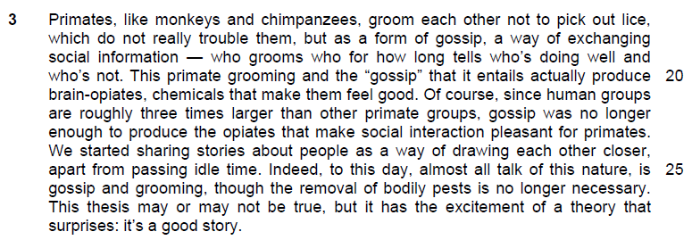

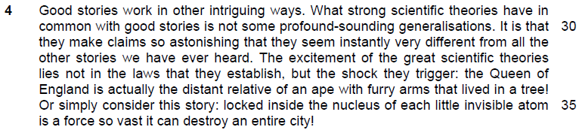

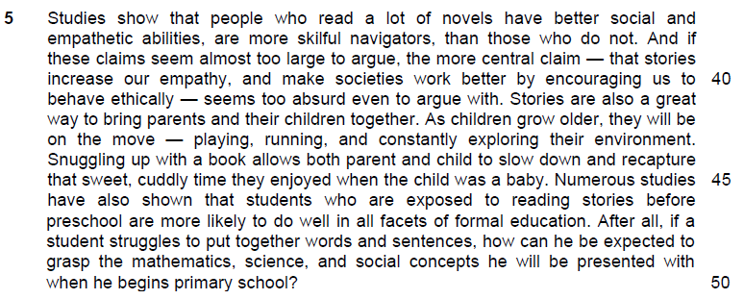

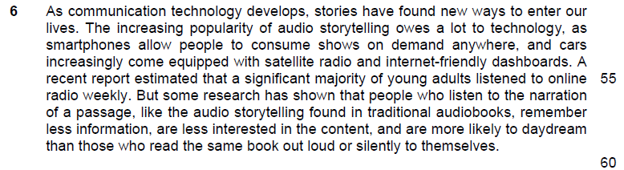

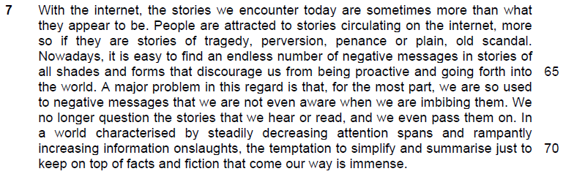

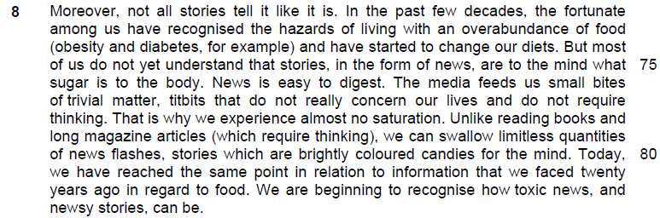

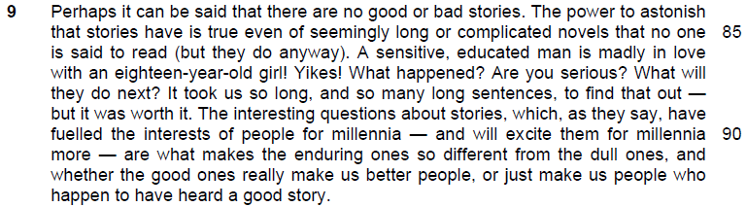

Read the passage in the Insert and then answer all the questions which follow below. Note that up to fifteen marks will be given for the quality and accuracy of your use of English throughout this paper.

NOTE: When a question asks for an answer IN YOUR OWN WORDS AS FAR AS POSSIBLE and you select the appropriate material from the passage for your answer, you must still use your own words to express it. Little credit can be given to answers which only copy words or phrases from the passage.

1. How do the closing sentences of the first paragraph (lines 6-7) establish the appeal of stories? Use your own words as far as possible. [2]

…………………………………………………………………………………………..

…………………………………………………………………………………………..

…………………………………………………………………………………………..

…………………………………………………………………………………………..

2. What reasons does the author provide in lines 8-12 to support her claim that ‘we all like stories’? Use your own words as far as possible. [2]

…………………………………………………………………………………………..

…………………………………………………………………………………………..

…………………………………………………………………………………………..

…………………………………………………………………………………………..

3. In lines 12-16, how does the author support her idea that ‘different people like different kinds of morals in their stories’? Use your own words as far as possible. [2]

…………………………………………………………………………………………..

…………………………………………………………………………………………..

…………………………………………………………………………………………..

…………………………………………………………………………………………..

4. In paragraph 3, what distinctions does the author draw between the grooming and gossiping that primates practise and the telling of stories by humans? Use your own words as far as possible. [3]

…………………………………………………………………………………………..

…………………………………………………………………………………………..

…………………………………………………………………………………………..

…………………………………………………………………………………………..

5. Explain the author’s use of the phrase ‘may or may not be true’ in line 27. [1]

…………………………………………………………………………………………..

…………………………………………………………………………………………..

6. In paragraph 4, what similarity does the author see between ‘strong scientific theories’ and ‘good stories’? Use your own words as far as possible. [2]

…………………………………………………………………………………………..

…………………………………………………………………………………………..

…………………………………………………………………………………………..

…………………………………………………………………………………………..

Summary Question
7. Using material from paragraphs 5-7 only (lines 37-71), summarise what the author has to say about the benefits and problems that are associated with stories.

Write your summary in no more than 120 words, not counting the opening words which are printed below. Use your own words as far as possible. [8]

Stories are beneficial because……………………………………………………….

…………………………………………………………………………………………..

…………………………………………………………………………………………..

…………………………………………………………………………………………..

…………………………………………………………………………………………..

…………………………………………………………………………………………..

…………………………………………………………………………………………..

…………………………………………………………………………………………..

…………………………………………………………………………………………..

…………………………………………………………………………………………..

…………………………………………………………………………………………..

…………………………………………………………………………………………..

…………………………………………………………………………………………..

…………………………………………………………………………………………..

…………………………………………………………………………………………..

…………………………………………………………………………………………..

…………………………………………………………………………………………..

…………………………………………………………………………………………..

…………………………………………………………………………………………..

…………………………………………………………………………………………..

…………………………………………………………………………………………..

…………………………………………………………………………………………..

…………………………………………………………………………………………..

…………………………………………………………………………………………..

…………………………………………………………………………………………..

…………………………………………………………………………………………..

…………………………………………………………………………………………..

…………………………………………………………………………………………..

…………………………………………………………………………………………..

…………………………………………………………………………………………..

…………………………………………………………………………………………..

…………………………………………………………………………………………..

…………………………………………………………………………………………..

…………………………………………………………………………………………..

…………………………………………………………………………………………..

…………………………………………………………………………………………..

…………………………………………………………………………………………..

…………………………………………………………………………………………..

…………………………………………………………………………………………..

…………………………………………………………………………………………..

8. How does the author show that ‘stories, in the form of news, are to the mind what sugar is to the body’ (lines 75-76)? Use your own words as far as possible. [3]

…………………………………………………………………………………………..

…………………………………………………………………………………………..

…………………………………………………………………………………………..

…………………………………………………………………………………………..

…………………………………………………………………………………………..

…………………………………………………………………………………………..

9. Explain the irony in lines 84-86. [1]

…………………………………………………………………………………………..

…………………………………………………………………………………………..

10. How is the idea that stories will excite people for ‘millennia more’ (lines 90-91) reflected in the opening lines (lines 1-3) of paragraph 1? [1]

…………………………………………………………………………………………..

…………………………………………………………………………………………..

Application Question
11. In this article, the author writes about why stories are so enduring and shares some of the concerns she has with them.

To what extent do you agree or disagree with her views? Illustrate your answer by referring to the ways in which you and your society regard stories. [10]

Structure of discussion

Point A
Part 1
1.Identify the point that reflects the view of the writer about story that you will view in your society
2. Explain her view
3. Does this view apply to your society? (agreeing )
4. Example

Part 2 – extent of agreement
- Why it may not apply to your society
- Example to support your view
- Linking sentence

…………………………………………………………………………………………..

…………………………………………………………………………………………..

…………………………………………………………………………………………..

…………………………………………………………………………………………..

…………………………………………………………………………………………..

…………………………………………………………………………………………..

…………………………………………………………………………………………..

…………………………………………………………………………………………..

…………………………………………………………………………………………..

…………………………………………………………………………………………..

…………………………………………………………………………………………..

…………………………………………………………………………………………..

…………………………………………………………………………………………..

…………………………………………………………………………………………..

…………………………………………………………………………………………..

…………………………………………………………………………………………..

…………………………………………………………………………………………..

…………………………………………………………………………………………..

…………………………………………………………………………………………..

…………………………………………………………………………………………..

…………………………………………………………………………………………..

…………………………………………………………………………………………..

…………………………………………………………………………………………..

…………………………………………………………………………………………..

…………………………………………………………………………………………..

…………………………………………………………………………………………..

…………………………………………………………………………………………..

…………………………………………………………………………………………..

…………………………………………………………………………………………..

…………………………………………………………………………………………..

…………………………………………………………………………………………..

…………………………………………………………………………………………..

…………………………………………………………………………………………..

…………………………………………………………………………………………..

…………………………………………………………………………………………..

…………………………………………………………………………………………..

…………………………………………………………………………………………..

…………………………………………………………………………………………..

…………………………………………………………………………………………..

…………………………………………………………………………………………..

…………………………………………………………………………………………..

