GP June Intensive Revision
Comprehension Learning Skills 1 – Reading Skills

The objective of reading is to comprehend the ideas in a sentence, a paragraph or a passage. This is one of the fundamental steps in effective learning.

To comprehend a passage, it is imperative for students to develop efficient and effective reading skills. Students need to correct their bad reading habits and adopt a reading procedure that will enable them to extract information effectively and enhance their passive vocabulary development. In the reading process, students need to be able absorb the main points and sub-points. It is also crucial for students to draw implications from the reading.

- Factors undermining Reading Process

  - Weak Concentration

Reading requires full concentration and the absence of concentration will affect the students’ abilities to comprehend a passage. Lack of concentration is usually the result of tiredness, posture and uncomfortable environment.

  - Improper Attitude

Improper attitude towards reading will also affect the effectiveness and efficiency of reading. The lack of interest on the theme of the passage will undermine the students’ effort to focus on reading the articles.

  - Subjective mindset

It is common for the readers to misinterpret the idea in the passage due to their subjective mindset. Instead of comprehending the idea of the passage according the writer’s intent, readers may understand the passage according to their own interpretation.
(provide answers as set by the writer)

Main areas of concern:
1. Meaning of Text
2. Implications of text (inference)

  - Undesirable Reading Behaviour

Readers with undesirable behaviours tend to slow their reading speed and weaken their comprehension. Some of the common bad reading behaviours can be seen in the following ways:

      - reading word by word
      - subvocalization
      - regression / back skipping
      - skipping sentences

  - Weak Intra-connection

Students who are unable to link various ideas in the passage are unable to link the various ideas in the paragraph or the passage to derive a meaningful understanding. This affects the students’ capabilities to comprehend factual information.

Content – overview of the issue, features or issues to be discussed, reasons, effects of the development

  - Weak extra-connection

Students who are not effective in analysis, criticism, appreciation and evaluation are usually weak in making interpretation of ideas during their reading.

  - Inadequate Knowledge

The lack of knowledge on particular subject is another factor that will undermine the students’ ability to comprehend the passage. Students may require some prior knowledge to comprehend a passage. Students’ ability to comprehend a passage may be reduced if they are unable to link their general knowledge to the ideas in the subject.

  - Weak Vocabulary Power

Poor language proficiency is another factor that will undermine the comprehension skills of a reader.

- Steps to take note in reading a comprehension passage

  - Read the passage carefully with concentration and enthusiasm.

  - Along the reading process, you need to derive the theme of the passage which is usually revealed in the first or second paragraph.

  - As you read along, you need to extract the main ideas of the respective paragraphs in the passage. Link the main ideas of the respective paragraphs so as to derive an understanding of the implication of the paragraphs. In the course of extraction of ideas, students need to look out for topic sentence which contains the main idea of the paragraph.

areas to take note in reading

- Theme of the passage
- main areas of discussion
-perspective of discussion – causes, effects, impact, comparison
-categorization of discussion – economic issue, social factor, political, individual, health
3) paragraph development – causation – based on nature of discussion (explanation may on process explanation, evaluation ….)
4) proposition – providing direction of discussion for AQ and summary

  - In the extraction of information, there is a need to identify the sub-clauses or phrases that are linked to the idea of the passage and interpret the respective phrases and sub-clauses in accordance to the writer’s point of view. These sub-clauses and phrases will reveal the conceptualized ideas that the writer is trying to depict which will support his evaluation, explanation or description

  - Based on the main ideas extracted from the respective paragraphs, students need to derive the main propositions of the passage which will help in the derivation of information for the answering of Application-based and Summary question.

  - It is also important for students to know the purposes of other sentences and able to differentiate them from the topic sentence. Some of the sentences are used to elaborate the main point of the sentence while some are examples and analogies that the writer is stating to elaborate his point.

Points to take note:

- Read the passage without regression.

- Do not pause for vocabulary understanding or read word by word. Remember that the objective of reading is to comprehend the ideas of the passage. You can attempt to understand more about the meaning of the word when you read further as it usually gives you a clue on the meaning of the word. Very often, the reader can figure out the meaning of the word as he reads on.

- Avoid subjective mindset. Read for the writer’s intent and the implications provided in the passage. Ask yourself what the writer is trying to say to you.

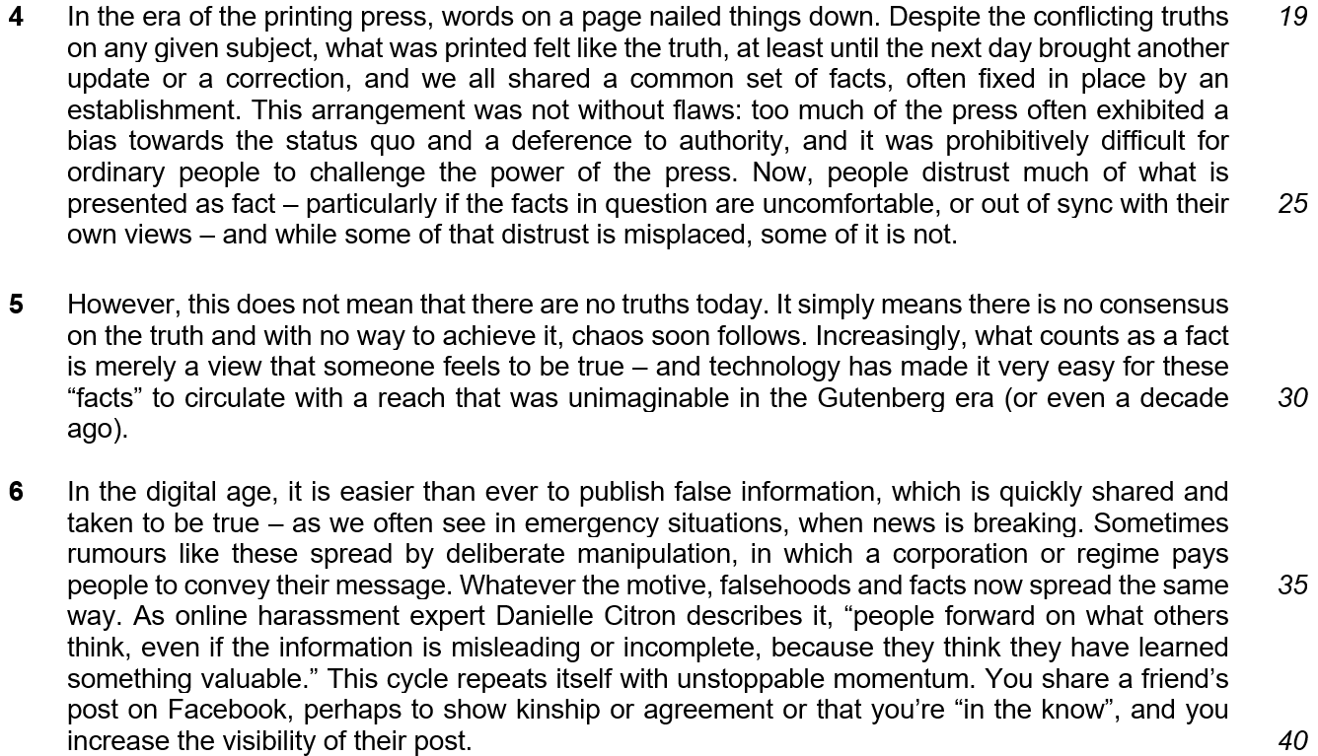

paragraph 4/5 – public is doubtful of the accuracy of news – printed news is biased towards institutions – no consensus on the truth

paragraph 6 – explains why people will spread falsehood
- Ease of technology
- Needs to share for relationship
- Needs to satisfy the ego of cleverness

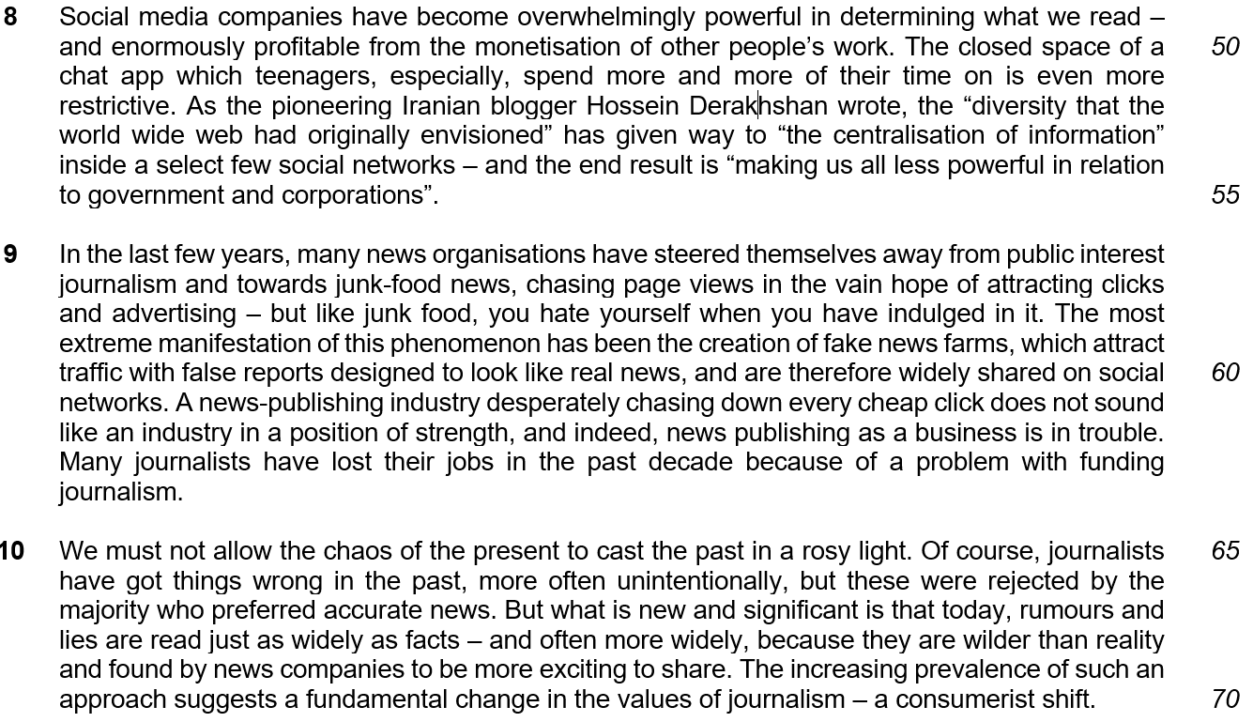

Q5. Explain the contrast between what had been “originally envisioned” (line 53) and what has happened in the world wide web. Use your own words as far as possible. [2]

