GP Term 4 2018 – Comprehension – Topic 1: Reflective Issues (Positive) – Happiness

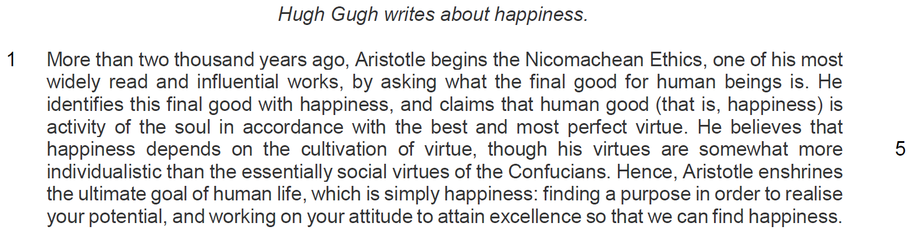

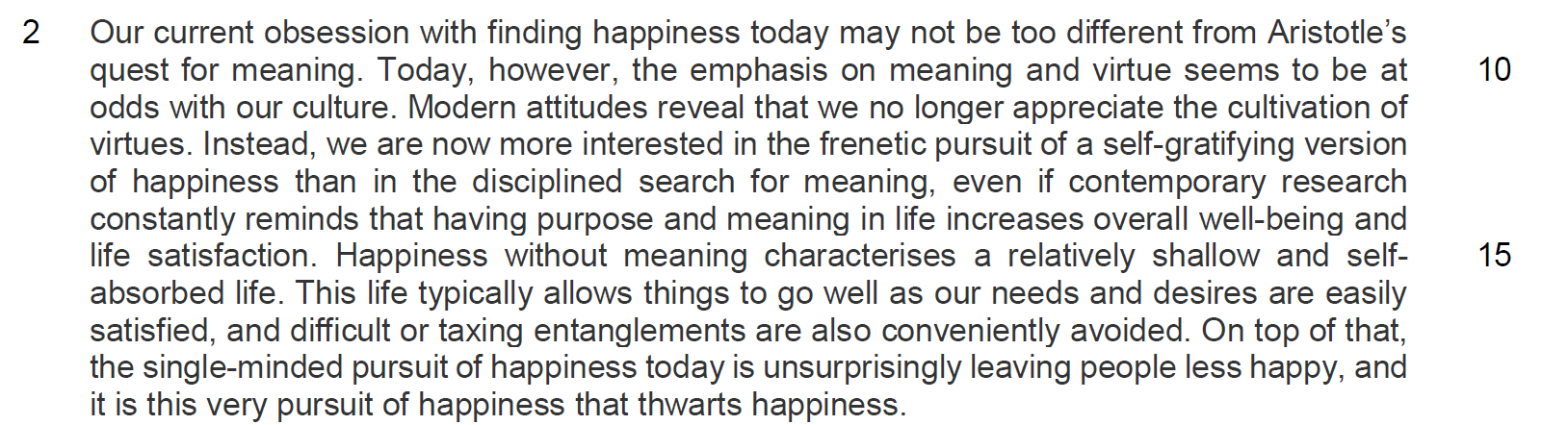

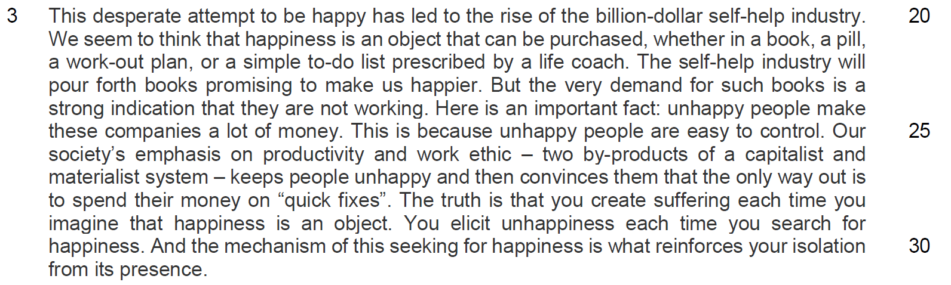

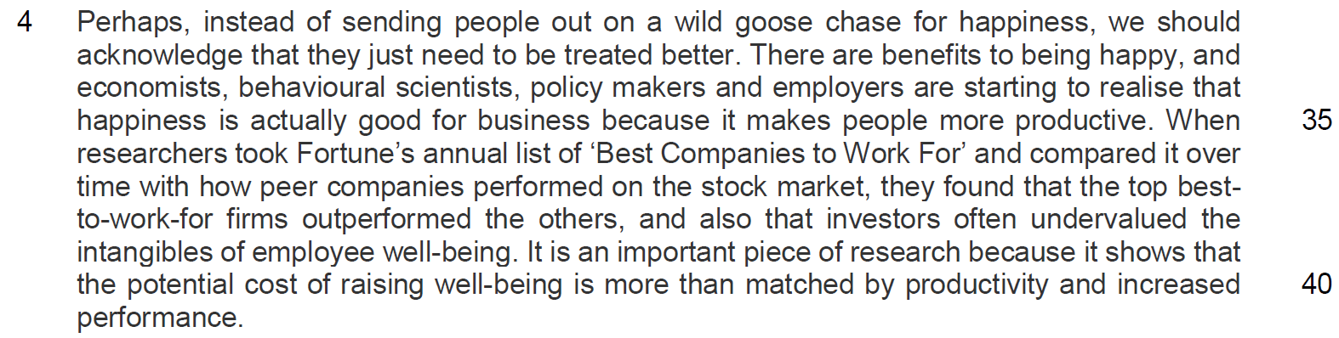

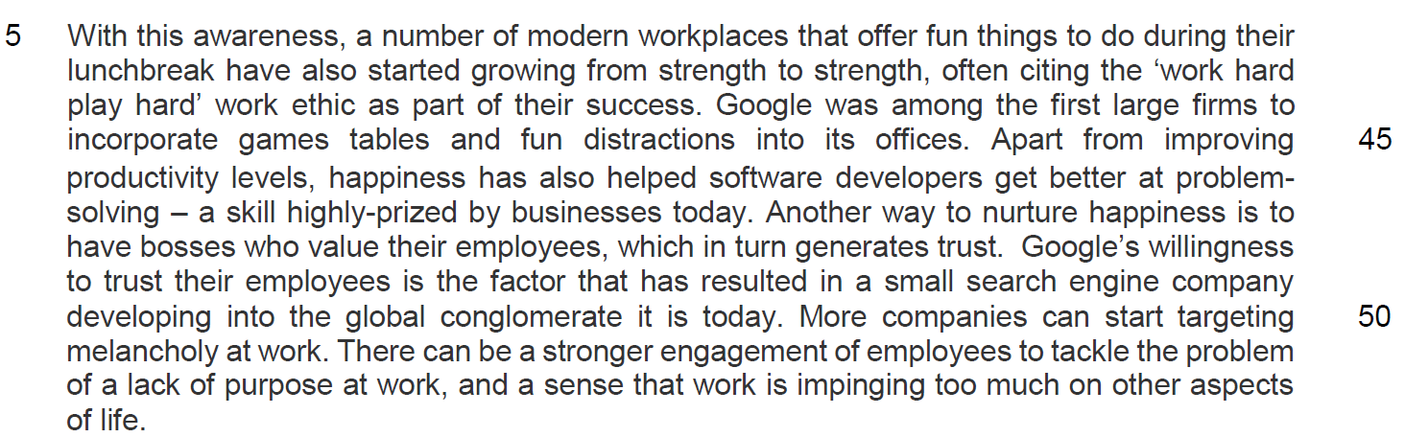

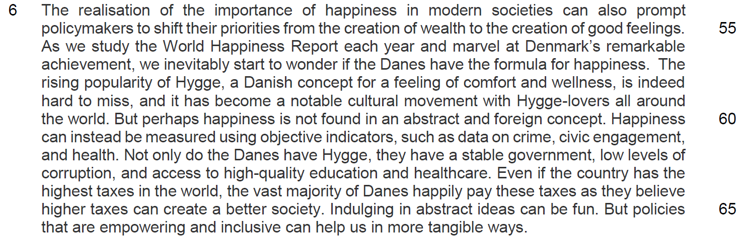

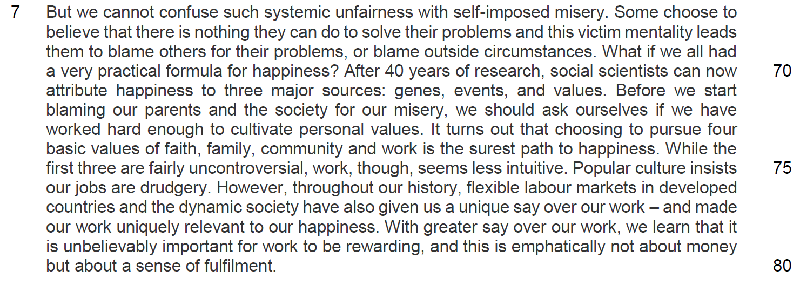

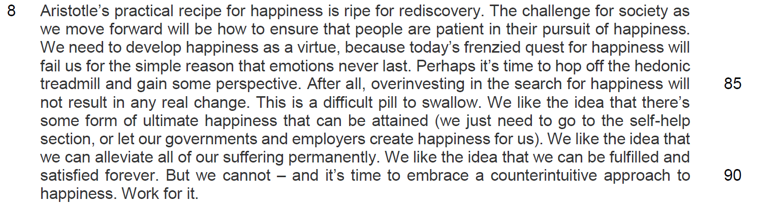

Questions
Q1) Suggest reasons for the author beginning the passage with a reference to Aristotle’s Nicomachean Ethics. [2]

…………………………………………………………………………………………………..

…………………………………………………………………………………………………..

…………………………………………………………………………………………………..

…………………………………………………………………………………………………..

Q2) Why does the author use the word ‘enshrines’ (line 6) with reference to happiness? [1]

…………………………………………………………………………………………………..

…………………………………………………………………………………………………..

Q3) In lines 15-17, how does the author support his idea that people are now more interested in a ‘self-gratifying version of happiness than in the disciplined search for meaning’ (lines 12-13)? Use your own words as far as possible. [3]

…………………………………………………………………………………………………..

…………………………………………………………………………………………………..

…………………………………………………………………………………………………..

…………………………………………………………………………………………………..

…………………………………………………………………………………………………..

…………………………………………………………………………………………………..

Q4) Suggest why the author uses the word ‘unsurprisingly’ in line 18. [2]

…………………………………………………………………………………………………..

…………………………………………………………………………………………………..

…………………………………………………………………………………………………..

…………………………………………………………………………………………………..

Q5) What is the author’s purpose in using the word ‘very’ in line 23? [2]

…………………………………………………………………………………………………..

…………………………………………………………………………………………………..

…………………………………………………………………………………………………..

…………………………………………………………………………………………………..

Q6) Why has the author placed the term ‘quick fixes’ (line 28) in inverted commas? [1]

…………………………………………………………………………………………………..

…………………………………………………………………………………………………..

Summary Writing
Q7) Using material from paragraphs 4 to 6 only (lines 32–66), summarise how and why happiness is significant to society.

Write your summary in no more than 120 words, not counting the opening words which are printed below. Use your own words as far as possible. [8]

Happiness is significant because ……………………………………………………………

…………………………………………………………………………………………………..

…………………………………………………………………………………………………..

…………………………………………………………………………………………………..

…………………………………………………………………………………………………..

…………………………………………………………………………………………………..

…………………………………………………………………………………………………..

…………………………………………………………………………………………………..

…………………………………………………………………………………………………..

…………………………………………………………………………………………………..

…………………………………………………………………………………………………..

…………………………………………………………………………………………………..

…………………………………………………………………………………………………..

…………………………………………………………………………………………………..

…………………………………………………………………………………………………..

…………………………………………………………………………………………………..

…………………………………………………………………………………………………..

…………………………………………………………………………………………………..

…………………………………………………………………………………………………..

…………………………………………………………………………………………………..

…………………………………………………………………………………………………..

…………………………………………………………………………………………………..

Q8) Explain why the author says that work is ‘less intuitive’ (line 75) than faith, family, and community in achieving happiness? Use your own words as far as possible. [2]

…………………………………………………………………………………………………..

…………………………………………………………………………………………………..

…………………………………………………………………………………………………..

…………………………………………………………………………………………………..

Q9) In lines 76-78, what reasons does the author give to explain why our work can bring about happiness today? Use your own words as far as possible. [2]

…………………………………………………………………………………………………..

…………………………………………………………………………………………………..

…………………………………………………………………………………………………..

…………………………………………………………………………………………………..

Q10) In lines 81-86, what contrasts does the author make between what happiness should be and what it is today? Use your own words as far as possible. [2]

…………………………………………………………………………………………………..

…………………………………………………………………………………………………..

…………………………………………………………………………………………………..

…………………………………………………………………………………………………..
Application Question
Q11) In this article, Hugh Gugh makes a number of observations about happiness and our modern-day pursuit of it. How far would you agree with his observations, relating your arguments to your own experience and that of your society? [10]

…………………………………………………………………………………………………..

…………………………………………………………………………………………………..

…………………………………………………………………………………………………..

…………………………………………………………………………………………………..

…………………………………………………………………………………………………..

…………………………………………………………………………………………………..

…………………………………………………………………………………………………..

…………………………………………………………………………………………………..

…………………………………………………………………………………………………..

…………………………………………………………………………………………………..

…………………………………………………………………………………………………..

…………………………………………………………………………………………………..

…………………………………………………………………………………………………..

…………………………………………………………………………………………………..

…………………………………………………………………………………………………..

…………………………………………………………………………………………………..

…………………………………………………………………………………………………..

…………………………………………………………………………………………………..

…………………………………………………………………………………………………..

…………………………………………………………………………………………………..

…………………………………………………………………………………………………..

…………………………………………………………………………………………………..

…………………………………………………………………………………………………..

…………………………………………………………………………………………………..

…………………………………………………………………………………………………..

…………………………………………………………………………………………………..

…………………………………………………………………………………………………..

…………………………………………………………………………………………………..

…………………………………………………………………………………………………..

…………………………………………………………………………………………………..

…………………………………………………………………………………………………..

…………………………………………………………………………………………………..

…………………………………………………………………………………………………..

…………………………………………………………………………………………………..

…………………………………………………………………………………………………..

…………………………………………………………………………………………………..

…………………………………………………………………………………………………..

…………………………………………………………………………………………………..

…………………………………………………………………………………………………..

…………………………………………………………………………………………………..

…………………………………………………………………………………………………..

…………………………………………………………………………………………………..

…………………………………………………………………………………………………..

…………………………………………………………………………………………………..

…………………………………………………………………………………………………..

…………………………………………………………………………………………………..

…………………………………………………………………………………………………..

…………………………………………………………………………………………………..

