GP Comprehension – Reflective Issues – Change (AJC 2014)

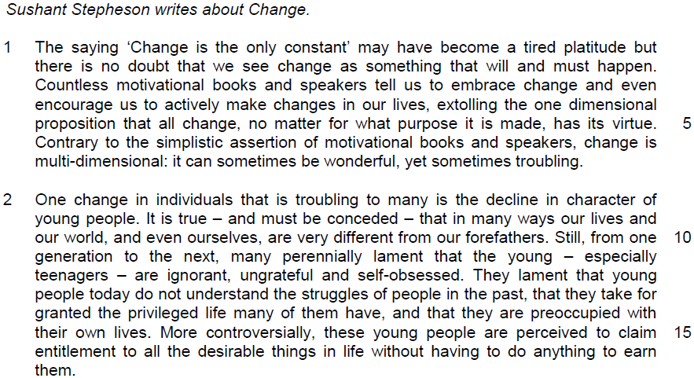

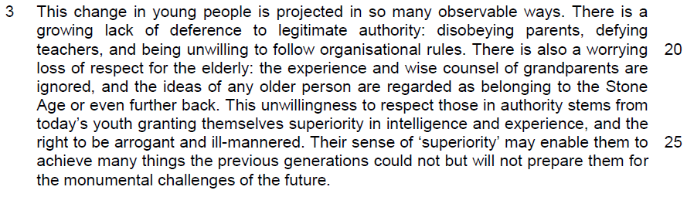
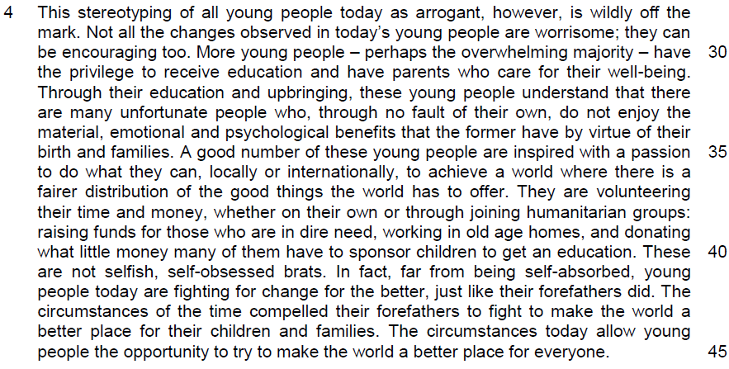

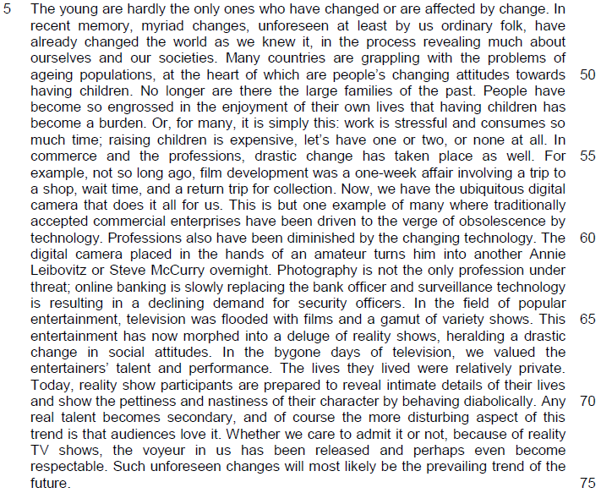

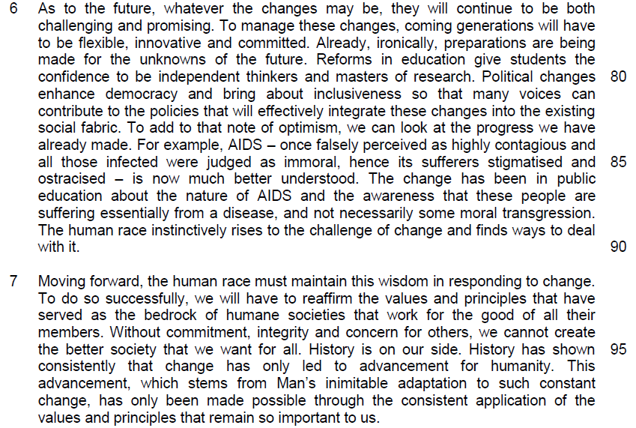

Read the passage in the insert and then answer all the questions which follow below. Note that up to fifteen marks will be given for the quality and accuracy of your use of English throughout this paper.

NOTE: When a question asks for an answer IN YOUR OWN WORDS AS FAR AS POSSIBLE and you select the appropriate material from the passages for your answer, you must still use your own words to express it. Little credit can be given to answers which only copy words or phrases from the passages.

1. In paragraph 1, what do ‘(c)ountless motivational books and speakers’ (line 3) tell us to do? Use your own words as far as possible.

…………………………………………………………………………………………
………………………………………………………………………………………[1]

2. Why do many people lament that the young are ‘ignorant, ungrateful and self-obsessed’ (line 12)? Use your own words as far as possible.

…………………………………………………………………………………………

…………………………………………………………………………………………

…………………………………………………………………………………………

…………………………………………………………………………………………

…………………………………………………………………………………………
……………………………………………………………………………………….[3]

3. In paragraph 3, what explanations does the author offer for young people’s lack of respect for legitimate authority? Use your own words as far as possible.

…………………………………………………………………………………………

…………………………………………………………………………………………

…………………………………………………………………………………………
………………………………………………………………………………………[2]

4. Why does the author place ‘superiority’ (line 25) in inverted commas?

…………………………………………………………………………………………
………………………………………………………………………………………[1]

5. What contrast between young people today and in the past is the author making in lines 43-45? Use your own words as far as possible.

…………………………………………………………………………………………

…………………………………………………………………………………………

…………………………………………………………………………………………
………………………………………………………………………………………[2]

6. What is the author implying by the use of the words ‘at least by us ordinary folk’ (line 47)?

…………………………………………………………………………………………
………………………………………………………………………………………[1]

7. When the author writes that having children ‘has become a burden’ (lines 52-53), what is he suggested about people’s view in the past towards having children?

…………………………………………………………………………………………
………………………………………………………………………………………[1]

8. Explain the author’s use of the word ‘relatively’ (line 68).

…………………………………………………………………………………………
………………………………………………………………………………………[1]

9. What does the author mean by ‘the voyeur in us has been released’ (line 73).

…………………………………………………………………………………………

…………………………………………………………………………………………

…………………………………………………………………………………………
………………………………………………………………………………………[2]

10. Explain the irony in ‘preparations are being made for the unknowns of the future’ (lines 78-79).

…………………………………………………………………………………………

…………………………………………………………………………………………

…………………………………………………………………………………………
………………………………………………………………………………………[2]

11. In paragraph 6, what perception of AIDS sufferers has changed due to public education? Use your own words as far as possible.

…………………………………………………………………………………………
………………………………………………………………………………………[1]

=

12. Using material from paragraphs 2–4 only, summarise what the author has to say about the opinions many have of young people, how young people’s behaviour may justify such opinions, and why these opinions may not be entirely correct.

Write your summary in no more than 120 words, not counting the opening words which are printed below. Use your own words as far as possible.

Many think that young people are …………………………………………………

…………………………………………………………………………………………

…………………………………………………………………………………………
…………………………………………………………………………………………

…………………………………………………………………………………………

…………………………………………………………………………………………

…………………………………………………………………………………………

…………………………………………………………………………………………

…………………………………………………………………………………………

…………………………………………………………………………………………

…………………………………………………………………………………………

…………………………………………………………………………………………

…………………………………………………………………………………………

…………………………………………………………………………………………

…………………………………………………………………………………………

…………………………………………………………………………………………

…………………………………………………………………………………………

…………………………………………………………………………………………

…………………………………………………………………………………………

…………………………………………………………………………………………
………………………………………………………………………………………[8]

13. In this article, Sushant Stepheson makes a number of observations about the subject of change. How relevant do you find his observations to yourself and your own society?

…………………………………………………………………………………………

…………………………………………………………………………………………
…………………………………………………………………………………………

…………………………………………………………………………………………

…………………………………………………………………………………………

…………………………………………………………………………………………

…………………………………………………………………………………………

…………………………………………………………………………………………

…………………………………………………………………………………………

…………………………………………………………………………………………

…………………………………………………………………………………………

…………………………………………………………………………………………

…………………………………………………………………………………………

…………………………………………………………………………………………

…………………………………………………………………………………………

…………………………………………………………………………………………

…………………………………………………………………………………………

…………………………………………………………………………………………

…………………………………………………………………………………………

…………………………………………………………………………………………

…………………………………………………………………………………………

…………………………………………………………………………………………

…………………………………………………………………………………………

…………………………………………………………………………………………
…………………………………………………………………………………………

…………………………………………………………………………………………

…………………………………………………………………………………………

…………………………………………………………………………………………

…………………………………………………………………………………………

…………………………………………………………………………………………

…………………………………………………………………………………………

…………………………………………………………………………………………

…………………………………………………………………………………………

…………………………………………………………………………………………

…………………………………………………………………………………………

…………………………………………………………………………………………

…………………………………………………………………………………………

…………………………………………………………………………………………

…………………………………………………………………………………………

…………………………………………………………………………………………

…………………………………………………………………………………………

…………………………………………………………………………………………

…………………………………………………………………………………………

…………………………………………………………………………………………

…………………………………………………………………………………………

…………………………………………………………………………………………

…………………………………………………………………………………………

…………………………………………………………………………………………
…………………………………………………………………………………………

…………………………………………………………………………………………

…………………………………………………………………………………………

…………………………………………………………………………………………

…………………………………………………………………………………………

…………………………………………………………………………………………

…………………………………………………………………………………………

…………………………………………………………………………………………

…………………………………………………………………………………………

…………………………………………………………………………………………

…………………………………………………………………………………………

…………………………………………………………………………………………

…………………………………………………………………………………………

…………………………………………………………………………………………

…………………………………………………………………………………………

…………………………………………………………………………………………

…………………………………………………………………………………………

…………………………………………………………………………………………

…………………………………………………………………………………………

…………………………………………………………………………………………
……………………………………………………………………………………..[10]

