GP Term 4 2017 – Comprehension Topic 2: Social Issues – Non-Violence & Civil Societies

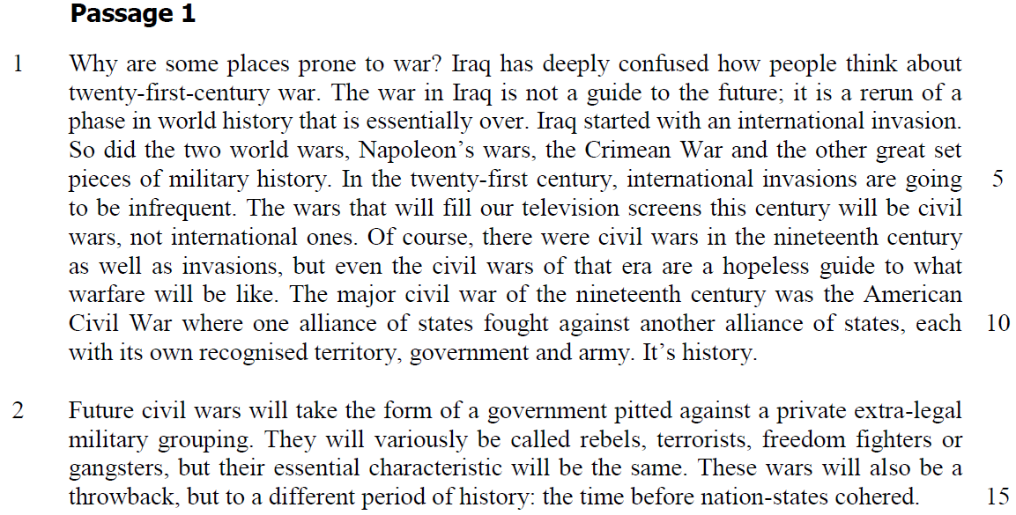

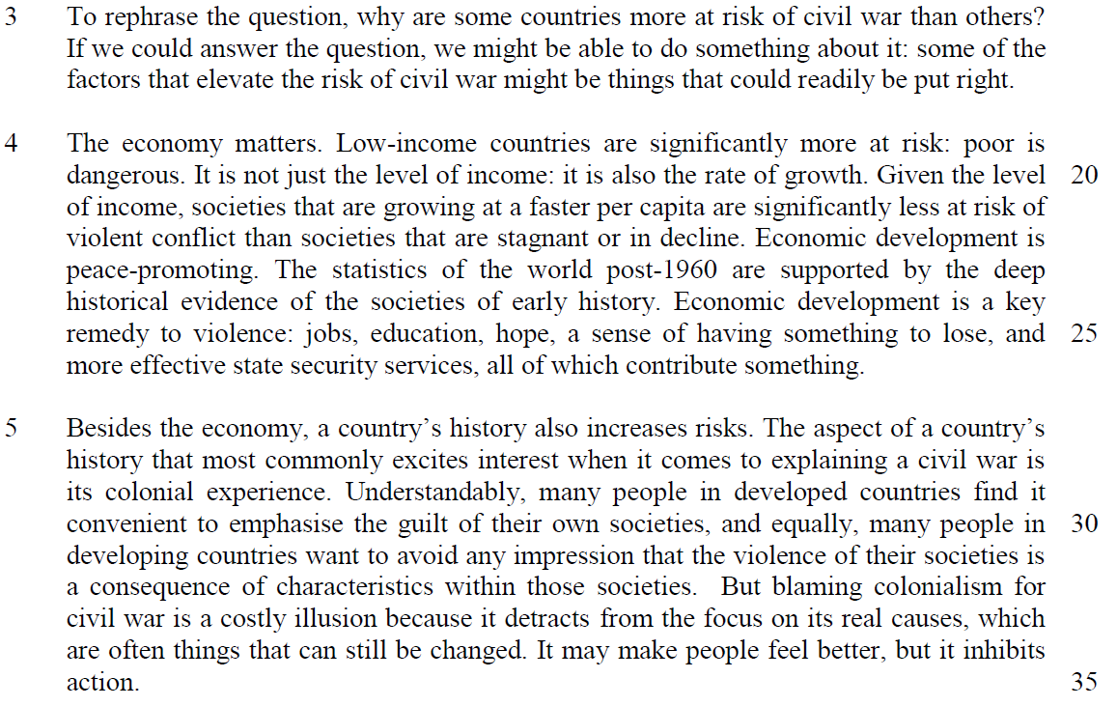

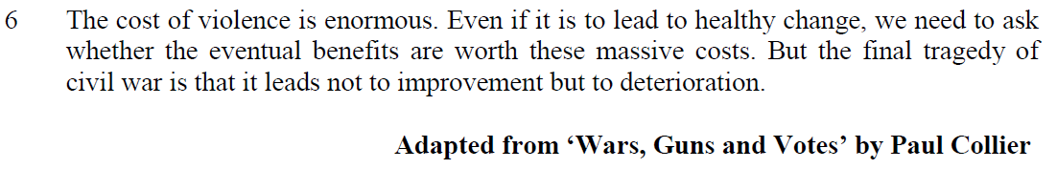

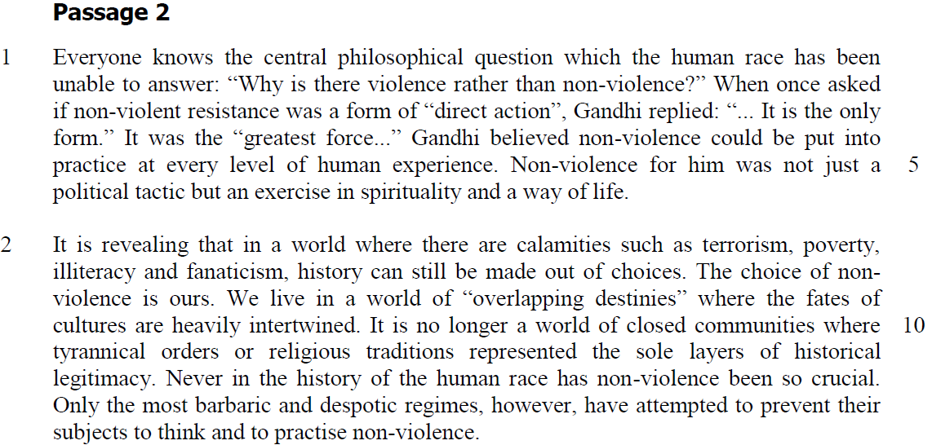

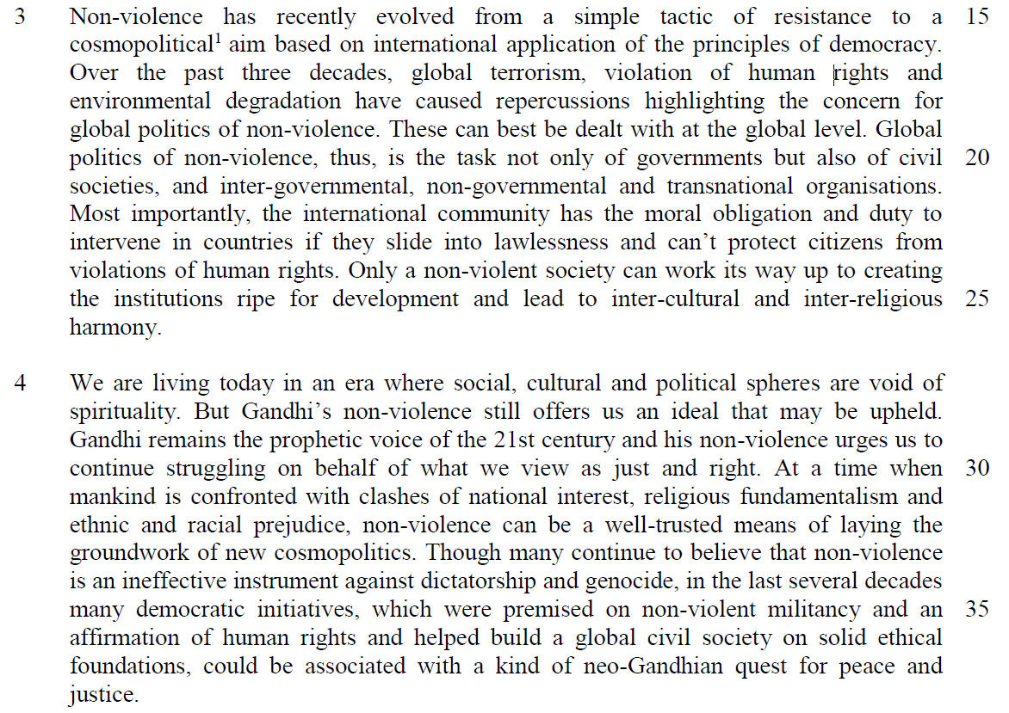

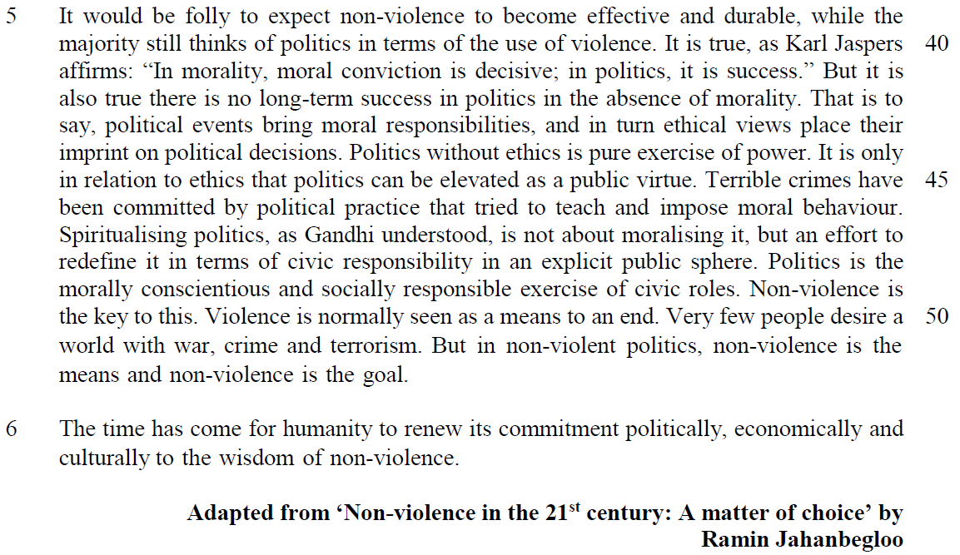

Read the passage in the insert and then answer all the questions. Note that up to fifteen marks will be given for the quality and accuracy of your use of English throughout this Paper.

NOTE: When a question asks for an answer IN YOUR OWN WORDS AS FAR AS POSSIBLE and you select the appropriate material from the passage for your answer, you must still use your own words to express it. Little credit can be given to answers which only copy words or phrases from the passage.

Questions on Passage 1

1. Explain what the author means by “The wars that will fill our television screens this century will be civil wars …” (lines 6-7). [1]

…………………………………………………………………………………………..

…………………………………………………………………………………………..

2. What does the author intend you to understand by the statement “It’s history.” at the end of the first paragraph? [1]

…………………………………………………………………………………………..

…………………………………………………………………………………………..

3. “They will variously be called rebels, terrorists, freedom fighters or gangsters, but their essential characteristic will be the same.” (lines 13-14)

What essential characteristic is the author thinking of here? [1]

…………………………………………………………………………………………..

4. Explain how, according to paragraph 2, future civil wars will differ from those of the nineteenth century. Use your own words as far as possible. [2]

…………………………………………………………………………………………..

…………………………………………………………………………………………..

…………………………………………………………………………………………..

…………………………………………………………………………………………..

5. In paragraph 4, why does the author say that the “… poor is dangerous” (lines 19-20)? [1]

…………………………………………………………………………………………..

…………………………………………………………………………………………..

6. Using your own words as far as possible, explain the danger of “… blaming colonialism for civil war…” (lines 32-33). [2]

…………………………………………………………………………………………..

…………………………………………………………………………………………..

…………………………………………………………………………………………..

…………………………………………………………………………………………..

Questions on Passage 2
7. From paragraph 1, explain how the writer thinks we can be advantaged by Gandhi’s approach of non-violence. [2]

…………………………………………………………………………………………..

…………………………………………………………………………………………..

…………………………………………………………………………………………..

8. Explain why you would disagree with the writer’s use of quotation marks round “overlapping destinies” (line 9). [2]

…………………………………………………………………………………………..

…………………………………………………………………………………………..

9. The writer recognises that many people may doubt the effectiveness of Gandhi’s approach of non-violence. Identify two words from paragraph four and explain how each of them reflects this scepticism. [2]’

…………………………………………………………………………………………..

…………………………………………………………………………………………..

…………………………………………………………………………………………..

…………………………………………………………………………………………..
Summary Writing
10. Summarise the writer’s rationale for using non-violence as an effective strategy in building civil societies.

Using material from paragraphs 4 and 5, write your summary in no more than 120 words, not counting the opening words which are printed below. Use your own words as far as possible. [8]

Non-violence is effective in building civil societies because

…………………………………………………………………………………………..

…………………………………………………………………………………………..

…………………………………………………………………………………………..

…………………………………………………………………………………………..

…………………………………………………………………………………………..

…………………………………………………………………………………………..

…………………………………………………………………………………………..

…………………………………………………………………………………………..

…………………………………………………………………………………………..

…………………………………………………………………………………………..

…………………………………………………………………………………………..

…………………………………………………………………………………………..

…………………………………………………………………………………………..

…………………………………………………………………………………………..

…………………………………………………………………………………………..

…………………………………………………………………………………………..

…………………………………………………………………………………………..

…………………………………………………………………………………………..

Application Question (AQ)
11. Both passages deal with the importance of promoting peace to help build a global civil society.

How far do you agree with the writers’ views? Using material from both passages, discuss how your view has been challenged or confirmed by these passages. You must also rely on your own ideas and knowledge of today’s world. [8]

…………………………………………………………………………………………..

…………………………………………………………………………………………..

…………………………………………………………………………………………..

…………………………………………………………………………………………..

…………………………………………………………………………………………..

…………………………………………………………………………………………..

…………………………………………………………………………………………..

…………………………………………………………………………………………..

…………………………………………………………………………………………..

…………………………………………………………………………………………..

…………………………………………………………………………………………..

…………………………………………………………………………………………..

…………………………………………………………………………………………..

…………………………………………………………………………………………..

…………………………………………………………………………………………..

…………………………………………………………………………………………..

…………………………………………………………………………………………..

…………………………………………………………………………………………..

…………………………………………………………………………………………..

…………………………………………………………………………………………..

…………………………………………………………………………………………..

…………………………………………………………………………………………..

…………………………………………………………………………………………..

…………………………………………………………………………………………..

…………………………………………………………………………………………..

…………………………………………………………………………………………..

…………………………………………………………………………………………..

…………………………………………………………………………………………..

…………………………………………………………………………………………..

…………………………………………………………………………………………..

…………………………………………………………………………………………..

…………………………………………………………………………………………..

…………………………………………………………………………………………..

…………………………………………………………………………………………..

…………………………………………………………………………………………..

…………………………………………………………………………………………..

…………………………………………………………………………………………..

…………………………………………………………………………………………..

…………………………………………………………………………………………..

…………………………………………………………………………………………..

…………………………………………………………………………………………..

