GP Term 4 2017 – Comprehension – Topic 1: Reflective Issues (Positive) – Importance of Failure

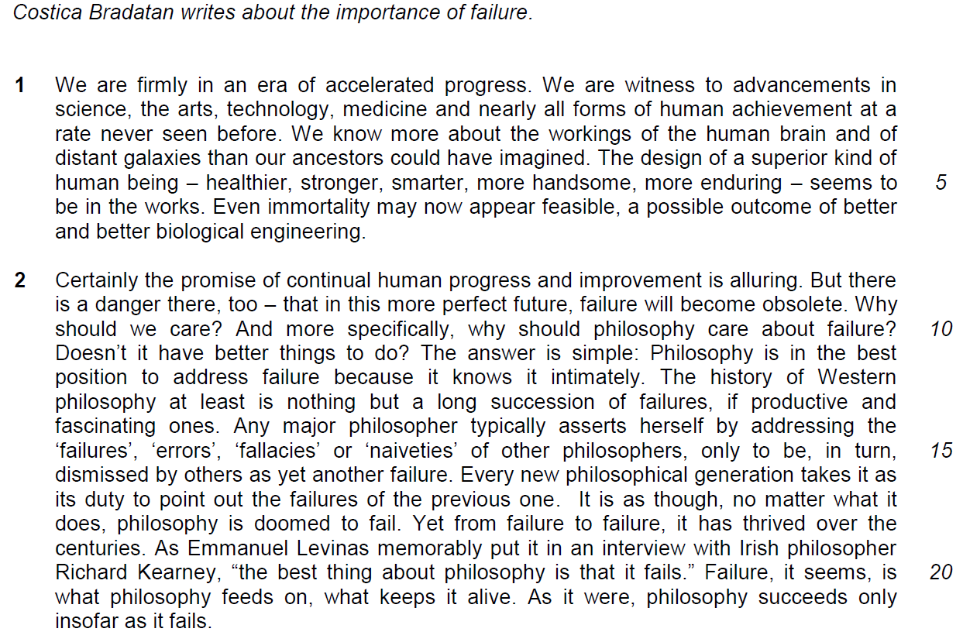

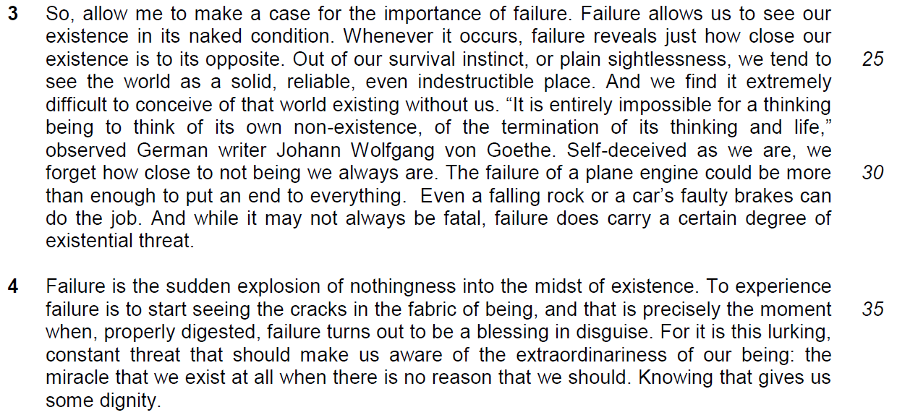

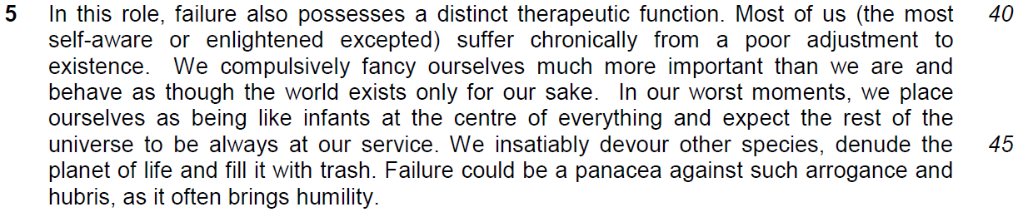

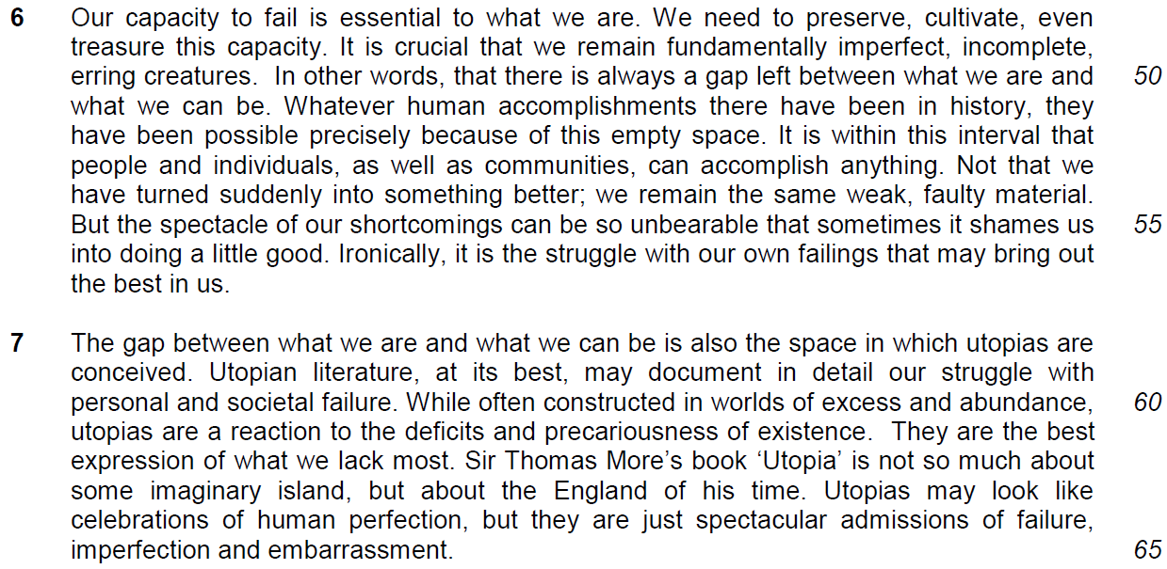

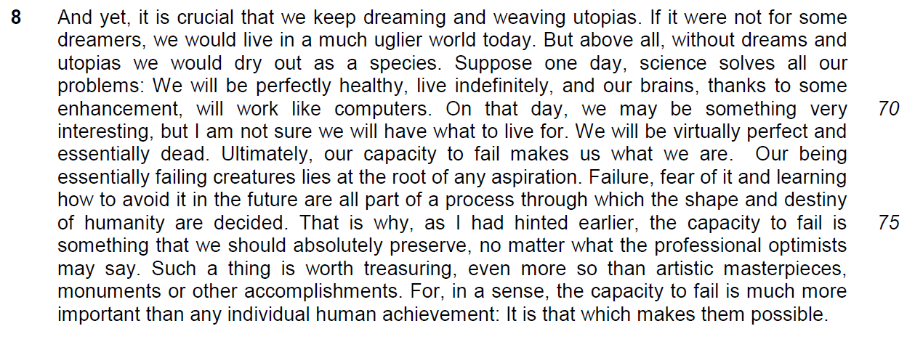

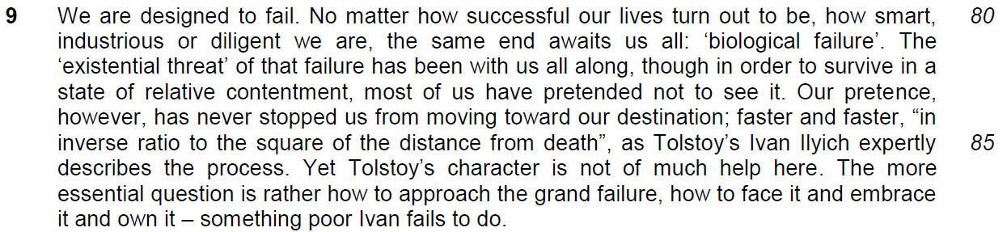

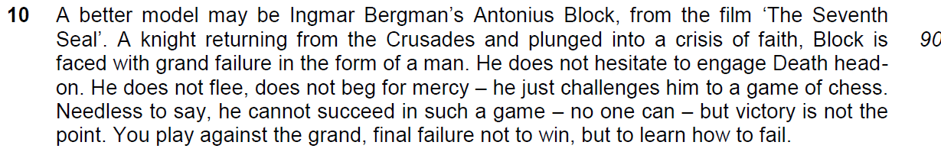

Read the passage in the insert and then answer all the questions. Note that up to fifteen marks will be given for the quality and accuracy of your use of English throughout this Paper.

NOTE: When a question asks for an answer IN YOUR OWN WORDS AS FAR AS POSSIBLE and you select the appropriate material from the passage for your answer, you must still use your own words to express it. Little credit can be given to answers which only copy words or phrases from the passage.

1. Why is the promise of continual human progress and improvement ‘alluring’ (line 8)? Use your own words as far as possible. [2]

……………………………………………………………………………………………………………………………………
……………………………………………………………………………………………………………………………………

……………………………………………………………………………………………………………………………………

2. What is the author’s intention in asking a series of questions in lines 9–11? [1]

……………………………………………………………………………………………………………………………………
……………………………………………………………………………………………………………………………………

3. Why are the words ‘failures’, ‘errors’, ‘fallacies’ and ‘naiveties’ (line 15) in inverted commas? [1]

……………………………………………………………………………………………………………………………………
……………………………………………………………………………………………………………………………………

4. What is the author suggesting about the nature of philosophy in the last sentence of paragraph 2? [1]

……………………………………………………………………………………………………………………………………
……………………………………………………………………………………………………………………………………

5. Explain what the author means by saying that ‘failure reveals just how close our existence is to its opposite’ (lines 24–25). Use your own words as far as possible. [3]

……………………………………………………………………………………………………………………………………
……………………………………………………………………………………………………………………………………

……………………………………………………………………………………………………………………………………
……………………………………………………………………………………………………………………………………

6. Why does the author use the phrase ‘the most self-aware or enlightened excepted’ (lines 40–41)? [1]

……………………………………………………………………………………………………………………………………
……………………………………………………………………………………………………………………………………

7. Explain the author’s use of the word ‘may’ in line 63. [2]

……………………………………………………………………………………………………………………………………
……………………………………………………………………………………………………………………………………

……………………………………………………………………………………………………………………………………
……………………………………………………………………………………………………………………………………

8. Why does the author argue that ‘we will be virtually perfect and essentially dead’ (lines 71–72) if science solves all our problems? Use your own words as far as possible. [2]

……………………………………………………………………………………………………………………………………
……………………………………………………………………………………………………………………………………

……………………………………………………………………………………………………………………………………
……………………………………………………………………………………………………………………………………

9. What does ‘biological failure’ (line 81) refer to and why have we ‘pretended not to see it’ (line 83)? Use your own words as far as possible. [3]

……………………………………………………………………………………………………………………………………
……………………………………………………………………………………………………………………………………

……………………………………………………………………………………………………………………………………
……………………………………………………………………………………………………………………………………

……………………………………………………………………………………………………………………………………
……………………………………………………………………………………………………………………………………

10. What does ‘biological failure’ (line 81) refer to and why have we ‘pretended not to see it’ (line 83)? Use your own words as far as possible. [1]

……………………………………………………………………………………………………………………………………
……………………………………………………………………………………………………………………………………

11. Using material from paragraphs 4 to 6 (lines 34 to 57), summarise why the author believes that failure is important.

Write your summary in no more than 120 words, not counting the opening words which are printed below. Use your own words as far as possible. [8]

Failure holds immense importance for human beings because …………………..

……………………………………………………………………………………………………………………………………
……………………………………………………………………………………………………………………………………

……………………………………………………………………………………………………………………………………
……………………………………………………………………………………………………………………………………

……………………………………………………………………………………………………………………………………
……………………………………………………………………………………………………………………………………

……………………………………………………………………………………………………………………………………
……………………………………………………………………………………………………………………………………

……………………………………………………………………………………………………………………………………
……………………………………………………………………………………………………………………………………

……………………………………………………………………………………………………………………………………
……………………………………………………………………………………………………………………………………

……………………………………………………………………………………………………………………………………
……………………………………………………………………………………………………………………………………

……………………………………………………………………………………………………………………………………
……………………………………………………………………………………………………………………………………

……………………………………………………………………………………………………………………………………
……………………………………………………………………………………………………………………………………

……………………………………………………………………………………………………………………………………
……………………………………………………………………………………………………………………………………

……………………………………………………………………………………………………………………………………
12. Costica Bradatan argues strongly in favour of failure. How applicable are the author’s observations to you and your society? Illustrate your answer by referring to the ways in which you and your society regard failure. [10]
…………………………………………………………………………………………………………………………………
……………………………………………………………………………………………………………………………………
……………………………………………………………………………………………………………………………………
……………………………………………………………………………………………………………………………………

……………………………………………………………………………………………………………………………………
……………………………………………………………………………………………………………………………………

……………………………………………………………………………………………………………………………………
……………………………………………………………………………………………………………………………………

……………………………………………………………………………………………………………………………………
……………………………………………………………………………………………………………………………………

……………………………………………………………………………………………………………………………………
……………………………………………………………………………………………………………………………………

……………………………………………………………………………………………………………………………………
……………………………………………………………………………………………………………………………………

……………………………………………………………………………………………………………………………………
……………………………………………………………………………………………………………………………………

……………………………………………………………………………………………………………………………………
……………………………………………………………………………………………………………………………………

……………………………………………………………………………………………………………………………………
……………………………………………………………………………………………………………………………………

……………………………………………………………………………………………………………………………………
……………………………………………………………………………………………………………………………………

……………………………………………………………………………………………………………………………………
……………………………………………………………………………………………………………………………………

……………………………………………………………………………………………………………………………………
……………………………………………………………………………………………………………………………………

……………………………………………………………………………………………………………………………………
……………………………………………………………………………………………………………………………………

……………………………………………………………………………………………………………………………………
……………………………………………………………………………………………………………………………………

……………………………………………………………………………………………………………………………………
……………………………………………………………………………………………………………………………………

……………………………………………………………………………………………………………………………………
……………………………………………………………………………………………………………………………………

……………………………………………………………………………………………………………………………………
……………………………………………………………………………………………………………………………………

……………………………………………………………………………………………………………………………………
……………………………………………………………………………………………………………………………………

……………………………………………………………………………………………………………………………………
……………………………………………………………………………………………………………………………………

……………………………………………………………………………………………………………………………………
……………………………………………………………………………………………………………………………………

……………………………………………………………………………………………………………………………………
……………………………………………………………………………………………………………………………………

……………………………………………………………………………………………………………………………………
……………………………………………………………………………………………………………………………………

……………………………………………………………………………………………………………………………………
……………………………………………………………………………………………………………………………………

……………………………………………………………………………………………………………………………………

