GP June Intensive Revision
Comprehension Learning Skills 1 – Reading Skills

The objective of reading is to comprehend the ideas in a sentence, a paragraph or a passage. This is one of the fundamental steps in effective learning.

To comprehend a passage, it is imperative for students to develop efficient and effective reading skills. Students need to correct their bad reading habits and adopt a reading procedure that will enable them to extract information effectively and enhance their passive vocabulary development. In the reading process, students need to be able absorb the main points and sub-points. It is also crucial for students to draw implications from the reading.

- Factors undermining Reading Process

  - Weak Concentration

Reading requires full concentration and the absence of concentration will affect the students’ abilities to comprehend a passage. Lack of concentration is usually the result of tiredness, posture and uncomfortable environment.

  - Improper Attitude

Improper attitude towards reading will also affect the effectiveness and efficiency of reading. The lack of interest on the theme of the passage will undermine the students’ effort to focus on reading the articles.

  - Subjective mindset

It is common for the readers to misinterpret the idea in the passage due to their subjective mindset. Instead of comprehending the idea of the passage according the writer’s intent, readers may understand the passage according to their own interpretation.
(provide answers as set by the writer)
  - Undesirable Reading Behaviour

Readers with undesirable behaviours tend to slow their reading speed and weaken their comprehension. Some of the common bad reading behaviours can be seen in the following ways:

      - reading word by word
      - subvocalization
      - regression / back skipping
      - skipping sentences

  - Weak Intra-connection

Students who are unable to link various ideas in the passage are unable to link the various ideas in the paragraph or the passage to derive a meaningful understanding. This affects the students’ capabilities to comprehend factual information.
Content – overview of the issue, features or issues to be discussed, reasons, effects of the development
  - Weak extra-connection

Students who are not effective in analysis, criticism, appreciation and evaluation are usually weak in making interpretation of ideas during their reading.

  - Inadequate Knowledge

The lack of knowledge on particular subject is another factor that will undermine the students’ ability to comprehend the passage. Students may require some prior knowledge to comprehend a passage. Students’ ability to comprehend a passage may be reduced if they are unable to link their general knowledge to the ideas in the subject.

  - Weak Vocabulary Power

Poor language proficiency is another factor that will undermine the comprehension skills of a reader.

- Steps to take note in reading a comprehension passage

  - Read the passage carefully with concentration and enthusiasm.

  - Along the reading process, you need to derive the theme of the passage which is usually revealed in the first or second paragraph.

  - As you read along, you need to extract the main ideas of the respective paragraphs in the passage. Link the main ideas of the respective paragraphs so as to derive an understanding of the implication of the paragraphs. In the course of extraction of ideas, students need to look out for topic sentence which contains the main idea of the paragraph.

areas to take note in reading

- Theme of the passage
- main areas of discussion
-perspective of discussion – causes, effects, impact, comparison
-categorization of discussion – economic issue, social factor, political, individual, health
3) paragraph development – causation – based on nature of discussion (explanation may on process explanation, evaluation ….)
4) proposition – providing direction of discussion for AQ and summary

  - In the extraction of information, there is a need to identify the sub-clauses or phrases that are linked to the idea of the passage and interpret the respective phrases and sub-clauses in accordance to the writer’s point of view. These sub-clauses and phrases will reveal the conceptualized ideas that the writer is trying to depict which will support his evaluation, explanation or description

  - Based on the main ideas extracted from the respective paragraphs, students need to derive the main propositions of the passage which will help in the derivation of information for the answering of Application-based and Summary question.

  - It is also important for students to know the purposes of other sentences and able to differentiate them from the topic sentence. Some of the sentences are used to elaborate the main point of the sentence while some are examples and analogies that the writer is stating to elaborate his point.

Points to take note:

- Read the passage without regression.

- Do not pause for vocabulary understanding or read word by word. Remember that the objective of reading is to comprehend the ideas of the passage. You can attempt to understand more about the meaning of the word when you read further as it usually gives you a clue on the meaning of the word. Very often, the reader can figure out the meaning of the word as he reads on.

- Avoid subjective mindset. Read for the writer’s intent and the implications provided in the passage. Ask yourself what the writer is trying to say to you.

Practice 1 - Extraction of information
Passage 1
By ‘liberal education’ is meant education that includes literature, history and appreciation of the arts, and gives them equal weight with scientific and practical subjects. Education in these pursuits opens the possibility for us to live more reflectively and knowledgeably, especially about the range of human experience and sentiment, as it exists now and here, and in the past and elsewhere. That, in turn, makes us better understand the interests, needs and desires of others, so that we can treat them with respect and sympathy, however different the choices they make or experiences that have shaped their lives. When respect and sympathy are returned, rendering it mutual, the result is that the gaps which can prompt fiction between people, and even war in the end, come to be bridged or at least tolerated. The latter is enough.

Qn 1. Using your own words, how do we benefit from a ‘liberal education’? (3)
i) the possibility for us to live more reflectively and knowledgeably, especially about the range of human experience and sentiment

meaning – make us think and learn more about our human civilization
- exists now and here, and in the past and elsewhere

meaning – from different periods and aspects of our development
- makes us better understand the interests, needs and desires of others, so that we can treat them with respect and sympathy, however different the choices they make or experiences that have shaped their lives

meaning – enrich our knowledge about others so that we can treat them with proper manner despite the differences that we have
- When respect and sympathy are returned, rendering it mutual

meaning – this presence of mutual respect and understanding occurs
- ,the result is that the gaps which can prompt fiction between people, and even war in the end, come to be bridged or at least tolerated.

meaning – the conflicts among people can be cleared and physical conflicts can be eliminated.

Answer:

Liberal education will make us think and learn more about our human civilization of different periods and from all aspects. This, in turn, enriches our knowledge about others so that we can treat them with proper manner despite the differences that we have. When this presence of mutual respect and understanding occurs, the conflicts among people can be cleared and physical conflicts can be eliminated.

Qn 2. Explain what the author means by ‘The latter is enough’? Use your own words as far as possible. (language expression)

Meaning of the subject ‘The latter’ – refers to ………………………………..

Meaning of ‘enough’ – refers to……………………………………………………..

…………………………………………………………………………………………
…………………………………………………………………………………………

……………………………………………………………………………………...…

Paragraph 2
The vision is utopian; no doubt in World war 2, there were German SS officers who read Shakespeare and listened to Beethoven, and then went to work in the gas chambers: so liberal education does not automatically produce better people. But it does so far more often than the stupidity and selfishness which arise from lack of knowledge and impoverishment of insight.
- What is the purpose of the paragraph?

…………………………………………………………………………………………
…………………………………………………………………………………………

……………………………………………………………………………………...…

- What does the word ‘better’ mean?

…………………………………………………………………………………………
…………………………………………………………………………………………

……………………………………………………………………………………...…

- What does the last sentence imply?

…………………………………………………………………………………………
…………………………………………………………………………………………

……………………………………………………………………………………...…

Practice 2
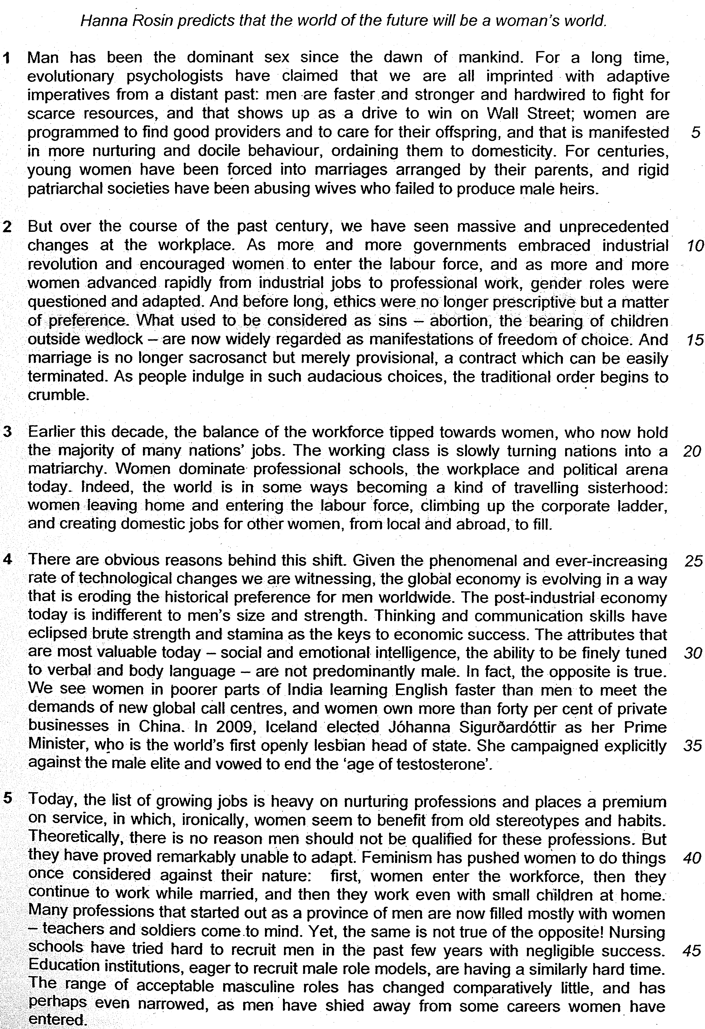

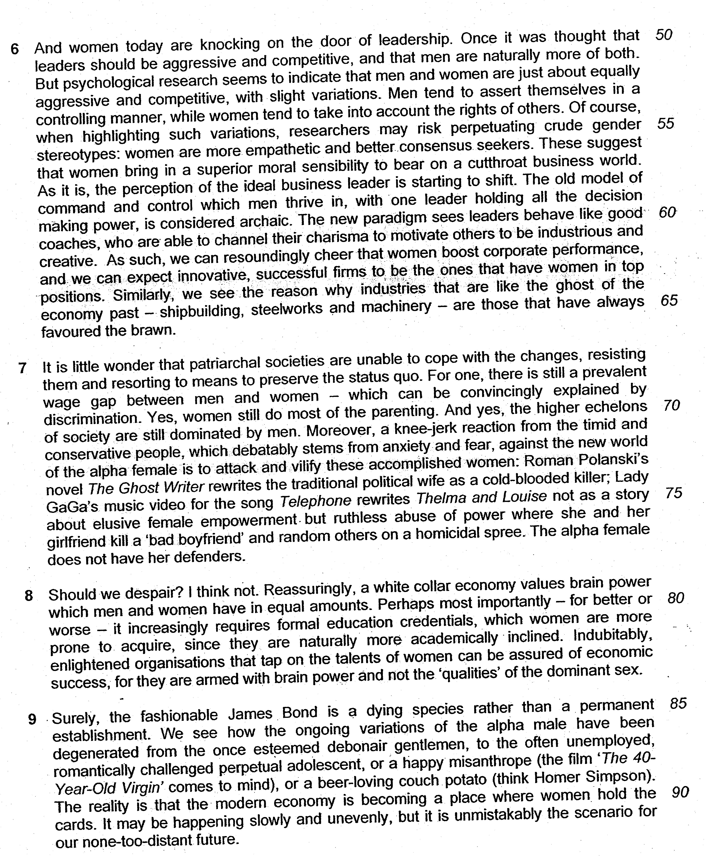

1. According to the author, what happens when 'ethics were no longer prescriptive but a matter of preference' (lines 13-14)? Use your own words as far as possible.

Lifted
What used to be considered as sins - abortion, the bearing of children outside wedlock - are widely regarded as manifestations of freedom of choice. And marriage is no longer sacrosanct but merely provisional, a contract which can be easily terminated.

          - explain the meaning of the phrase –
We can decide on what kind of values we can have
          - what happens – reasons for the development based on the phrase
        - lower our moral standard and allow actions and behaviours which are considered wrong in the past –justifying the actions to be ethical - we change the social values we have and adopt new values
Paraphrased :
…………………………………………………………………………………………
…………………………………………………………………………………………

……………………………………………………………………………………...…

2. What does the phrase 'travelling sisterhood' (line 22) suggest about women?

Inferred answer
………………………………………………………………………………………….
………………………………………………………………………………………….

……………………………………………………………………………………...…..

3. What qualities does the author imply women have from the examples given from lines 32-34?

Lifted
We see women in poorer parts of India learning English faster than men to meet the demands of new global call centres, ... and women own more than forty per cent of private businesses in China.
Inferred
………………………………………………………………………………………….
………………………………………………………………………………………….

4. 'Feminism has pushed women to do things once considered against their nature' (lines 40-41).

According to the author, what would women do if they were to follow their supposed nature? Use your own words as far as possible.

Lifted
… first, women enter the workforce, then they continue to work while married, and then they work even with small children at home.

Paraphrased
………………………………………………………………………………………….
………………………………………………………………………………………….

……………………………………………………………………………………...…..
5. Using your own words as far as possible, explain how women are different from men although they are 'equally aggressive and competitive' (lines 52-53).

Lifted
Men tend to assert themselves in a controlling manner while women tend to take into account the rights of others

Paraphrased
………………………………………………………………………………………….
………………………………………………………………………………………….

……………………………………………………………………………………...…..

6. 'Why does the author find the 'white collar economy' reassuring to women (line 79)? Use your own words as far as possible.

Lifted
Reassuringly, a white collar economy values brain power which men and women have in equal amounts… Perhaps most importantly – for better or worse – it increasingly requires formal education credentials which women are more prone to acquire since they are naturally more academically inclined

Paraphrased
………………………………………………………………………………………….
……………………………………………………………………………………...…

