GP Term 3 2017 – Comprehension – Topic 3: Education – Moral Education

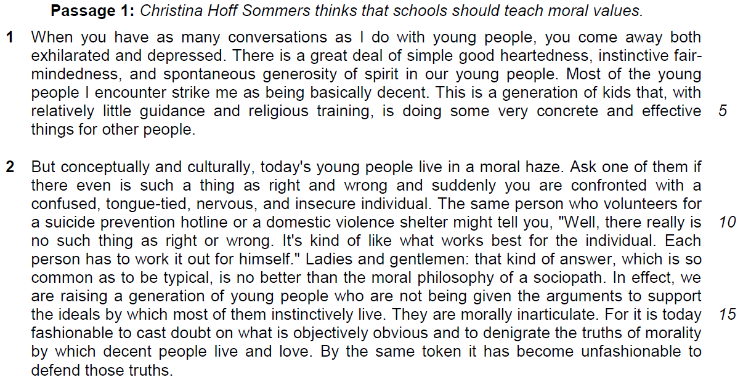

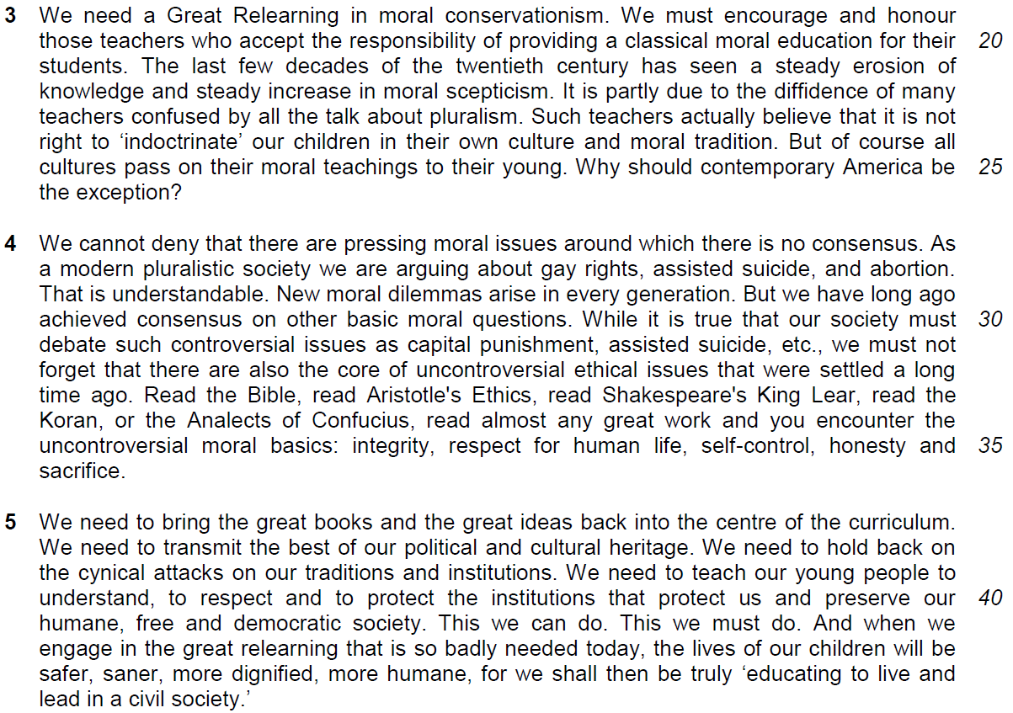
Why the youths will need moral education?
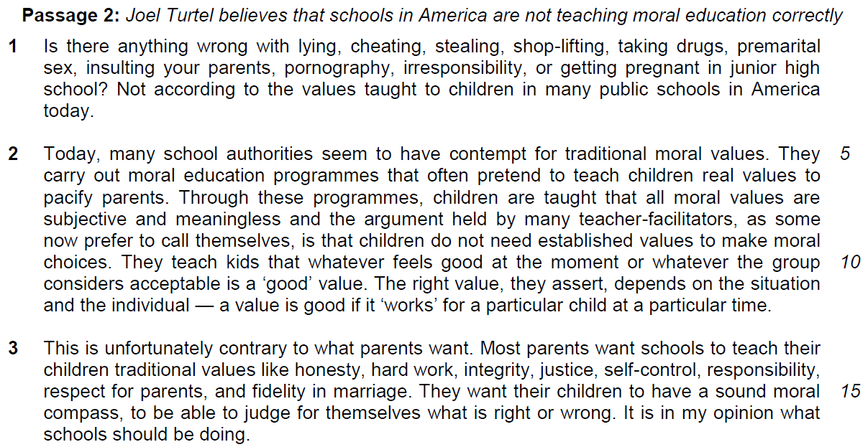

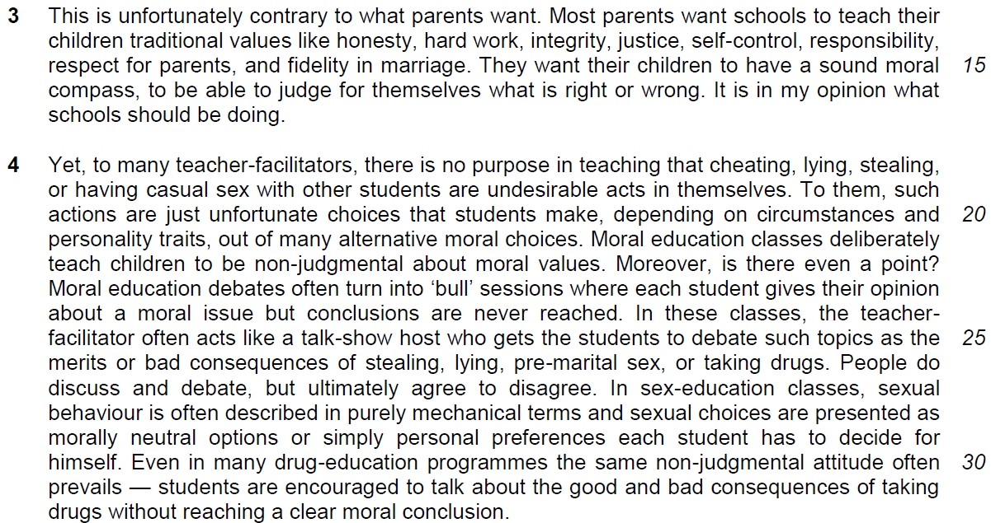

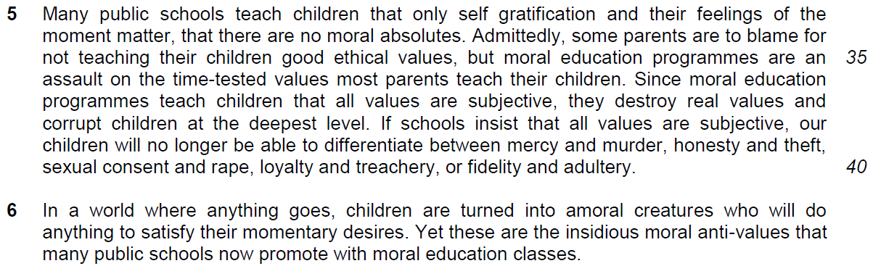

Read the passages in the insert and then answer all the questions. Note that up to fifteen marks will be given for the quality and accuracy of your use of English throughout this paper.

NOTE: When a question asks for an answer IN YOUR OWN WORDS AS FAR AS POSSIBLE and you select the appropriate material from the passage for your answer, you must still use your own words to express it. Little credit can be given to answers which only copy words and phrases from the passages.
From Passage 1
Q1) What does the phrase ‘exhilarated and depressed’ (line 2) suggest about the writer’s attitude towards young people? [1]

……………………………………………………………………………………………………………………………………
……………………………………………………………………………………………………………………………………

Q2) Explain in your own words as far as possible, the irony in lines 9 – 12. [2]

……………………………………………………………………………………………………………………………………

……………………………………………………………………………………………………………………………………

……………………………………………………………………………………………………………………………………

……………………………………………………………………………………………………………………………………

Q3) Explain in your own words as far as possible what the writer means when he says young people are ‘morally inarticulate’ (line 15). [2]

……………………………………………………………………………………………………………………………………

……………………………………………………………………………………………………………………………………

……………………………………………………………………………………………………………………………………

……………………………………………………………………………………………………………………………………

Q4) According to the writer, explain what ‘the diffidence of many teachers confused by all the talk about pluralism’ (lines 22 – 23) has caused. Use your own words as far as possible. [2]

……………………………………………………………………………………………………………………………………

……………………………………………………………………………………………………………………………………

……………………………………………………………………………………………………………………………………

……………………………………………………………………………………………………………………………………
Q5) Explain why ‘indoctrinate’ (line 24) is in quotation marks. [1]

……………………………………………………………………………………………………………………………………

……………………………………………………………………………………………………………………………………

……………………………………………………………………………………………………………………………………

Q6) Explain in your own words as far as possible the writer’s intention for beginning four sentences with ‘We need…’ in paragraph 5. [2]

……………………………………………………………………………………………………………………………………

……………………………………………………………………………………………………………………………………

……………………………………………………………………………………………………………………………………

……………………………………………………………………………………………………………………………………

From Passage 2
Q7) What does the writer suggest about teacher-facilitators when he says that they ‘often pretend to teach children real values to pacify parents’ (lines 6 – 7)? Explain in your own words as far as possible. [3]

……………………………………………………………………………………………………………………………………

……………………………………………………………………………………………………………………………………

……………………………………………………………………………………………………………………………………

……………………………………………………………………………………………………………………………………

……………………………………………………………………………………………………………………………………

……………………………………………………………………………………………………………………………………

Q8) According to the writer, what do school authorities consider to be a ‘good’ value (line 11)? Explain in your own words as far as possible. [2]

……………………………………………………………………………………………………………………………………

……………………………………………………………………………………………………………………………………

……………………………………………………………………………………………………………………………………

……………………………………………………………………………………………………………………………………

Summary Question
Q9) Turtel strongly believes that public schools in America are not conducting moral education programmes properly.

Using material from paragraphs 3 to 5, summarise the criticisms he has towards the way moral education programmes are conducted and the consequences of such programmes. Write your answer in no more than 120 words, not counting the opening words which are printed below. Use your own words as far as possible. [7]

The writer disapproves of moral education programmes in American public schools because…

From the passage | Answer
- This is unfortunately contrary to what
- parents want. (line 13) (cause)

b. Most parents want schools to teach their children traditional values like honesty, hard work…(line 14) (cause)
c. They want their children to have a sound moral compass, to be able to judge for themselves what is right or wrong. (line 15-16) (cause)
OR
children will no longer be able to differentiate between mercy and murder, honesty and theft… (lines 39-40)
(consequence)
d. Yet, to many teacher-facilitators, there is no purpose in teaching that cheating, lying, stealing or having casual sex with other students are undesirable acts in themselves. (cause)
(lines 18-19)
e. To them, such actions are just unfortunate choices that students make... (line 20) (cause)
f. depending on circumstances and personality, out of many alternative moral values. (lines 20-21) (cause)
g. Moral education classes deliberately teach children to be non-judgmental about moral values. (lines 21-22) (cause)
h. Each student gives their opinion about a moral issue but conclusions are never reached. (lines 23-24) (consequence)
i. teach children only self gratification and feelings of the moment matter, (lines 33-34)
(cause)
j. but moral education programmes are an assault on the time-tested values most parents teach their children. (lines 35-36)
(consequence)
k. corrupt children at the deepest level. (line 38) (consequence)

Application Question
Q10) Both writers believe that schools should guide children in developing a sound moral character. Sommers suggests that schools should engage in a Great Relearning while Turtel criticises the way American public schools conduct moral education programmes.

With reference to the ideas presented in the passages, consider how far the young people in your society are in need of school-based moral education programmes. [8]

……………………………………………………………………………………………………………………………………

……………………………………………………………………………………………………………………………………

……………………………………………………………………………………………………………………………………

……………………………………………………………………………………………………………………………………

……………………………………………………………………………………………………………………………………

……………………………………………………………………………………………………………………………………

……………………………………………………………………………………………………………………………………

……………………………………………………………………………………………………………………………………

……………………………………………………………………………………………………………………………………

……………………………………………………………………………………………………………………………………

……………………………………………………………………………………………………………………………………

……………………………………………………………………………………………………………………………………

……………………………………………………………………………………………………………………………………

……………………………………………………………………………………………………………………………………

……………………………………………………………………………………………………………………………………

……………………………………………………………………………………………………………………………………

……………………………………………………………………………………………………………………………………

……………………………………………………………………………………………………………………………………

……………………………………………………………………………………………………………………………………

……………………………………………………………………………………………………………………………………

……………………………………………………………………………………………………………………………………

……………………………………………………………………………………………………………………………………

……………………………………………………………………………………………………………………………………

……………………………………………………………………………………………………………………………………

……………………………………………………………………………………………………………………………………

……………………………………………………………………………………………………………………………………

……………………………………………………………………………………………………………………………………

……………………………………………………………………………………………………………………………………

……………………………………………………………………………………………………………………………………

……………………………………………………………………………………………………………………………………

……………………………………………………………………………………………………………………………………

……………………………………………………………………………………………………………………………………

……………………………………………………………………………………………………………………………………

……………………………………………………………………………………………………………………………………

……………………………………………………………………………………………………………………………………

……………………………………………………………………………………………………………………………………

……………………………………………………………………………………………………………………………………

……………………………………………………………………………………………………………………………………

……………………………………………………………………………………………………………………………………

……………………………………………………………………………………………………………………………………

……………………………………………………………………………………………………………………………………

……………………………………………………………………………………………………………………………………

……………………………………………………………………………………………………………………………………

……………………………………………………………………………………………………………………………………

……………………………………………………………………………………………………………………………………

……………………………………………………………………………………………………………………………………

……………………………………………………………………………………………………………………………………

Application Question
Q10) Both writers believe that schools should guide children in developing a sound moral character. Sommers suggests that schools should engage in a Great Relearning while Turtel criticises the way American public schools conduct moral education programmes.

With reference to the ideas presented in the passages, consider how far the young people in your society need a school-based moral education programme. [8]

Thinking perspective:
Use the points given by the writers to explain why Singapore needs a school-based moral education or not.
Justify the reason that explain why the writer‘s point of view is justifiable.
eg1 – why Singapore students are unable to make moral judgement

Structure of Discussion:

Introduction
State briefly the requirement of the question – how far you do you agree with the proposition

Main body
Point 1:
1. Quote from the passage
According to Joel Turtel, - students live in a ‘moral haze’ and are ‘morally inarticulate’
2. Explanation on why this explains Singapore youths need a moral-based education
The writer’s view is that they are unable to make moral judgement and decision and thus, this explains why there is a need for Singapore to have a school-based moral education.
3. why do you think that the youths in Singapore will need a school-based moral education
Discuss on how Singapore students are brought up and taught in school and society.

According to National Crime Prevention Council, most problem youths come from homes lacking in parental guidance and are usually under-achievers in schools and with low self-esteem.

4. Example

According to Department of Singapore Statistics, the number of youth crime has been falling which shows the relentless efforts by Ministry of Education in imparting moral education has become a significant recognition that school-based moral education is needed by youths especially for the group from 12 -14 age groups.

5. Extent of Agreement:
There is extensive regulation by the government as imposed by Juvenile Court and social institution like National Youth Challenge Council There also many religious institutions which act as moral institutions to guide the youths. The fact that the number of juvenile delinquents is on the fall explains why there is no need of school-based moral education which is demanding task for the teacher.

6. linking sentence
It is a very debateable issue whether school-based moral education is needed. However, it is rational to conclude that all or more means of education by more institutions would be helpful to enrich the moral acumen of our youths.

Point 2

2.1 Quote
According to Joel Tutel, ‘there is no purposes in teaching that cheating, lying, stealing, or having casual sex with other students are undesirable acts in themselves’

2.2 Explanation – why this explains that the youth of Singapore does not need a school-based education

2.3 Why you agree with this view that Singapore does not need a school-based education

2.4 Example

2.5 Extent of Agreement – why you may not agree

2.6 Linking sentence

3. Conclusion

