GP Comprehension – Reflective Issues – Fairness (SAJC 2013)

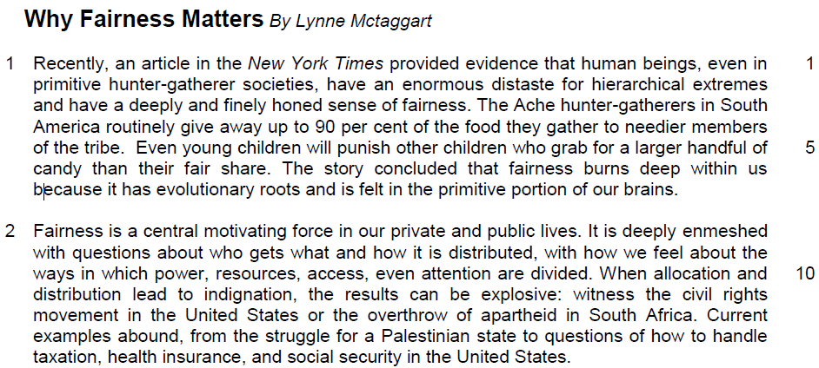

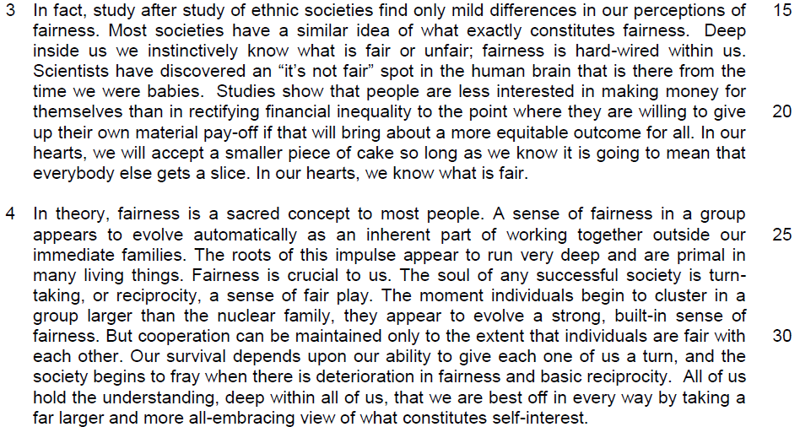

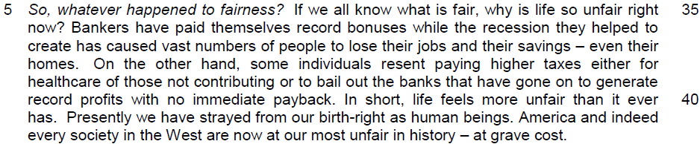

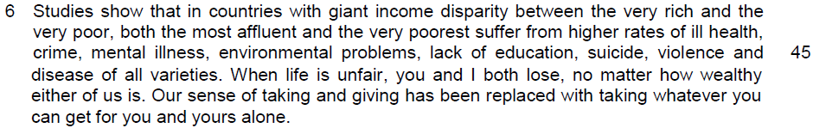

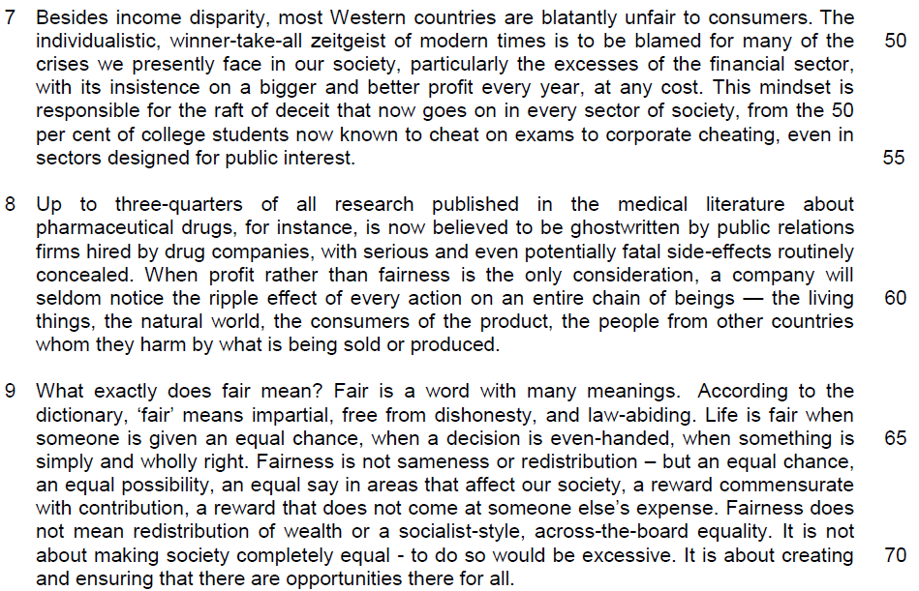

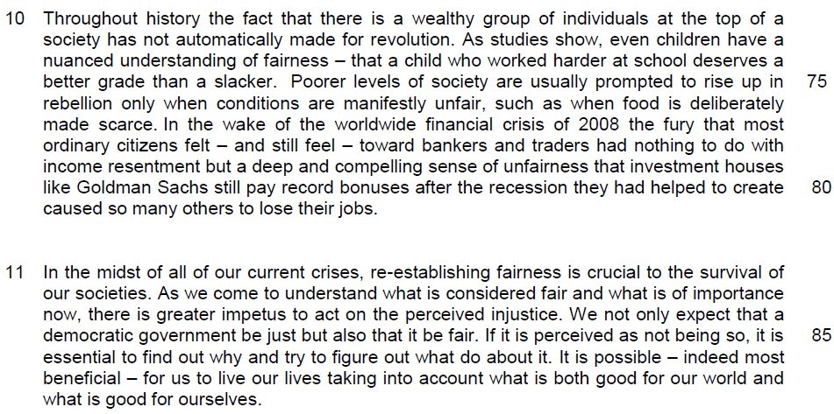

Read the passage in the insert and then answer all the questions which follow below. Note that up to fifteen marks will be given for the quality and accuracy of your use of English throughout this paper.

NOTE: When a question asks for an answer IN YOUR OWN WORDS AS FAR AS POSSIBLE and you select the appropriate material from the passages for your answer, you must still use your own words to express it. Little credit can be given to answers which only copy words or phrases from the passages.

1. What is the ‘enormous distaste’ (line 2) that primitive hunter-gatherer societies share? Use your own words as far as possible.

……………………………………………………………………………………...…
………………………………………………………………………………………[1]

2. Why is the sentence ‘So, whatever happened to fairness?’ in line 35 italicised?

…………………………………………………………………………………………

…………………………………………………………………………………………
………………………………………………………………………………………[2]

3. Explain what the author means by the phrase ‘strayed from our birth-right as human beings’ (line 41).

…………………………………………………………………………………………

…………………………………………………………………………………………
……………………………………………………………………………………….[2]

4. Why does the author use the words ‘you’ and ‘I’ in line 46?

…………………………………………………………………………………………
………………………………………………………………………………………[1]

5. Explain what the author means by ‘our sense of taking and giving has been replaced with taking whatever you can get for you and yours alone’ (lines 47-48).

…………………………………………………………………………………………
………………………………………………………………………………………[1]

6. (i) Why are most western countries ‘blatantly unfair to consumers’ (line 49)? Use your own words as far as possible.

…………………………………………………………………………………………
………………………………………………………………………………………[1]

6. (ii) How is this blatant unfairness to consumers illustrated?

…………………………………………………………………………………………
…………………………………………………………………………………………
………………………………………………………………………………………[2]

7. In paragraph 8, instead of public relations firms, suggest who should write the research about pharmaceutical drugs?

…………………………………………………………………………………………
………………………………………………………………………………………[1]

8. What does the word ‘routinely’ (line 58) imply about the attitude of drug companies in concealing the side-effects of drugs?

…………………………………………………………………………………………
………………………………………………………………………………………[1]

9. When the author cited fairness as ‘…impartial, free from dishonesty, and law-abiding’ (line 64), what is he implying about unfairness? Use your own words as far as possible.

…………………………………………………………………………………………

…………………………………………………………………………………………

…………………………………………………………………………………………
………………………………………………………………………………………[3]

10. Explain why inequality does not automatically lead to revolution in paragraph 10. Use your own words as far as possible.

…………………………………………………………………………………………

…………………………………………………………………………………………
………………………………………………………………………………………[2]

=

11. Using material from paragraphs 2 to 4 only, summarise why fairness is important. Write your summary in no more than 120 words, not counting the opening words which are printed below. Use your own words as far as possible.

Fairness has always been …………………………………………………………

…………………………………………………………………………………………

…………………………………………………………………………………………
…………………………………………………………………………………………

…………………………………………………………………………………………

…………………………………………………………………………………………

…………………………………………………………………………………………

…………………………………………………………………………………………

…………………………………………………………………………………………

…………………………………………………………………………………………

…………………………………………………………………………………………

…………………………………………………………………………………………

…………………………………………………………………………………………

…………………………………………………………………………………………

…………………………………………………………………………………………

…………………………………………………………………………………………

…………………………………………………………………………………………

…………………………………………………………………………………………

…………………………………………………………………………………………

…………………………………………………………………………………………

…………………………………………………………………………………………
………………………………………………………………………………………[8]

12. In this article, Lynne Mctaggart argues for the need for fairness in society today. How relevant are her views to you and your society?

…………………………………………………………………………………………

…………………………………………………………………………………………
…………………………………………………………………………………………

…………………………………………………………………………………………

…………………………………………………………………………………………

…………………………………………………………………………………………

…………………………………………………………………………………………

…………………………………………………………………………………………

…………………………………………………………………………………………

…………………………………………………………………………………………

…………………………………………………………………………………………

…………………………………………………………………………………………

…………………………………………………………………………………………

…………………………………………………………………………………………

…………………………………………………………………………………………

…………………………………………………………………………………………

…………………………………………………………………………………………

…………………………………………………………………………………………

…………………………………………………………………………………………

…………………………………………………………………………………………

…………………………………………………………………………………………

…………………………………………………………………………………………

…………………………………………………………………………………………

…………………………………………………………………………………………
…………………………………………………………………………………………

…………………………………………………………………………………………

…………………………………………………………………………………………

…………………………………………………………………………………………

…………………………………………………………………………………………

…………………………………………………………………………………………

…………………………………………………………………………………………

…………………………………………………………………………………………

…………………………………………………………………………………………

…………………………………………………………………………………………

…………………………………………………………………………………………

…………………………………………………………………………………………

…………………………………………………………………………………………

…………………………………………………………………………………………

…………………………………………………………………………………………

…………………………………………………………………………………………

…………………………………………………………………………………………

…………………………………………………………………………………………

…………………………………………………………………………………………

…………………………………………………………………………………………

…………………………………………………………………………………………

…………………………………………………………………………………………

…………………………………………………………………………………………

…………………………………………………………………………………………
…………………………………………………………………………………………

…………………………………………………………………………………………

…………………………………………………………………………………………

…………………………………………………………………………………………

…………………………………………………………………………………………

…………………………………………………………………………………………

…………………………………………………………………………………………

…………………………………………………………………………………………

…………………………………………………………………………………………

…………………………………………………………………………………………

…………………………………………………………………………………………

…………………………………………………………………………………………

…………………………………………………………………………………………

…………………………………………………………………………………………

…………………………………………………………………………………………

…………………………………………………………………………………………

…………………………………………………………………………………………

…………………………………………………………………………………………

…………………………………………………………………………………………

…………………………………………………………………………………………
……………………………………………………………………………………..[10]

