reGP Comprehension – Importance of Stories
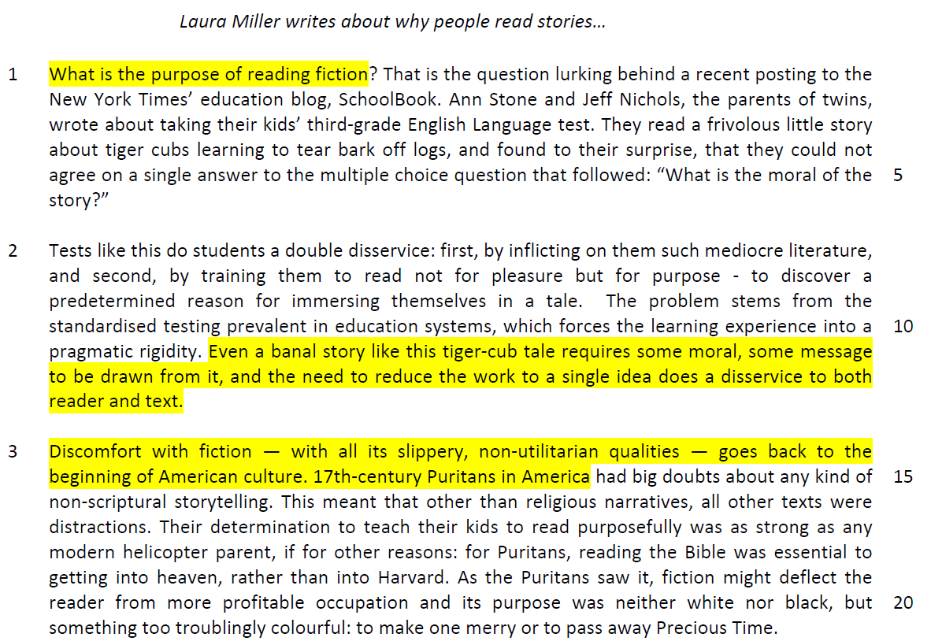

p 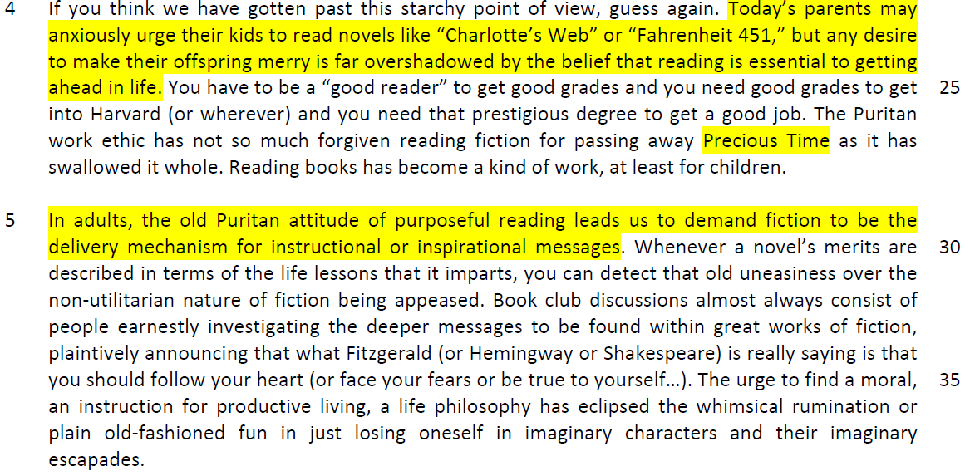

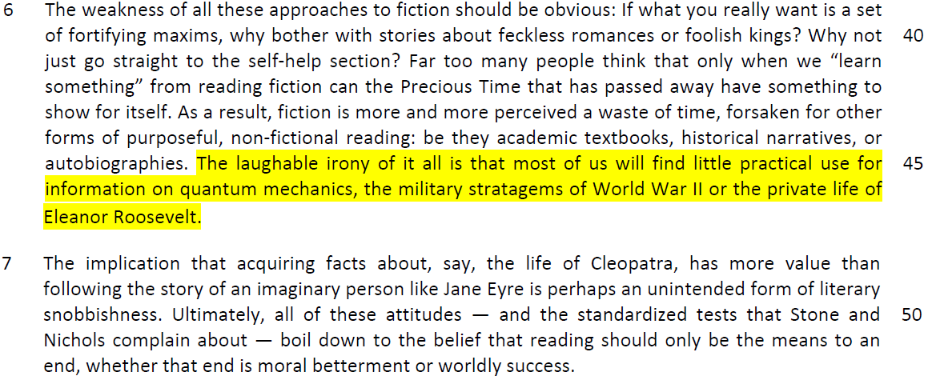
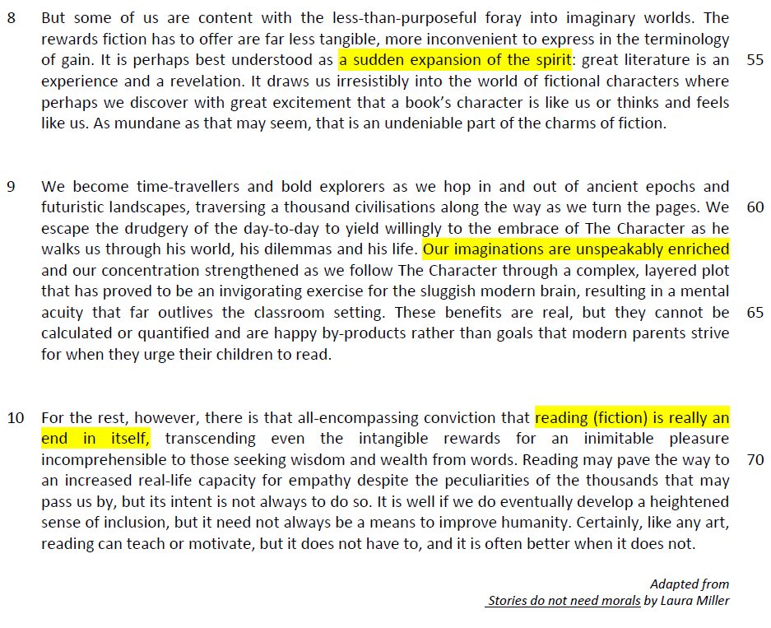

Questions
1. What does the word ‘frivolous’ (line 3) suggest about the story found in the children’s English Language test? [1]

……………………………………………………………………………………………………………………………………
……………………………………………………………………………………………………………………………………

2. Why were the parents surprised by their inability to agree on a common answer to the multiple choice question that followed the story (lines 3-6)? [1]

……………………………………………………………………………………………………………………………………
……………………………………………………………………………………………………………………………………

3. How would students benefit if ‘standardised testing’ (line 10) were removed from the education system? Use your own words as far as possible. [2]

……………………………………………………………………………………………………………………………………
……………………………………………………………………………………………………………………………………

……………………………………………………………………………………………………………………………………
……………………………………………………………………………………………………………………………………

4. What is the similarity and difference between the 17th-century Puritans (line 15) and modern helicopter parents (line 18)? Use your own words as far as possible. [2]

……………………………………………………………………………………………………………………………………
……………………………………………………………………………………………………………………………………

……………………………………………………………………………………………………………………………………
5. Explain what the author means by ‘neither black nor white, but something too troublingly colourful’ (lines 20-21). Use your own words as far as possible. [3]

……………………………………………………………………………………………………………………………………
……………………………………………………………………………………………………………………………………

……………………………………………………………………………………………………………………………………
……………………………………………………………………………………………………………………………………

6. Explain the author’s use of capital letters in ‘Precious Time’ (line 21). [1]

……………………………………………………………………………………………………………………………………
……………………………………………………………………………………………………………………………………

7. According to the author in paragraph 4, why do today’s parents urge their children to read, and why do they ‘anxiously’ (line 23) do so? Use your own words as far as possible. [2]

……………………………………………………………………………………………………………………………………
……………………………………………………………………………………………………………………………………

……………………………………………………………………………………………………………………………………
8. What is the author hinting at by her use of the phrase ‘old uneasiness’ (line 31)? [2]

……………………………………………………………………………………………………………………………………
……………………………………………………………………………………………………………………………………

……………………………………………………………………………………………………………………………………
9. Explain the irony in the last sentence of paragraph 6. [2]

……………………………………………………………………………………………………………………………………
……………………………………………………………………………………………………………………………………

……………………………………………………………………………………………………………………………………
10. What answer does the author give in paragraph 10 to her opening question in line 1? [1]

……………………………………………………………………………………………………………………………………
……………………………………………………………………………………………………………………………………

Summary Writing
11. Using material from paragraphs 8-10 only, summarise what the author has to say about the benefits of reading fiction.

Write your summary in no more than 120 words, not counting the opening words which are printed below. Use your own words as far as possible. [8]

The benefits of reading fiction are…
S/No | From the passage | Paraphrased equivalent
1 | It is perhaps best understood as a sudden expansion of the spirit (line 55)
2 | great literature is an experience (line 55-56)
3 | and a revelation (line 56)
4 | It draws us irresistibly into the world of fictional characters where perhaps we discover with great excitement (line 56-57)
5 | that a book’s character is like us or thinks and feels like us (line 57)
6 | We become time-travellers and bold explorers as we hop in and out of ancient epochs and futuristic landscapes, (lines 59-60)
7 | traversing a thousand civilisations along the way as we turn the pages. (lines 60)
8 | We escape the drudgery of the day-to-day (lines 60-61)
9 | our concentration strengthened (line 64)

S/No | Points/Ideas from the passage (Essence of the point/idea in bold) | Paraphrased equivalent
10 | our concentration strengthened (line 64)
11 | proved to be an invigorating exercise for  the sluggish modern brain (line 64)
12 | resulting in a mental acuity that far outlives  the classroom setting (lines 64-65)
13 | reading (fiction) is really an end in itself  (lines 68-69)
14 | …. the intangible rewards (line 69)
15 | for an inimitable pleasure (line 69)
16 | increased real-life capacity for empathy  (line 71)
17 | develop a heightened sense of inclusion  (lines 72-73)
18 | reading can teach (line 74)
19 | or motivate (line 74)

12. Application Question
In this article, Laura Miller makes a number of observations about reading fiction. How applicable do you find her observations to yourself and your own society? [10]

- Quote
- explain the meaning of the quote
- Answer the requirements of the question
- applicability of her ideas in your life and your society
(your education and your society)

Introduction’
Main body
2 points which support that it is applicable
1 point which supports hat it is not applicable
……………………………………………………………………………………………………………………………………
……………………………………………………………………………………………………………………………………

……………………………………………………………………………………………………………………………………
……………………………………………………………………………………………………………………………………

……………………………………………………………………………………………………………………………………
……………………………………………………………………………………………………………………………………

……………………………………………………………………………………………………………………………………
……………………………………………………………………………………………………………………………………

……………………………………………………………………………………………………………………………………
……………………………………………………………………………………………………………………………………

……………………………………………………………………………………………………………………………………
……………………………………………………………………………………………………………………………………

……………………………………………………………………………………………………………………………………
……………………………………………………………………………………………………………………………………

……………………………………………………………………………………………………………………………………
……………………………………………………………………………………………………………………………………

……………………………………………………………………………………………………………………………………
……………………………………………………………………………………………………………………………………

……………………………………………………………………………………………………………………………………
……………………………………………………………………………………………………………………………………

……………………………………………………………………………………………………………………………………
……………………………………………………………………………………………………………………………………

……………………………………………………………………………………………………………………………………
……………………………………………………………………………………………………………………………………

……………………………………………………………………………………………………………………………………
……………………………………………………………………………………………………………………………………

……………………………………………………………………………………………………………………………………
……………………………………………………………………………………………………………………………………

……………………………………………………………………………………………………………………………………
……………………………………………………………………………………………………………………………………

……………………………………………………………………………………………………………………………………
……………………………………………………………………………………………………………………………………

……………………………………………………………………………………………………………………………………
……………………………………………………………………………………………………………………………………

……………………………………………………………………………………………………………………………………
……………………………………………………………………………………………………………………………………

……………………………………………………………………………………………………………………………………
……………………………………………………………………………………………………………………………………

……………………………………………………………………………………………………………………………………
……………………………………………………………………………………………………………………………………

……………………………………………………………………………………………………………………………………
……………………………………………………………………………………………………………………………………

……………………………………………………………………………………………………………………………………
……………………………………………………………………………………………………………………………………

……………………………………………………………………………………………………………………………………

