GP Comprehension – Loneliness
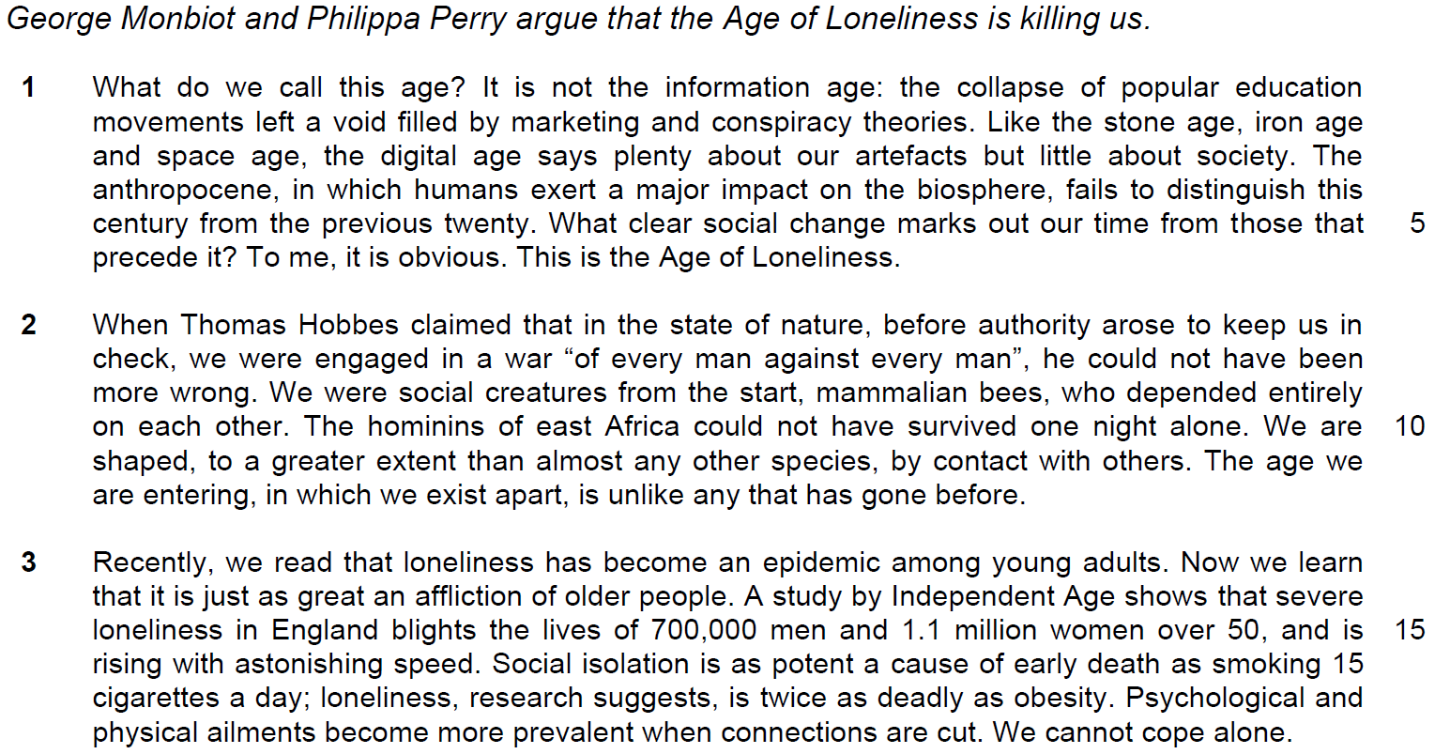

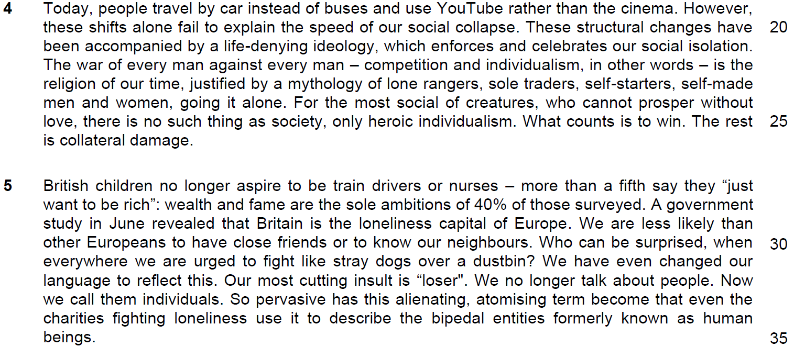

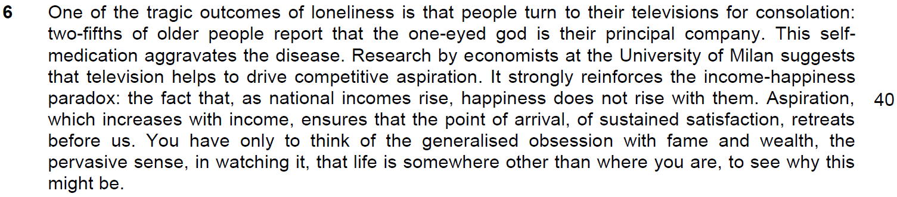

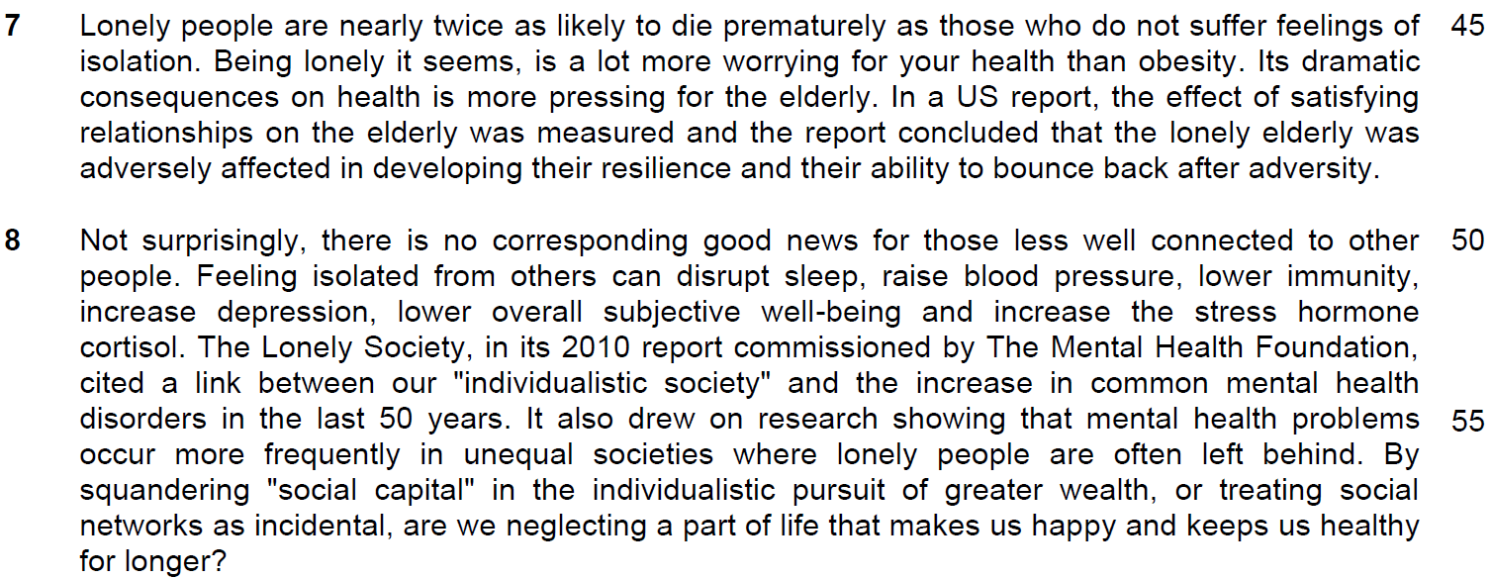

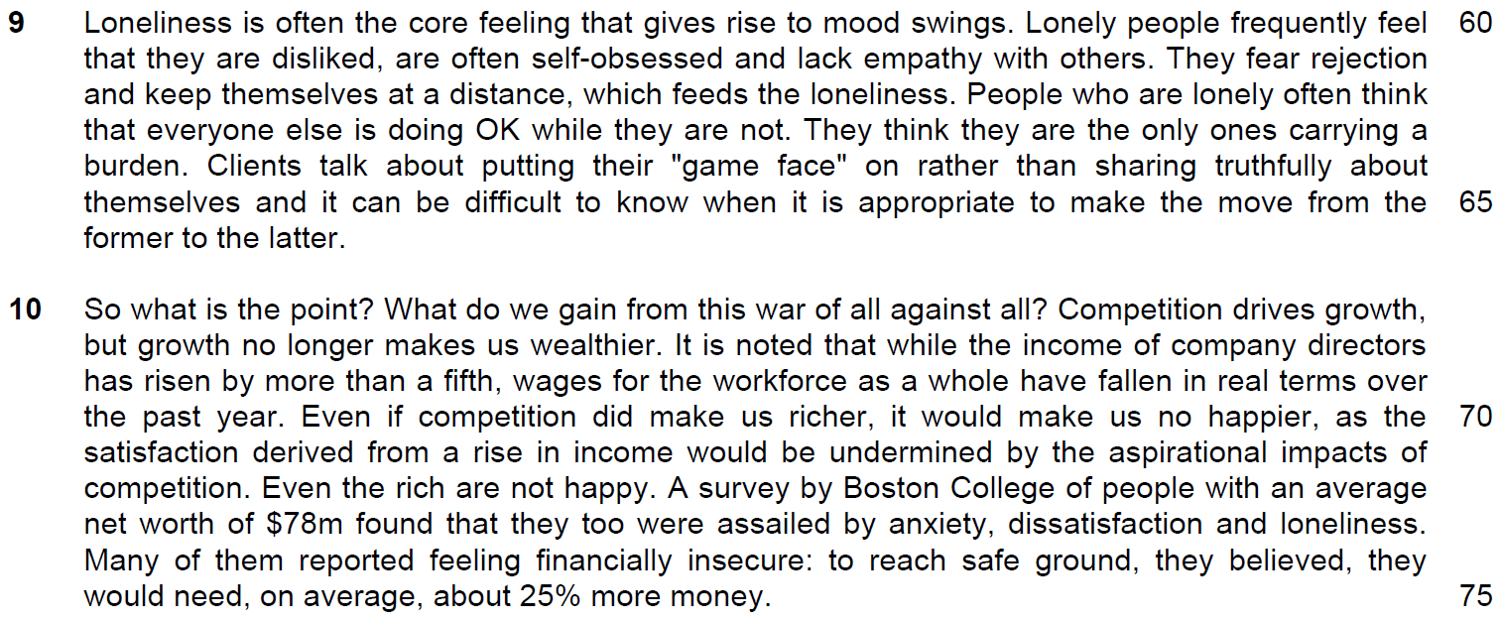

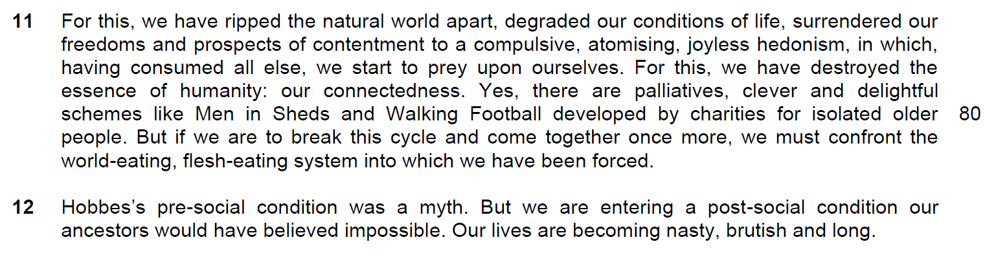

Read the passage in the Insert and then answer all the questions. Note that up to fifteen marks will be given for the quality and accuracy of your use of English throughout this Paper.

NOTE: When a question asks for an answer IN YOUR OWN WORDS AS FAR AS POSSIBLE and you select the appropriate material from the passage for your answer, you must still use your own words to express it. Little credit can be given to answers which only copy words and phrases from the passage.

1. In lines 2-3, what similarity do the authors see between the Age of Loneliness and the ages that precede it? Use your own words as far as possible. [2]

……………………………………………………………………………………………………………………………………
……………………………………………………………………………………………………………………………………

……………………………………………………………………………………………………………………………………
……………………………………………………………………………………………………………………………………

2. What is the claim made by Thomas Hobbes in lines 7-8 and why do the authors disagree with it? Use your own words as far as possible. [3]

……………………………………………………………………………………………………………………………………
……………………………………………………………………………………………………………………………………

……………………………………………………………………………………………………………………………………
……………………………………………………………………………………………………………………………………

……………………………………………………………………………………………………………………………………
……………………………………………………………………………………………………………………………………

3. In paragraph 3, what do the words ‘just as’ tell you about the effect of the epidemic on older people? [1]

……………………………………………………………………………………………………………………………………
……………………………………………………………………………………………………………………………………

4. What is implied by the ‘shifts’ (line 21) described in the sentence ‘Today people travel by car instead of buses and use YouTube rather than the cinema’ in line 20? [2]

……………………………………………………………………………………………………………………………………
……………………………………………………………………………………………………………………………………

……………………………………………………………………………………………………………………………………
……………………………………………………………………………………………………………………………………

5. Explain the phrase ‘to fight like stray dogs over a dustbin’ (line 32). [2]

……………………………………………………………………………………………………………………………………
……………………………………………………………………………………………………………………………………

……………………………………………………………………………………………………………………………………
……………………………………………………………………………………………………………………………………

6. Explain the ‘income-happiness paradox’ in lines 40-41. Use your own words as far as possible. [2]

……………………………………………………………………………………………………………………………………
……………………………………………………………………………………………………………………………………

……………………………………………………………………………………………………………………………………
……………………………………………………………………………………………………………………………………

7. What does the word ‘assailed’ in line 74 tell us about how loneliness affects the rich? [1]

……………………………………………………………………………………………………………………………………
……………………………………………………………………………………………………………………………………

8(a) What does ‘this’ in line 77 refer to? [1]

……………………………………………………………………………………………………………………………………
……………………………………………………………………………………………………………………………………

8(b) Why does the author repeat the phrase ‘for this’ in lines 77 and 79? [1]

……………………………………………………………………………………………………………………………………
……………………………………………………………………………………………………………………………………

9) What are the authors’ opinion about schemes like ‘Men in Sheds’ and ‘Walking Football’ in line 82? [1]

……………………………………………………………………………………………………………………………………
……………………………………………………………………………………………………………………………………

10) Why is Hobbes mentioned again in the first line of paragraph 12? [1]

……………………………………………………………………………………………………………………………………
……………………………………………………………………………………………………………………………………

Summary Writing
11. Using material from paragraphs 7 to 9, summarise what the authors have to say about the harmful effects of loneliness on people.

Write your summary in no more than 120 words, not counting the opening words which are printed below. Use your own words as far as possible. [8]

Loneliness leads to …
S/No | From the passage | Paraphrased equivalent
1 | nearly twice as likely to die prematurely as those who do not suffer feelings of isolation.
2 | a lot more worrying for your health than obesity.
3 | more pressing for the elderly
4 | the lonely elderly was adversely affected in developing their resilience  OR  and their ability to bounce back after adversity
5 | can disrupt sleep, raise blood pressure, lower immunity, increase depression, lower overall subjective well-being and increase the stress hormone cortisol.
6 | increase in common mental health disorders in the last 50 years.

S/No | Points/Ideas from the passage (Essence of the point/idea in bold) | Paraphrased equivalent
7 | unequal societies
8 | where lonely people are often left behind.
9 | neglecting a part of life that makes us happy and keeps us healthy for longer?
10 | gives rise to mood swings
11 | feel that they are disliked
12 | self-obsessed
13 | lack empathy with others.
14 | fear rejection
15 | keep themselves at a distance

S/No | Points/Ideas from the passage (Essence of the point/idea in bold) | Paraphrased equivalent
16 | feeds the loneliness.
17 | often think that everyone else is doing OK while they are not.  OR  they are the only ones carrying a burden.
18 | putting their "game face" on
19 | rather than sharing truthfully about themselves
20 | difficult to know when it is appropriate to make the move from the former to the latter.

12. Application Question
George Monbiot and Philippa Perry argue that the age of loneliness is killing us.
How applicable are their observations to yourself and your own society? [10]

introduction
- state that the age of loneliness is affecting us and our society in a negative way
- Singapore has a society that fits most of the observation stated by the writers – thus implying the observation of the era of loneliness is applicable to us
Main body
observation stated and explained must be linked to loneliness
eg – high degree of competition -tarnish our relationship – see your friend as a competitor – your social circle is now narrowed – felt this sense of loneliness – affecting your life
create tangible examples with the name of institution
link to example to your assertion or point
……………………………………………………………………………………………………………………………………
……………………………………………………………………………………………………………………………………

……………………………………………………………………………………………………………………………………
……………………………………………………………………………………………………………………………………

……………………………………………………………………………………………………………………………………
……………………………………………………………………………………………………………………………………

……………………………………………………………………………………………………………………………………
……………………………………………………………………………………………………………………………………

……………………………………………………………………………………………………………………………………
……………………………………………………………………………………………………………………………………

……………………………………………………………………………………………………………………………………
……………………………………………………………………………………………………………………………………

……………………………………………………………………………………………………………………………………
……………………………………………………………………………………………………………………………………

……………………………………………………………………………………………………………………………………
……………………………………………………………………………………………………………………………………

……………………………………………………………………………………………………………………………………
……………………………………………………………………………………………………………………………………

……………………………………………………………………………………………………………………………………
……………………………………………………………………………………………………………………………………

……………………………………………………………………………………………………………………………………
……………………………………………………………………………………………………………………………………

……………………………………………………………………………………………………………………………………
……………………………………………………………………………………………………………………………………

……………………………………………………………………………………………………………………………………
……………………………………………………………………………………………………………………………………

……………………………………………………………………………………………………………………………………
……………………………………………………………………………………………………………………………………

……………………………………………………………………………………………………………………………………
……………………………………………………………………………………………………………………………………

……………………………………………………………………………………………………………………………………
……………………………………………………………………………………………………………………………………

……………………………………………………………………………………………………………………………………
……………………………………………………………………………………………………………………………………

……………………………………………………………………………………………………………………………………
……………………………………………………………………………………………………………………………………

……………………………………………………………………………………………………………………………………
……………………………………………………………………………………………………………………………………

……………………………………………………………………………………………………………………………………
……………………………………………………………………………………………………………………………………

……………………………………………………………………………………………………………………………………
……………………………………………………………………………………………………………………………………

……………………………………………………………………………………………………………………………………
……………………………………………………………………………………………………………………………………

……………………………………………………………………………………………………………………………………

