GP Term 4 2017 – Comprehension Topic 2: Social Issues – Racial Prejudice

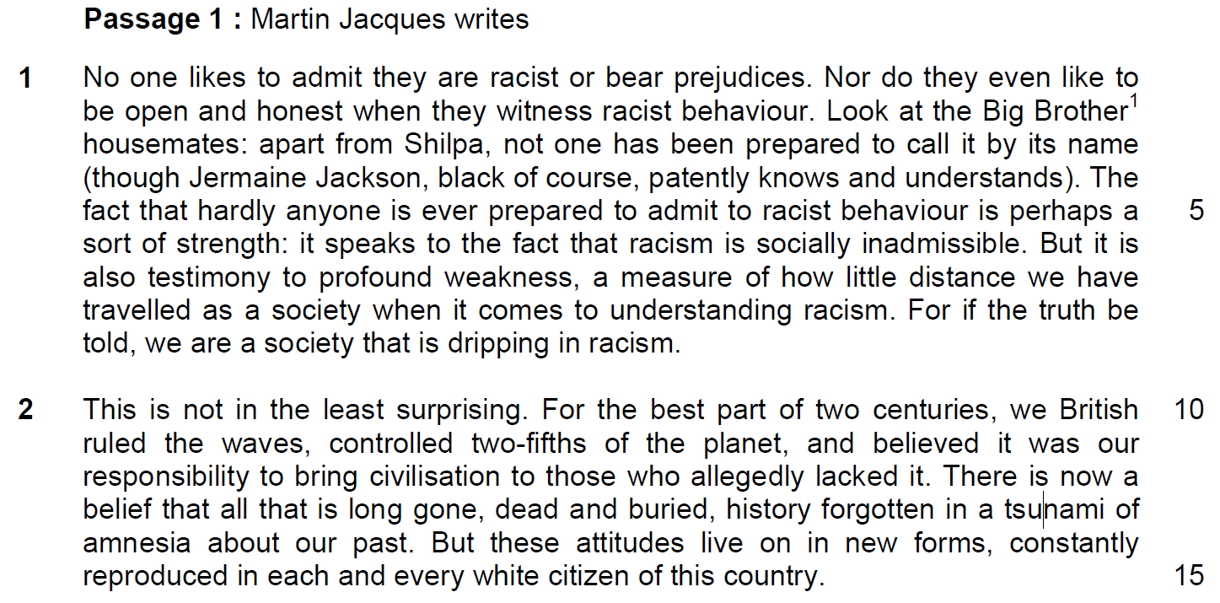

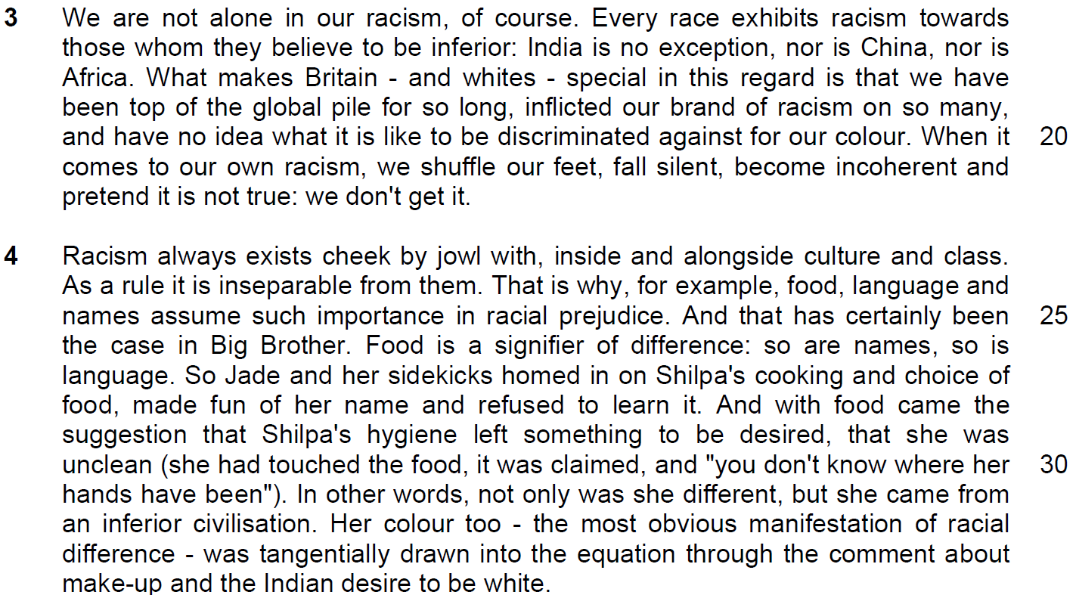

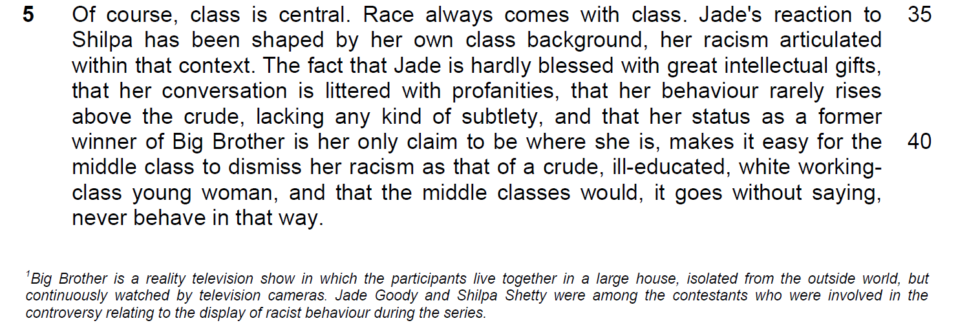

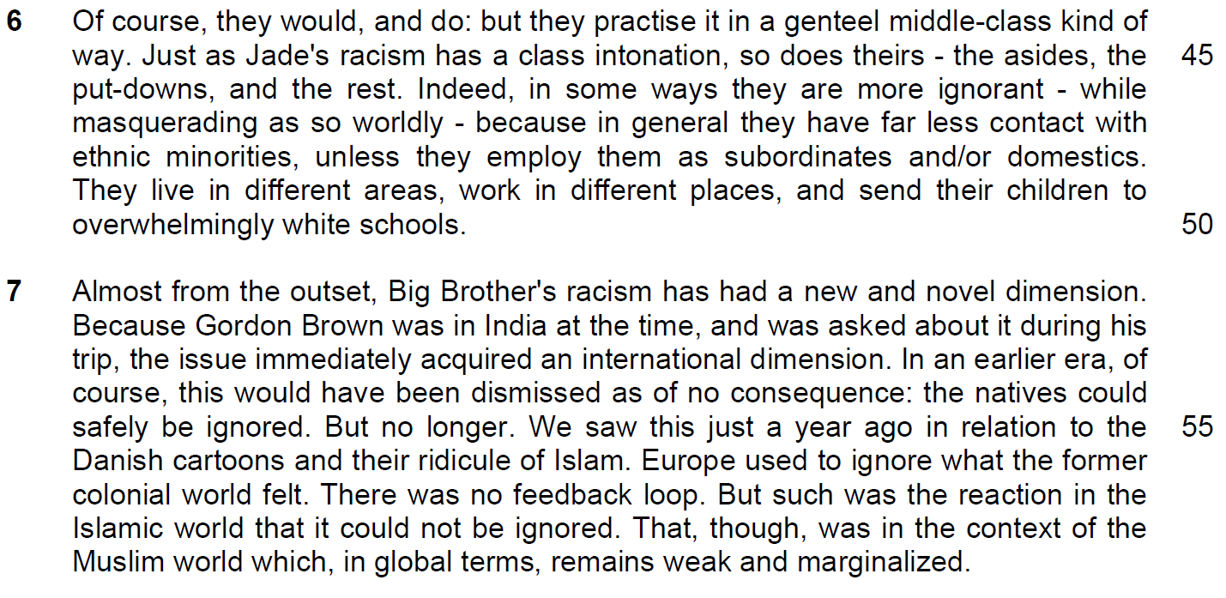

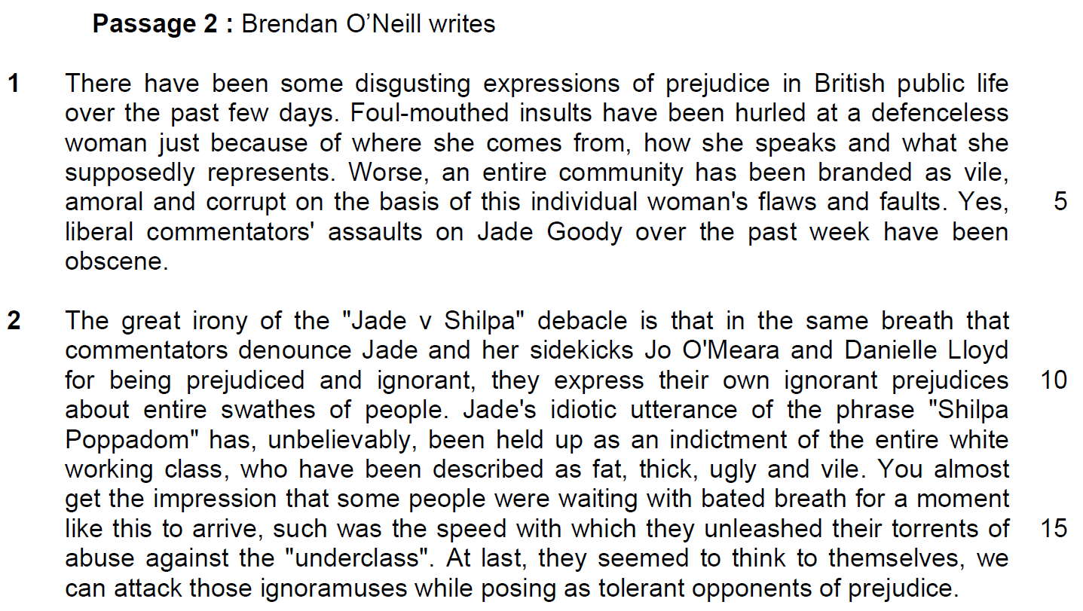

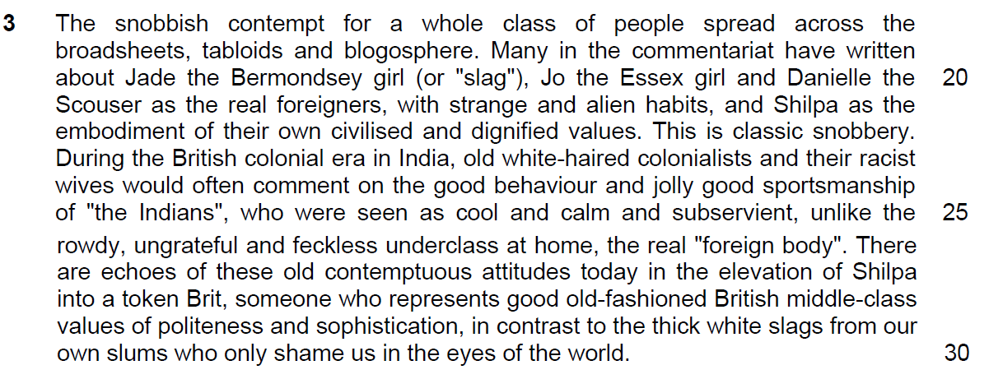

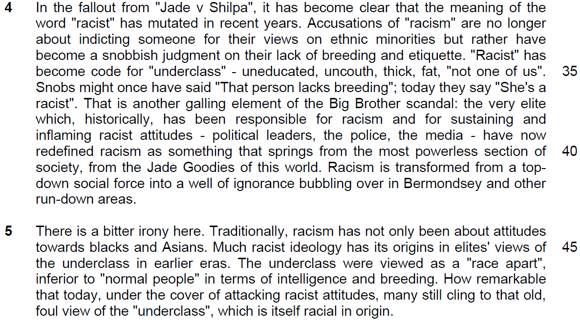

Read the passage in the insert and then answer all the questions. Note that up to fifteen marks will be given for the quality and accuracy of your use of English throughout this Paper.

NOTE: When a question asks for an answer IN YOUR OWN WORDS AS FAR AS POSSIBLE and you select the appropriate material from the passage for your answer, you must still use your own words to express it. Little credit can be given to answers which only copy words or phrases from the passage.

Questions on Passage 1

1(a) Why does the author place the phrase ‘through Jermaine Jackson, black of course, patently knowns and understands’ (line 4) in brackets or parenthesis? [1]

…………………………………………………………………………………………..

…………………………………………………………………………………………..

…………………………………………………………………………………………..

1(b) Explain the author’s use of the phrase ‘of course’ (line 4). [1]

…………………………………………………………………………………………..

…………………………………………………………………………………………..

2(a) ‘The fact that hardly anyone is ever prepared to admit to racist behaviour is perhaps a sort of strength it is also testimony to profound weakness’ (lines 4-7).

Explain the paradox in the quotation. [2]

…………………………………………………………………………………………..

…………………………………………………………………………………………..

…………………………………………………………………………………………..

…………………………………………………………………………………………..

2(b) What does ‘perhaps’ (line 5) say about his conclusion? [1]

…………………………………………………………………………………………..

…………………………………………………………………………………………..
3. ‘we are a society that is dripping in racism.’
Explain why the author uses the word ‘dripping’ (line 9). [1]

…………………………………………………………………………………………..

…………………………………………………………………………………………..

4. What does the expression ‘believed it was our responsibility to bring civilization to those who allegedly lacked it’ (lines 11 – 12) tell you about the author’s opinion of the British conquerors and their justification? [2]

…………………………………………………………………………………………..

…………………………………………………………………………………………..

…………………………………………………………………………………………..

…………………………………………………………………………………………..

Summary Question
5. Using material from paragraphs 4 to 6 of Passage 1, summarise the ways in
which racism exhibits itself and the reasons for its manifestations.

Write your summary in no more than 120 words, not counting the opening words which are printed below. Use your own words as far as possible. [8]

Racism exhibits itself through

…………………………………………………………………………………………..

…………………………………………………………………………………………..

…………………………………………………………………………………………..

…………………………………………………………………………………………..

…………………………………………………………………………………………..

…………………………………………………………………………………………..

…………………………………………………………………………………………..

…………………………………………………………………………………………..

…………………………………………………………………………………………..

…………………………………………………………………………………………..

…………………………………………………………………………………………..

…………………………………………………………………………………………..

…………………………………………………………………………………………..

…………………………………………………………………………………………..

…………………………………………………………………………………………..

…………………………………………………………………………………………..

…………………………………………………………………………………………..

…………………………………………………………………………………………..

6. In paragraph 7, why is it difficult for the Western world to ignore reactions from the old colonial world? Use your own words as far as possible. [2]

…………………………………………………………………………………………..

…………………………………………………………………………………………..

…………………………………………………………………………………………..

…………………………………………………………………………………………..

7. What point does the author want to make when he says ‘That, though, was in the context of the Muslim world which in global terms, remains weak and marginalized’ (lines 58 – 59)? [1]

…………………………………………………………………………………………..

…………………………………………………………………………………………..

…………………………………………………………………………………………..

Question from Passage 2
8. Explain what makes the author conclude that ‘people were waiting with bated
breath for a moment like this to arrive’ (lines 14 – 15). Use your own words as
far as possible. [2]

…………………………………………………………………………………………..

…………………………………………………………………………………………..

…………………………………………………………………………………………..

…………………………………………………………………………………………..

9. ‘the meaning of the word “racist” has mutated in recent years’ (lines 31 – 32).
What does it suggest about human nature? [1]

…………………………………………………………………………………………..

…………………………………………………………………………………………..

…………………………………………………………………………………………..

Application Question (AQ)
10. Jacques argues that racism is exhibited by every race and O’Neill argues that racism can take on different forms.

To what extent has racism affected your country? How are these experiences similar to, or different from those discussed in both passages? [8]

…………………………………………………………………………………………..

…………………………………………………………………………………………..

…………………………………………………………………………………………..

…………………………………………………………………………………………..

…………………………………………………………………………………………..

…………………………………………………………………………………………..

…………………………………………………………………………………………..

…………………………………………………………………………………………..

…………………………………………………………………………………………..

…………………………………………………………………………………………..

…………………………………………………………………………………………..

…………………………………………………………………………………………..

…………………………………………………………………………………………..

…………………………………………………………………………………………..

…………………………………………………………………………………………..

…………………………………………………………………………………………..

…………………………………………………………………………………………..

…………………………………………………………………………………………..

…………………………………………………………………………………………..

…………………………………………………………………………………………..

…………………………………………………………………………………………..

…………………………………………………………………………………………..

…………………………………………………………………………………………..

…………………………………………………………………………………………..

…………………………………………………………………………………………..

…………………………………………………………………………………………..

…………………………………………………………………………………………..

…………………………………………………………………………………………..

…………………………………………………………………………………………..

…………………………………………………………………………………………..

…………………………………………………………………………………………..

…………………………………………………………………………………………..

…………………………………………………………………………………………..

…………………………………………………………………………………………..

…………………………………………………………………………………………..

…………………………………………………………………………………………..

…………………………………………………………………………………………..

…………………………………………………………………………………………..

…………………………………………………………………………………………..

…………………………………………………………………………………………..

…………………………………………………………………………………………..

…………………………………………………………………………………………..

…………………………………………………………………………………………..

